USSR Battle Set: order “Patriotic War” 1st Class #173649, order “Patriotic War” 2nd Class #352825, order “Red Star” #704498, order “Red Star” #3443371, medal “for Courage” #365071, order “Patriotic War” 1st Class (85) #801279 with documents.

Awarded to:
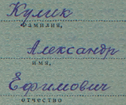
Kulik Aleksandr Efimovich
Кулик Александр Ефимович

Medal “for Courage” #365071 awarded for:
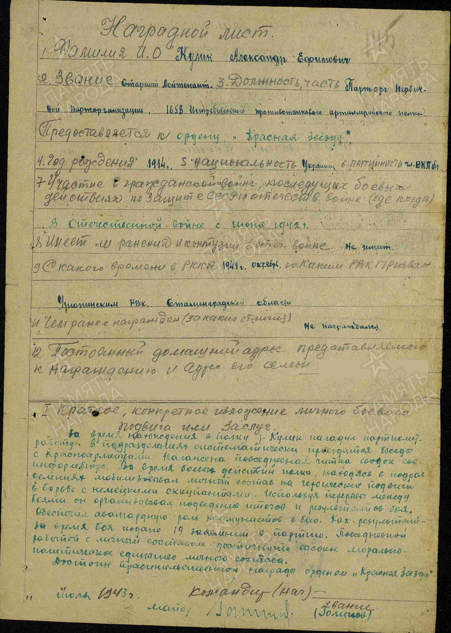
Kulik Aleksandr Efimovich – senior lieutenant, leader of main communist party organization of 1658 Fighter anti-tank artillery regiment.

While serving in the regiment, Kulik organized party-political work within the units and regularly met with soldiers. He conducted daily readings of reports from the Soviet Information Bureau.

During the regiment's combat operations, he worked directly with frontline units, inspiring soldiers to perform heroic deeds in battles against the German invaders. During breaks in combat, he organized reviews and analyses of combat operations. He ensured the leading role of Communists in battle.

As a result of his work, he received 19 applications for membership in the Communist Party during combat operations. Through his constant efforts, he achieved a high level of morale and political unity among the personnel.

He is worthy of the government award, the Order of the Red Star.
“ “ July 1943 Commander
Major (Golinov)
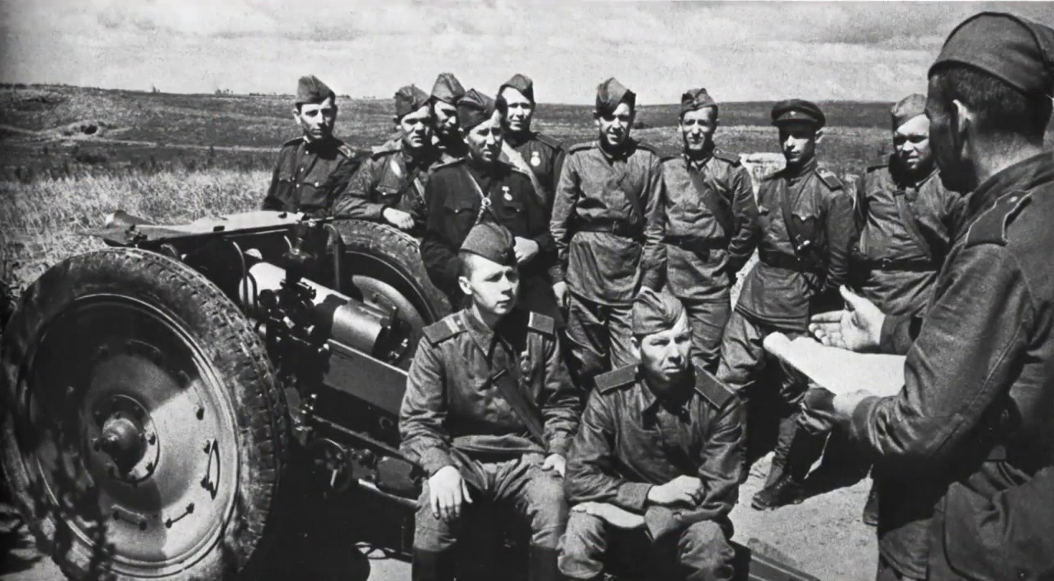
Political leader.

Order “Red Star” #704498 awarded for:
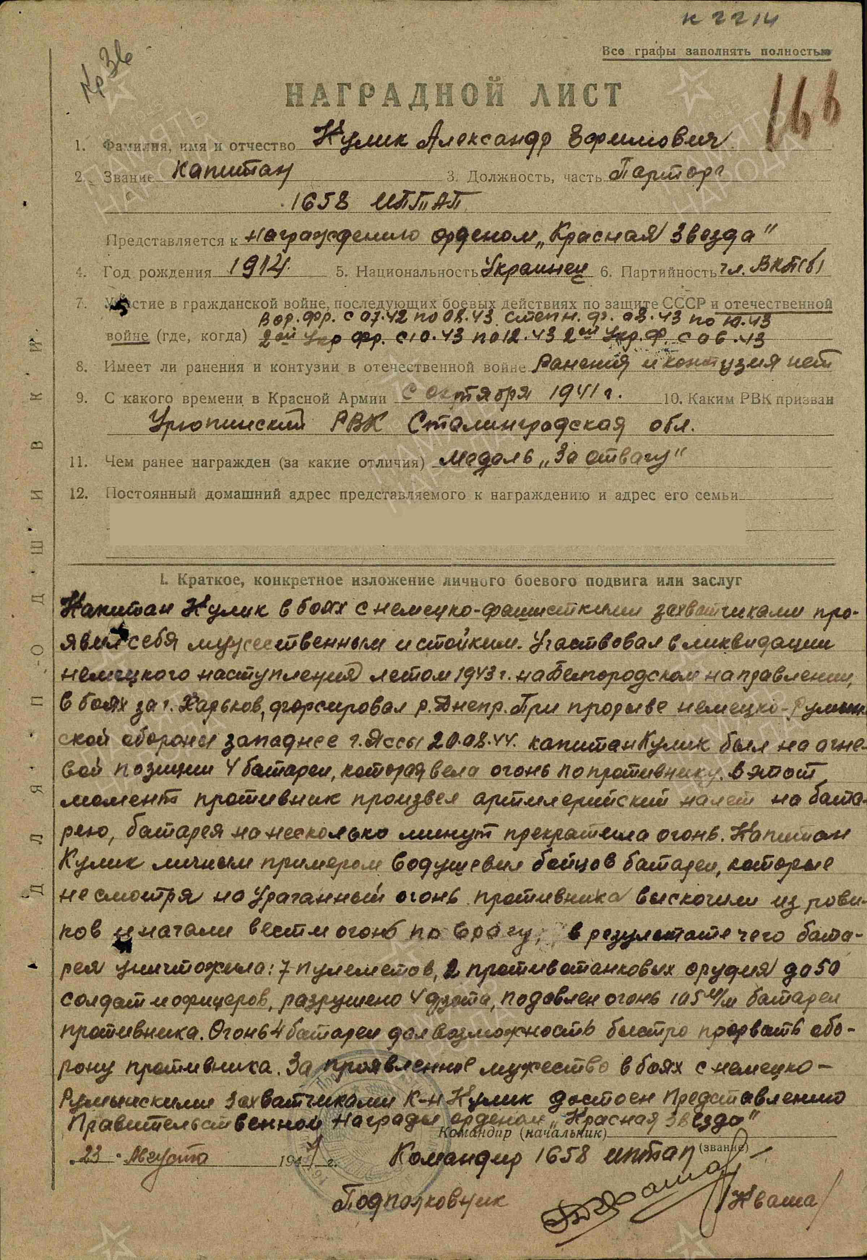
Kulik Aleksandr Efimovich – captain, party leader of 1658 Fighter anti-tank artillery regiment.

In battles against the German invaders, Kulik proved himself to be brave and steadfast. He participated in repelling the German offensive in the summer of 1943 in the Belgorod sector, in the battles for the city of Kharkov, and in the crossing of the Dnieper River.

During the breakthrough of the German-Romanian defensive line west of Iași on August 20, 1944, Kulik was at the firing position of the 4th artillery battery, directing its fire. During the battle, the enemy subjected the battery to heavy artillery bombardment, causing it to cease fire for several minutes.

By his personal example, Kulik inspired the soldiers to leave their shelters despite the intense artillery fire and resume firing on the enemy. As a result, the battery destroyed 7 heavy machine guns, 2 mounted machine guns, 4 artillery pieces, and approximately 50 enemy soldiers and officers, and suppressed the fire of a 105-mm artillery battery.

The fire of the 4th artillery battery enabled the rapid breakthrough of the enemy's defensive line.

For the courage and bravery he displayed in battles against the German and Romanian invaders, Kulik is worthy of the government award, the Order of the Red Star.
“23” August 1944. Commander of 1658 FATAR
Lieutenant-colonel (Kvasha)
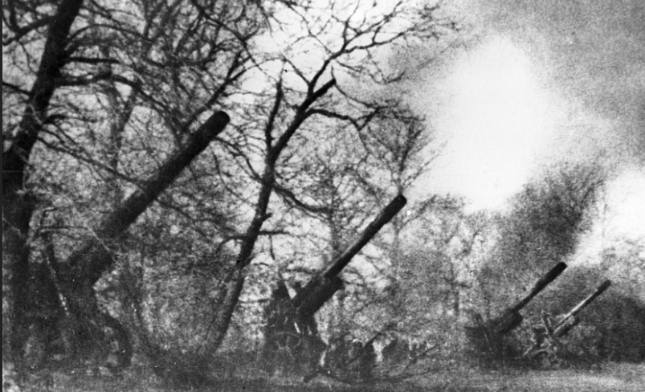
Artillery.

Order “Patriotic War” 2nd Class #352825 awarded for:
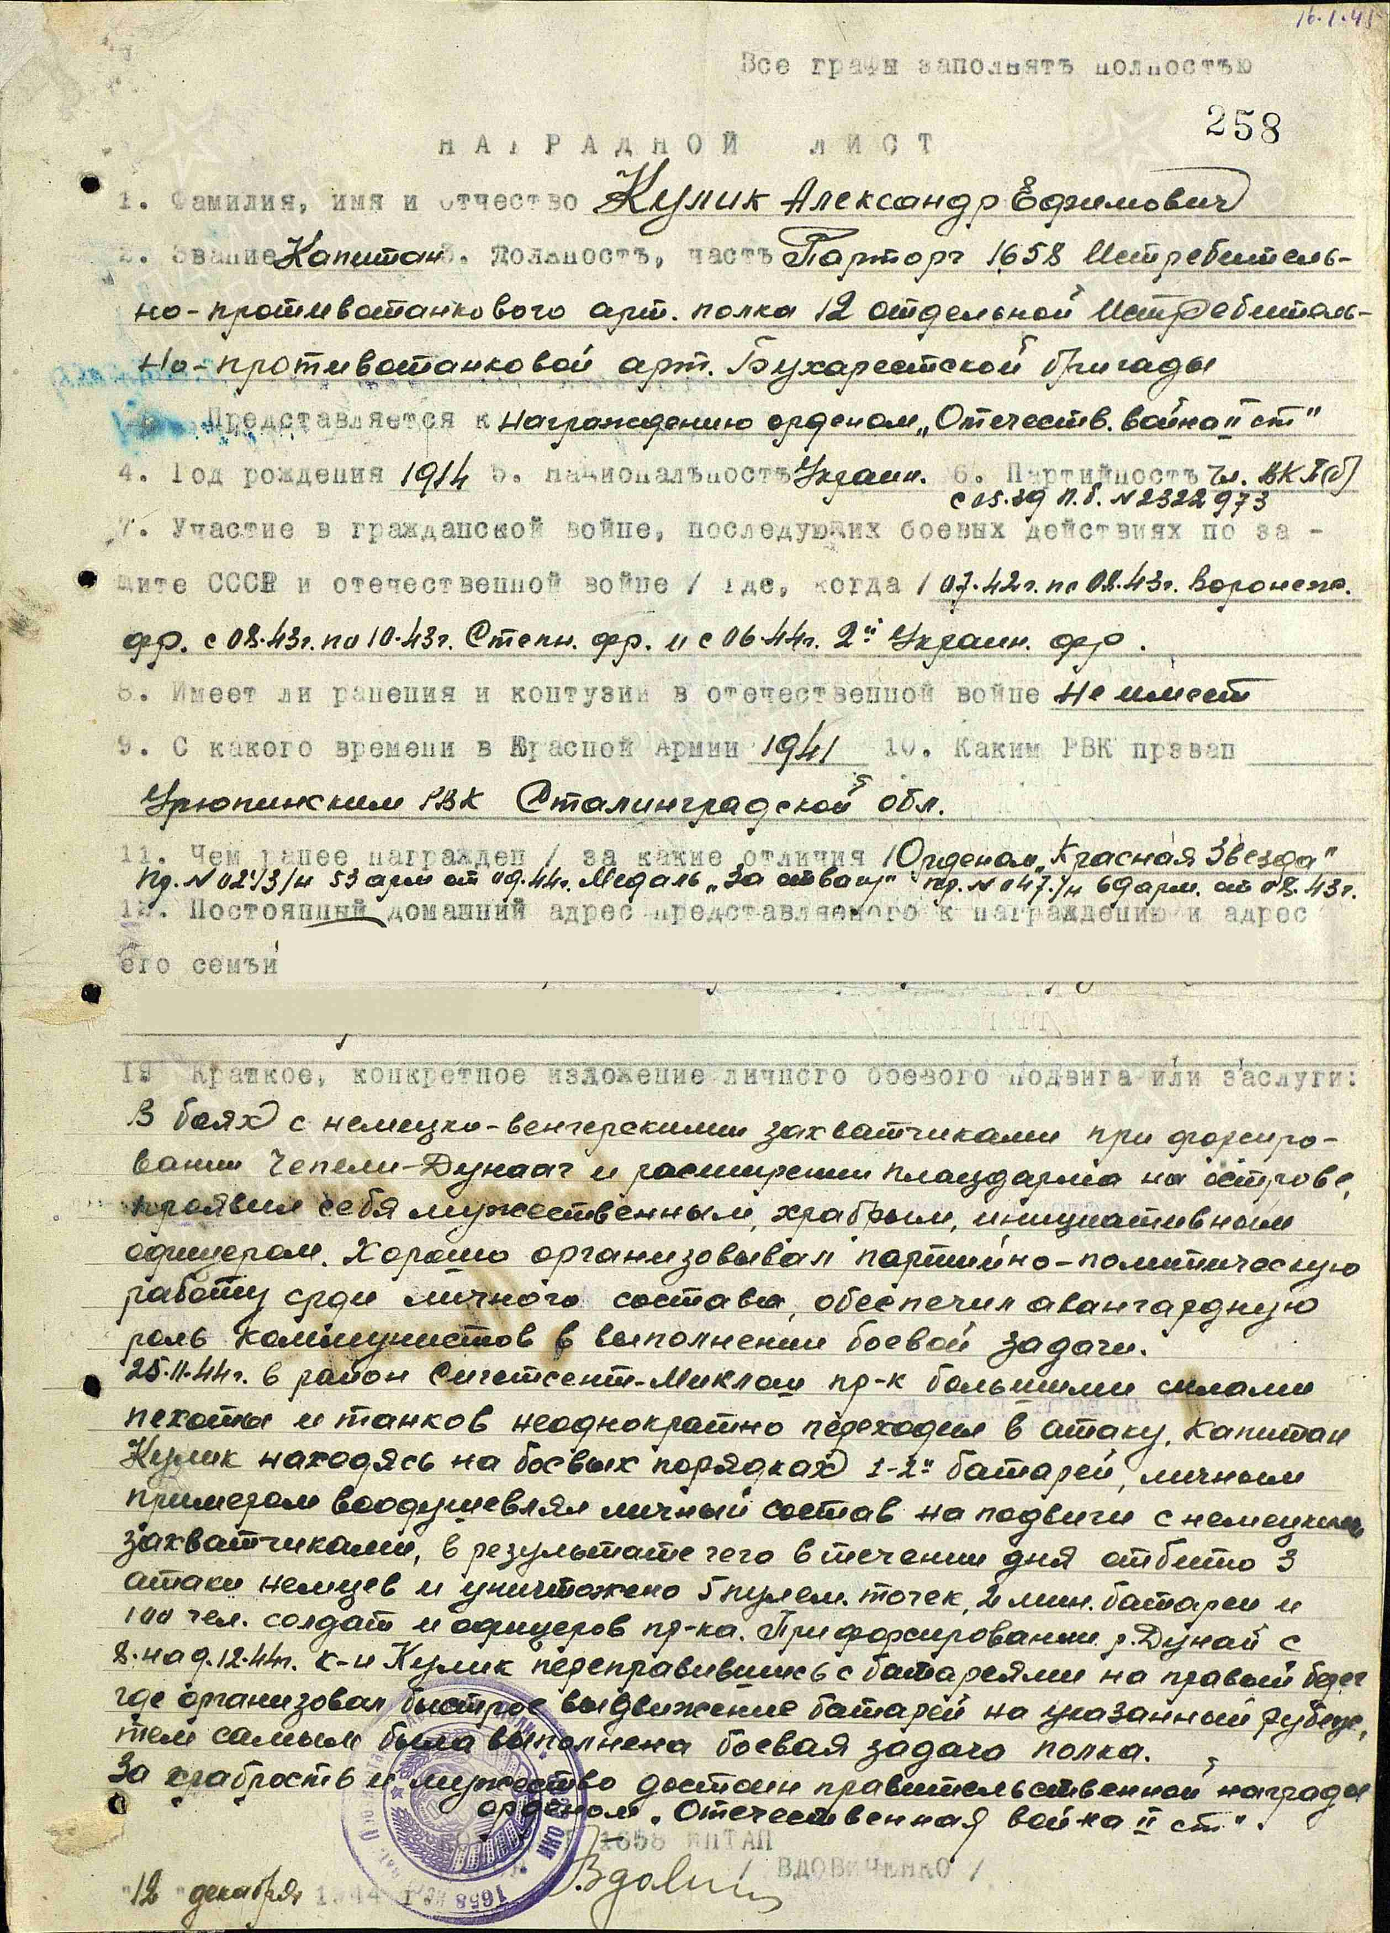
Kulik Aleksandr Efimovich – captain, party leader of 1658 fighter anti-tank artillery regiment of 12 separate fighter anti-tank artillery Bucharest brigade.
In combats with Germany-Hungary invaders during crossing Danube branch Cepeli Dunag showed himself as brave, courageous and initiative officer. Excellent organized communist party propaganda work among staff and secured leadership role of communists in combats.
In November 25, 1944 on territory of Hungary enemy by big forces of infantry and tanks repeatedly attacked, Kulik in combat formations of 1 & 2 artillery batteries by personal example inspired staff on feats with German’s invaders, as result during day reflected 3 attacks and destroyed 5 machine-gun fire points, 2 mortar batteries and killed 100 enemy soldiers and officers. During crossing Dunabe river from December 8 to 8, 1944 Kulik crossed with batteries on right bank, where organized moving of batteries on marked positions, performing by this regiment’s combat task.
For bravery and courage deserves governmental award order “Patriotic war 2nd class”.

Commander of 1658 fighter anti-tank artillery regiment
MAJOR (VDOVICHENKO)
“12” December 1944

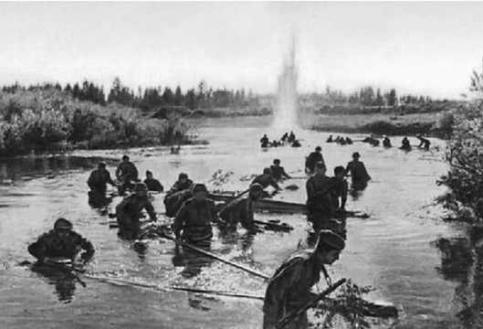
Crossing of river

order “Patriotic War” 1st Class #173649 awarded for:
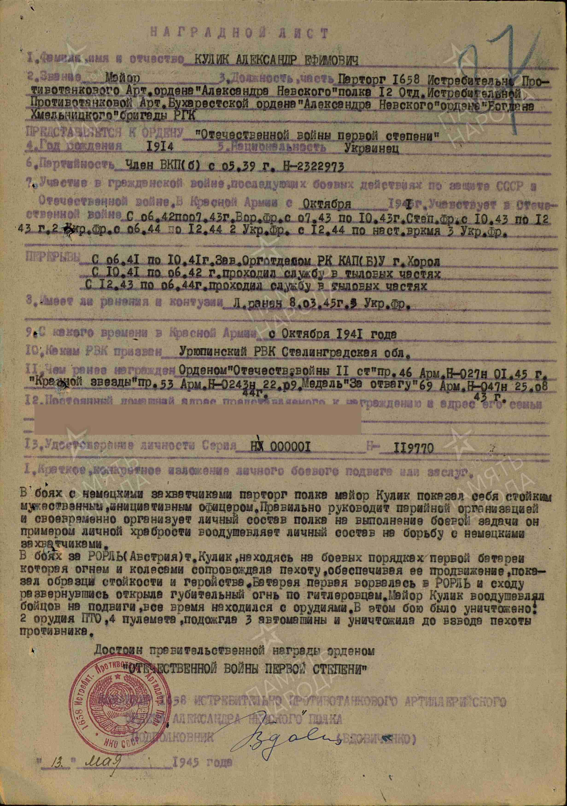
Kulik Aleksandr Efimovich – major, party leader of 1658 fighter anti-tank artillery regiment of 12 separate fighter anti-tank artillery Bucharest brigade.
Awarded for persistent and courageous leadership in combat against German forces. Effectively directed Party work within the regiment, mobilizing personnel to fulfill combat missions and inspiring soldiers through personal example. During operations in Austria, while serving with the 1st artillery battery supporting the infantry advance, he remained with the guns under fire as the battery was the first to enter a settlement and engage the enemy. Under his leadership, the battery destroyed 2 anti-tank guns and 4 machine-gun positions, set fire to 3 vehicles, and killed approximately a platoon of enemy infantry, contributing directly to the successful advance of Soviet forces.

Deserves governmental award order
“PATRIOTIC WAR FIRST CLASS”

COMMANDER OF of 1658 fighter anti-tank artillery regiment
LIEUTENANT-COLONEL (VDOVICHENKO)

“13” may 1945
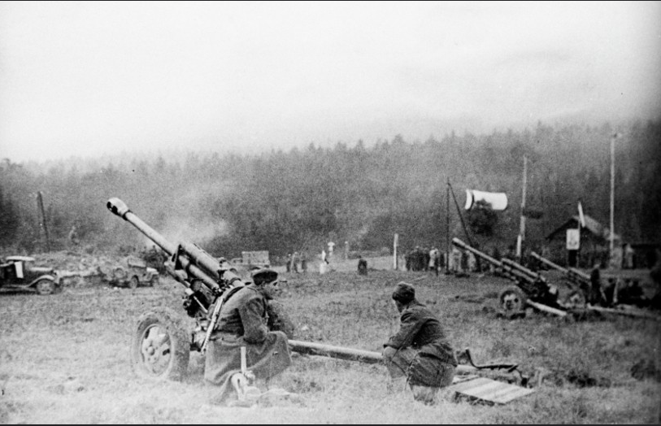
Soviet artillerymen.

