USSR Order Red Star #1405833 with doc.

Awarded to:
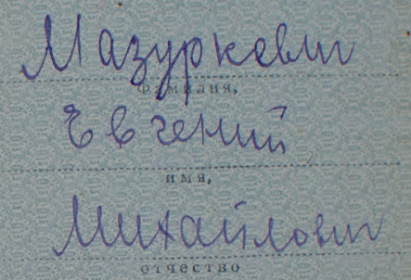
Mazurkevich Evgeniy Mikhaylovich
Мазуркевич Евгений Михайлович

Order Red Star #1405833 awarded for:
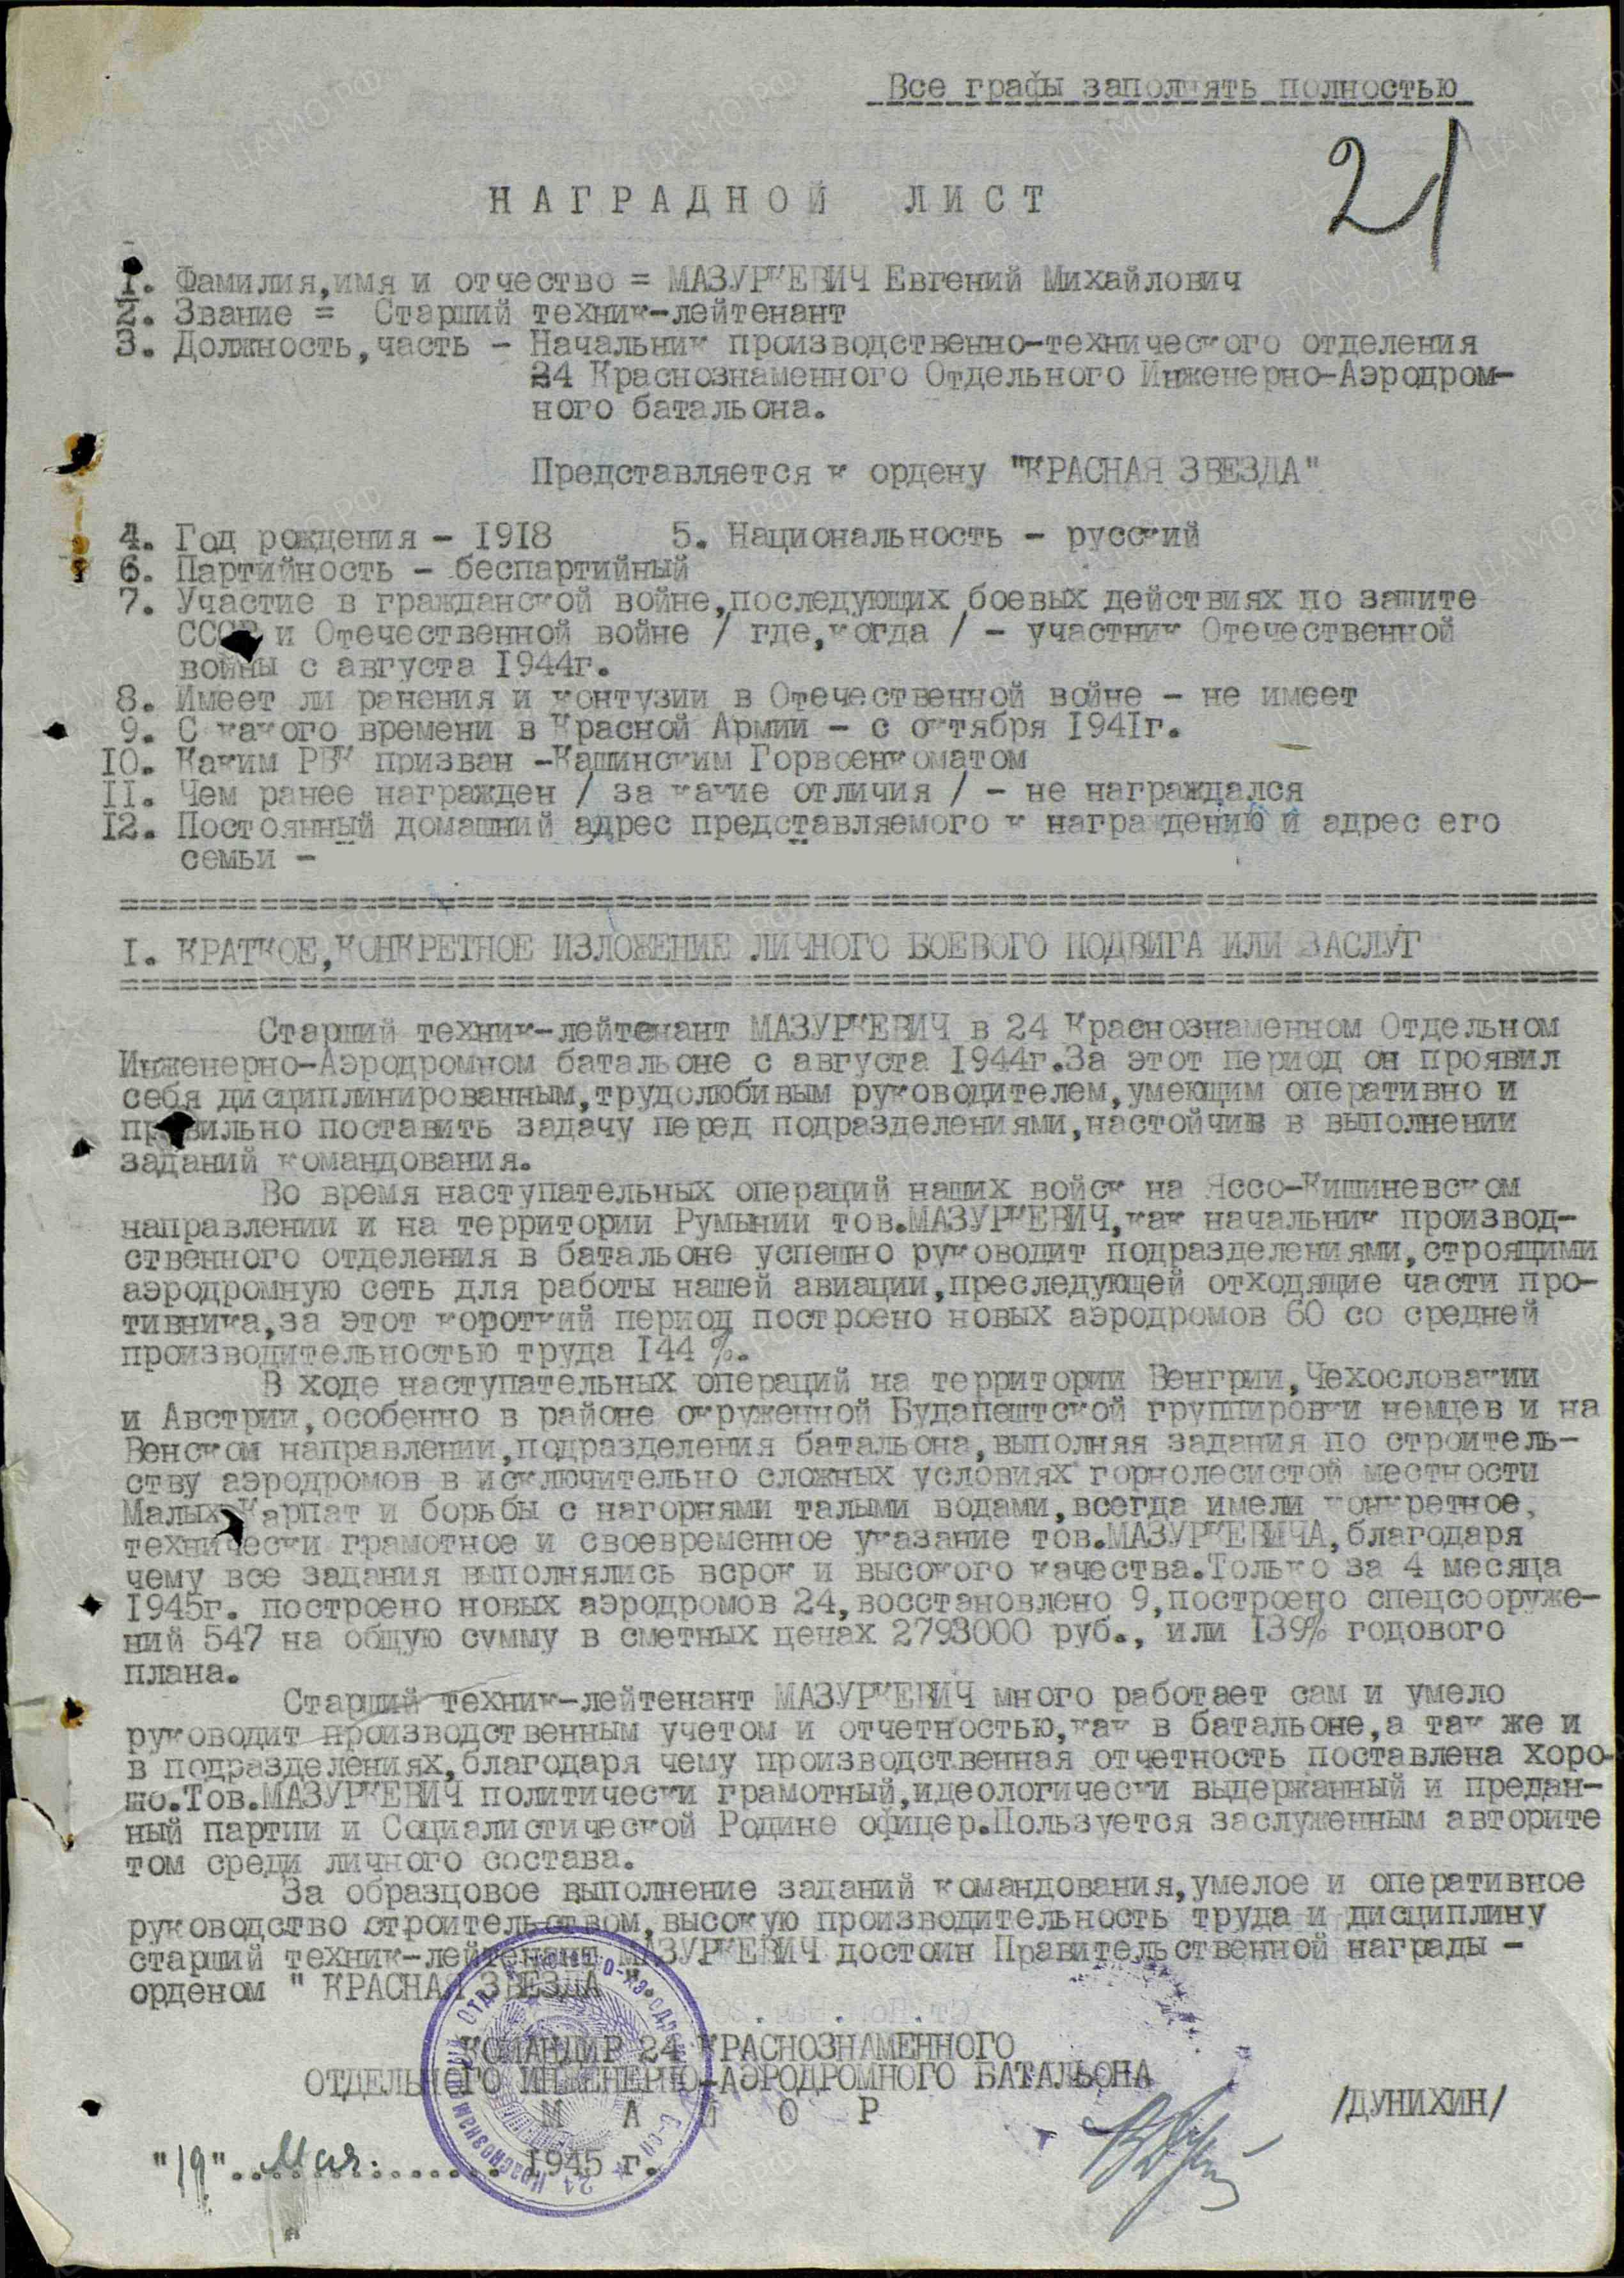
MAZURKEVICH Evgeniy Mikhaylovich – senior technician – lieutenant, chief of production-technical department of 24 Red Banner Separate Engineering-Airdrome battalion.

MAZURKEVIC in 24 battalion served from August 1941. For this period he showed himself as disciplined, hardworking manager, that able quickly and correctly gave task to units, persistent in performing of Command’s tasks.
During advancing operations of our troops in Jassy–Kishinev direction and on territory of Romania, MAZURKEVICH as chief successfully managed departments, constructing airdrome net for work of our aviation, attacking retreating enemy units, for that short period built new airdromes 60 with average labor productivity 144%.
During advancing operations on territory of Hungary, Czech-Slovakia and Austria, especially in region of surrounded German’s Budapest group of troops and Vienna direction, battalion units performing tasks on construction of airdromes in hard conditions of mountains and forest terrain of Little Carpathians and fought with mountain melt water, MAZURKEVIC’S orders performed timely and with excellent quality. Only for 4 months of 1945 built new 24 airdromes, repaired 9, performed special constructions 547 with value 2 793 000 rubles or 139% of year plan.
MAZURKEVIC worked a lot personally and skillfully managed production accounting and reporting. MAZURKEVIC politically competent, devoted to Communist party and Socialist Motherland officer. Enjoys authority among staff.
For excellent performing Command’s tasks, skillful and quick managing of construction, high labor productivity and discipline – MAZURKEVICH deserves Governmental award – order “RED STAR”.

COMMANDER OF 24 RED BANNER
SEPARATE ENGINEERING-AIRDROME BATTALION
M A J O R /DUNIHIN/
“19” May 1945

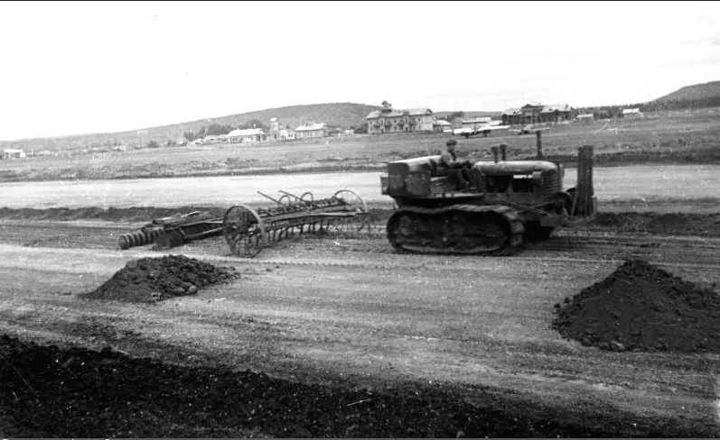
Building of airdrome

