USSR Order “Red Star” #669809 with document.

Awarded to:
Koval Grigoriy Ignatievich
(Коваль Григорий Игнатьевич)

Order “Red Star” #669809 awarded for:
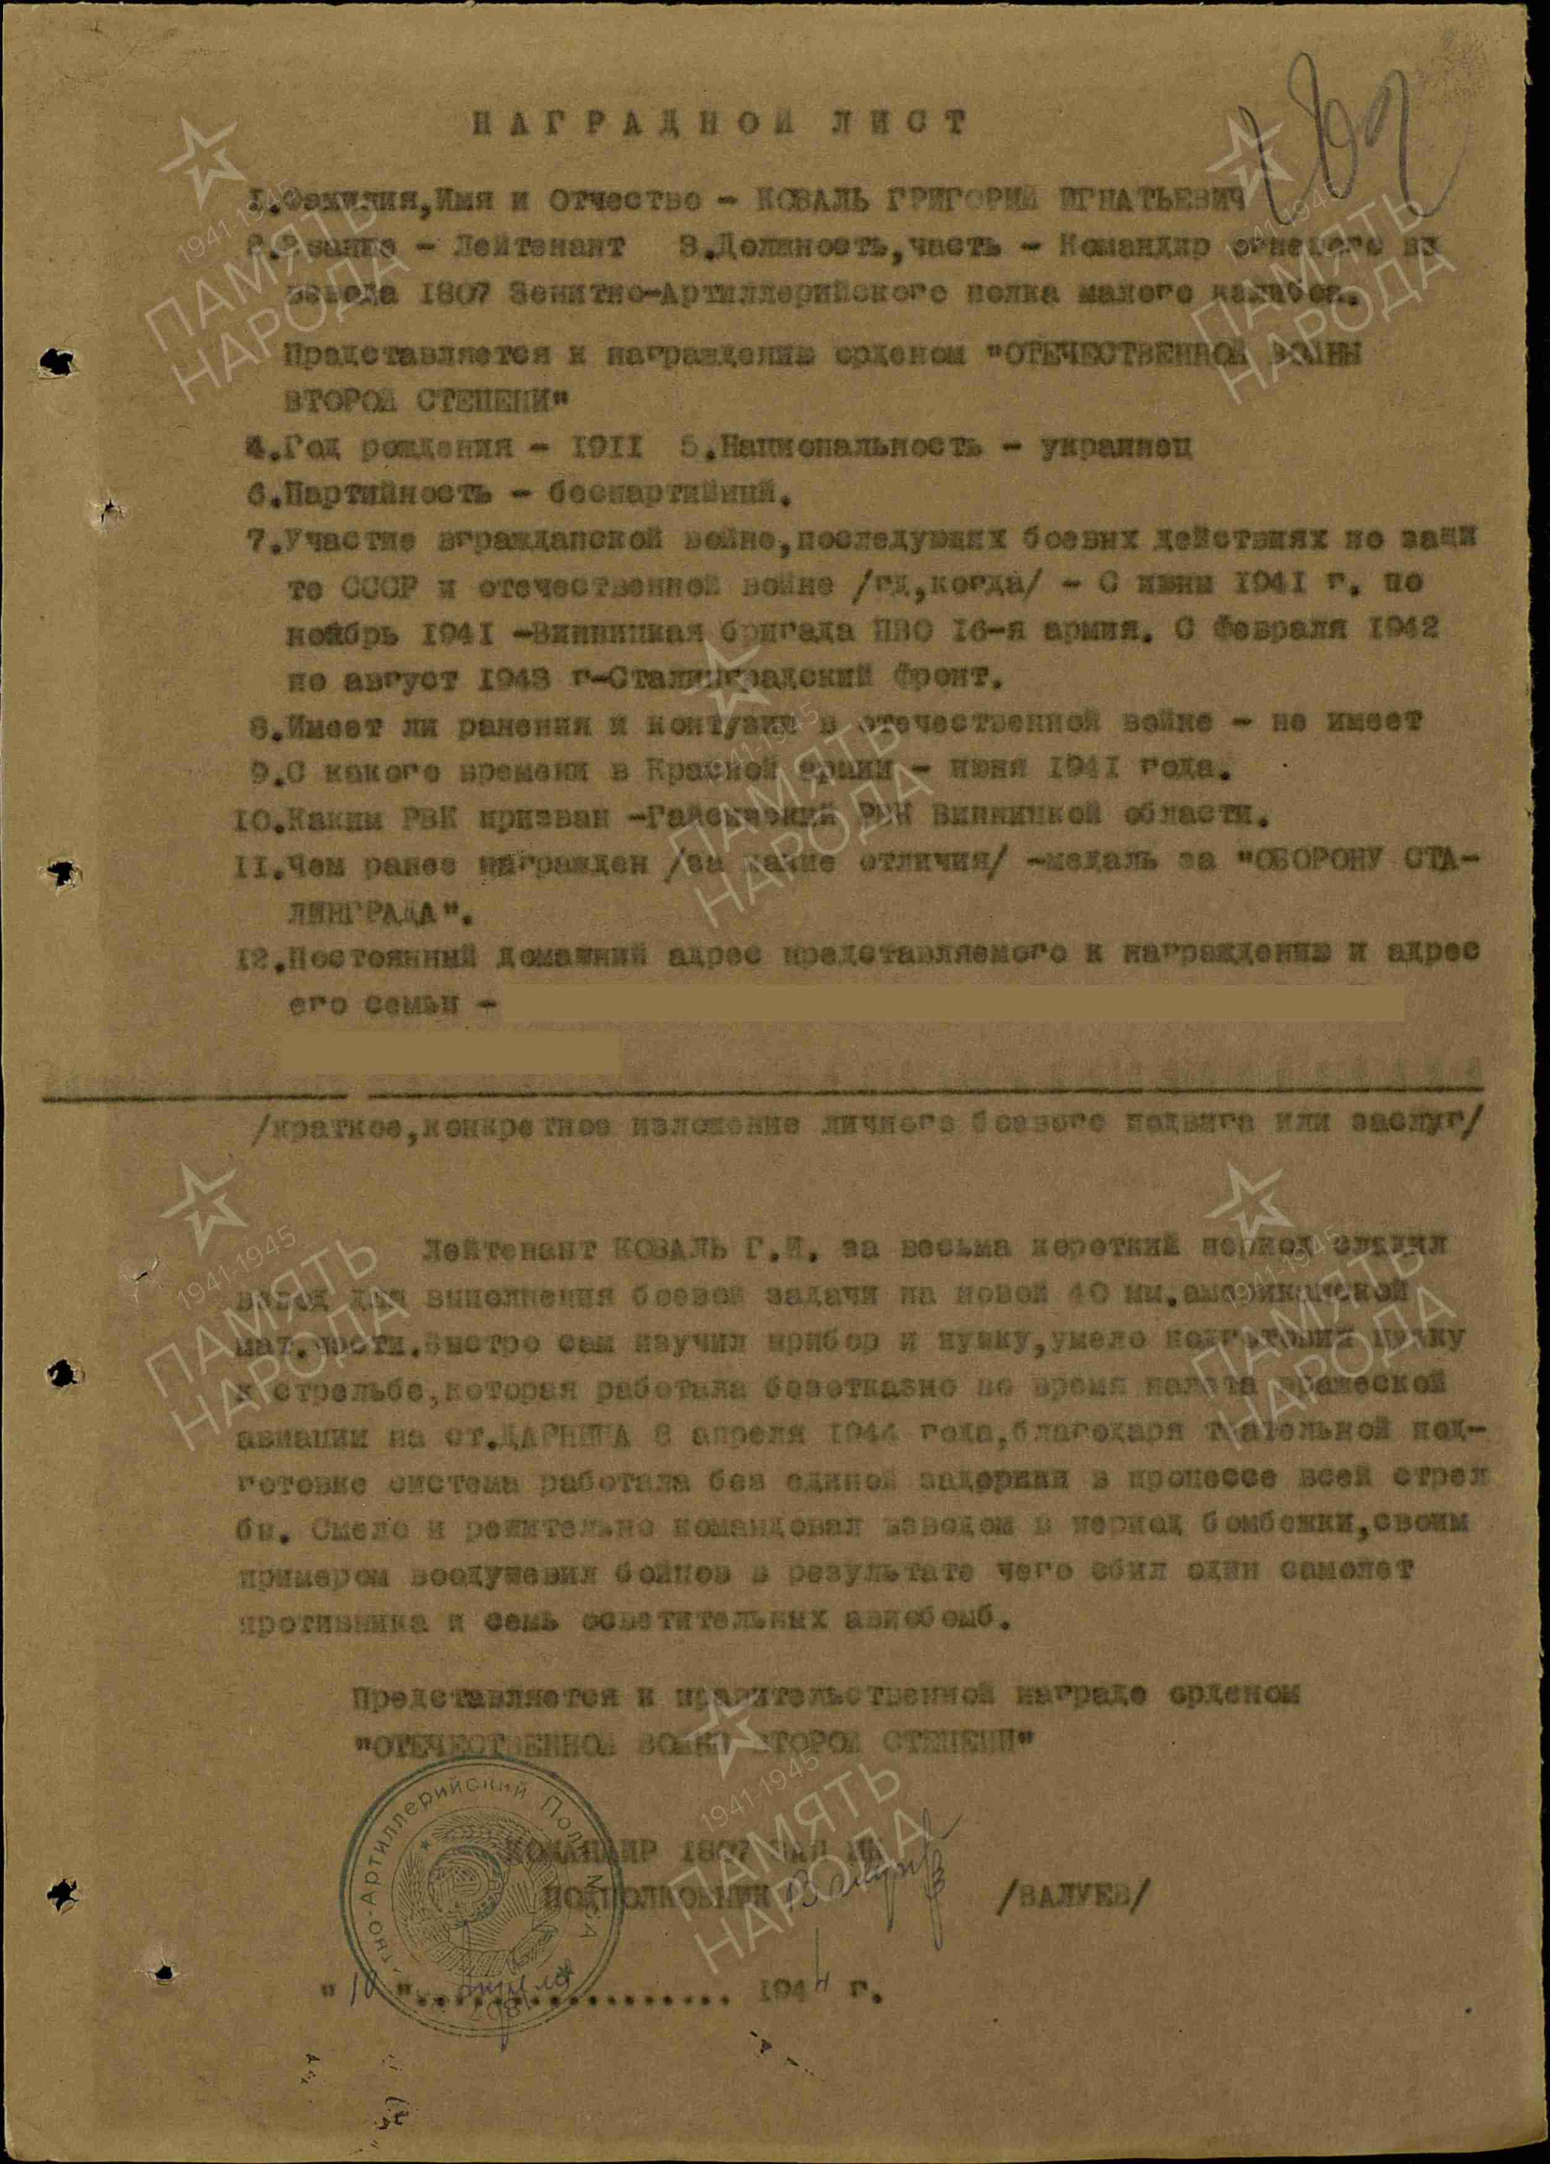
KOVAL GRIGORIY IGNATIEVICH – lieutenant, commander of fire platoon of 1807 Air Defense – Artillery regiment of small caliber.
KOVAL, in a short period of time, studied the American 40mm artillery air defense cannon, learned to shoot quickly and accurately, and skillfully prepared cannons for combat operations against enemy aviation near station DARNITSA on April 8, 1944. Through excellent preparation, the cannons worked without any delays during firing. He boldly and decisively managed the platoon during enemy aviation bombing and, by his personal example, inspired the soldiers; as a result, 1 enemy plane was shot down and 7 illumination aviation bombs were destroyed.

Submitted to governmental award order “PATRIOTIC WAR 2ND CLASS”

COMMANDER OF 1807 AIR DEFENSE ARTILLERY REGIMENT
LIEUTENANT-COLONEL /VALUEV/
“10” April 1944

But higher award commission after reading his feat decided award him by lower grade award – order “Red Star”.

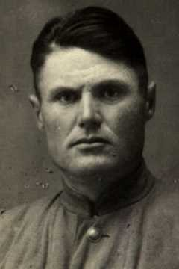
KOVAL GRIGORIY IGNATIEVICH

