Order “Patriotic War” 2nd Class #340256 awarded for:
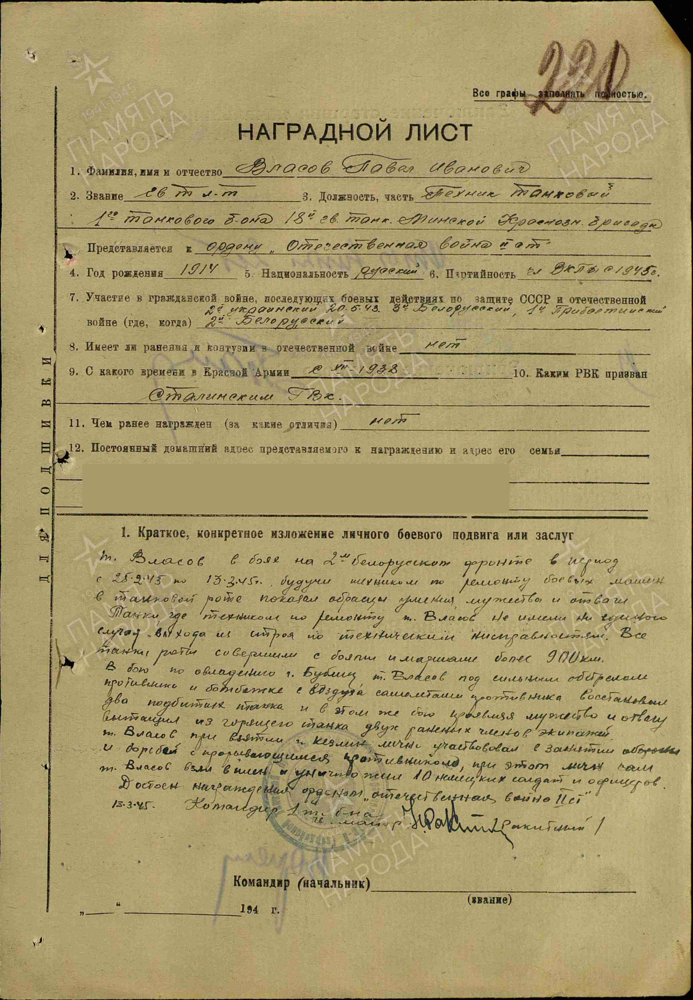
Vlasov Pavel Ivanovich - guard’s lieutenant, tank technician of 1st tank battalion of 18 Guard’s tank Minsk Red banner brigade.

Vlasov, serving on the 2nd Belorussian Front from February 25 to March 13, 1945, worked as a combat vehicle repair technician in a tank company and demonstrated outstanding skill, bravery, and courage.

The tanks maintained by Vlasov did not fail due to technical issues. All tanks of the company covered more than 900 km in combat operations.

During the battle for the capture of Bobolice (Poland), under heavy enemy fire and air attacks, Vlasov repaired two damaged tanks. In the same engagement, showing courage and determination, he evacuated two wounded crew members from a burning tank.

During the capture of Kuźmina (Poland), he personally took part in breaking through the enemy’s defenses, where he captured and eliminated 10 German soldiers and officers.

He merits the award of the Order of the Patriotic War, 2nd Class.
13.3.1945. Commander of 1 tank battalion
Gurd’s major /Rikitnyi/

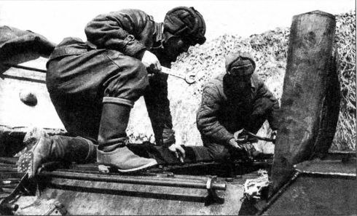
Technicians.

Order “Red Banner” #226311 awarded for:
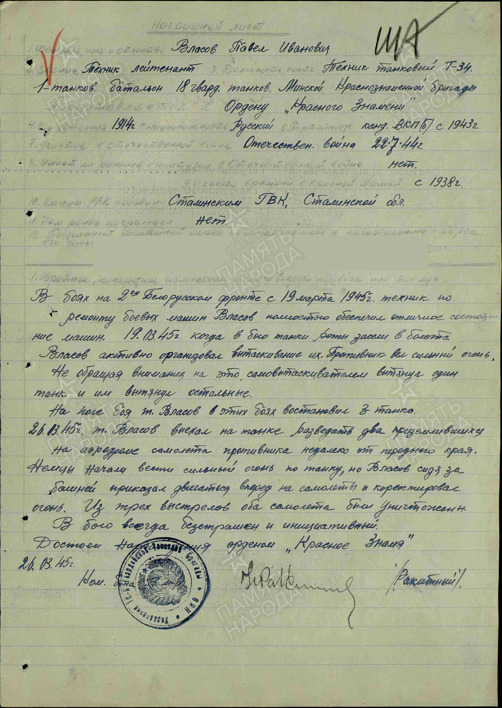
Vlasov Pavel Ivanovich – technician lieutenant, tank technician of T-34 of 1st Tank battalion of 18 Guard’s tank Minsk Red Banner brigade.
During combat operations on the 2nd Belorussian Front beginning in March 1945, Vlasov ensured that the company’s tanks remained in excellent condition. On March 19, 1945, when the company’s tanks became stuck in a swamp during battle, he organized their recovery. Despite heavy enemy fire, he personally used a recovery vehicle to pull out one tank, which then helped tow the others to safety.

On the battlefield, he restored three tanks during these engagements. On March 26, 1945, Vlasov advanced in a tank to reconnoiter two enemy aircraft at an airfield near the front line. When German forces opened heavy fire on the tank, Vlasov, positioned at the gun, ordered the vehicle to move forward and opened aimed fire. With three shots, both aircraft were destroyed.

He consistently demonstrated fearlessness and initiative in combat.

He merits the award of the Order of the Red Banner.
26.03.1945
Commander of battalion % Rakytnyi %

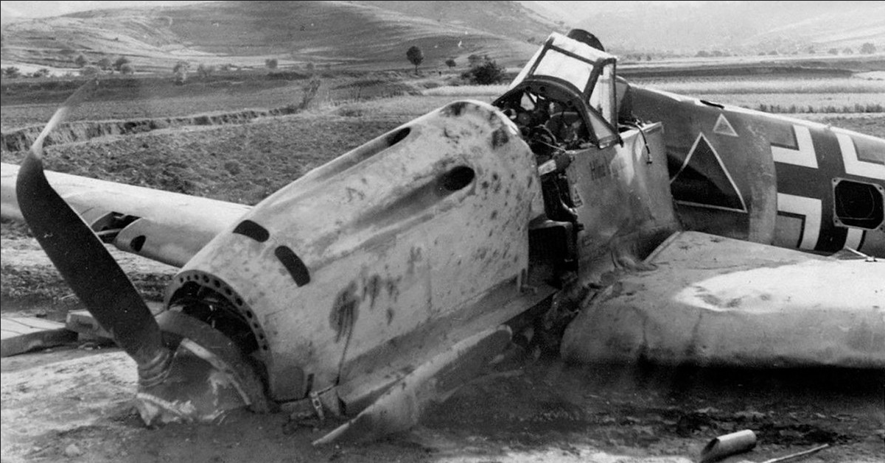
Destroyed German’s plane

Order “Red Star” #1666578 awarded for:
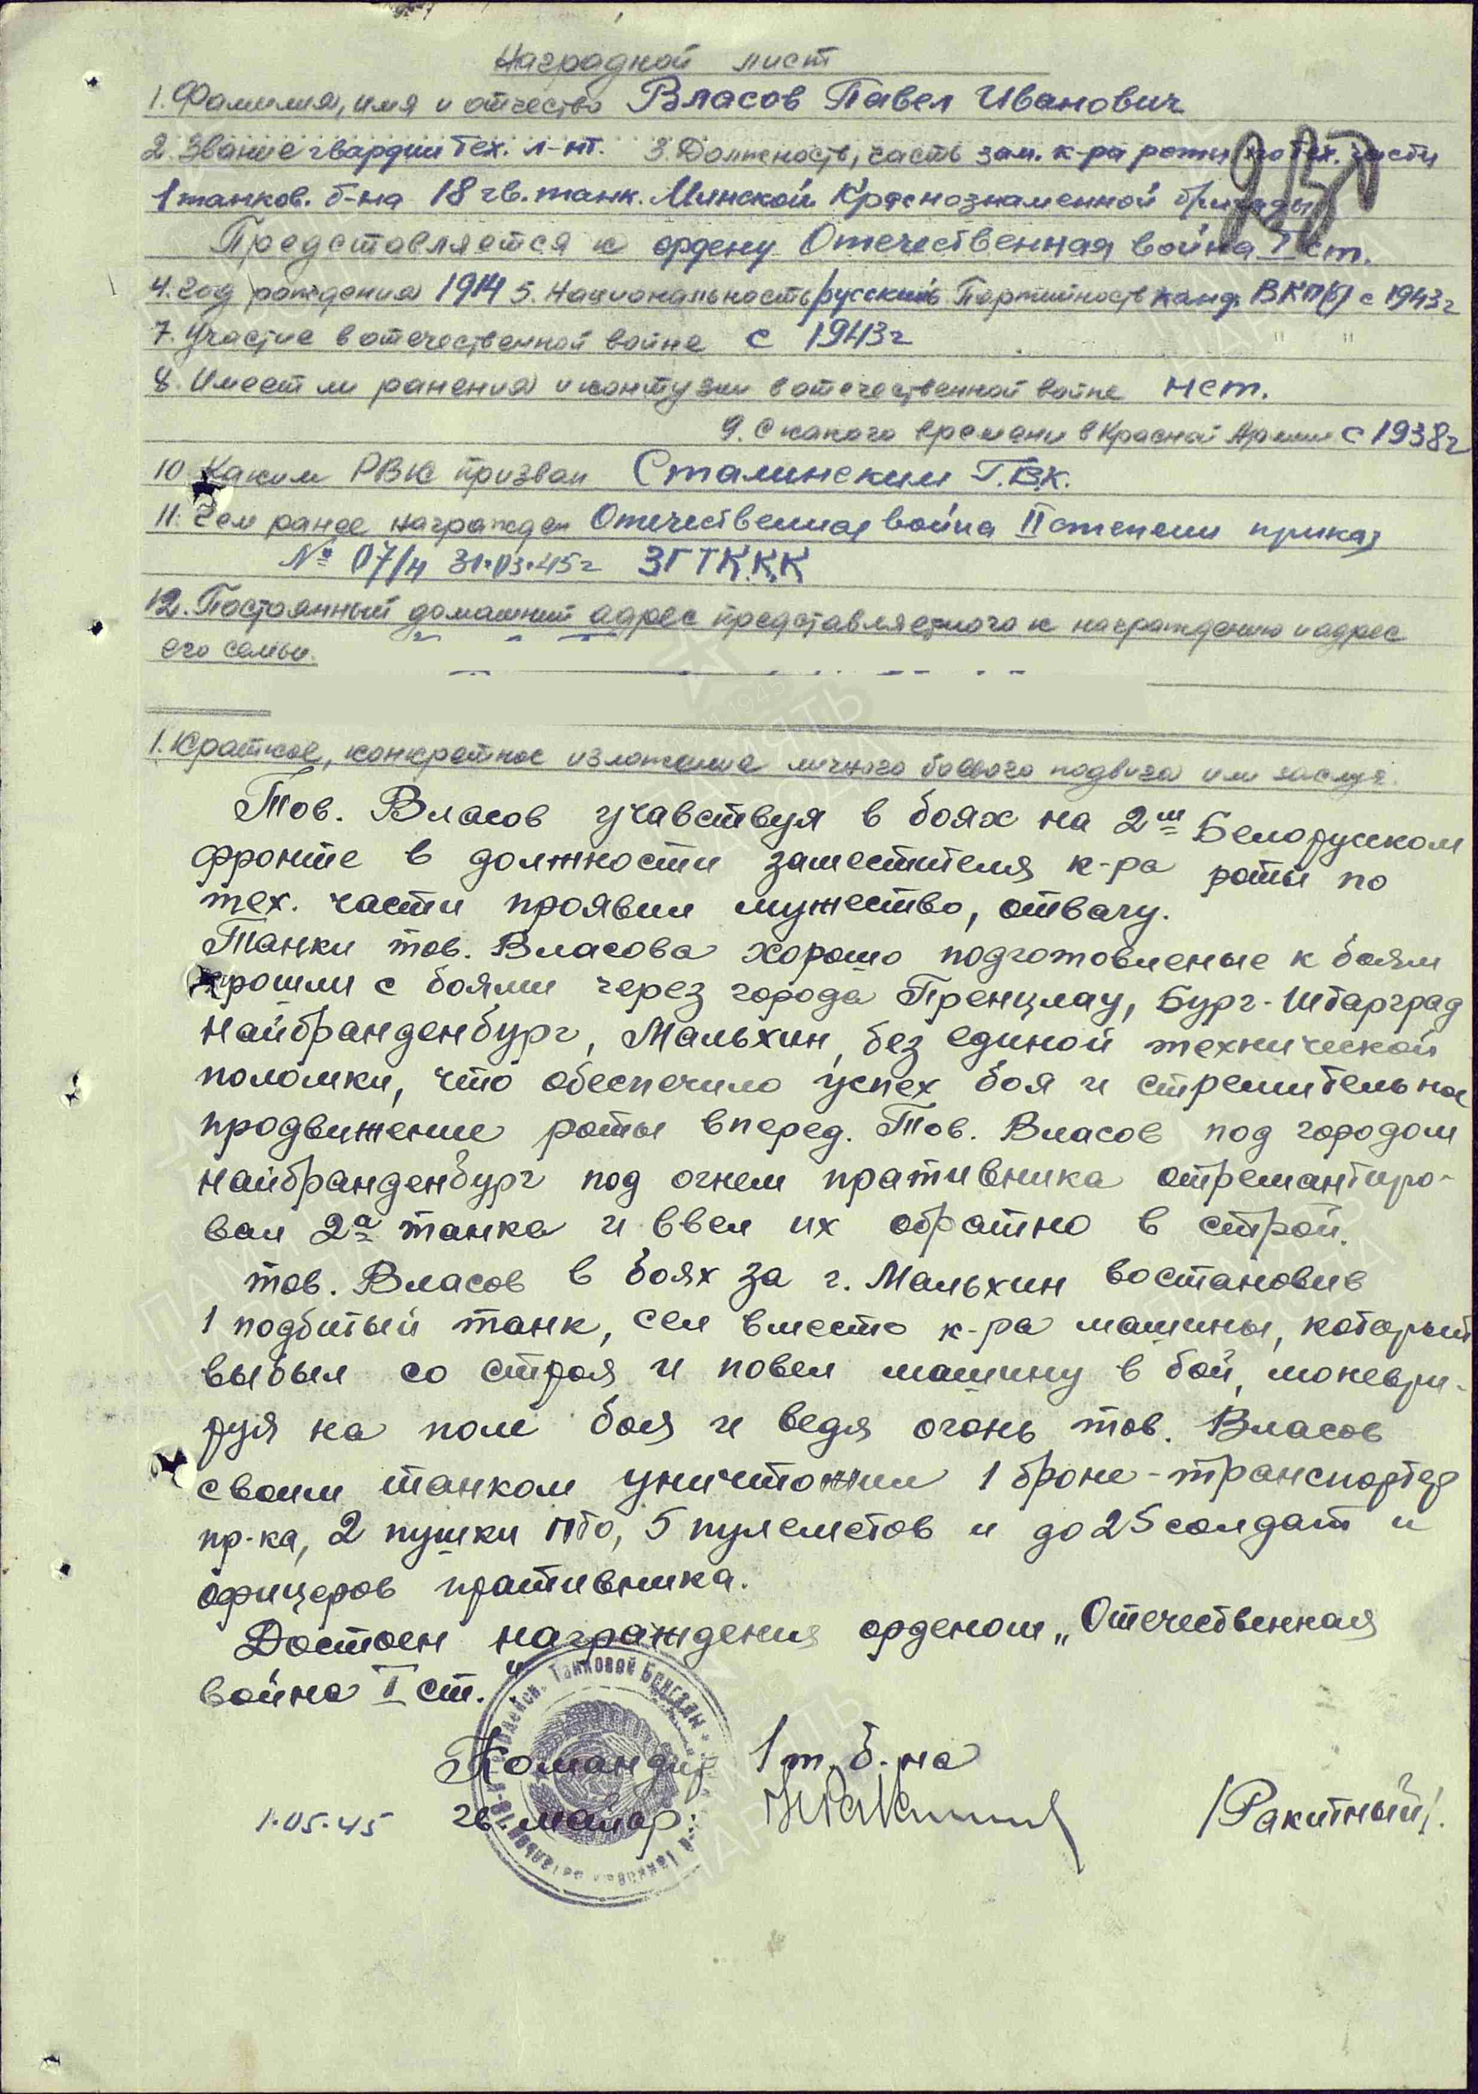
Vlasov Pavel Ivanovich – guard’s technician lieutenant, deputy commander of commander of technical part of 1 tank battalion of 18 guard’s tank Minsk Red Banner Brigade.

Vlasov took part in combat operations on the 2nd Belorussian Front as deputy commander for technical matters, demonstrating bravery and courage.

The tanks under his supervision were excellently prepared for battle and advanced through Prenzlau, Burg Stargard, Neubrandenburg, and Malchin (all in Germany) without a single technical failure, ensuring successful engagements and the rapid advance of the company. In Neubrandenburg, under enemy fire, Vlasov repaired two tanks and returned them to service.

During the battle for Malchin, he restored one damaged tank, replaced the wounded tank commander, and personally led the tank into combat. Maneuvering across the battlefield and firing, he destroyed one armored personnel carrier, two anti-tank guns, five machine-gun positions, and eliminated 25 enemy soldiers and officers.

He merits the award of the Order of the Patriotic War, 1st Class.

Commander of 1st tank battalion
1.05.45 Guard’s major: /Rakitnyi/

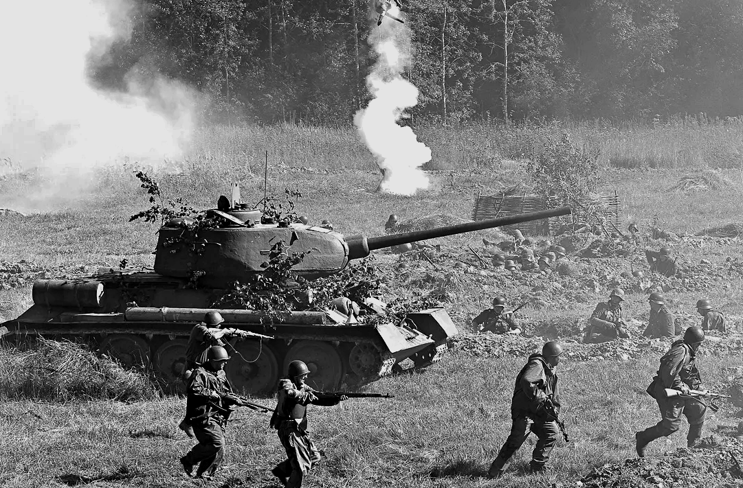
Tank on battlefield.

