USSR Battle Set: medal “for Courage” #2625413, medal “for Courage” #2250519 with document.

Awarded to:
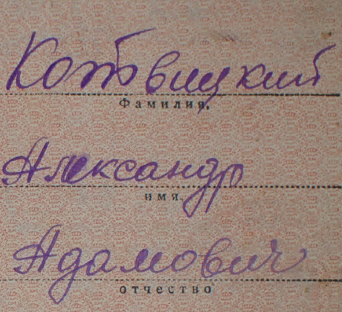
Kotvitskiy Aleksandr Adamovich
(Котвицкий Александр Адамович)

medal “for Courage” #2250519 awarded for:
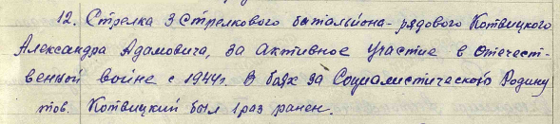
12. Shooter of 3rd rifle battalion – soldier Kotvitskiy Aleksandr Adamovich, for active participation in WWII from 1944. In combats for Socialist Motherland he was wounded 1 time.

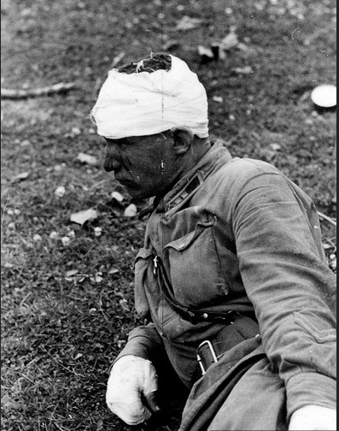
Wounded soldier.

medal “for Courage” #2625413 awarded for:
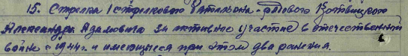
15. Shooter of 1st rifle battalion - soldier Kotvitskiy Aleksandr Adamovich, for active participation in WWII from 1944 and wounding during this 2 times.

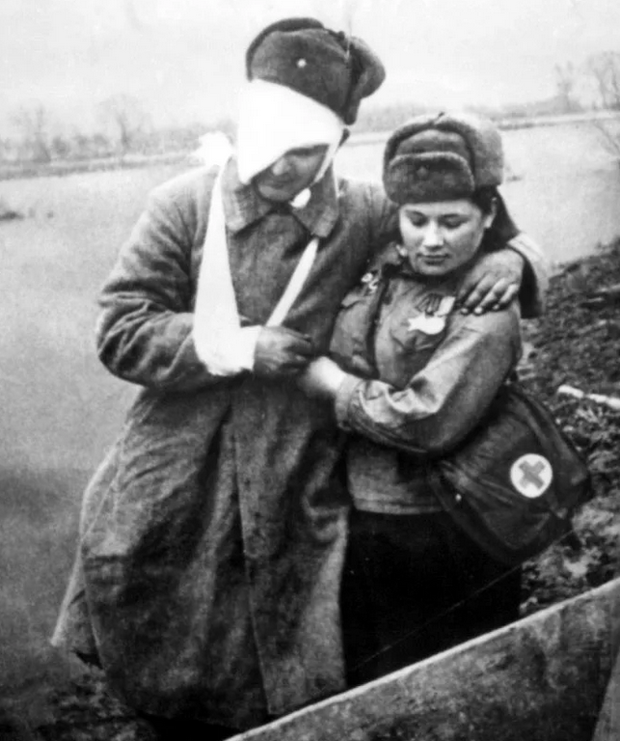
Wounded soldier

