USSR Battle Set: order “Red Star” #357532, medal “for Military Merit” #2820354, medal “for Capture Berlin”, medal “for Liberation Warsaw”, medal “for Victory over Germany” with documents.

Awarded to:
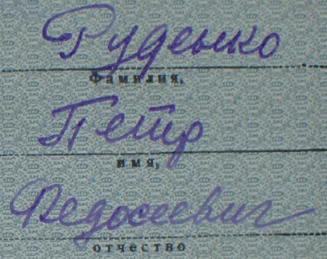
Rudenko Petr Fedoseevich
(Руденко Петр Федосеевич)

Order “Red Star” #357532 with native silver screw-nut.
Medal “for Liberation Warsaw” awarded in May 15, 1946. Document signed by commander of 350 howitzer artillery regiment, major Gaysin.
Medal “for Capture Berlin” awarded in May 9. 1946. Document signed by acting as commander of 350 howitzer artillery regiment, major Gaysin.
Medal “for Victory over Germany” awarded in December 3, 1945. Document signed by commander of 350 howitzer artillery regiment, colonel Listov.

Order “Red Star” #357532 awarded for:
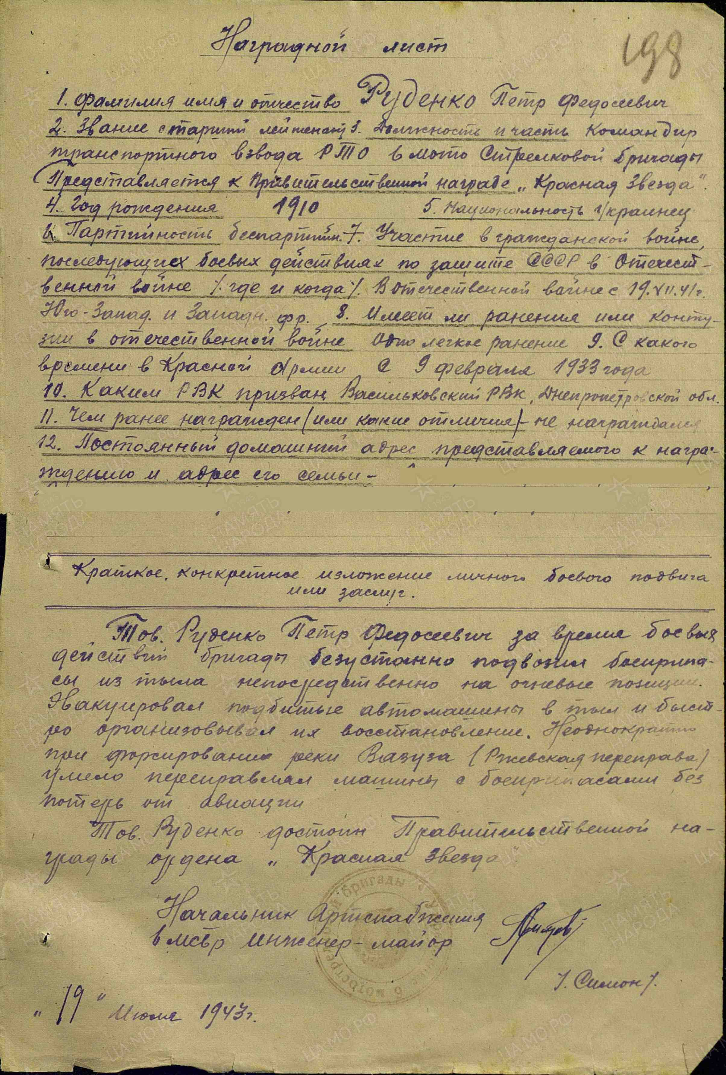

Rudenko Petr Fedoseevich – senior lieutenant, commander of transport platoon of 6 motorized rifle brigade.

During the brigade’s combat operations, Rudenko consistently delivered ammunition from the rear directly to the firing positions and organized their repair. Repeatedly, during the crossing of the Vazuza River (Rzhev crossing), he skillfully transported vehicles loaded with ammunition without any losses from enemy air attacks. Rudenko is deserving of the Government Order of the Red Star.

Chief of artillery supply of 6 Motorized-rifle brigade
Engineer-major %Simon%

“19” July 1943.

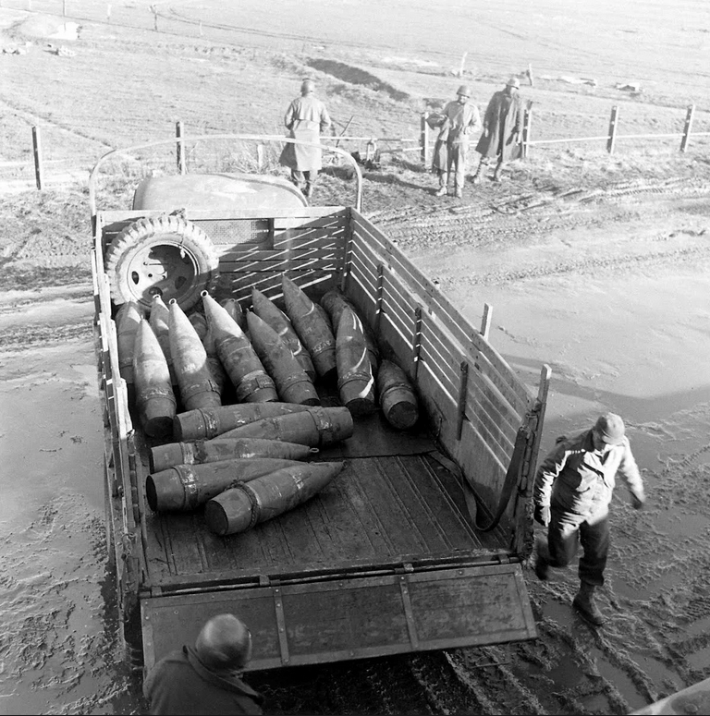
Delivery of ammunition.

