USSR Order “Glory” 3rd Class #230012 with research.

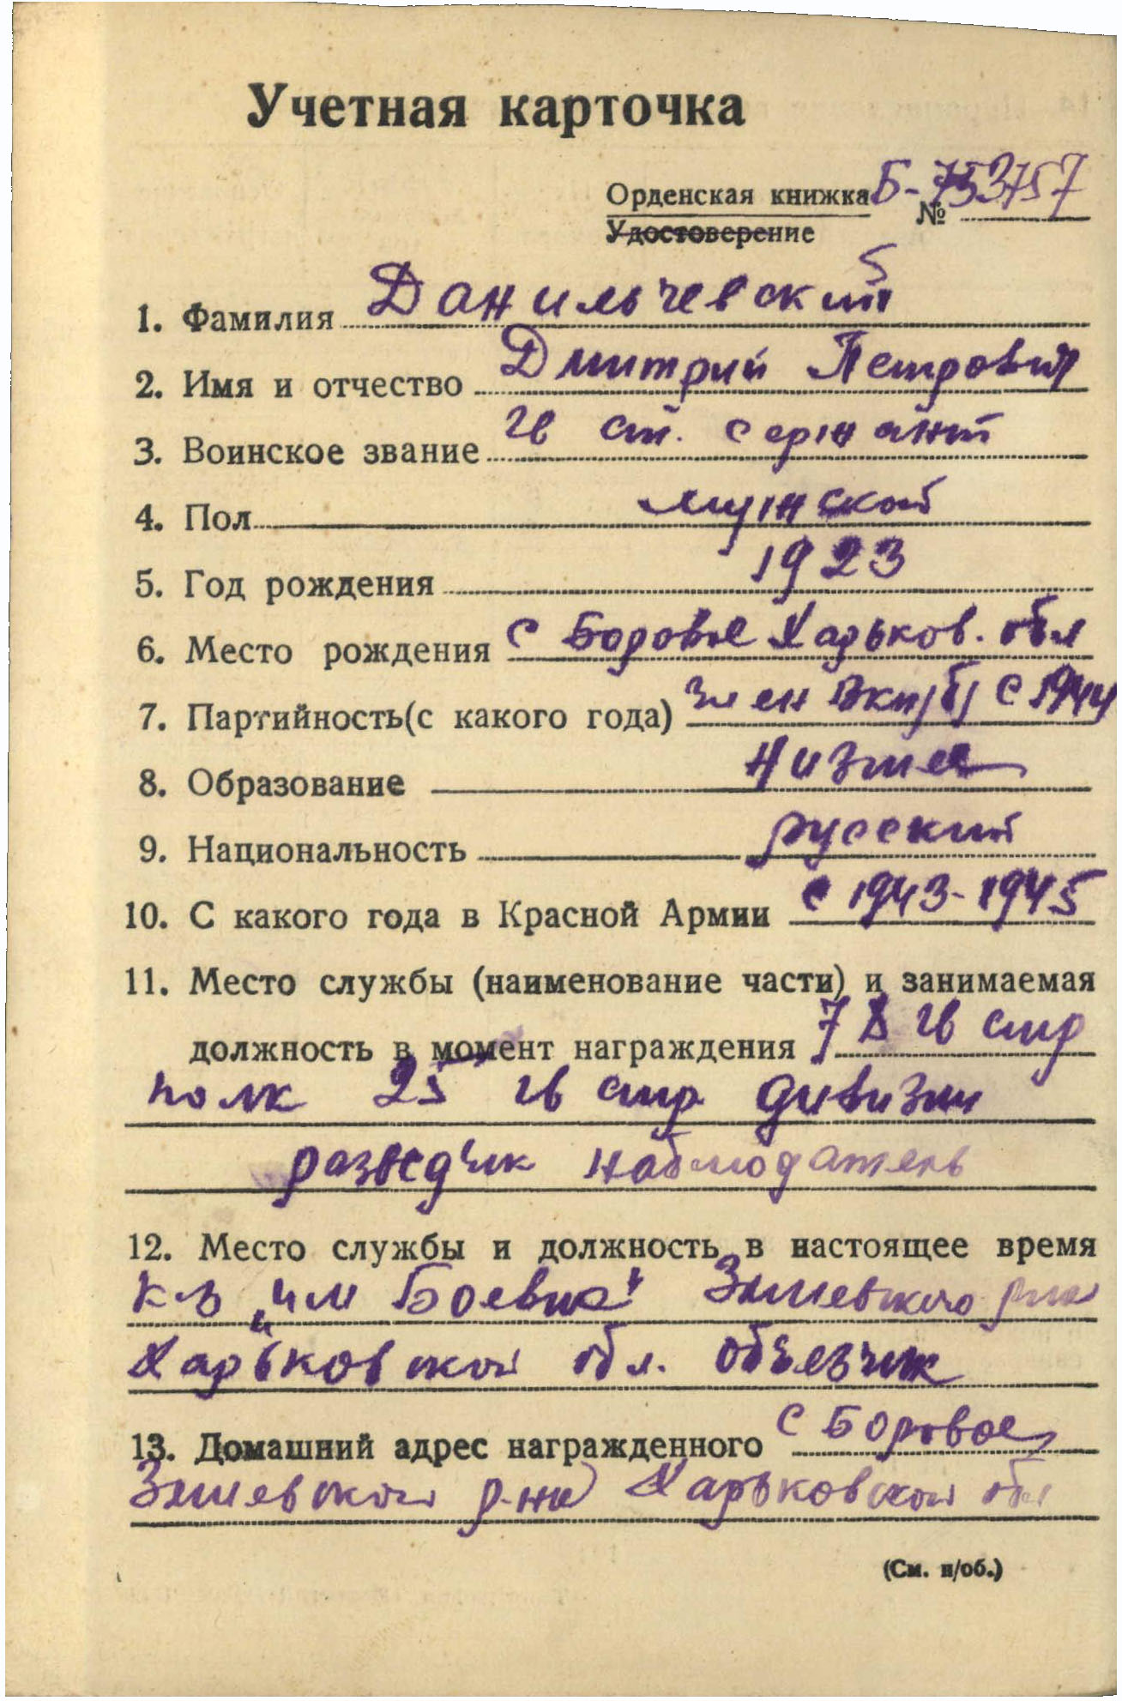

Danilchevskiy Dmitriy Petrovich (Данильчевский Дмитрий Петрович) – guard’s senior sergeant, male, birth in 1923, member of CPSU since 1944, lower education, Russian, served in Red Army from 1943 to 1945.

Was awarded by:

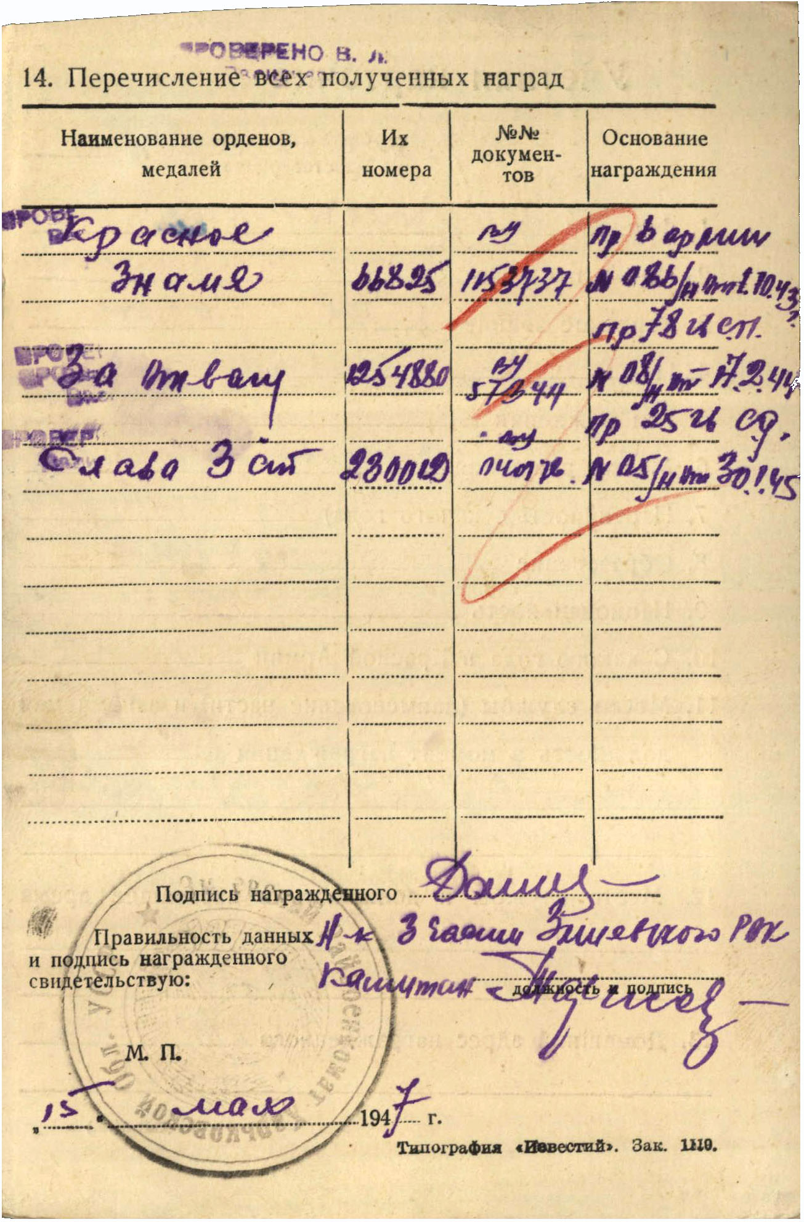

Order “Red Banner” #66825

Medal “for Courage” #1254880

Order “Glory” 3rd Class #280012

Order “Glory” 3rd Class #280012 awarded for:

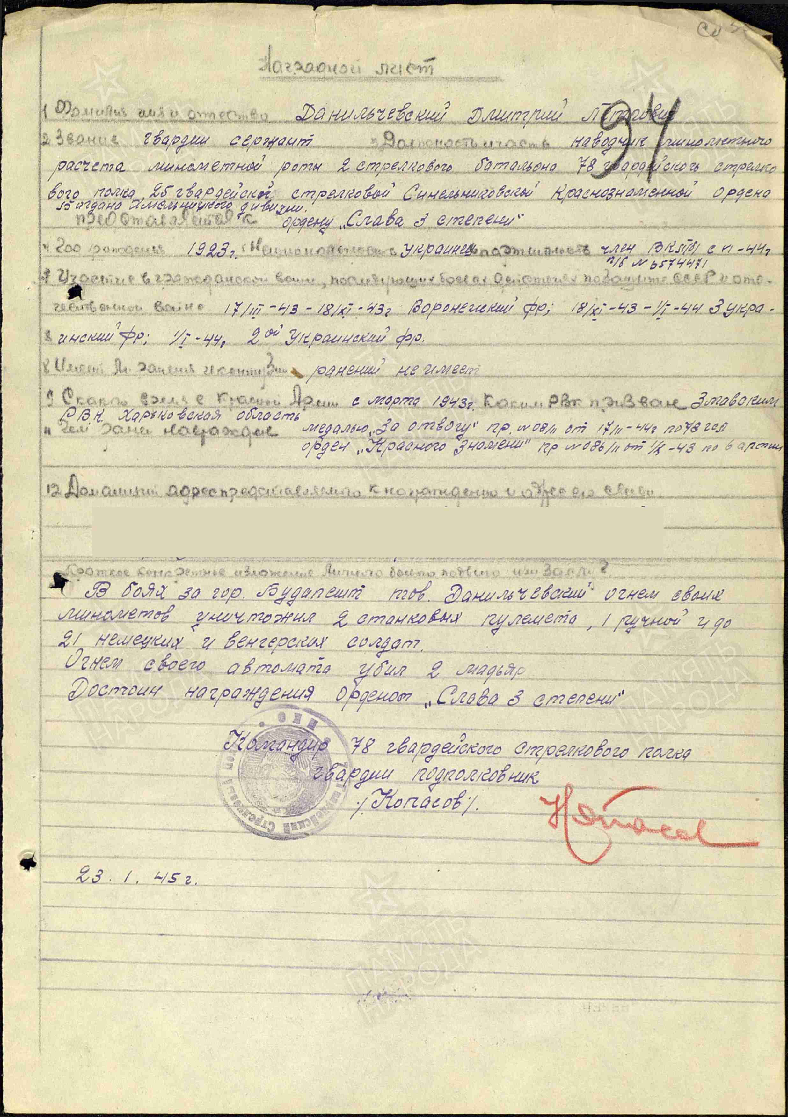

Danilchevskiy Dmitriy Petrovich – guard’s sergeant, aimer of mortar crew of mortar company of 2nd rifle battalion of 78 guard’s rifle regiment of 25 guard’s rifle Sinelnikovo Red Banner order of Bohdan Khmelnutsky division.

In combats for town Budapest (Hungary) Danilchevskiy by fire of his mortars destroyed 2 heavy machine-guns, 1 light machine-gun and killed 21 German and Hungary soldiers.

By fire from his machine-gun he personally killed 2 hungarians.

Deserves awarding by order “Glory” 3rd Class.

Commander of 78 guard’s rifle regiment

Guard’s lieutenant

%Kopasov%

23.1.1945

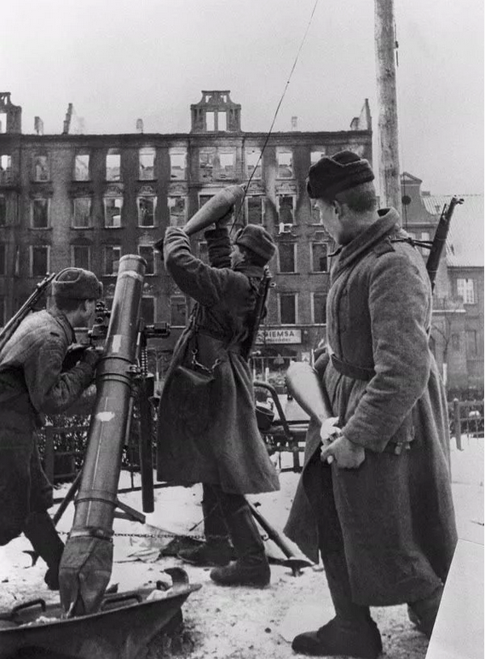

Mortar shooters.