USSR Order “Red Star” #2262487 with document.

Awarded to:
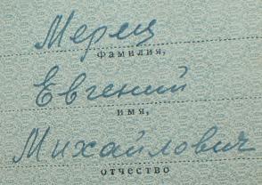
Merets Evgeniy Mikhaylovich
(Мерец Евгений Михайлович)

Order “Red Star” #2262487 awarded for:
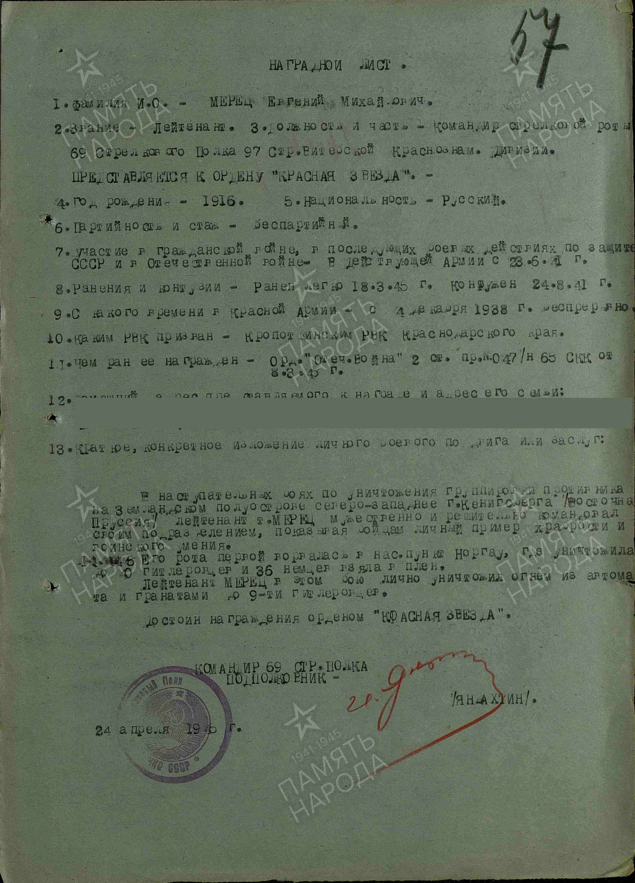
Merets Evgeniy Mikhaylovich – lieutenant, commander of rifle company of 69 rifle regiment of 97 rifle Vitebsk Red Banner division.

During the offensive battles to eliminate the enemy group on the Samland Peninsula (Germany), northwest of Königsberg (East Prussia), Merets led his squad with courage and determination, setting a personal example of bravery and combat skill. On April 4, 1945, his company was the first to storm the village of Norgau, where they killed 40 German soldiers and captured 36. In this battle, Merets personally killed 9 German soldiers with machine-gun fire and grenades. He deserves to be awarded the Order of the Red Star.

COMMANDER OF 69 RIFLE REGIMENT
LIEUTENANT-COLONEL-
%YNBAHTIN%
24 april 1945.

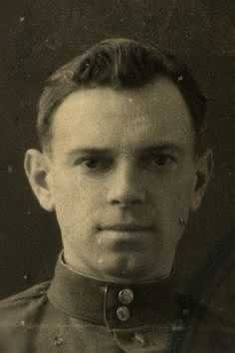
Merets Evgeniy Mikhaylovich

