USSR Battle Set: medal “for Courage” #2603126, medal “for Victory over Germany” with documents.

Awarded to:
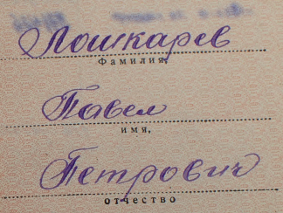
Loshkarev Pavel Petrovich
(Лошкарев Павел Петрович)

Medal “for Victory over Germany” awarded in July 16, 1946.

Also presented certification of wounding:
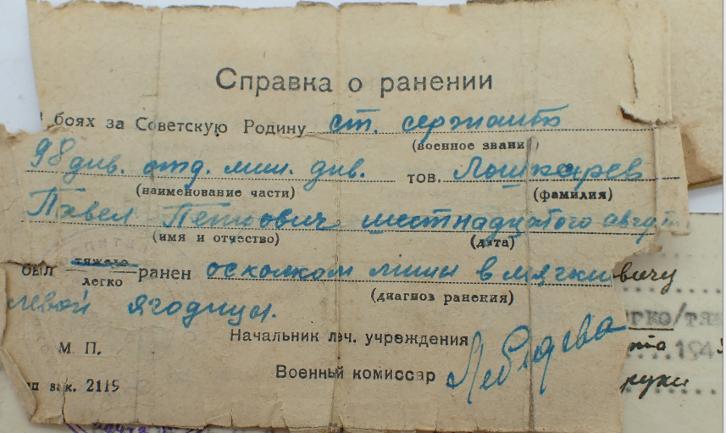
Senior sergeant Loshkarev Pavel Petrovich in August 16 wounded by mine fragment in right buttock.

And second certification of wounding:
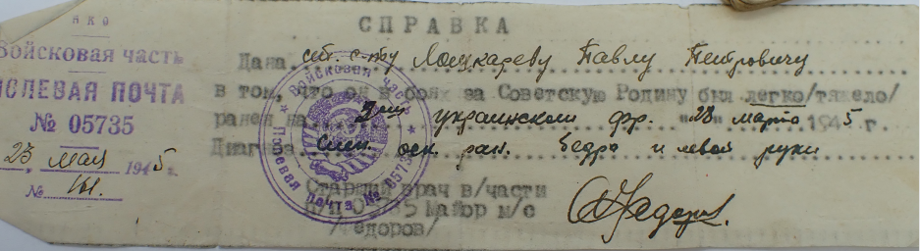
Senior sergeant Loshkarev Pavel Petrovich light wounded on 2nd Ukrainian front from March 28, 1945 shrapnel wound to the thigh and left arm.
medal “for Courage” #2603126 awarded for:
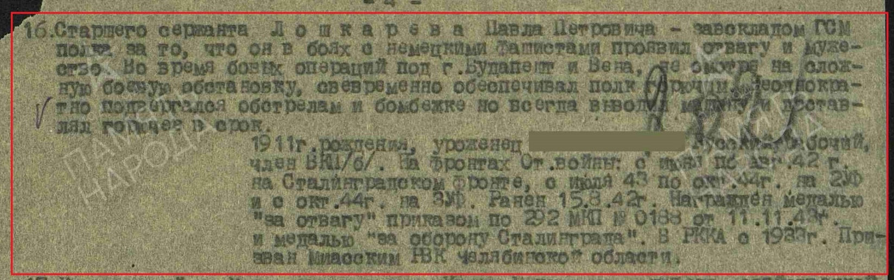
Senior Sergeant Loshkarev Pavel Petrovich, mechanic-driver of a GAZ vehicle. For the fact that during battle with German invaders, he showed courage and heroism. During a combat operation near the village of Annivka on October 30, 1943, under enemy aircraft fire, he saved a burning vehicle at the risk of his life.

