USSR Order “Red Star” #3695729 with research.
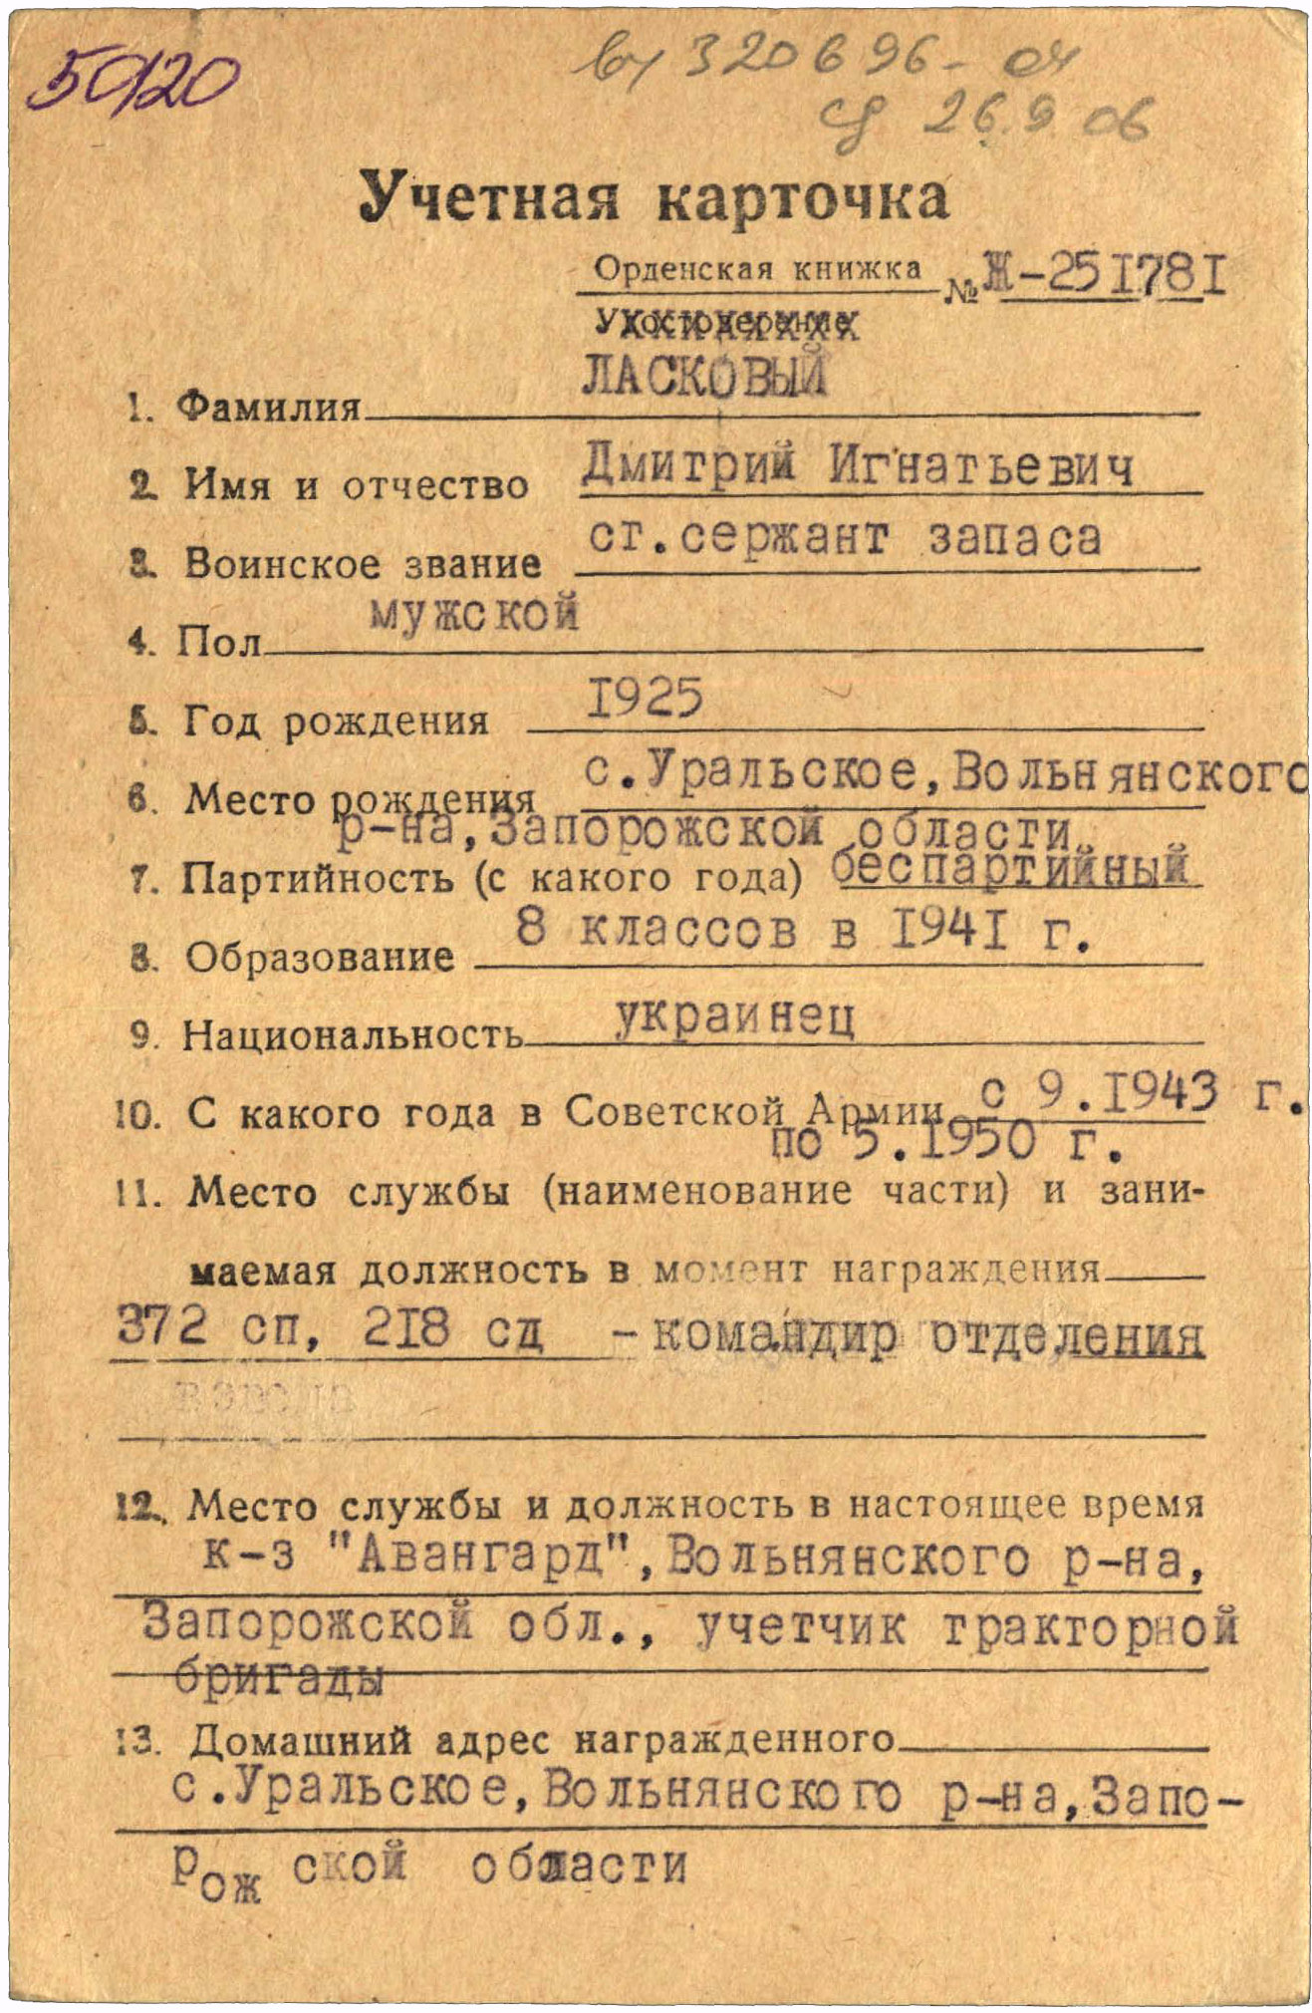
Laskovyi Dmitriy Ignatievich (Ласковый Дмитрий Игнатьевич) – senior sergeant in reserve, male, birth in 1925, education 8 classes, Ukrainian, served in Red Army from September 1943 to May 1950.
Was awarded by:
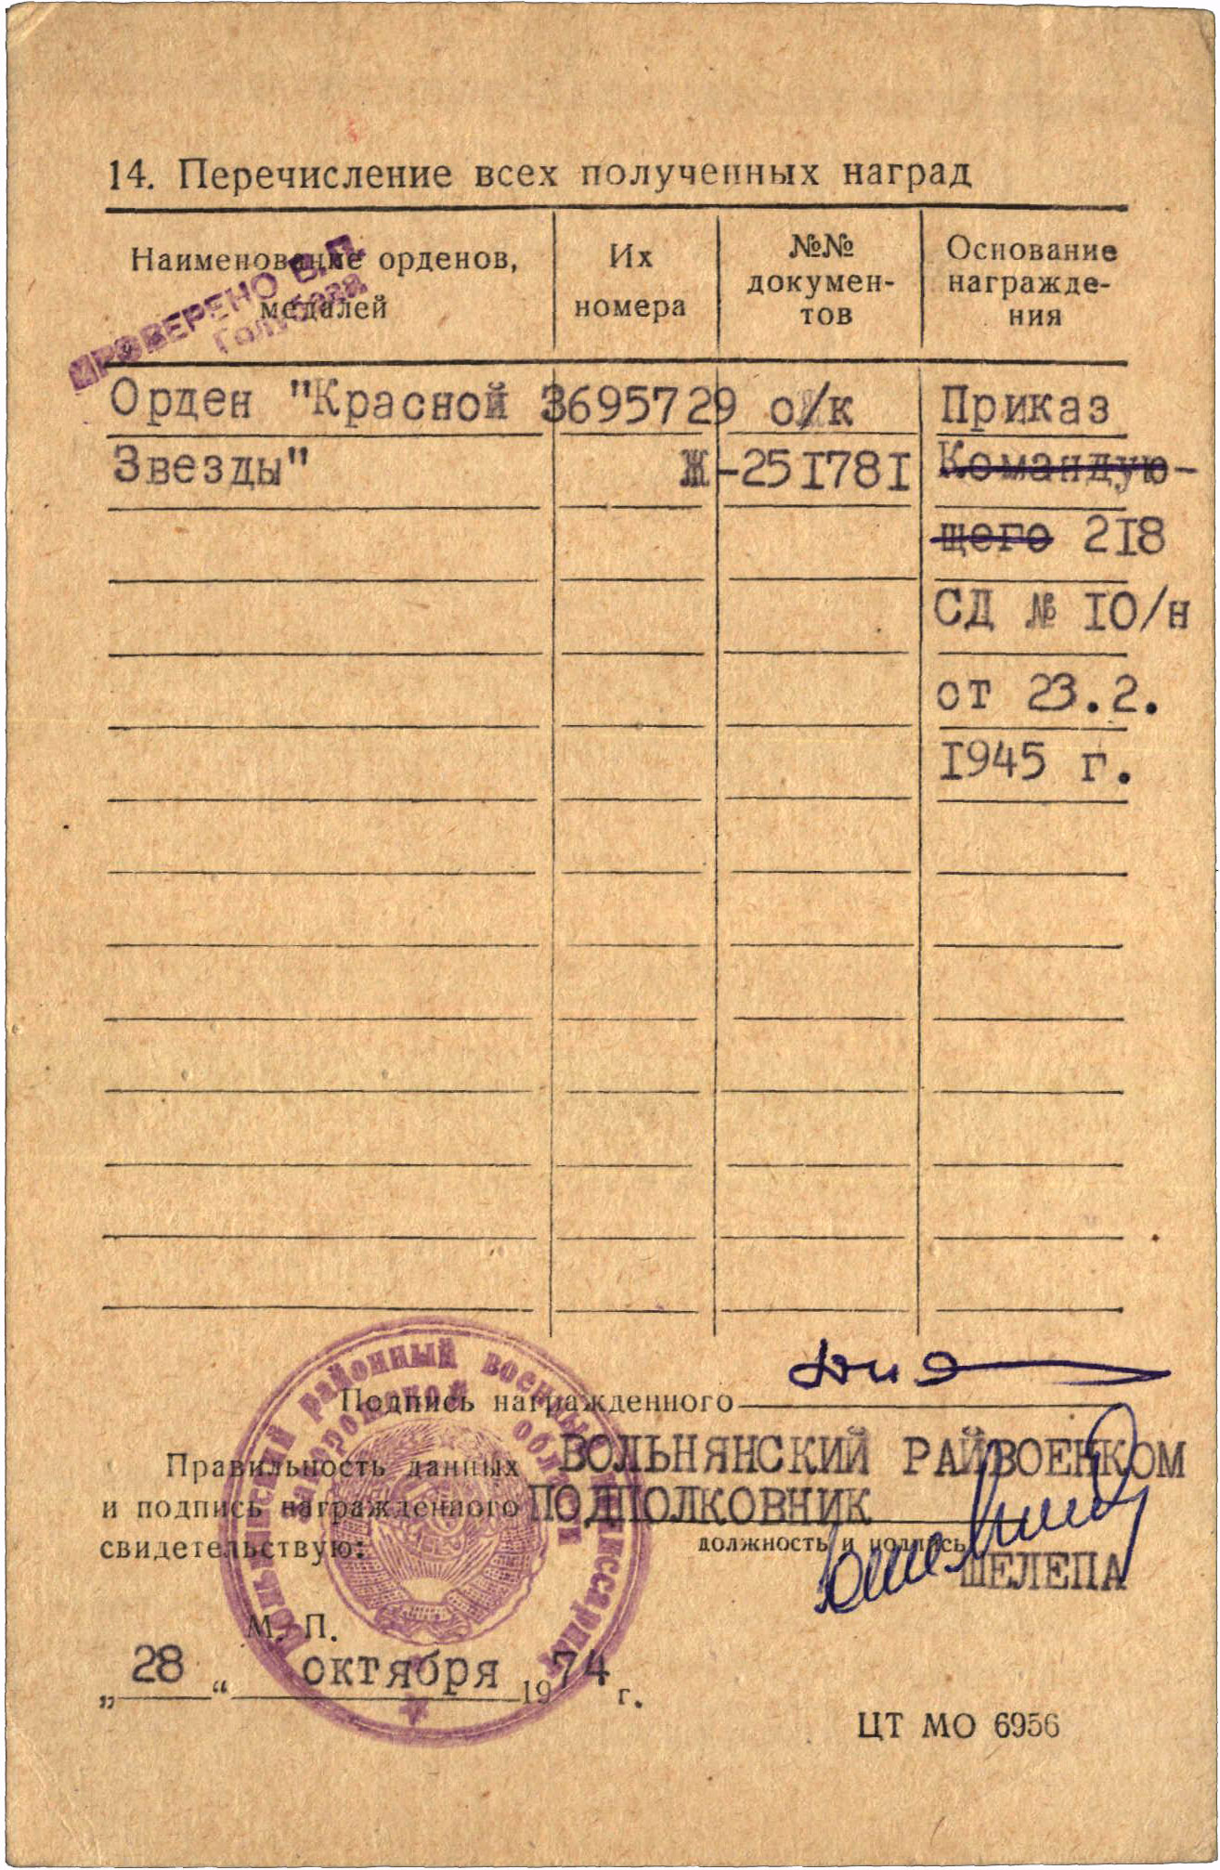
Order “Red Star” #3695729
Order “Red Star” #3695729 awarded for:
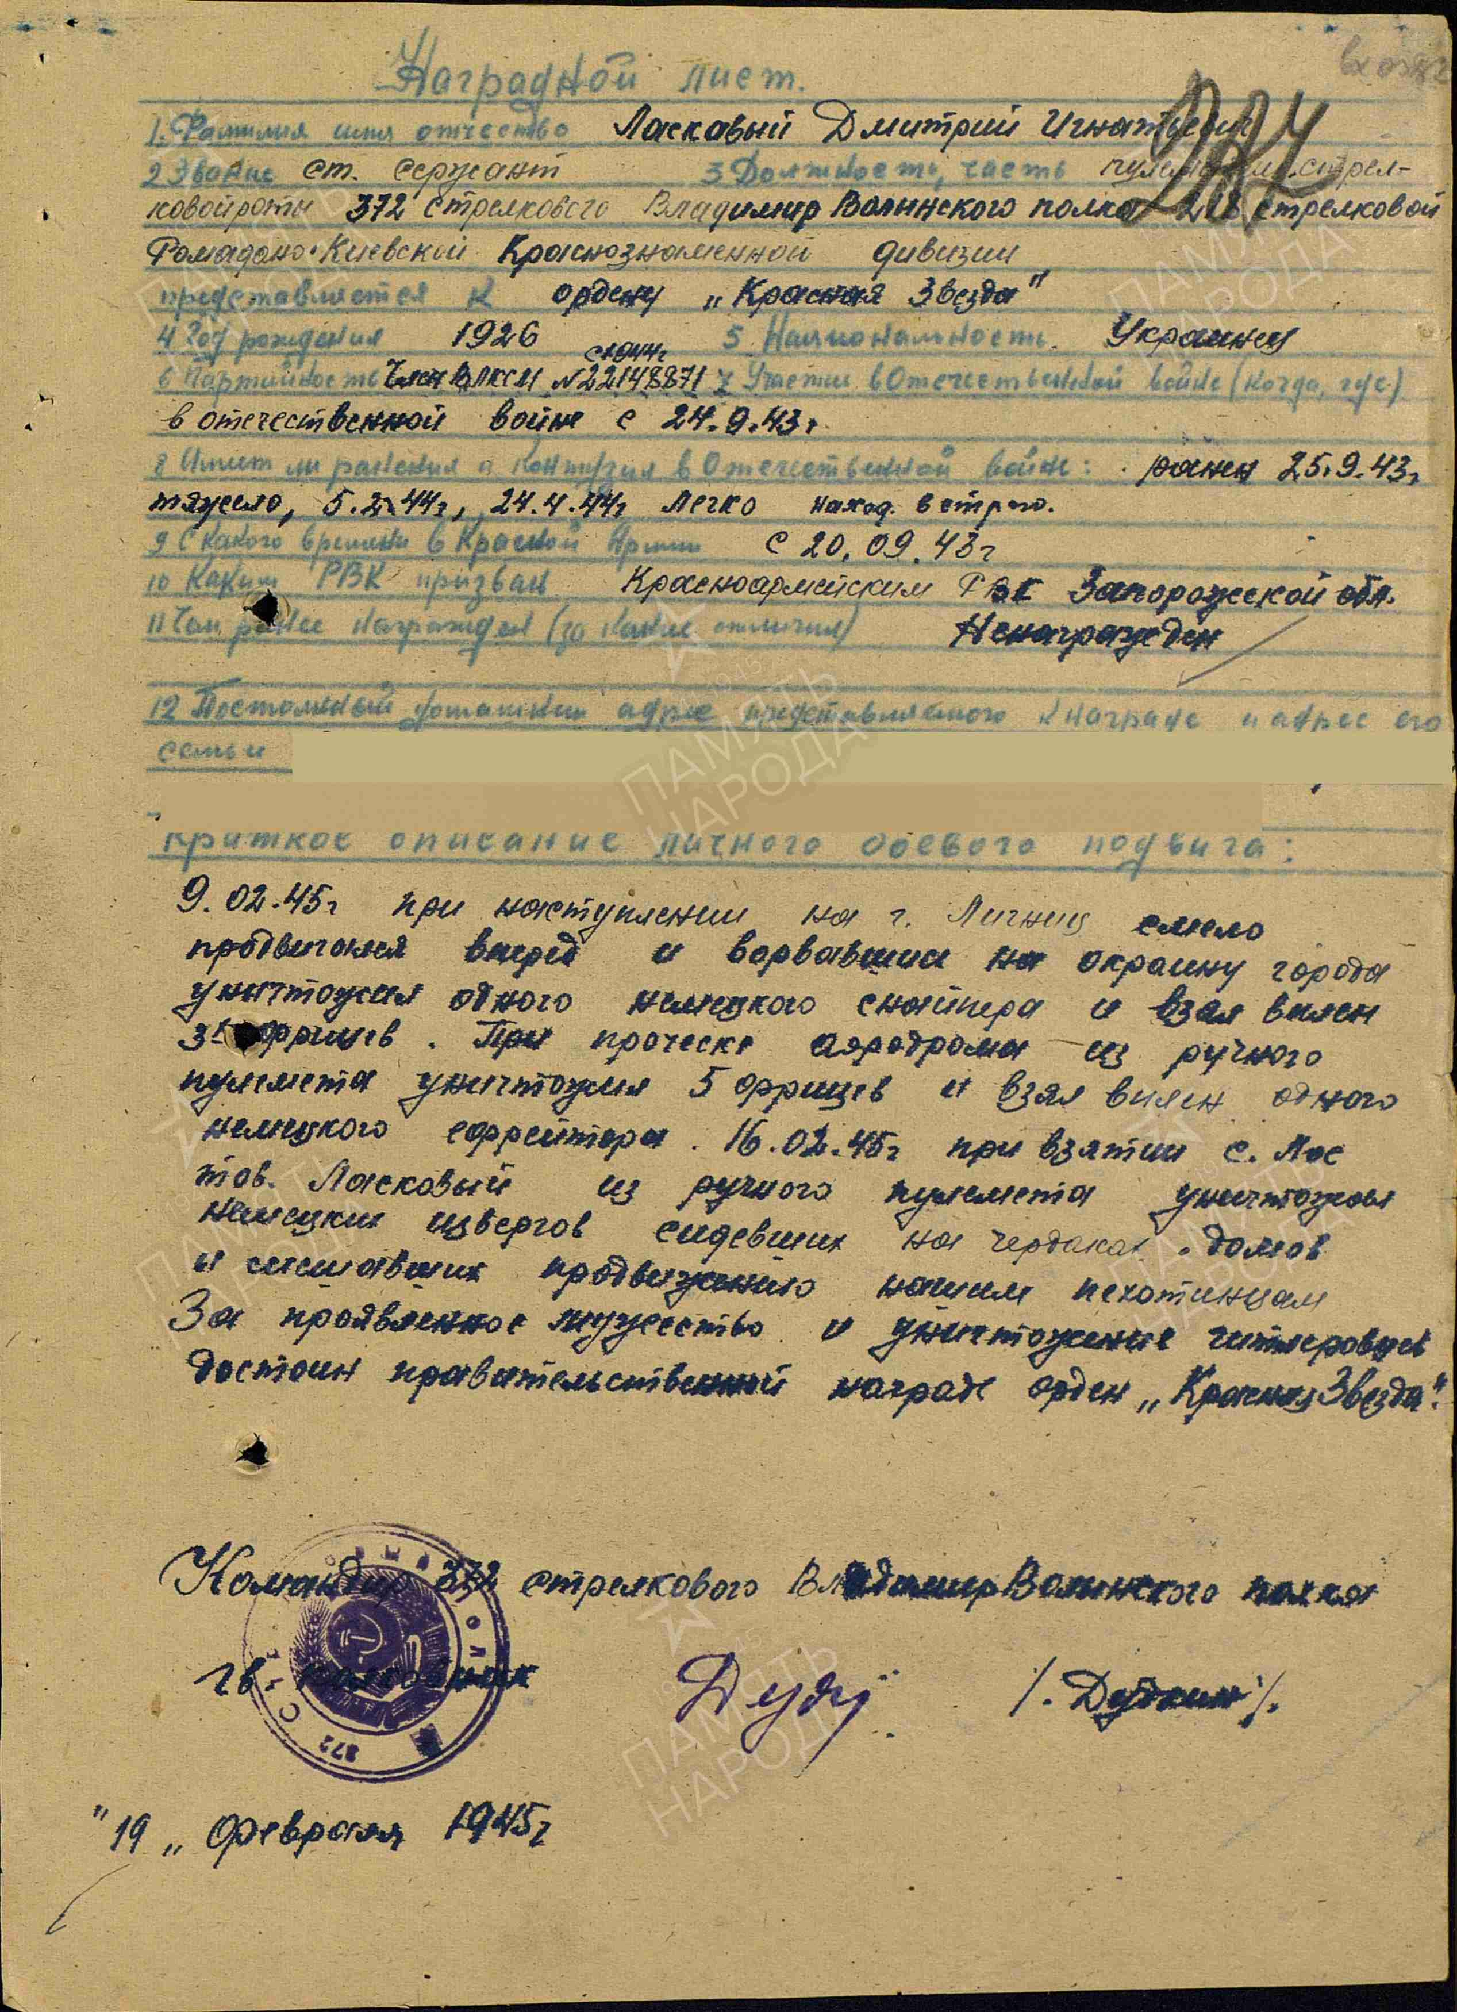
Laskovyi Dmitriy Ignatievich – senior sergeant, machine-gunner of rifle company of 372 rifle Vladimir-Volyn regiment of 218 rifle Romadan-Kiev red banner division.
On February 9th, 1945, during the advance on the town of Legnica [Poland], he bravely moved forward, broke through to the town’s outskirts, killed one German sniper, and captured three German soldiers. While clearing the airfield under machine-gun fire, he killed five German soldiers and captured one German corporal.

On February 16th, 1945, during the capture of the village of Los, he eliminated enemy machine gunners positioned in the attics of houses who were hindering the advance of our infantry.

For his displayed courage and effective combat actions, he deserves the Order of the Red Star.

Commander of 372 rifle Vladimir-Volyn regiment

Guards-colonel Dudkin

19 February 1945.

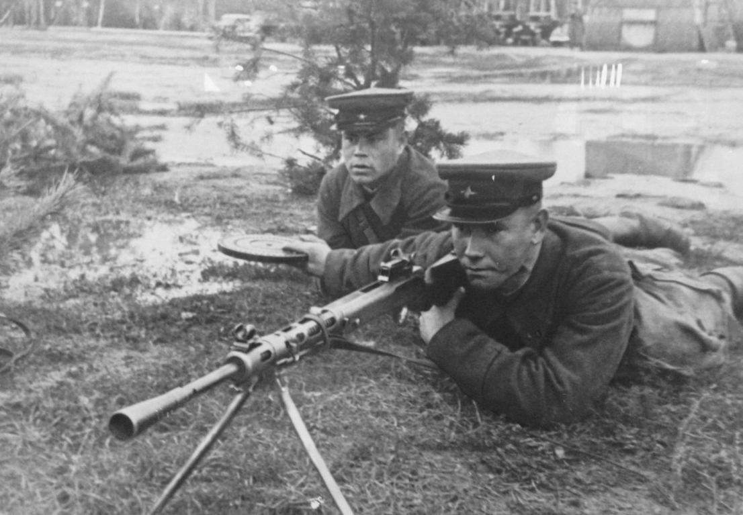
Machine-gunners.

