USSR Battle Set:” order “Glory” 3rd Class #482218, medal “for Courage” #1036048, medal “for Courage” #2149566 with document.

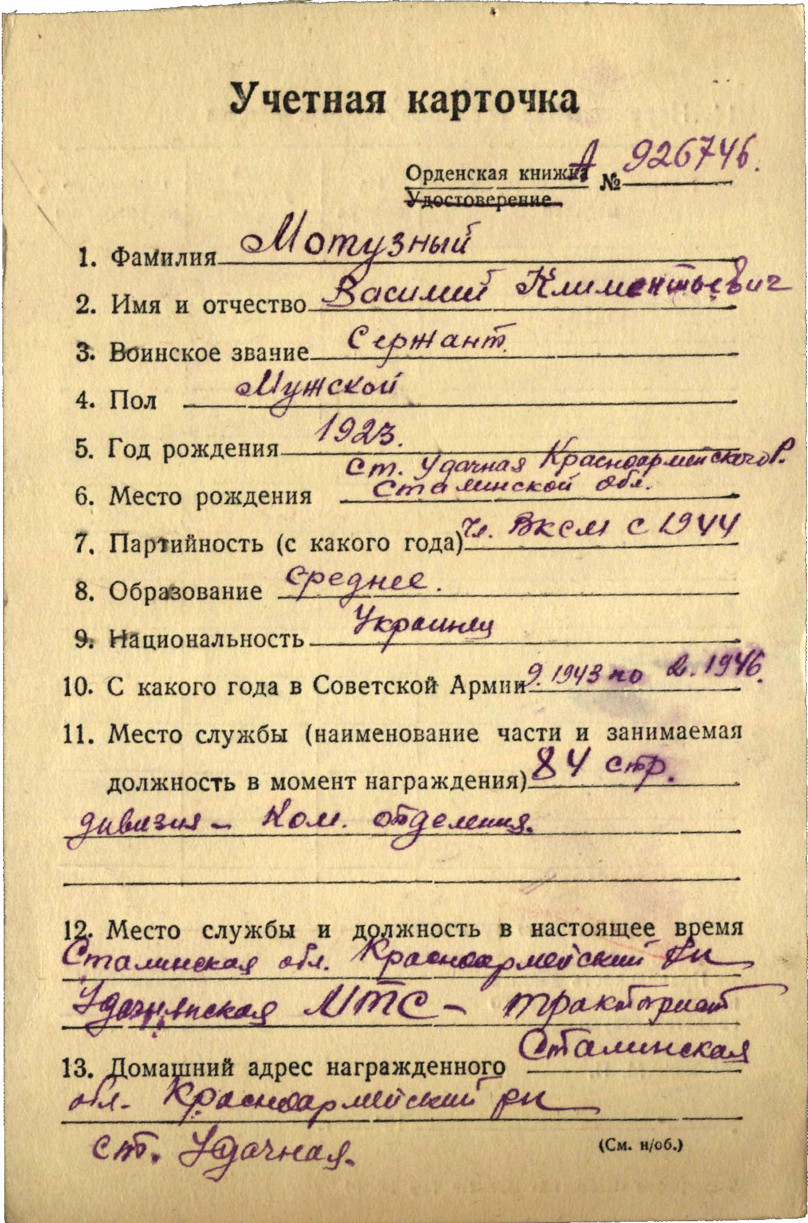

Motuznyi Vasiliy Klimentievich (Мотузный Василий Климентьевич) – sergeant, male, birth in 1923, member of CPSU since 1944, secondary education, Ukrainian, served in Red Army from September 1943 to February 1946.

Was awarded by:

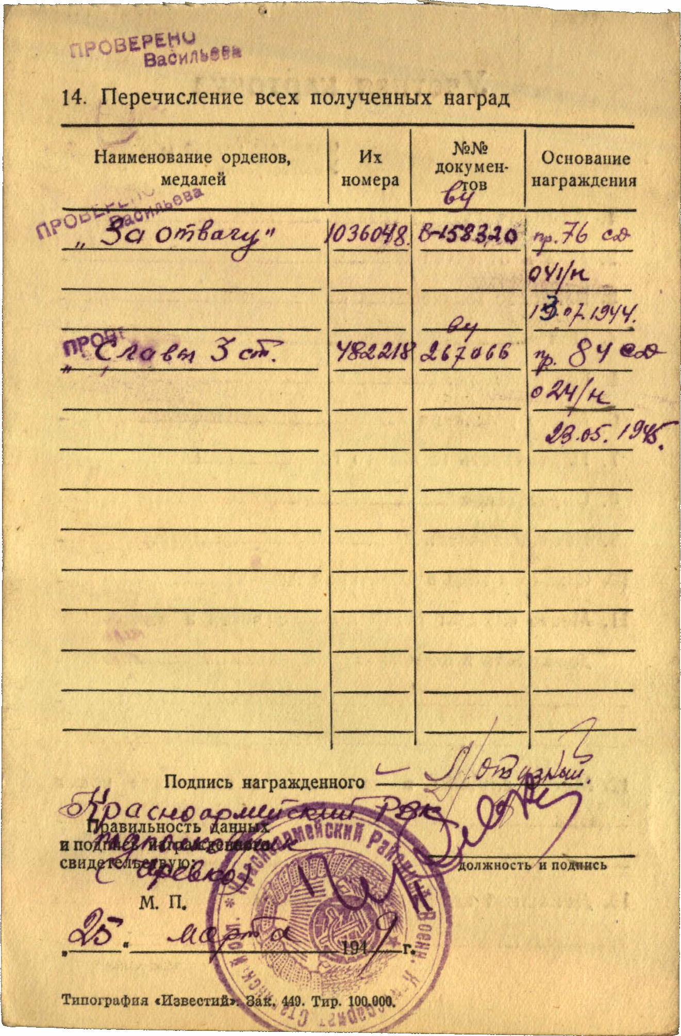

Medal “for Courage” #1036048

Order “Glory” 3rd Class #482218



Medal “for Courage” #2149566

Medals “for Courage” #1036048 & #2149566 **awarded by mistake for same feat:**

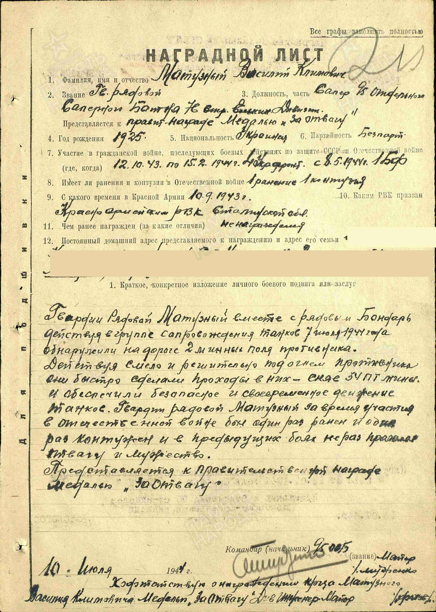

Motuznyi Vasiliy Klimentievich – soldier, sapper of separate 95 sapper battalion of 76 rifle divison.

Motuznyi together with soldier Bondar acting in tank escort group in July 7,1944 discovered 2 enemy’s minefields. Acting boldly and decisively under enemy’s fire he quickly made passageways in them – dismounting 34 anti-tank mines and secured safe and timely moving of tanks. Motuznyi during WWII was 1 time wounded and 1 time shell-shocked and in past combats repeatedly showed bravery and courage.

Submitted to Governmental award medal “for Courage”.

“10” July, 1944 Commander, major % Mudrenko %

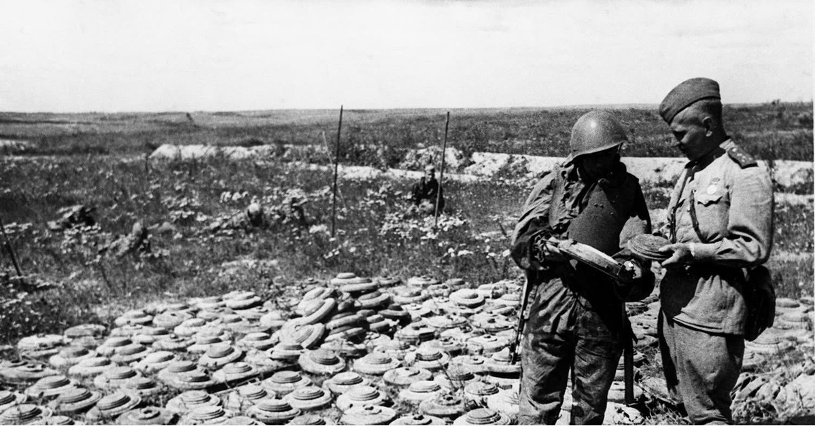

Soviet sappers.

order “Glory” 3rd Class #482218 awarded for:

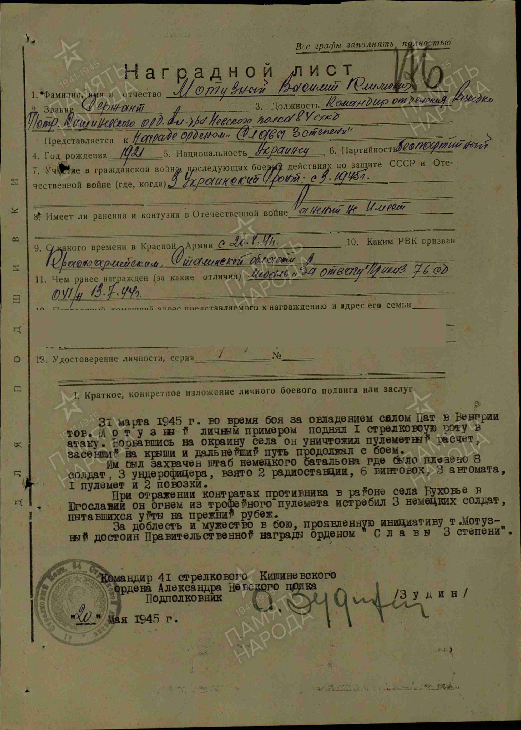

Motuznyi Vasiliy Klimentievich – sergeant, commander of scout’s squad of 41 rifle Chișinău order of Alexander Nevsky regiment of 46 rifle red banner division.

In March 31, 1945 during combats for capturing village Pat (Hungary) Motuznyi by personal example raised 1st rifle company into attack. Breaking to village’s outskirts he destroyed machine-gun crews on house roof and continue advance with combats.

He captured head quarter of German’s battalion, captured 8 soldiers, 3 Unteroffiziers, 2 radiostations, 6 rifles, 3 submachine-guns, 1 heavy machine-gun and 2 waggons.

During reflecting enemy’s counterattacks in region of village Buhovie (Yugoslavia) by fire from trophy submachine-gun killed 3 retreating German soldiers.

For valor and bravery in combat, showed initiative Motuznyi deserves Governmental award order “Glory 3rd Class”.

Commander of 41 rifle Chișinău

Order of Alexander Nevsky regiment

Lieutenant-colonel /Zudin/

“20” May 1945.

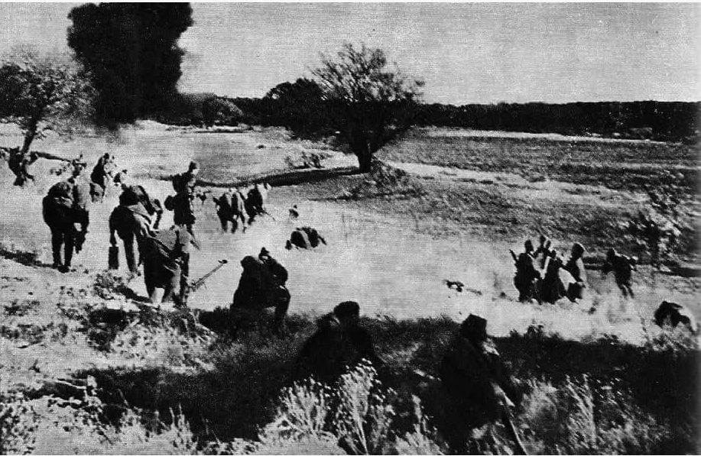

Soviet attack