USSR Order “Red Star” #3568394 with research.

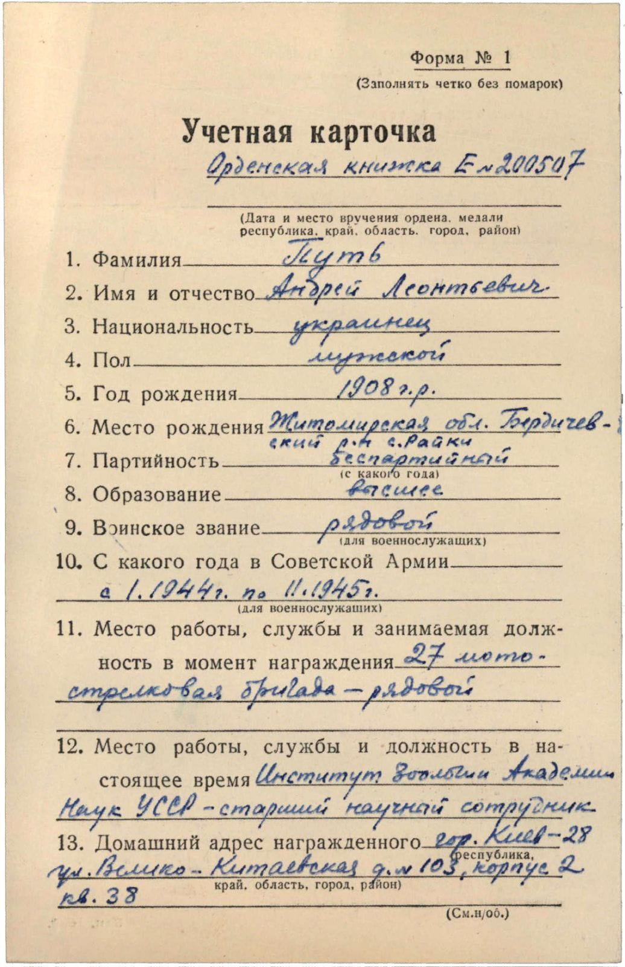

Put Andrey Leontievich (Путь Андрей Леонтьевич) – Ukrainian, male, birth in 1908, not party member, higher education, soldier, served in Red Army from January 1944 to November 1945

Was awarded by:

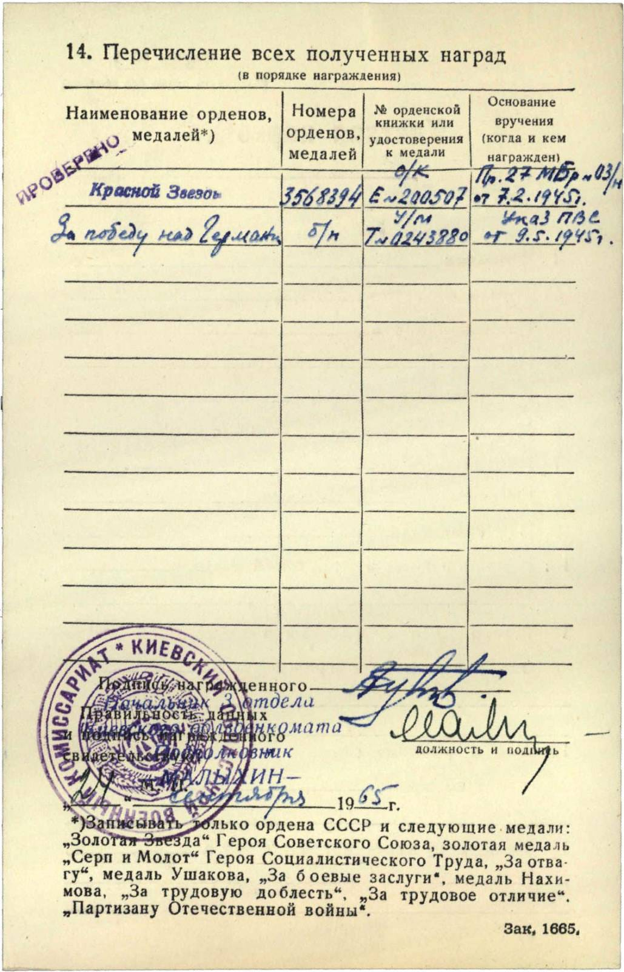

Order “Red Star” #3568394

Medal “for Victory over Germany”

Order “Red Star” #3568394 awarded for:

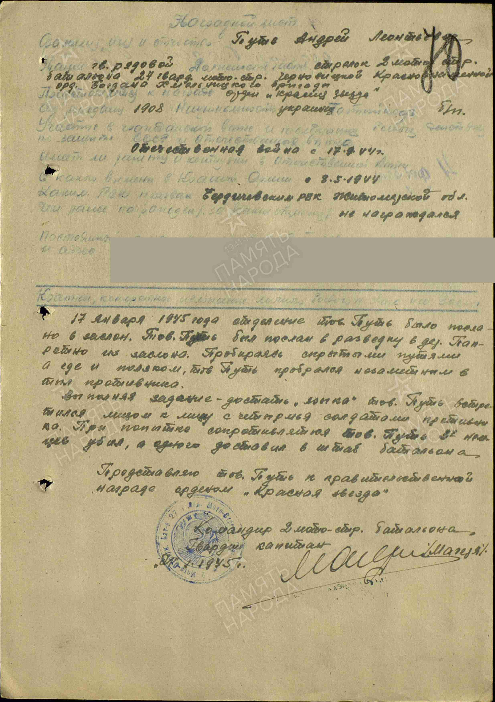

Put Andrey Leontievich – guard’s soldier, shooter of 2 motorized-rifle battalion of 27 Guard’s motorized-rifle Chernigov Red Banner order of Bohdan Khmelnutsky brigade.

On January 17, 1945, Comrade Put’s unit was sent on a reconnaissance mission to the village of Patreshno. Moving along hidden paths, he crawled into the enemy’s rear. While carrying out the task of capturing an enemy officer, he encountered four enemy soldiers. Put killed three Germans and captured one, whom he delivered to the battalion headquarters.

Comrade Put deserves to be awarded the governmental award of the Order of the “Red star”.

Commander of 2nd motorized-rifle battalion

Guard’s captain %Magelya%

“1” February 1945.

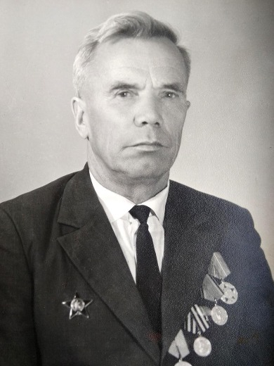

Put Andrey Leontievich wearing this order “Red Star”.