USSR Order “Red Star” #2712988 with document.

Awarded to:

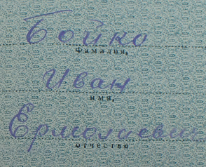

Boyko Ivan Ermolaevich

(Бойко Иван Ермолаевич)

Order “Red Star” #2712988 awarded for:

BOYKO Ivan Ermolaevich – lieutenant of quartermaster service, chief of financial support of 207 separate motorized engineering Chenstohovskiy Order of Bohdan Khmelnutsky and Red Star battalion.

Active participant of WWII. Continuously participated in combats from June 22, 1941 as sapper and paramedic, showed himself as brave and courageous soldier and in 1943 received officer’s rank.

As chief of financial support excellent organized financial support of staff, excellent organized accounting and reporting in battalion.

BOYKO repeatedly participated in combat actions of battalion, in hard conditions performed hard Command’s tasks, showing during this dedication and personal courage.

Acting in defense of Belgorod (RF), crossing river Dnieper (Ukraine), capturing Kiev and Lvov, in breaking enemy’s defense on Sandomierz bridgehead BOYKO actively contributed to performing by battalion all combat tasks.

Acting in breaking with units of 3 Guard’s tank army from January 12, 1945 BOYKO in hard conditions in region of Opole (Poland), in January 26, 1945 joined unequal combat with group of Germans soldiers and officers.

By fire from his personal weapon killed 2 Germans officers and wounded 2 soldiers.

During this combat he was heavy wounded.

BOYKO deserves Governmental award – order “PATRIOTIC WAR 2 CLASS”.

COMMANDER OF 207 SEPARATE MOTORIZED ENGINEERING CHENSTOHOVSKIY ORDER OF BOHDAN KHMELNUTSKY AND RED STAR BATTALION.

MAJOR (F.MYSYAKOV)

17 april 1945.

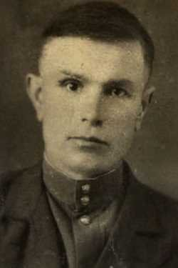

BOYKO Ivan Ermolaevich