USSR Order “Patriotic War” 2nd Class #699284 with research.

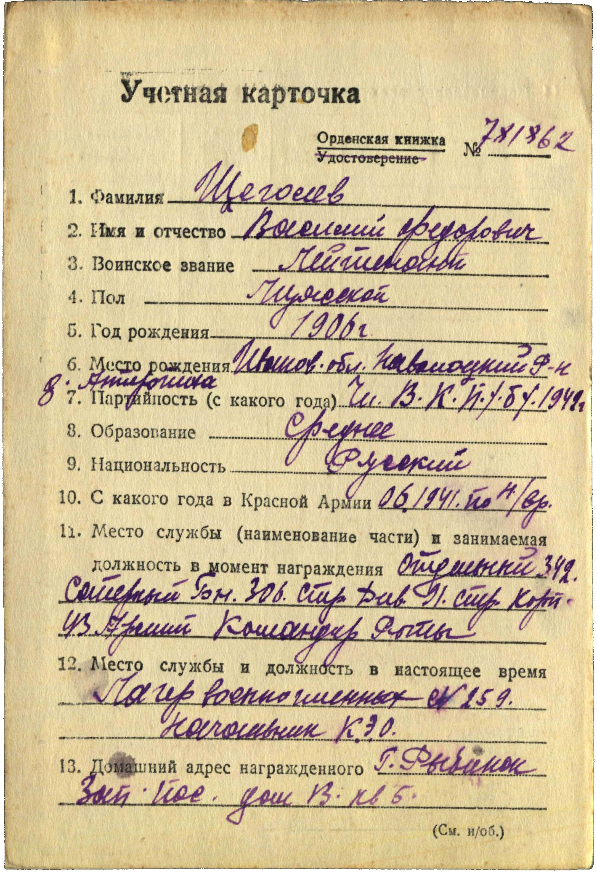

Schegolev Vasiliy Fedorovich (Щеголев Василий Федорович) -lieutenant, male, birth in 1906, member of CPSU since 1942, secondary education, Russian, served in Red Army from June 1941 to nowadays.

Was awarded by:

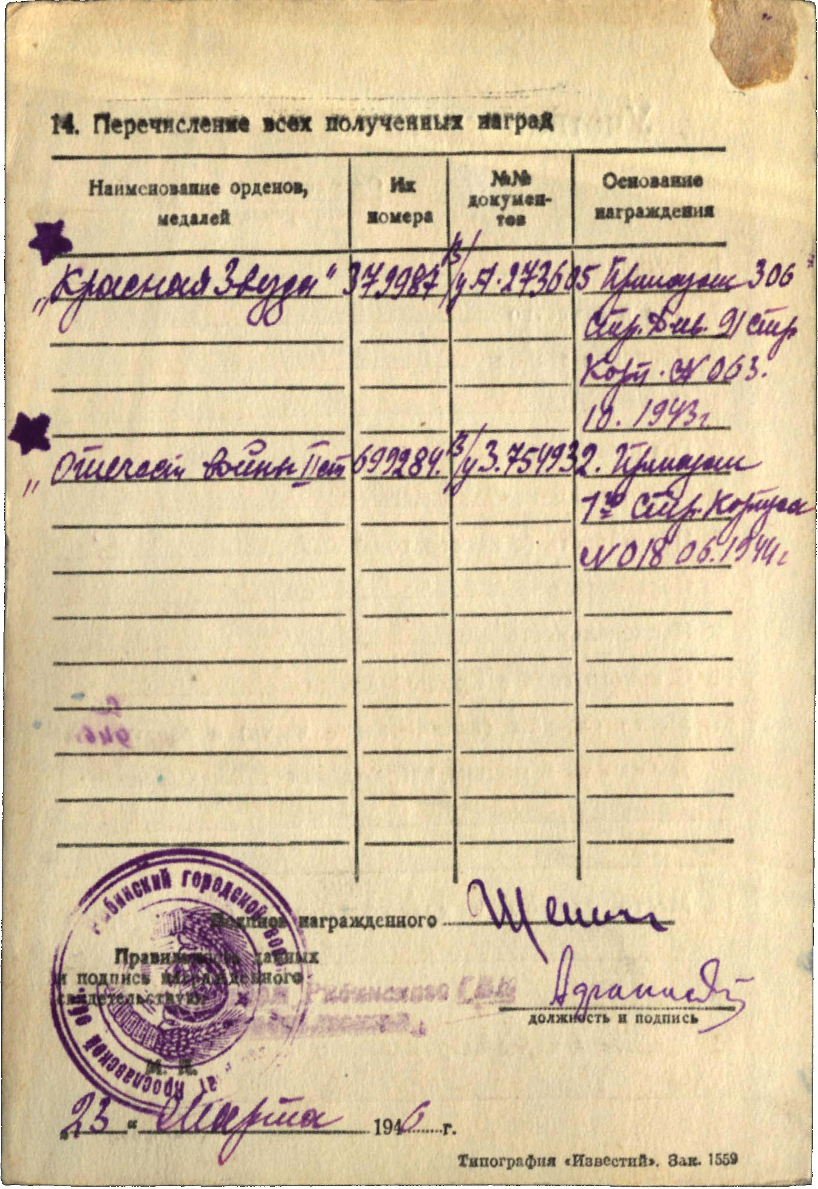

Order “Red Star” #379987

Order “Patriotic War” 2nd Class #699284

Order “Patriotic War” 2nd Class #699284 awarded for:

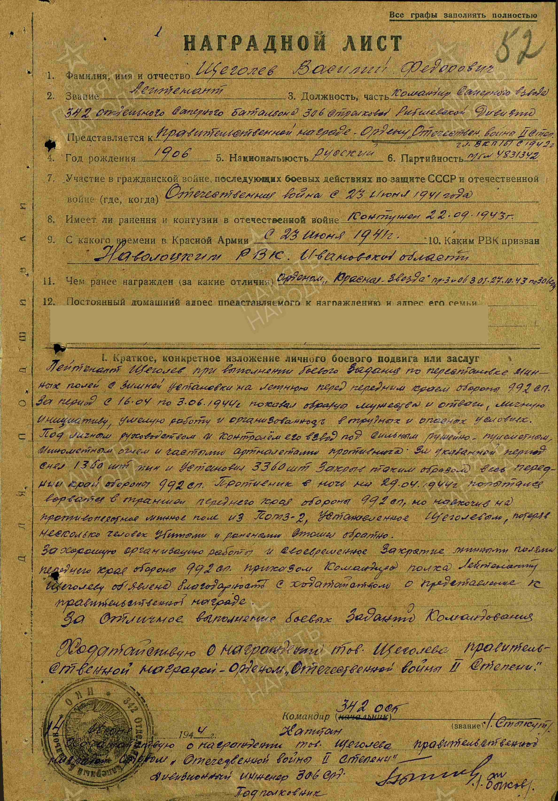

Schegolev Vasiliy Fedorovich – lieutenant, commander of sapper platoon of 342 rifle sapper battalion of 306 rifle Ribshevskaya division.

Schegolev during performing combat task on establishing mine fields from winter to summer near defense line of 992 rifle regiment. From April 16 to June 3, 1944 showed example of bravery and courage, personal initiative, skillful work and calm in hard and danger conditions.

Under his management platoon under heavy rifle and machine-gun, mortar and artillery fire for indicated period dismounted 1360 mines and established 3360 and covering all defense line of 992 rifle regiment. Enemy at night from April 29, 1944 tried break into trenches of our defense line of 992 rifle regiment, but facing mine field from POMZ-2 mines, lost several peoples and wounded and retreated.

For excellent organizational work and timely covering by mine fields of defense of 992 rifle regiment Schegolev announced gratitude with asking about submitting to governmental award.

For excellent performing of combat tasks of command asking about awarding Schegolev by governmental award – order “Patriotic war 2nd Class.

Commander of 342 rifle sapper battalion

Captain %Stykut%

“14” June 1944.

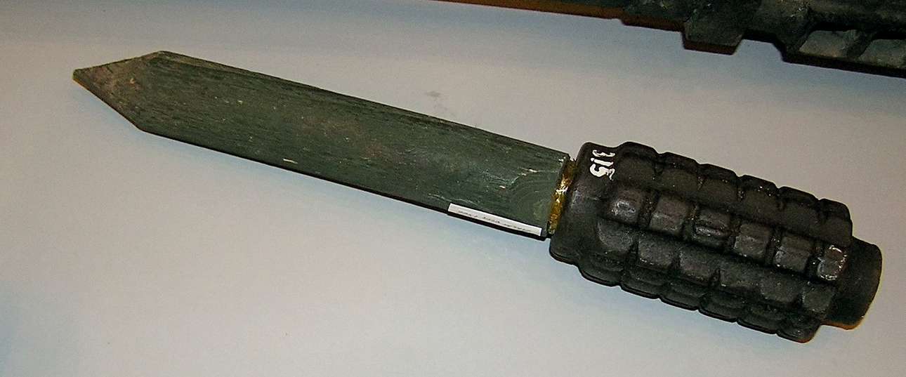

POMZ-2 mine