USSR Order “Patriotic War” 2nd Class #611000 with research.

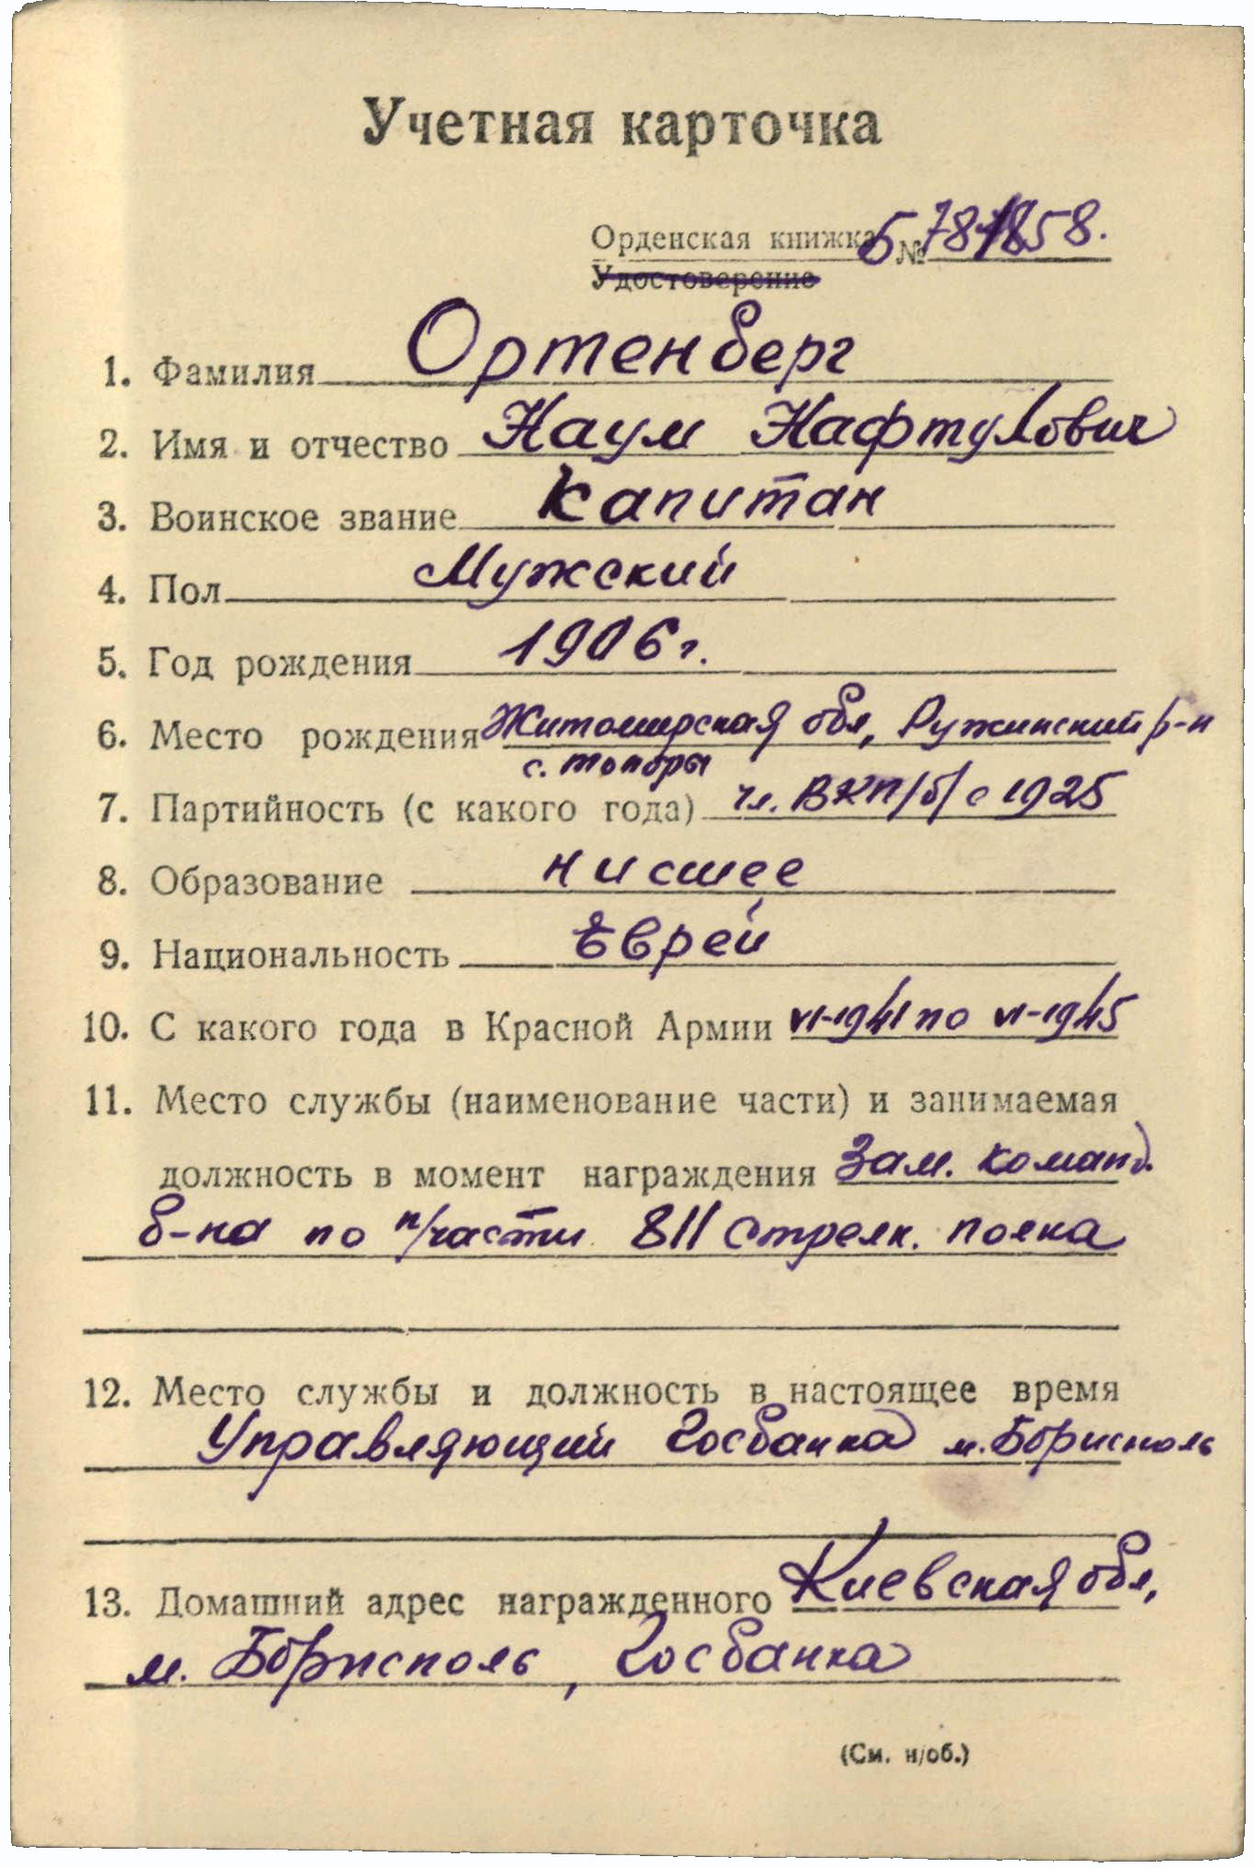

Ortenberg Naum Naftulovich (Ортенберг Наум Нафтулович) – captain, male, birth in 1906, member of CPSU since 1925, primary education, jew, served in Red Army from June 1941 to June 1945.

Was awarded by:

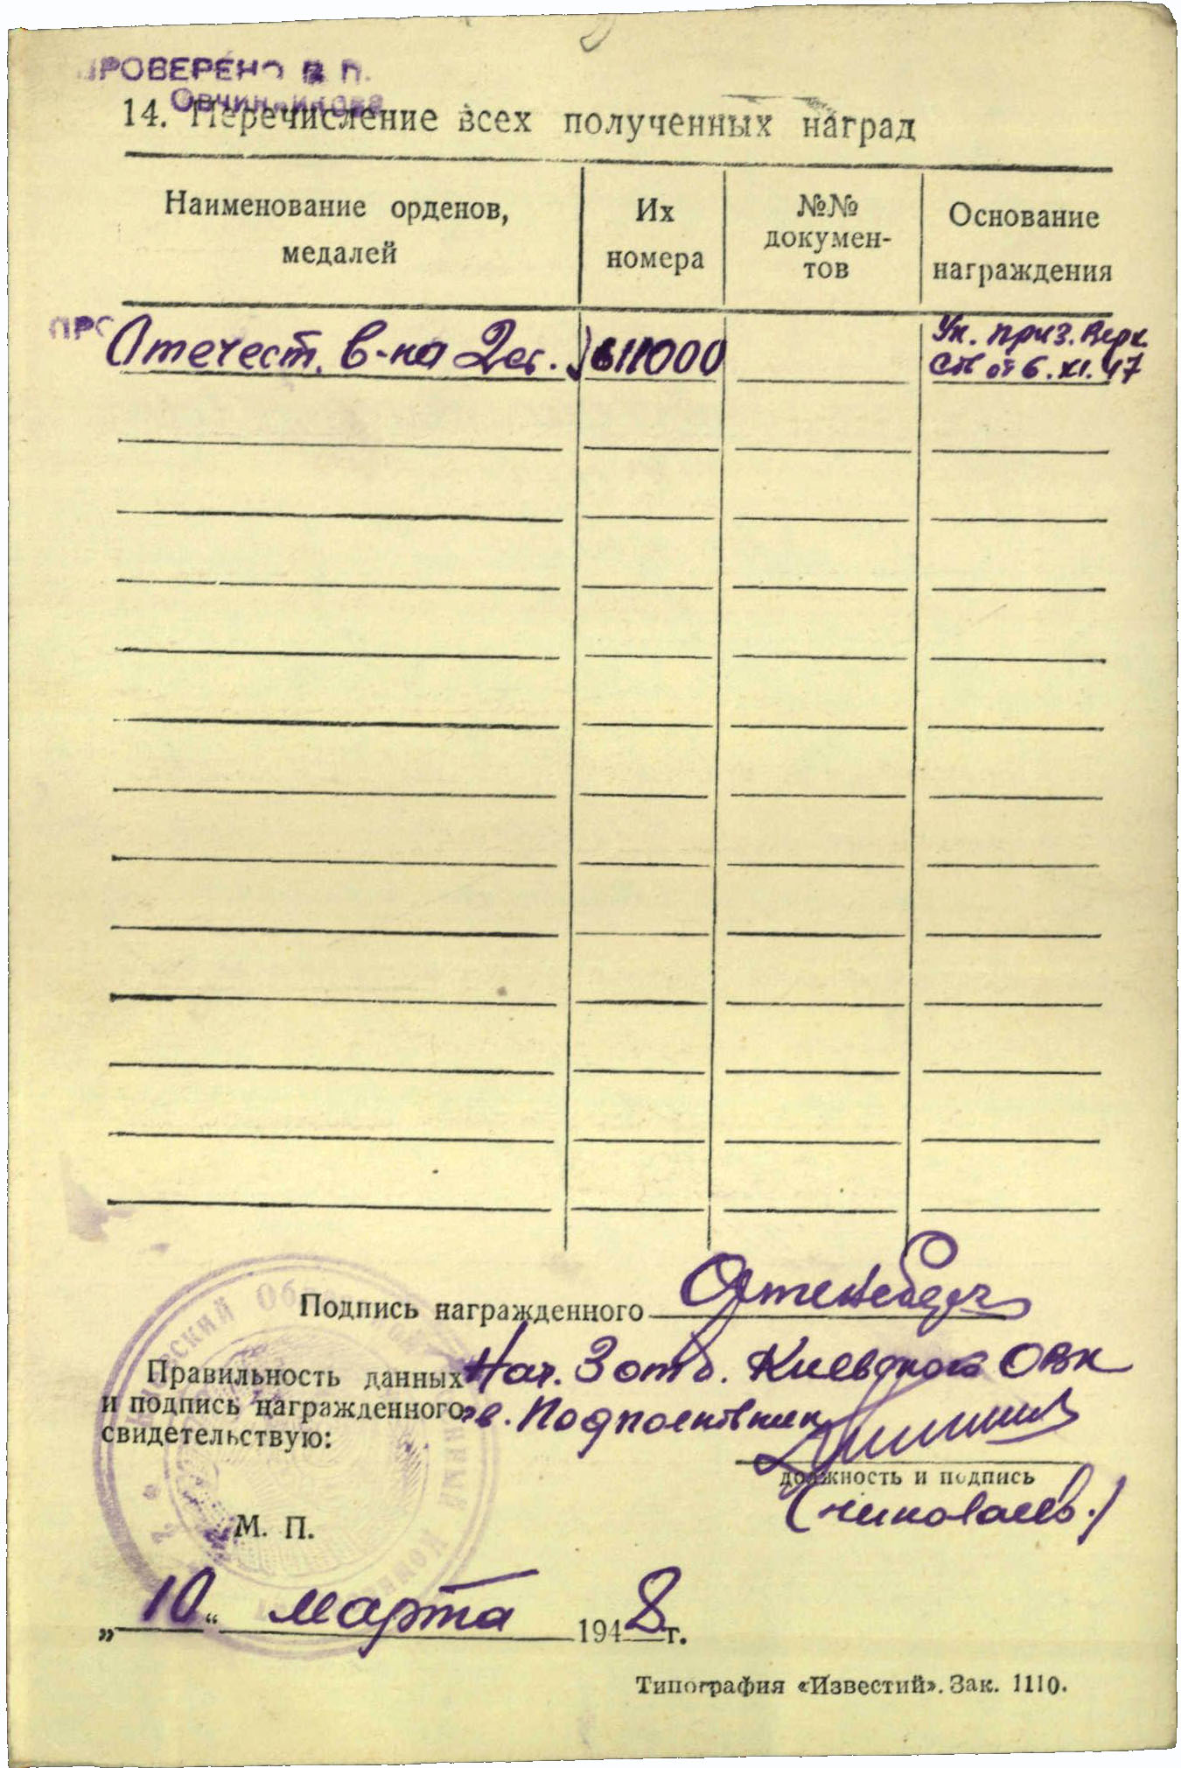

Order “Patriotic War” 2nd Class #611000

Order “Patriotic War” 2nd Class #611000 awarded for:

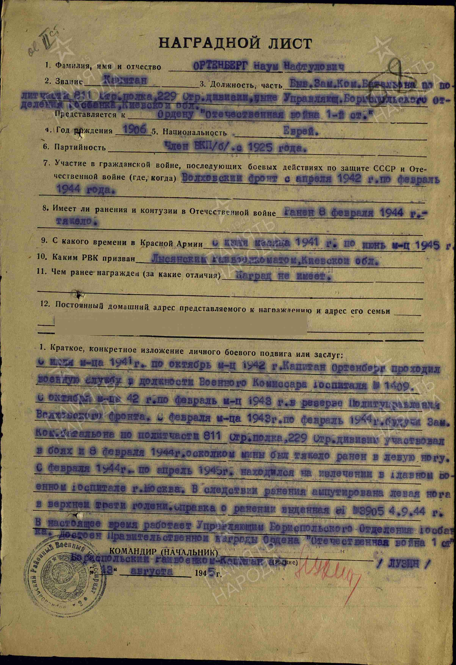

ORTENBERG Naum Naftulovich – captain, ex deputy commander of battalion of political part of 811 rifle regiment of 229 rifle division, now administrator of Borispol department of State Bank of Kiev region.

From July 1941 to November 1942 Ortenberg served as military commissar of hospital #1409 from October 1942 to February 1943 in reserve of Political management of Volhov front. From February 1943 to February 1944 as deputy commander of battalion of political part of 811 rifle regiment of 229 rifle division participated in combats from February 8, 1944, by mine fragment was heavy wounded in left leg. From February 1944 to April 1945 was on treatment in main Military Hospital in town Moscow. As result of wounding lost left leg in upper third of leg. Reference of wounding issued #3905 in September 4, 1944. Now worked as administrator of Borispol department of State Bank of Kiev region. Deserves Governmental award Order “Patriotic War 1st Class”.

Borispol regional military commissar /LUZIN/

“13” august 1945

But higher award commission after reading his feat decided award him by lower grade award – order “Patriotic War” 2nd Class.