USSR Battle Set: order “Patriotic War” 2nd Class #488874, medal “for Courage’ #644038, medal “for Defense Stalingrad”, medal “for Defense Kiev”, medal “for Victory over Germany” with documents.

Awarded to:

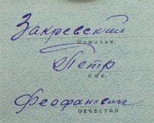

Zakrevskiy Petr Feofanovich

(Закревский Петр Феофанович)

Medal “for Defense Kiev” awarded in October 24, 1947.

Medal “for Victory over Germany” awarded in November 24, 1945.

Medal “for Defense Stalingrad” awarded in June 8, 1944. Document signed by commander of 109 guard’s rifle regiment of 37 guard’s Rechetskaya red banner order of Suvorov division, guard’s lieutenant-colonel Levin.

medal “for Courage’ #644038 awarded for:

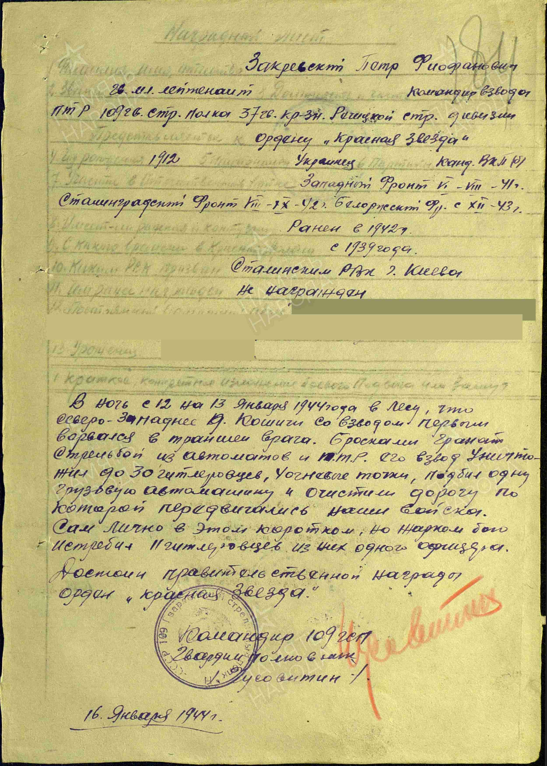

Zakrevskiy Petr Feofanovich, Guards Junior Lieutenant, commander of the anti-tank rifle platoon of the 109th Guards Rifle Regiment, 37th Guards Red Banner Rechitskaya Rifle Division. During the night of January 12–13, 1944, in the forest northwest of the village of Koshit, his platoon was the first to break into enemy trenches. Using grenades, machine-gun fire, and anti-tank rifles, they eliminated around 30 German soldiers, destroyed 4 enemy firing positions, damaged a truck, and cleared the highway for advancing Soviet troops. In this brief but intense battle, he personally killed 11 German soldiers, including an officer. He is recommended for the Order of the Red Star.

Commander of 109 guard’s rifle regiment

Guard’s colonel

% Chusovitin %

16 January 19444

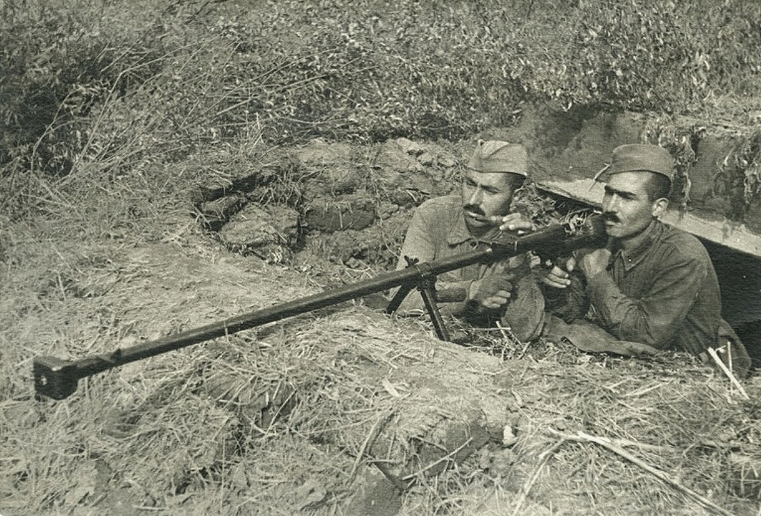

Anti-tank rifle.

order “Patriotic War” 2nd Class #488874 awarded for:

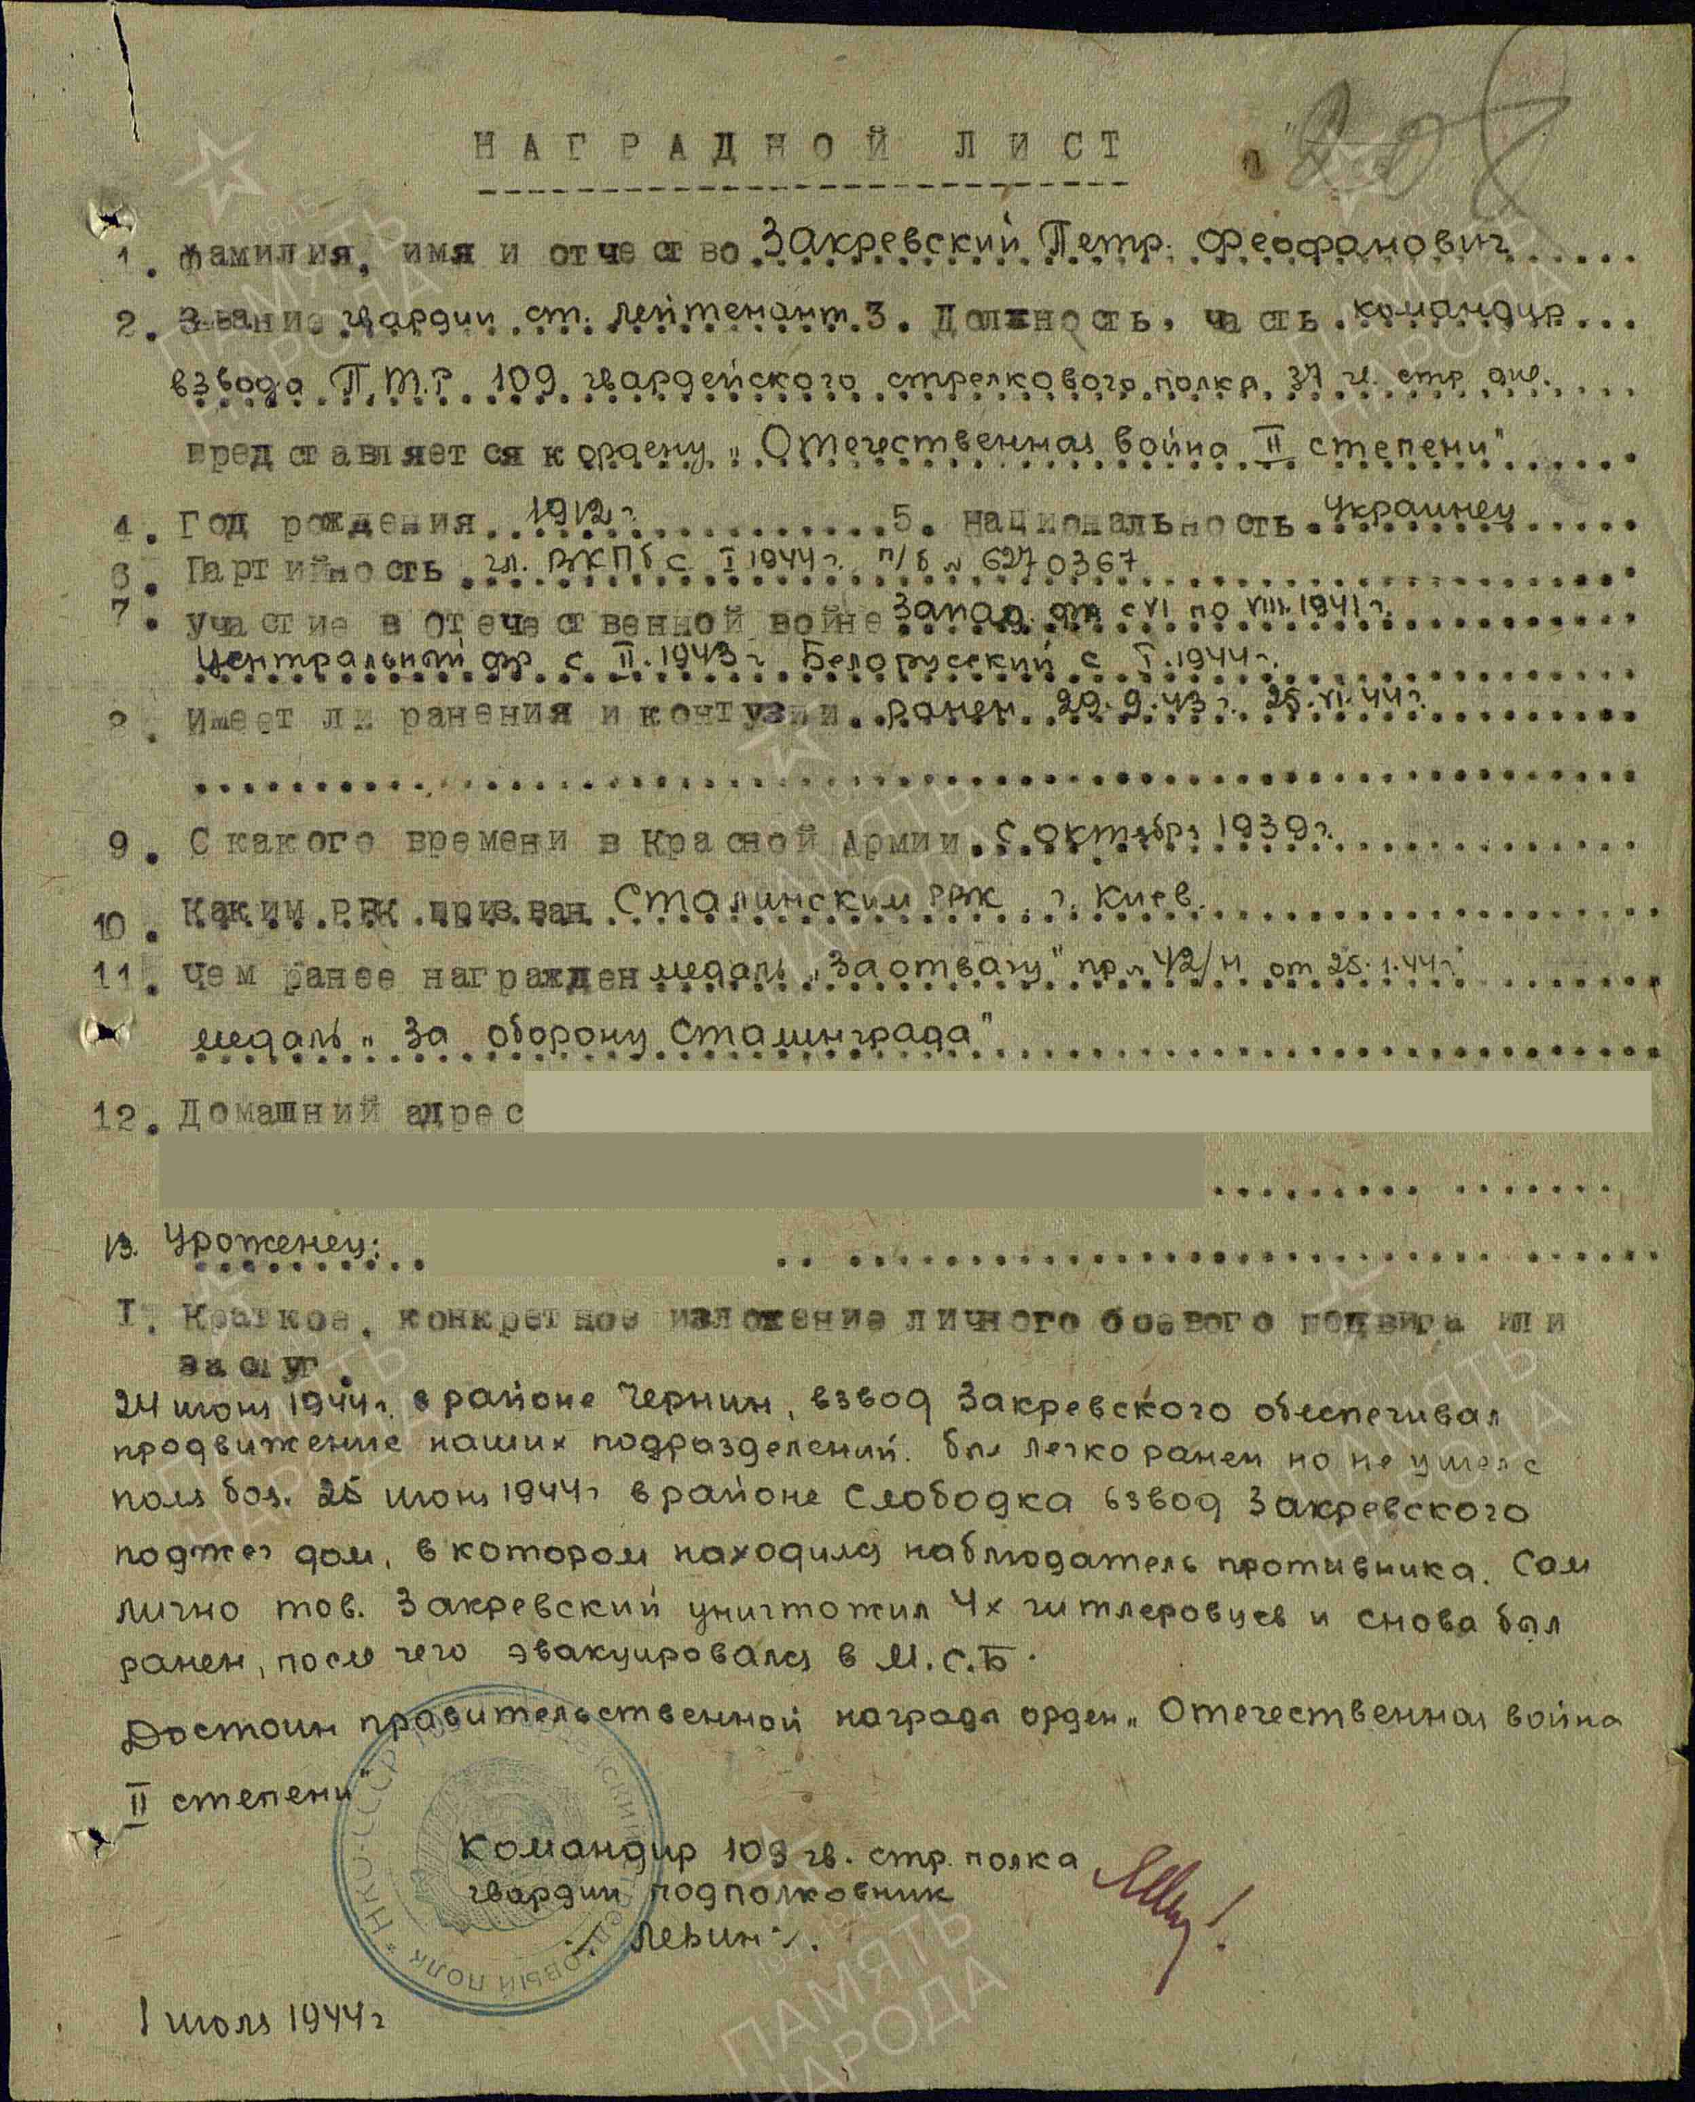

Zakrevskiy Petr Feofanovich, Guards Senior Lieutenant, commander of the anti-tank rifle platoon of the 109th Guards Rifle Regiment, 37th Guards Red Banner Rechitskaya Rifle Division. On June 24, 1944, near Chernin, his platoon supported the advance of Soviet units. Though lightly wounded, he remained in battle. On June 25, near Slobodka, his platoon set fire to a house occupied by enemy scouts. He personally killed four German soldiers but was wounded again and evacuated to a field hospital. He is recommended for the Order of the Patriotic War, 2nd Class.

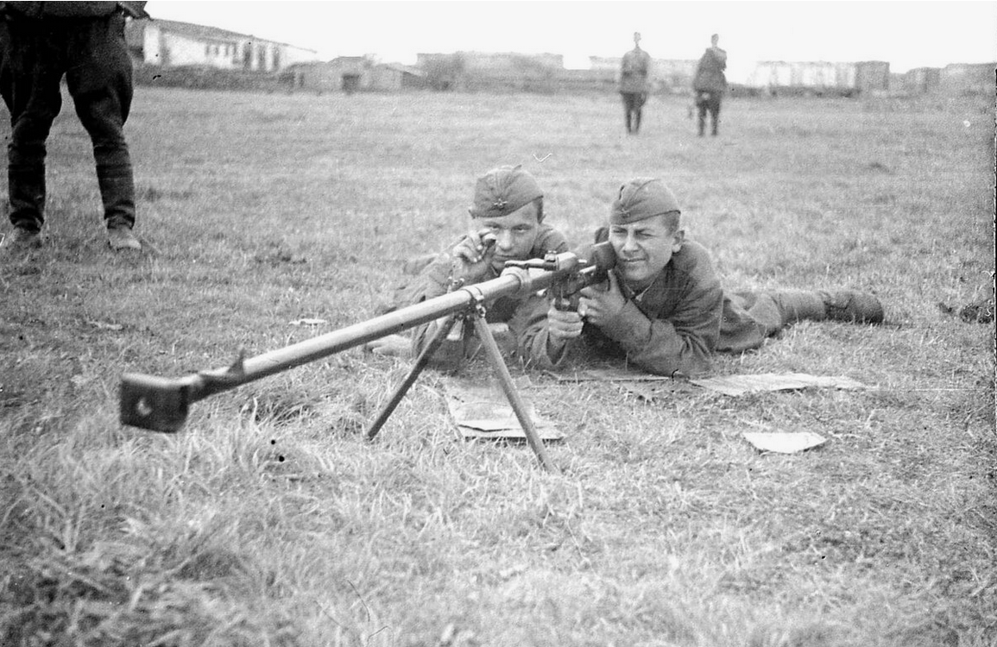

Anti-tank riflemen.