USSR Order “Glory” 3rd Class #107985 with research. Rare duplicate variation with stamped Cyrillic letter “Д” under stamped serial number called "Duplicate" instead of cleaned old serial number. Instead of lost medal can be issued duplicate is only in exceptional cases - at his loss in a combat situation, loss of a natural disaster or in other circumstances where award could not prevent this loss.

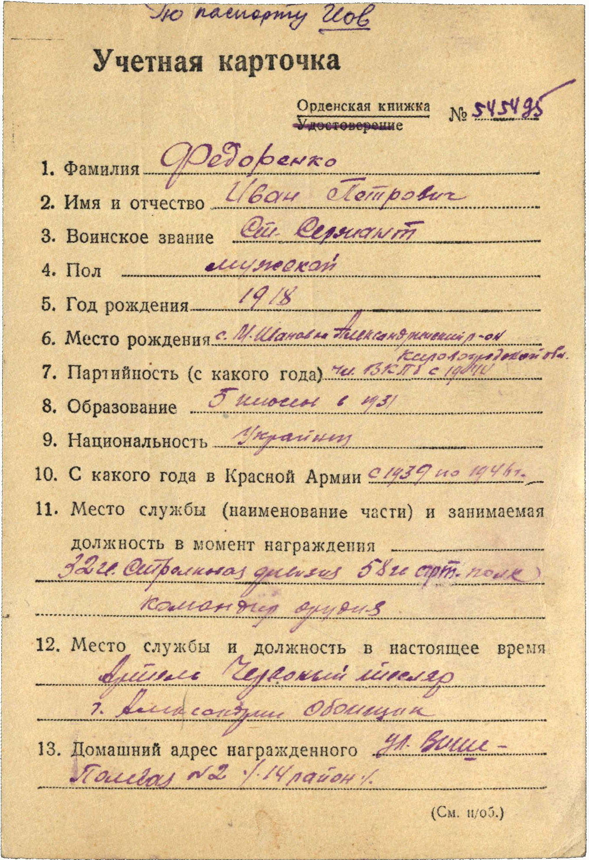

Fedorenko Ivan Petrovich (Федоренко Иван Петрович) -senior sergeant, male, birth in 1918, member of CPSU since 1944, education 5 classes in 1931 year, Ukrainian, served in Red Army from 1939 to 1946.

Was awarded by:

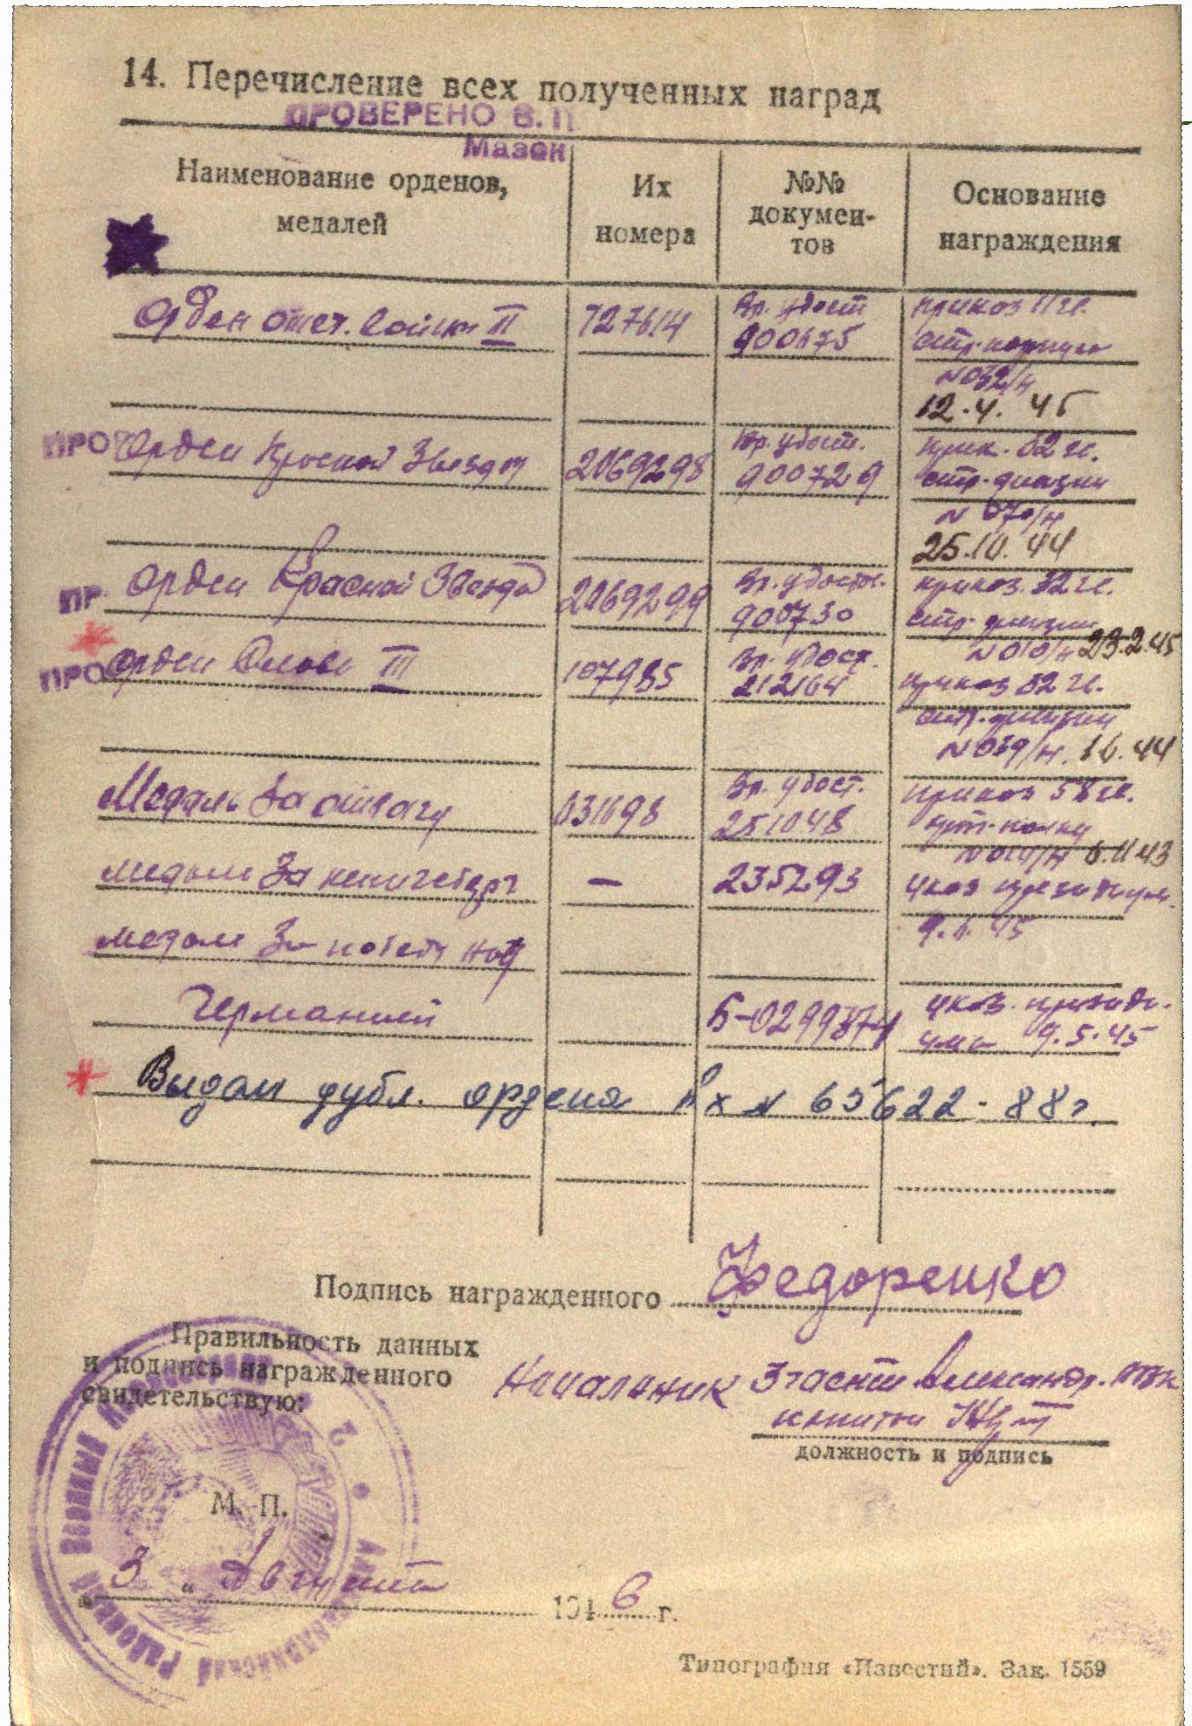

Order “Patriotic War” 2nd Class #727614

Order “Red Star” #2069298

Order “Red Star” #2069299

Order “Glory” 3rd class #107985

Medal “for Courage” #631698

Medal “for Capture Konigsberg”

Medal “for Victory over Germany”

And presented very interesting inscription: issued duplicate of order in 1988 year.

Order “Glory” 3rd class #107985 awarded for:

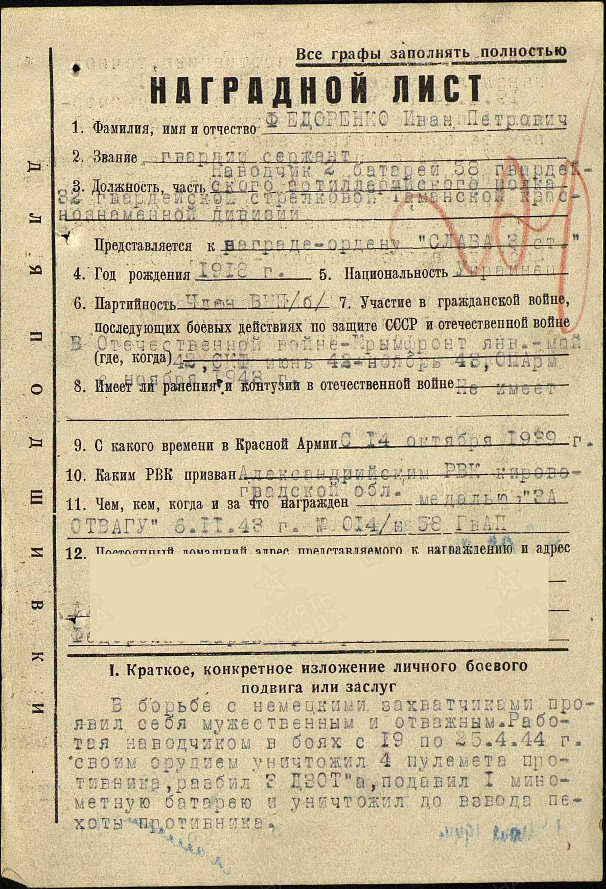

Fedorenko Ivan Petrovich – guard’s sergeant, aimer of 2nd battery of 58 guard’s artillery regiment of 32 guard’s rifle Taman red banner division.

In battles with the German invaders, he proved himself brave and courageous.

Serving as aimer from April 19 to 25, 1944, his cannon destroyed 4 machine guns, damaged 3 pillboxes, suppressed 1 mortar battery, and killed about a platoon of enemy infantry.

Despite enemy fire, he precisely aimed the cannon at designated targets.

On April 19, 1944, with point-blank fire, he destroyed 1 machine gun, enabling our infantry to advance.

From May 7 to 10, 1944, Fedorenko and his cannon destroyed 1 machine gun, 2 light machine guns, and scattered about a platoon of enemy infantry.

He deserves to be awarded the Order of Glory, 3rd Class.

Commander of 58 guard’s artillery regiment

Guard’s MAJOR /GRACHEV/

17 may 1944.

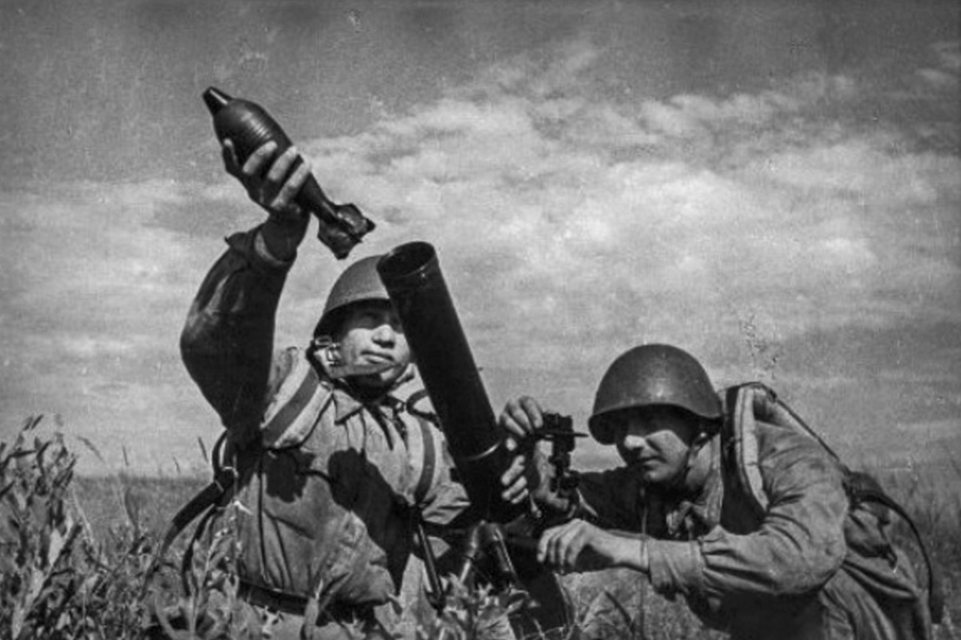

Mortar shooter