USSR Order “Red Star” #115167 with research. Rare early variation called "heel", because has rounded platform near screw's base. With native silver screw-nut.

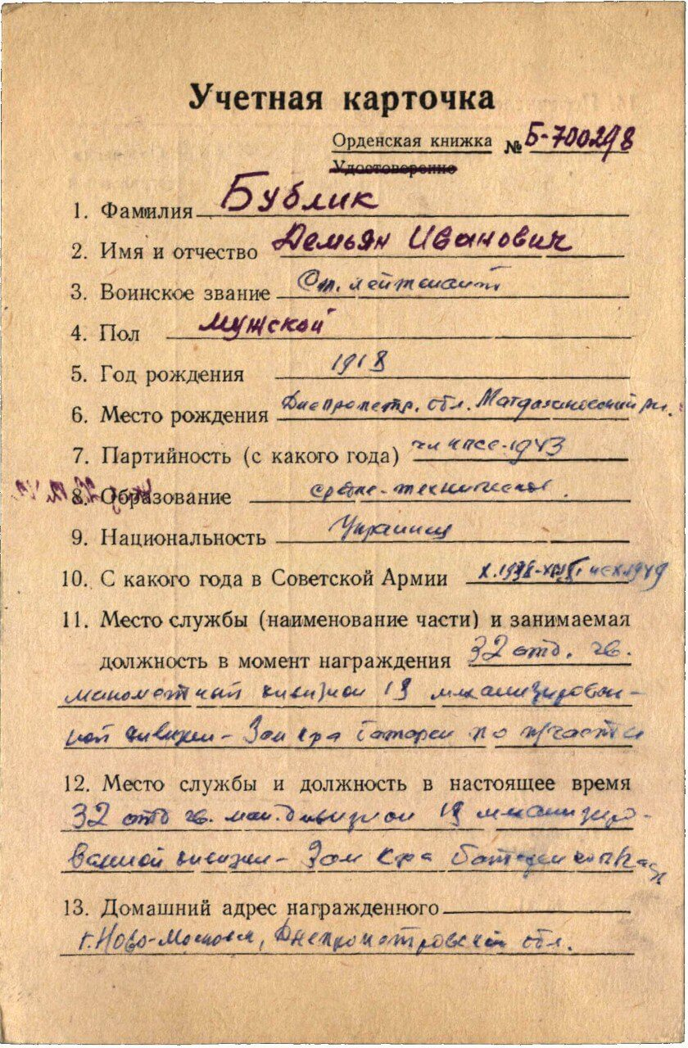

Bublik Demiyan Ivanovich (Бублик Демьян Иванович) – senior lieutenant, male, birth in 1918, member of CPSU since 1943, secondary technician education, Ukrainian, served in Red Army from October 1938 to October 1949.

Was awarded by:

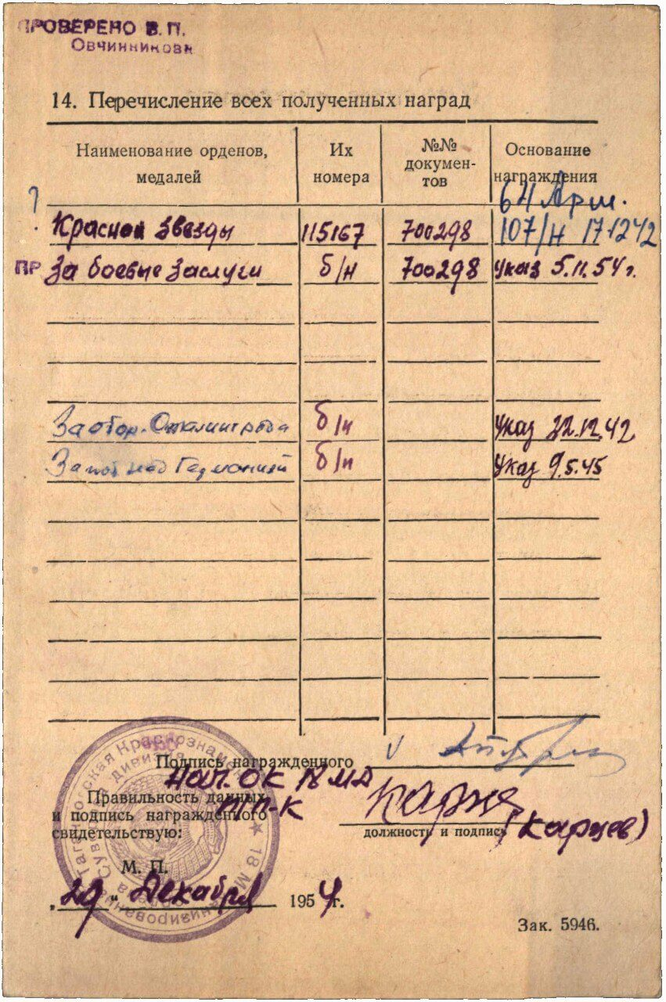

Order “Red Star” #115167

Medal “for Military Merit” without number

Medal “for Defense Stalingrad”

Medal “for Victory over Germany”

Order “Red Star” #115167 awarded for:

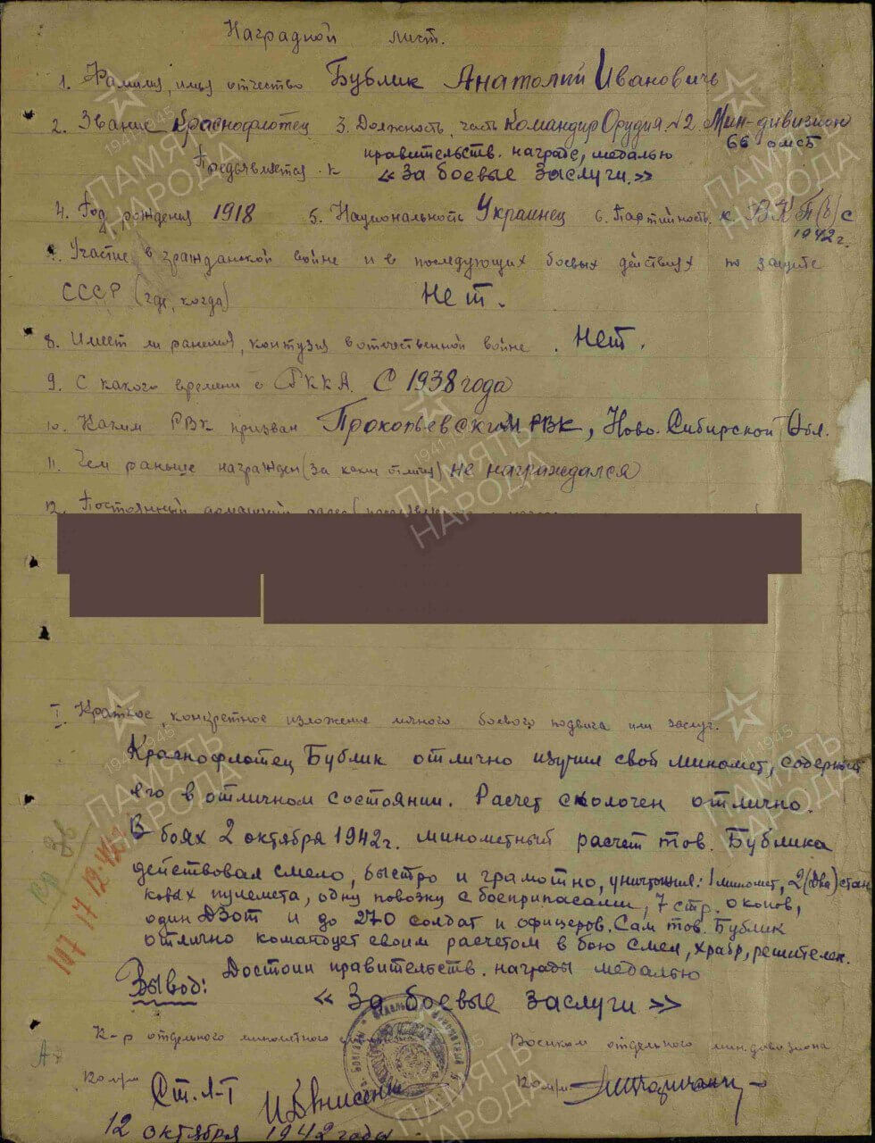

Bublik Demiyan Ivanovich – Red Army sailor, commander of cannon No. 2 of the mortar division. He mastered his mortar perfectly and kept it in excellent condition, ensuring his crew worked as a united team. In combat on October 2, 1942, Bublik’s crew fought bravely, skillfully, and swiftly, destroying one mortar, two heavy machine guns, one ammunition wagon, seven trenches, one pillbox, and about 270 enemy soldiers and officers. Bublik personally managed his crew with excellence, showing bravery, courage, and determination in battle.

Conclusion: Deserves governmental award medal “for Military Merit”.

12 october 1942

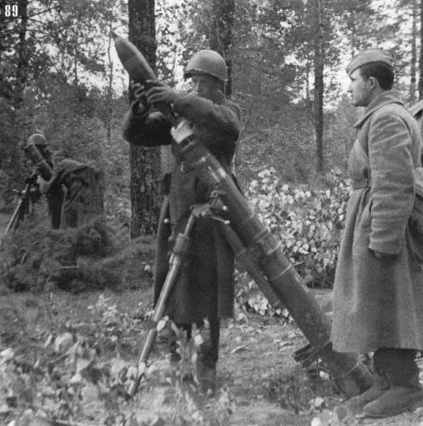

Mortar shooters.