USSR Battle Set: order “Red Banner “#551825, order “Patriotic War” 1st Class #78911, order “Patriotic War” 2nd Class #141105, order “Red Star” #63667, order “Patriotic War” 1st Class (85) #996236, medal “for Defense Soviet Arctic”, medal “for Victory over Germany”, badge “Veteran of Karelian Front” with documents.

Awarded to:

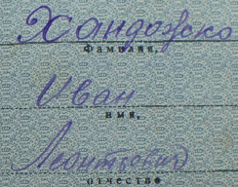

Handozhko Ivan Leontievich

(Хандожко Иван Леонтьевич)

Order “Red Banner “#551825 is "Oval" variant with serial number applied under big stamp "МОНЕТНЫЙ ДВОР" applied in two rows. Can be found in range of numbers 450253-566746. Produced on Leningrad Mint in 1955-57's (T4, V4, 3rd batch).

Order “Red Star” #63667 is rare early variation called "heel", because has rounded platform near screw's base. With native silver screw-nut.

Order “Patriotic War” 1st Class #141105 with silver screw-nut too.

Presented free ride tickets to order book.

Medal “for Victory over Germany” awarded in June 10, 1946.

Medal “for Defense Soviet Arctic” awarded in February 16, 1945.

Order “Patriotic War” 1st Class #78911 awarded for:

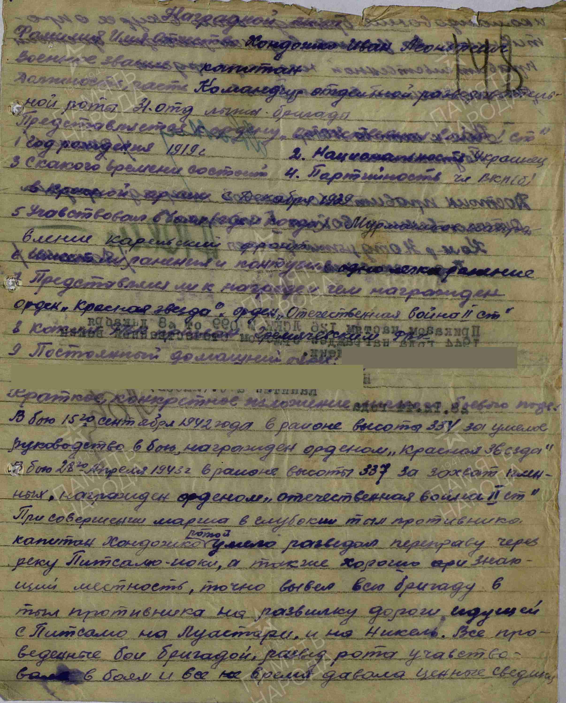

In combat on September 15, 1942, near elevation 334, he was awarded the Order of the Red Star for skillful leadership in battle.

In combat on April 28, 1943, near elevation 337, he was awarded the Order of the Patriotic War, 2nd Class, for capturing enemy soldiers.

During a march into the enemy rear, Handozhko’s company skillfully reconnoitered a crossing over the Petsamo River. Due to his excellent knowledge of the terrain, he successfully led the group behind enemy lines to the crossroads between Persamo and Luostari and toward the settlement of Nikel.

The reconnaissance group participated in all brigade operations, continuously gathering vital intelligence, ensuring brigade command had complete information about the enemy.

For his effective leadership of the reconnaissance unit, he deserves the Order of the Patriotic War, 1st Class.

Chief of head quarter of 31 separate ski brigade

Lieutenant-colonel %Droznin%

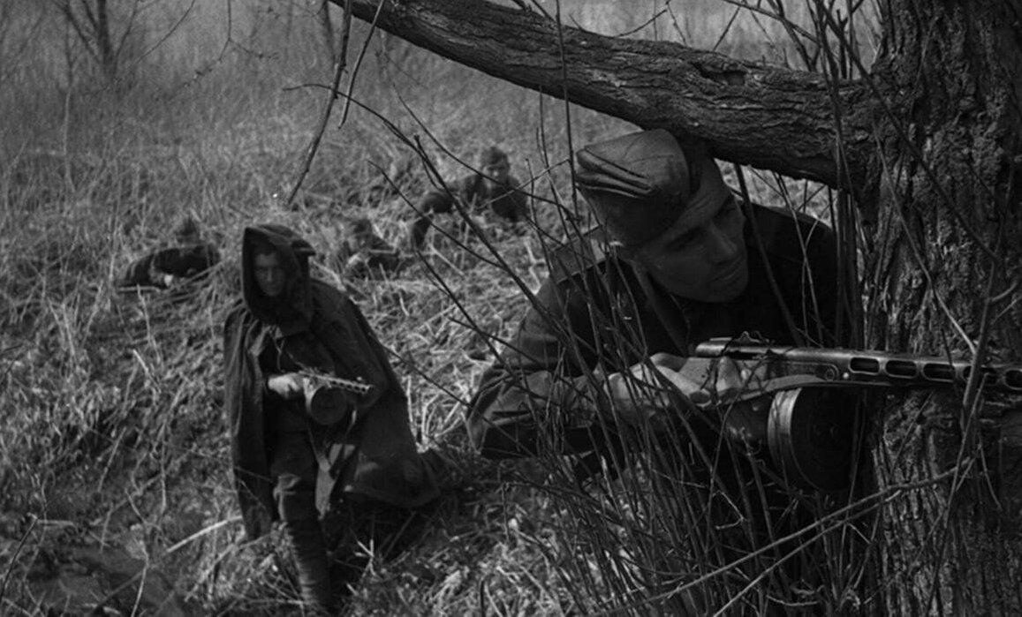

Soviet scouts.

order “Patriotic War” 2nd Class #141105 awarded for:

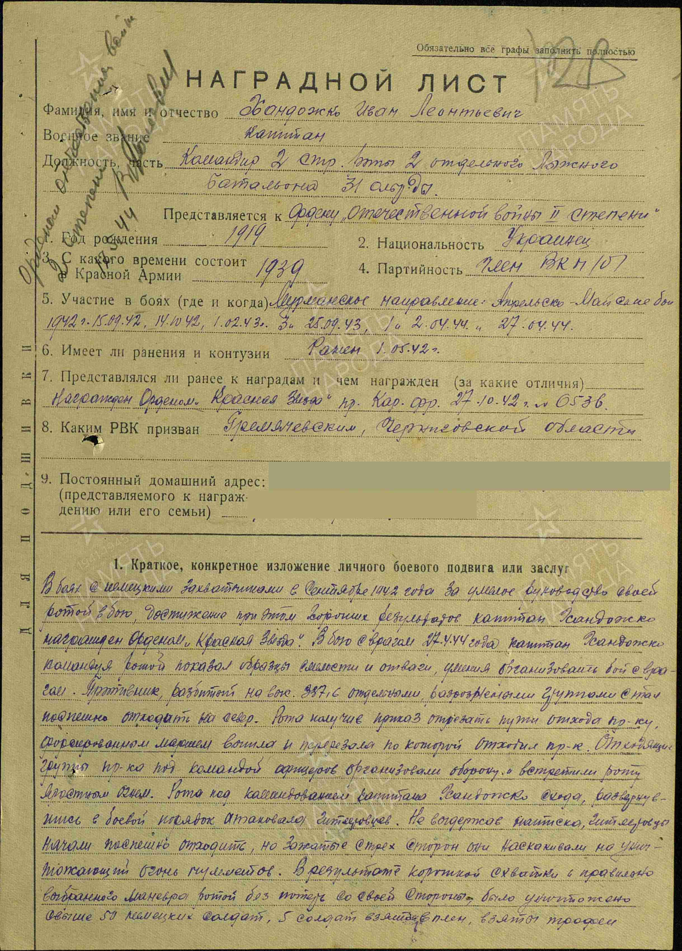

Handozhko Ivan Leontievich – captain, commander of 2nd rifle company of 2nd separate scout’s group of 31 separate ski brigade.

In battles against the German invaders in September 1942, for skillful leadership of his company and the results achieved, Handozhko was awarded the Order of the Red Star.

In combat on April 27, 1944, Handozhko demonstrated courage, bravery, and the ability to organize an effective battle while commanding his company. The enemy was defeated at elevation 337.6 and began retreating north. The company was ordered to cut off their retreat.

They moved into the enemy’s rear and blocked the escape route. The retreating Germans discovered them, set up a defense, and opened heavy fire. A battle ensued. Handozhko’s company counterattacked. Unable to withstand the pressure and surrounded from three sides under machine-gun fire, the Germans tried to retreat but were trapped. As a result of a swift and well-executed flanking maneuver, the company, without suffering losses, killed over 50 German soldiers, captured 5, and seized enemy trophies.

For excellent combat organization and effective command, Handozhko deserves the Order of the Patriotic War, 2nd Class.

Commander of 2nd separate scout’s group

Guard’s major Mashuhov

“1” May 1944

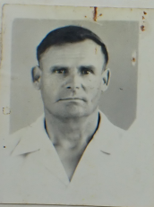

Handozhko Ivan Leontievich

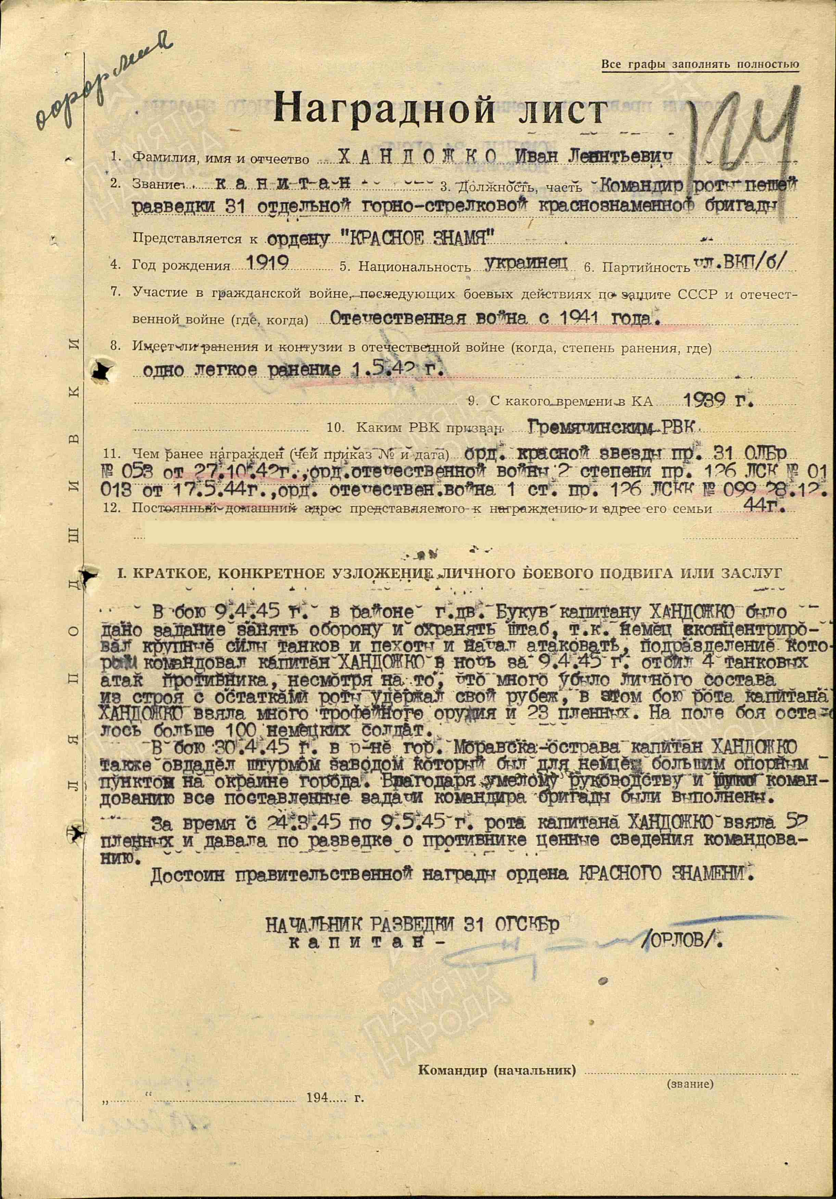Order “Red Banner “#551825 awarded for:

HANDOZHKO Ivan Leontievich – captain, commander of company foot reconnaissance of 31 separate mountain-rifle Red Banner brigade.

Handozhko Ivan Leontievich - Captain, commander of the foot reconnaissance company of the 31st Separate Mountain Rifle Red Banner Brigade.

In combat on April 9, 1945, near the village of Buków, Captain Handozhko was assigned to hold the line and defend the brigade headquarters. Despite a large German force of tanks and infantry attacking, his company repelled four tank assaults during the night. Despite heavy losses, Handozhko and his remaining men held their position. In this battle, the company captured numerous enemy weapons and took 23 prisoners. Over 100 German soldiers were left dead on the field.

On April 30, 1945, near the town of Moravská Ostrava, Handozhko also captured an industrial plant, a heavily fortified German stronghold on the town’s outskirts. Through skillful leadership, all combat objectives assigned by the brigade commander were achieved.

Between March 24 and April 9, 1945, Handozhko’s company captured 50 enemy soldiers and gathered valuable intelligence for command.

He deserves the government award – the Order of the Red Banner.

CHIEF OF INTELLIGENCE OF 31 SEPARATE MOUNTAIN-RIFLE RED BANNER BRIGADE.

Captain- /ORLOV/

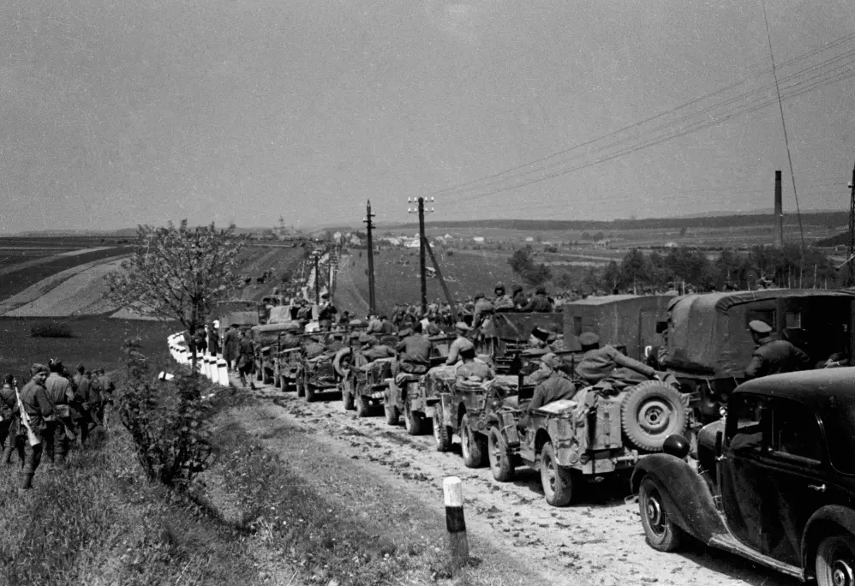

Soviet troops in Czech, 1945.