USSR Order “Glory” 3rd Class #367418 with research.

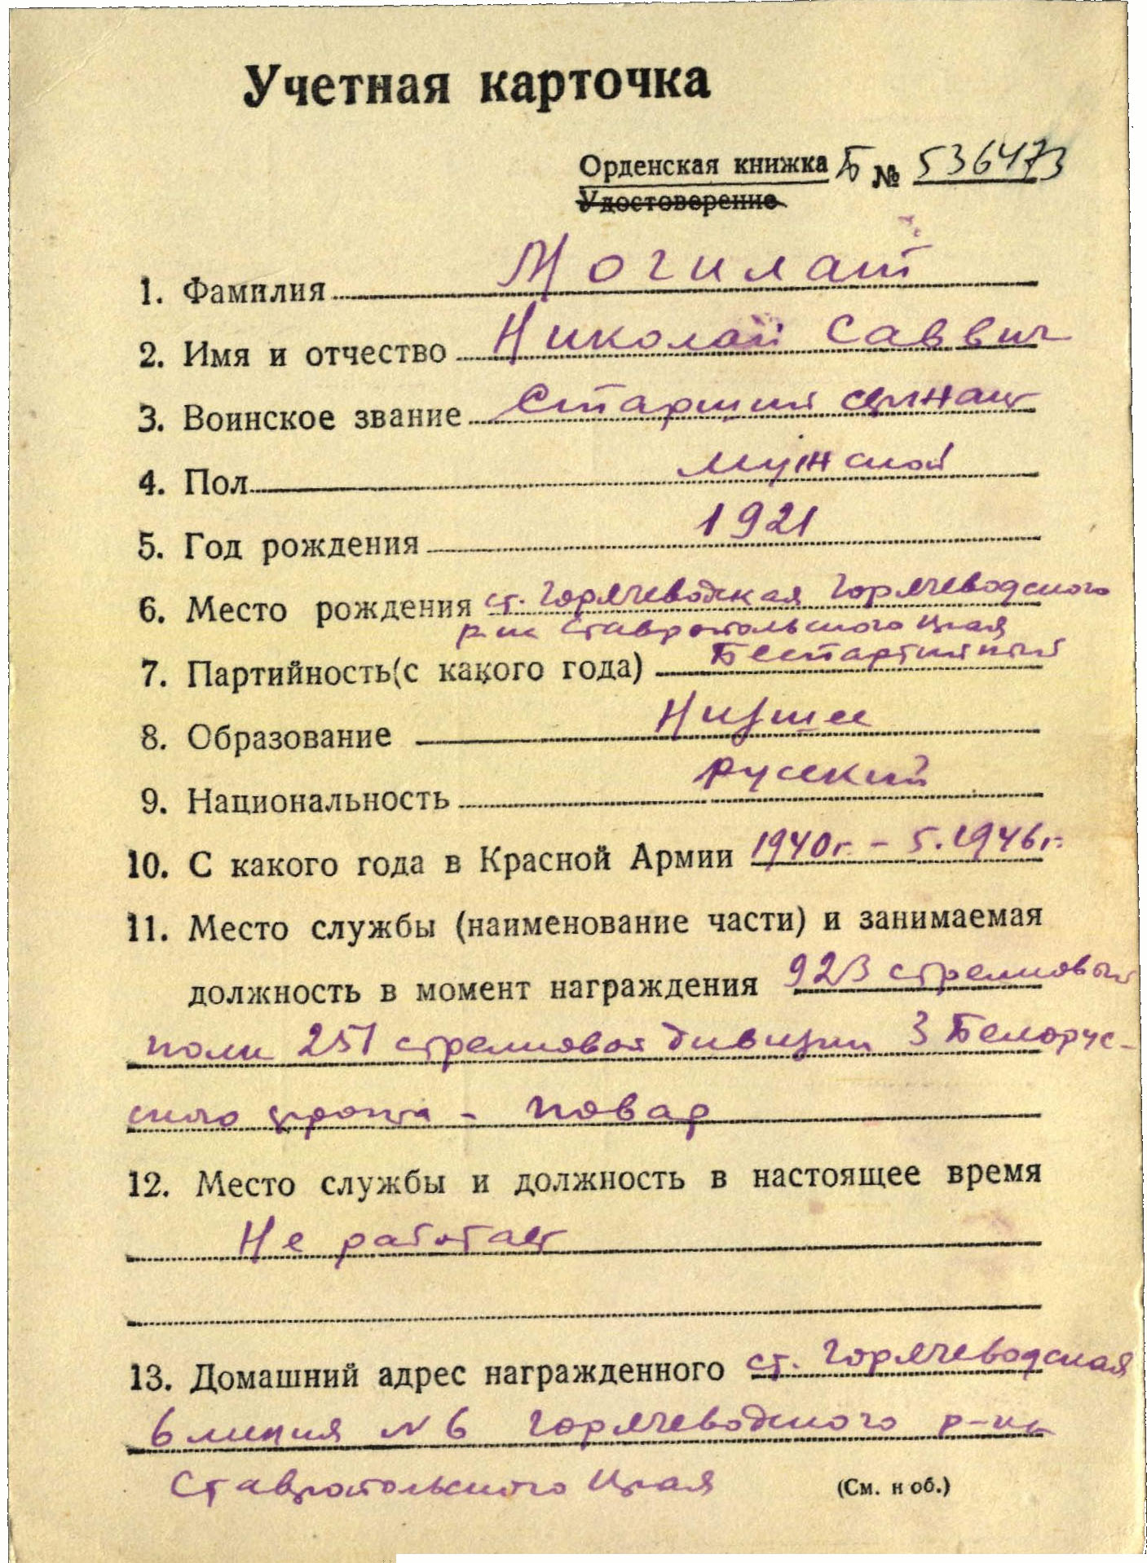

Mogilat Nikolay Savvych (Могилат Николай Саввич) – senior sergeant, male, birth in 1921, not party member, primary education, Russian, served in Red Army from 1940 to May 1946.

Was awarded by:

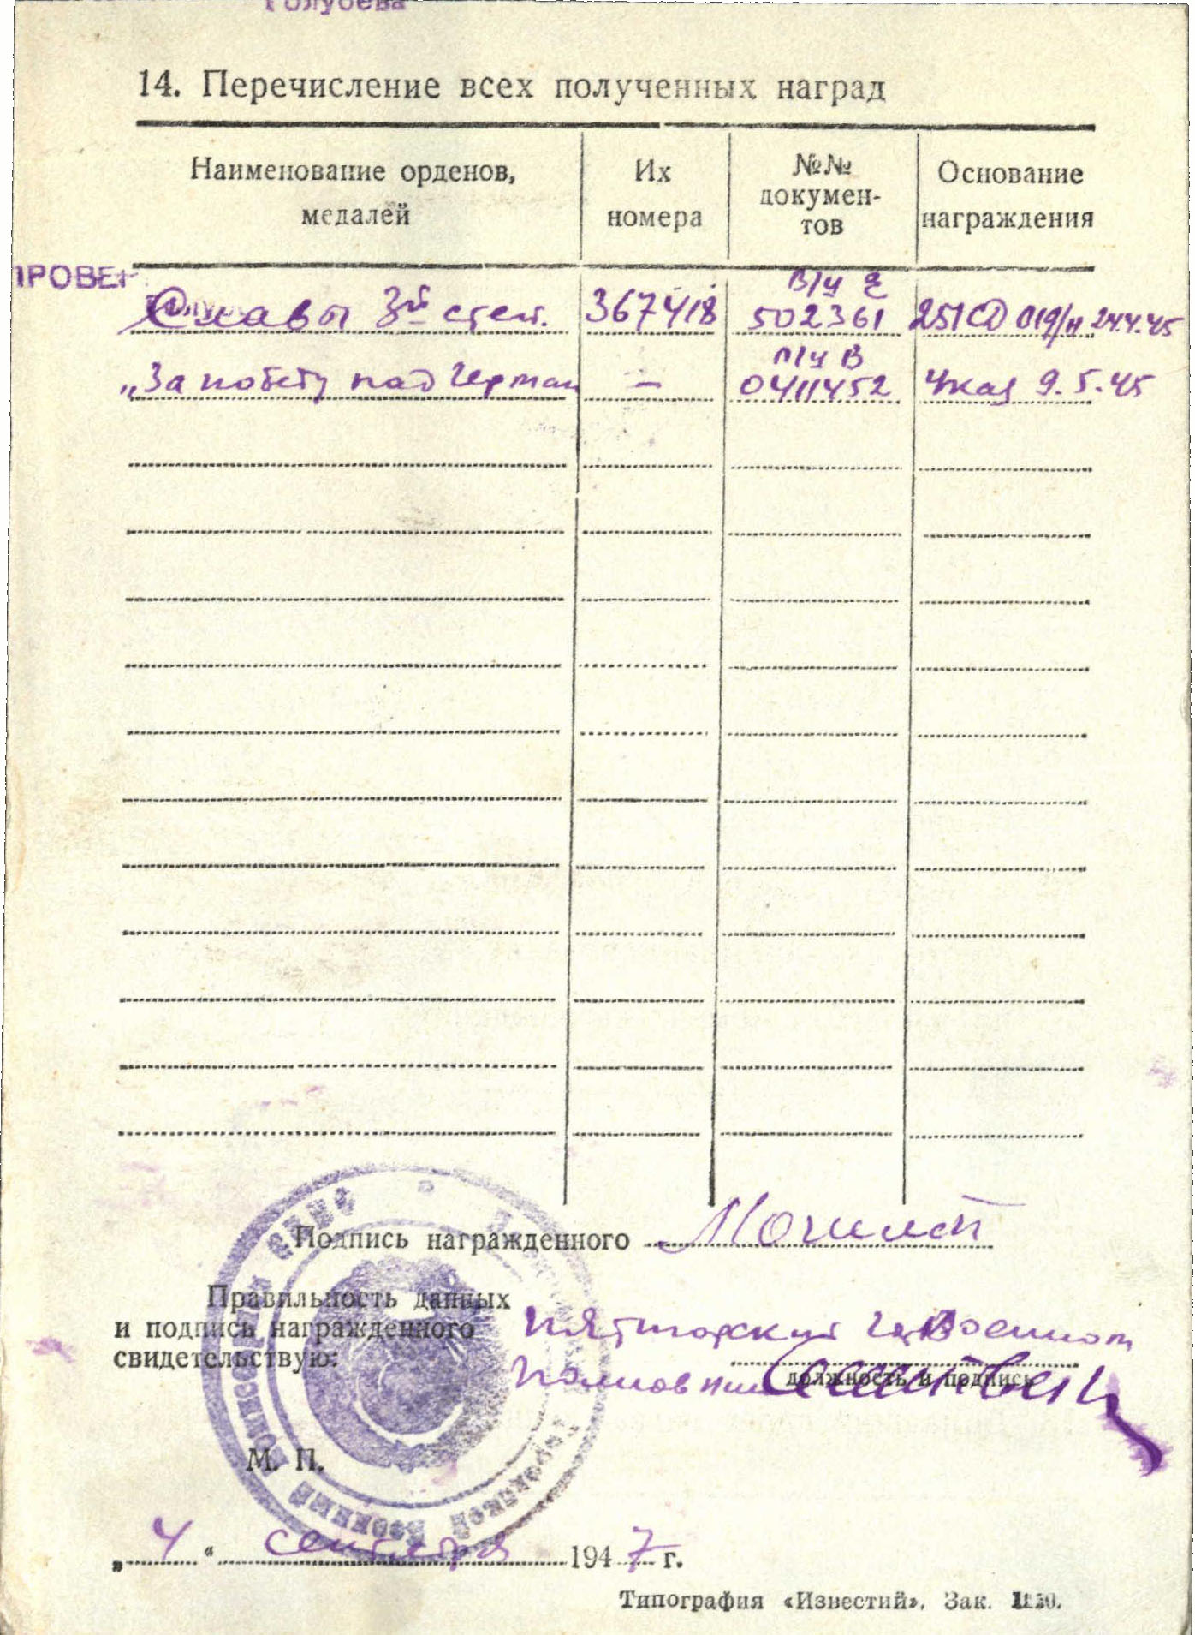

Order “Glory” 3rd Class #367418

Order “Glory” 3rd Class #367418 awarded for:

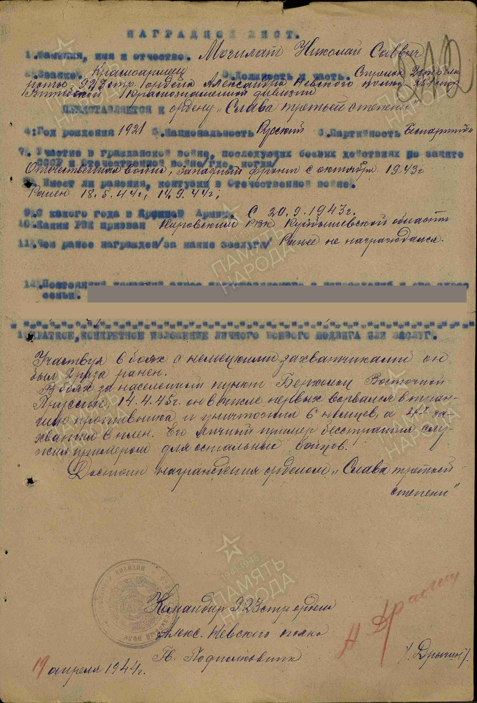

Mogilat Nikolay Savvych – red army soldier, shooter of 2 rifle company of 923 rifle order of Alexander Nevsky regiment of 251 rifle Vitebsk Red Banner division.

Participating in combats with German’s invaders he was 2 times wounded.

In combat for settlement in Eastern Prussia in April 14, 1945 he among first burst into enemy trenches and killed 6 Germans and 4 captured. His personal fearlessness served as example for other soldiers.

Deserves awarding by order “Glory” 3rd Class.

Commander of 923 rifle order of

Alexander Nevsky regiment

Guard’s Lieutenant-colonel %Drugin%

19 april 1944

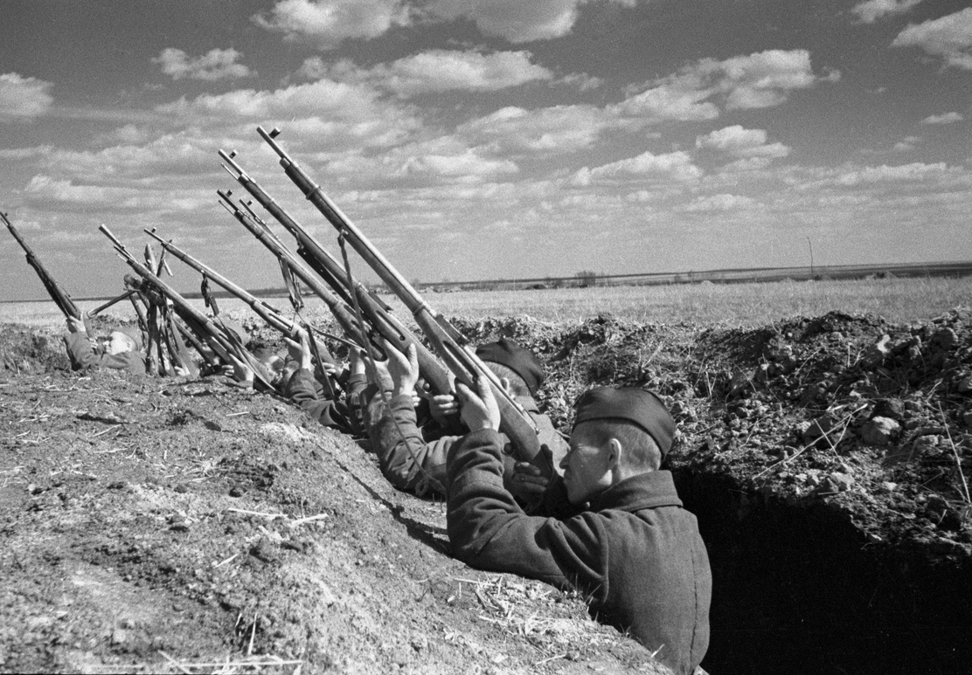

Shooters.