USSR Order “Red Star” #3344161 with documents. Also presented red army book.

Awarded to:

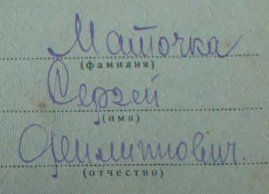

Matochka Sergey Filippovich

(Маточка Сергей Филиппович)

Order “Red Star” #3344161 awarded for:

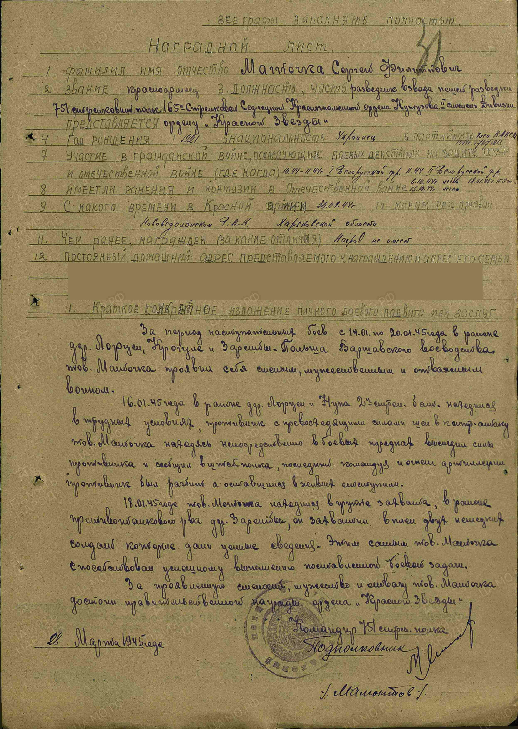

Matochka Sergey Filippovich – red army soldier, scout of foot reconnaissance platoon of 751 rifle regiment of 165 rifle Sedletskaya order of Kutuzov 2nd Class division.

During advancing combats from January 14 to 20, 1945 in region of Lorcen, Krogule and Zareshbki – Poland comrade Matochka showed himself as brave and courageous soldier.

In January 16, 1945 in region of village Lorcen and Nuka 2nd rifle battalion was being in hard conditions, enemy by superior forces counterattacked, Matochka traced enemies and reported about them to head quarter of regiment, head quarter opened fire on these enemies and destroy their positions, survived Germans retreated.

In January 18, 1945 Matochka being in capturing group near anti-tank ditch captured 2 German soldiers what gave important information. Matochka by this contributed to success performing of combat task.

For showed bravery and courage Matochka deserves governmental award order “Red Star”.

Commander of 751 rifle regiment

“28” March 1945 lieutenant-colonel

% Mamontov %

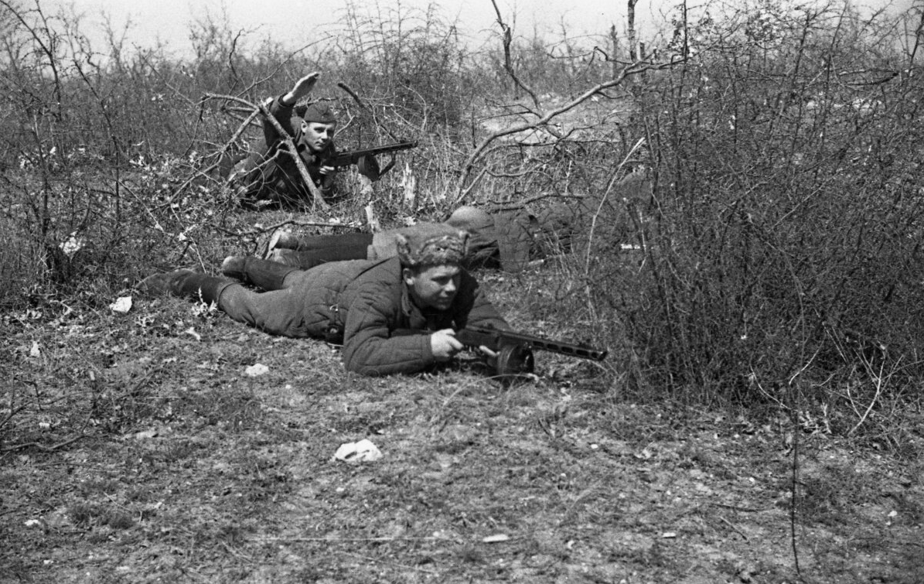

Soviet scouts.