USSR Battle Set: medal “for Military Merit” #692513, medal “for Military Merit” #2609910 with documents.

Awarded to:

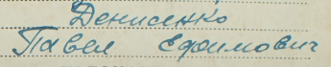

Denisenko Pavel Efimovich

(Денисенко Павел Ефимович)

Also presented documents to medals:

“For Victory over Germany” awarded in September 8, 1946.

“For Capture Berlin” awarded in April 5, 1947.

“For Defense Moscow” awarded August 1946.

Also presented gratitudes from Stalin for:

#246 from January 23, 1945 for capturing towns Willenburg and Ortelsburg.

#239 from January 21, 1945 for invading in Southern regions of Eastern Prussia and in combats and capturing towns Neidenburg and Allendorf.

#242 from January 22, 1945 for capturing town Allenstein.

From July 27, 1944 for liberation town Belostok.

#224 from January 17, 1945 for breaking enemy defense on Western bank of river Narva.

From June 29, 1944 for surrounding and destroying Bobruisk group of German’s troops and liberation town BOBRUISK.

#309 from March 25, 1945 for capturing town Heiligenbeil.

#303 from March 20, 1945 for capturing town Braunsberg.

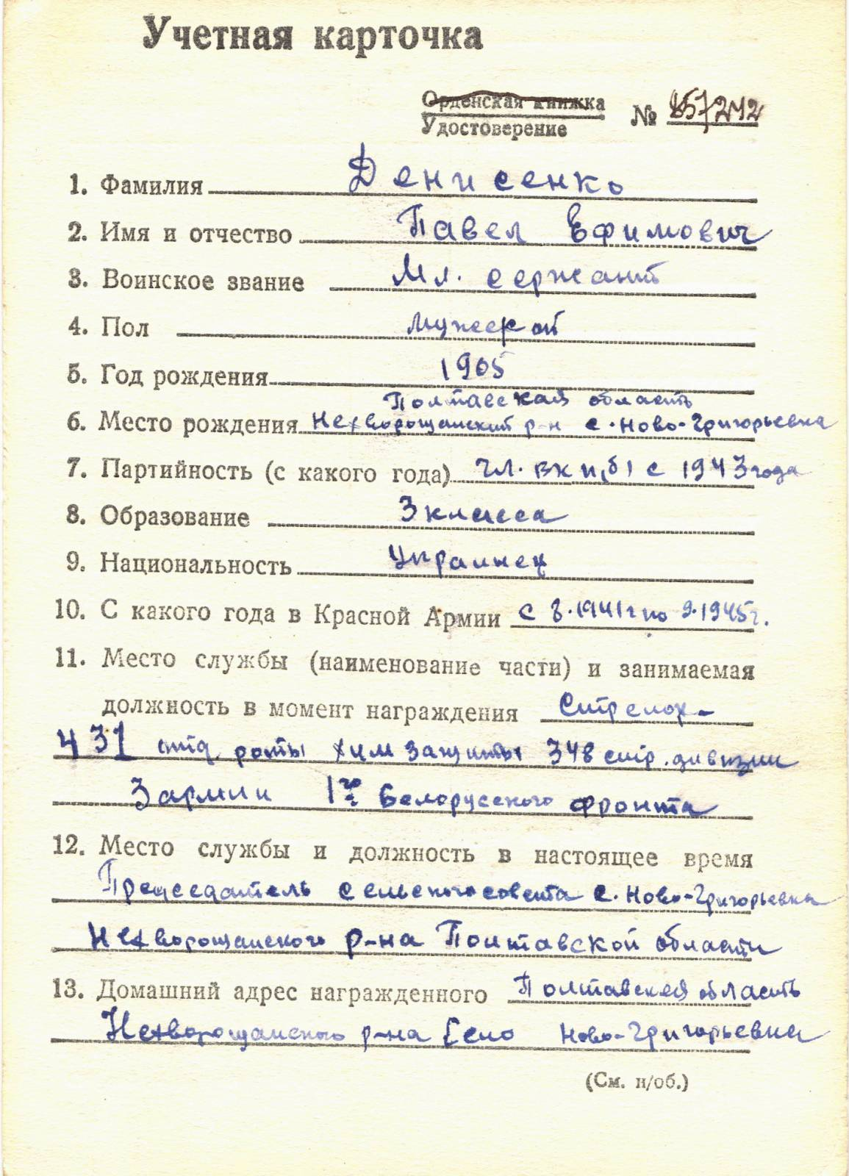

Denisenko Pavel Efimovich – junior sergeant, male, birth in 1905, member of CPSU since 1943, education 3 Classes, Ukrainian.



Awarded by medal “for Military Merit” #2609910

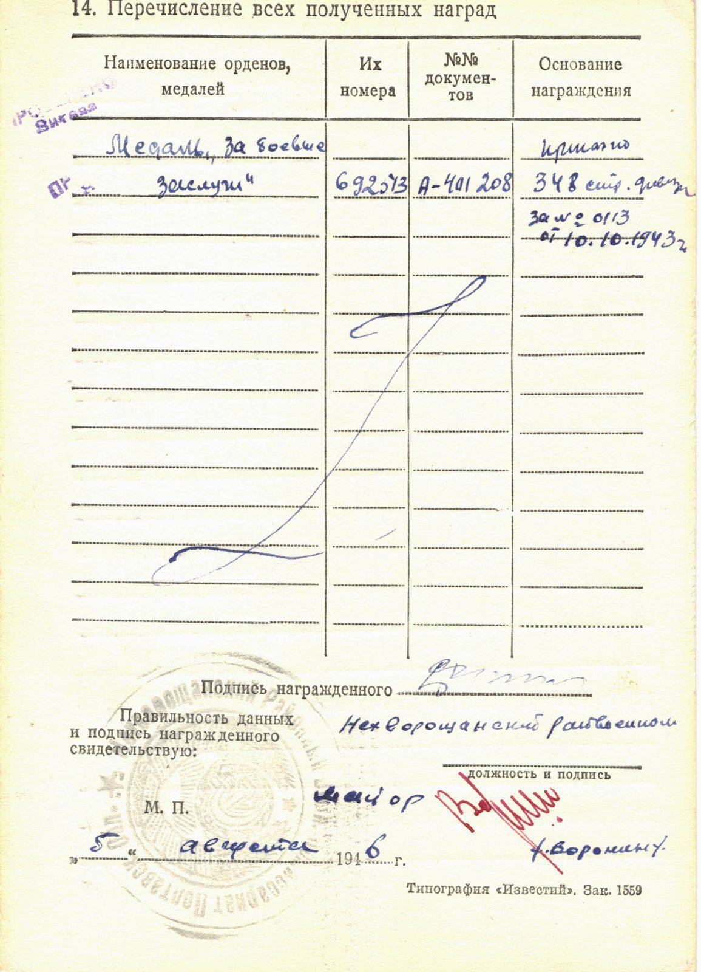

& medal “for Military Merit” #692043

Medal “for Military Merit” #692513 awarded for:

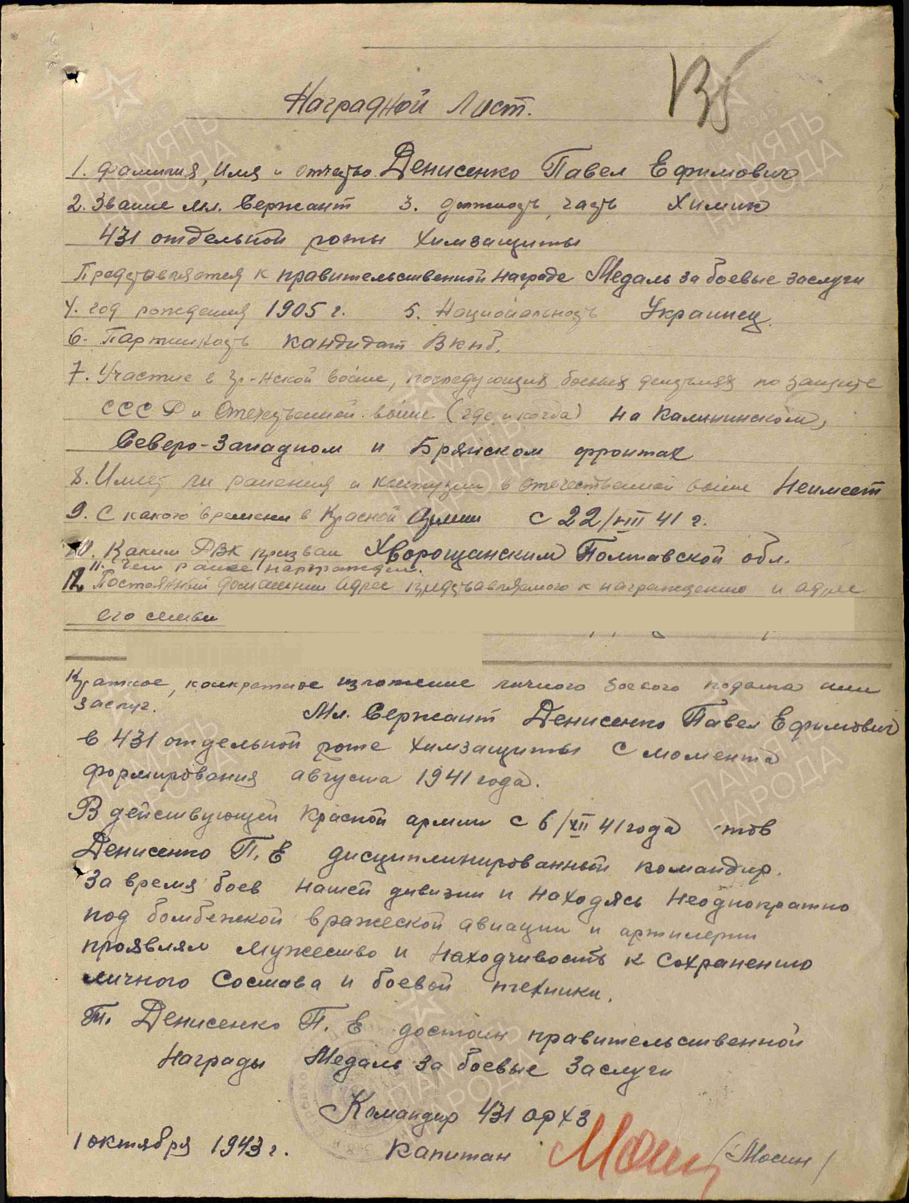

Denisenko Pavel Efimovich - Junior Sergeant, chemist of 431 separate company of Chemical protection.

Denisenko served in 431 separate company of Chemical protection since it’s creation in August 1941.

Served in Red Army from 6 July, 1941, Denisenko disciplined commander, under bombing of enemy’s aviation and artillery fire, showing bravery and cleverness for saving people and combat technics.

Denisenko deserves governmental award medal “for Military Merit”.

Commander of 431 separate company of chemical protection

Captain /Mosin/

1 october 1943.

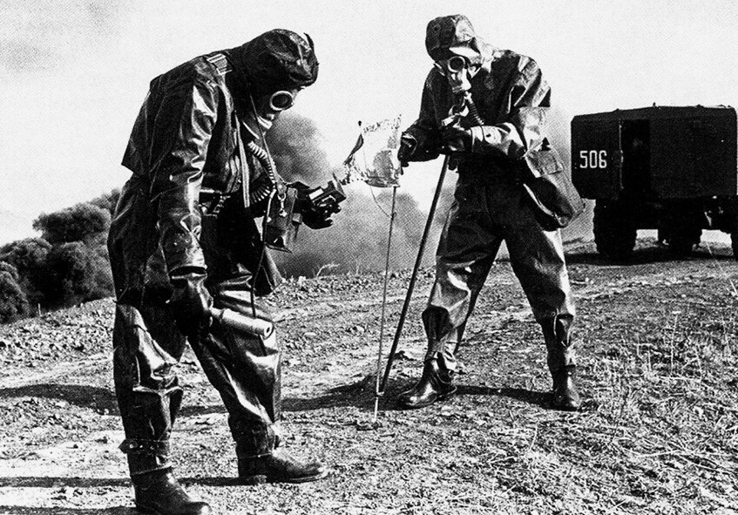

Chemists.

medal “for Military Merit” #2609910 awarded for:  
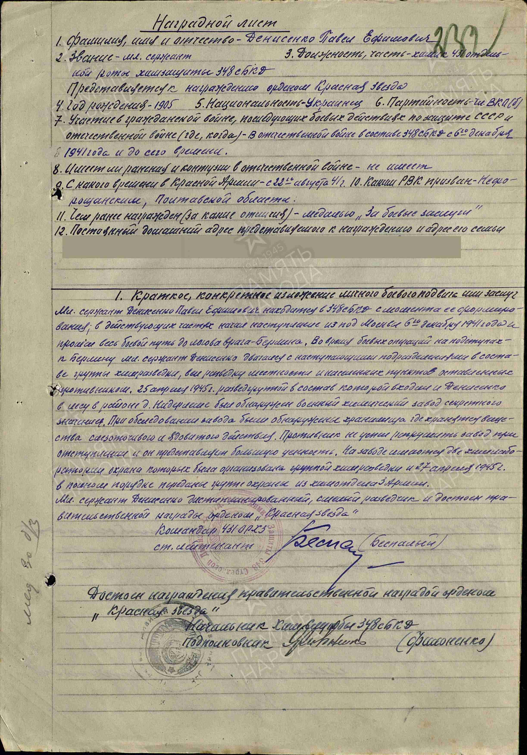

Denisenko Pavel Efimovich – junior sergeant, chemist of 431 separate company of chemical protection of 348 rifle battalion.

Denisenko in acting units begin service from beginning of advance from town Moscow December 6, 1941 and passed combat path to capital of Germany – Berlin. During combat actions near Berlin Denisenko moved with advancing units in staff of chemical intelligence group, led chemical reconnaissance of area and settlements leaving by enemy. In April 25, 1945 Denisenko’s intelligence group in forest discovered chemical secret plant. At plant discovered warehouse where tear gas and poisonous substances were stored. Enemy did not have time to destroy plant during retreat and it was of great value. On plant located 2 chemical laboratories, protection organized by group of chemical intelligence group and in April 27, 1945 transferred to defense group from chemical department of 3rd Army.

Denisenko disciplined, brave scout and deserves governmental award order “Red Star”.

Commander of 431 separate company of chemical protection

Senior lieutenant (Bespalyi)

But higher award commission after reading his feat decided award him by lover grade award – medal “for Military Merit”.

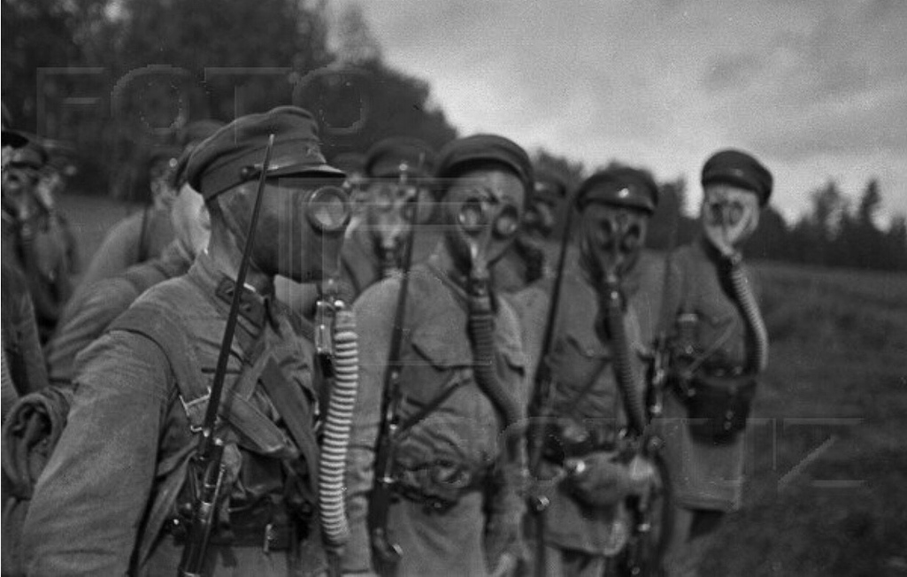

Chemical troops.