USSR Battle Set: order “Glory” 3rd Class #487513, medal “for Courage” #1623173 with documents.

Awarded to:

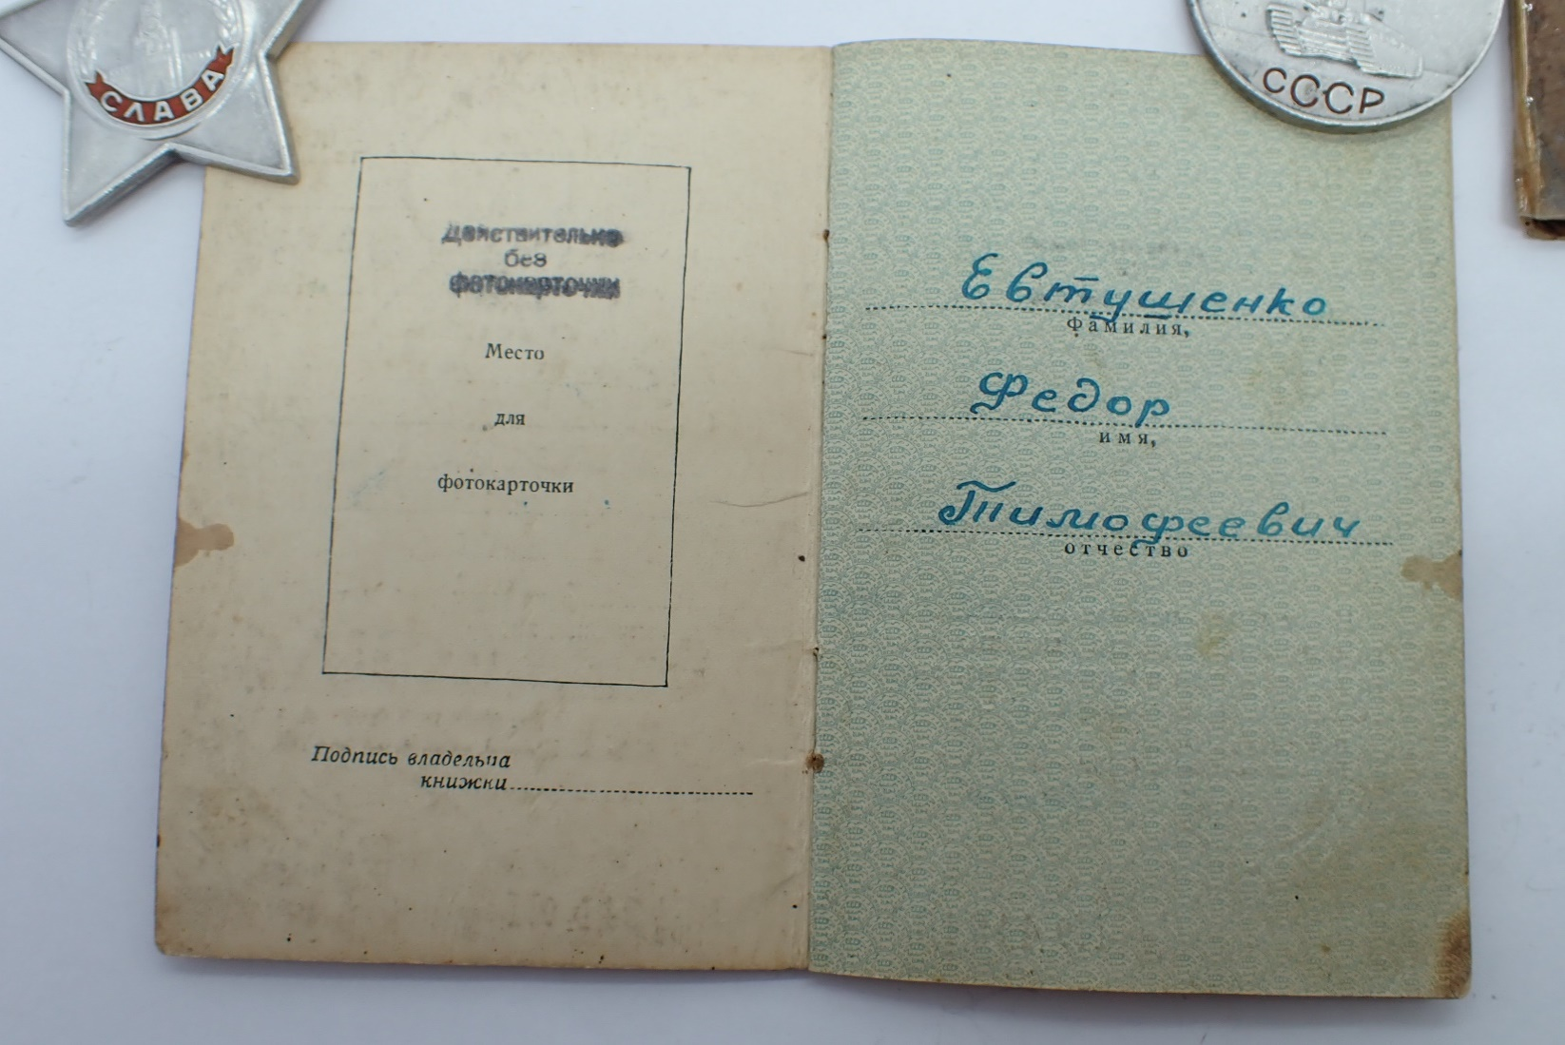

Evtushenko Fedor Timofeevich

(Евтушенко Федор Тимофеевич)

Also presented batch of documents: red army book, characteristic and photo of cavalier.

medal “for Courage” #1623173 awarded for:

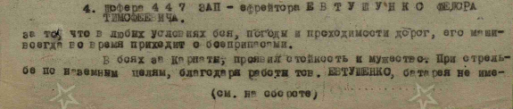

4. driver of 447 air defense artillery regiment – corporal EVTUSHENKO FEDOR TIMOFEEVICH for that he in any combat conditions, weather and road conditions, he always delivered ammunition timely. In combat for Carpathians mountains showed durability and bravery. During shooting on ground forces, through work of EVTUSHENKO artillery battery was secured by ammunition and led constant fire on enemy, what secured success to our advancing infantry units.

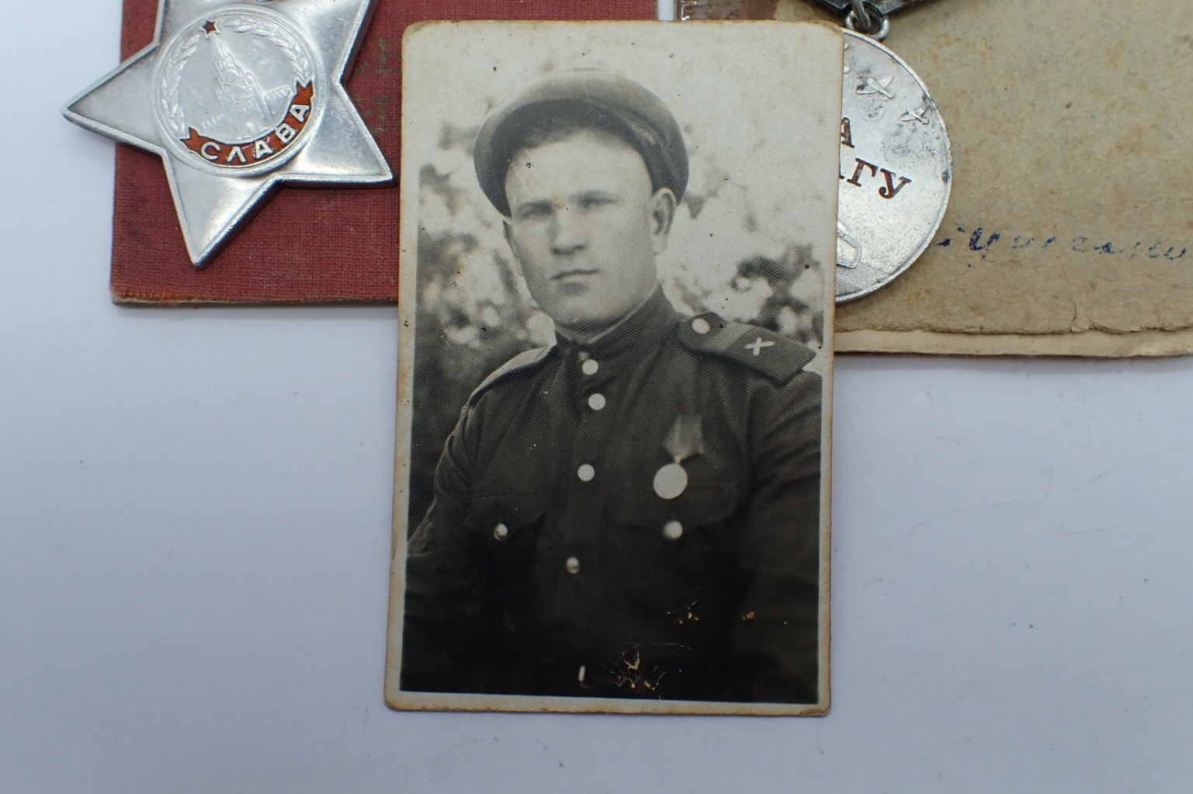

Evtushenko wearing this medal.

order “Glory” 3rd Class #487513 awarded for:

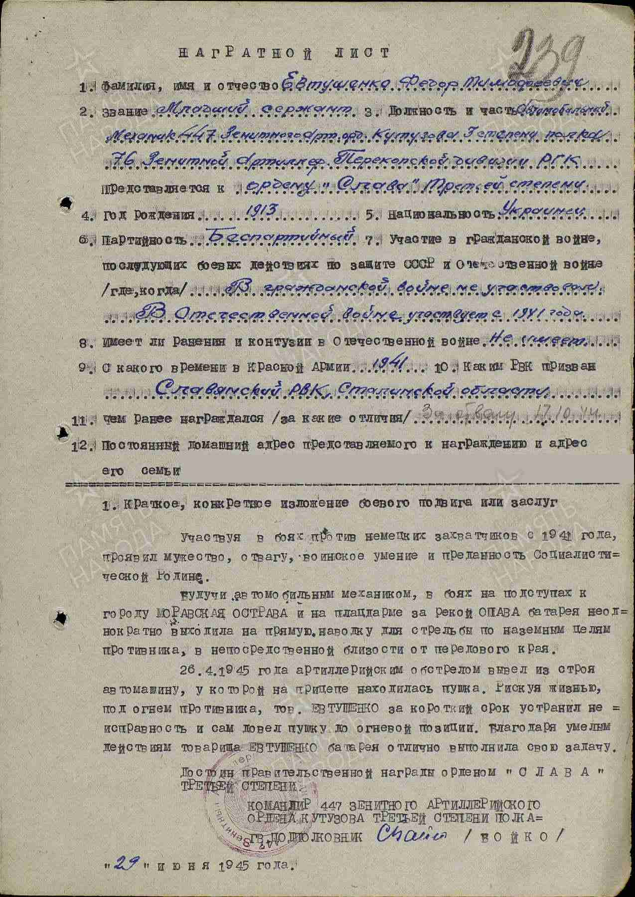

Evtushenko Fedor Timofeevich – junior sergeant, vehicle’s mechanic of 447 air defense artillery order of Kutuzov 3rd Class regiment of 76 Air defense artillery Perekop division of Reserve of Main Command.

Participating in combats against German’s invaders from 1941 year, showed bravery, courage, military skills and devotion to Socialist Motherland.

As vehicle’s mechanic, in combats near town OSTRAVA MORAVSKA and on bridgehead at river OPAVA artillery battery repeatedly moved on point blank fire distance on enemy’s ground targets, repeatedly at front line.

In April 26, 1945 artillery fire damaged vehicle carrying cannon. With risk to life, under enemy fire EVTUSHENKO quickly fixed vehicle and delivered cannon to fire position. Through skillful EVTUSHENKO’s actions artillery battery excellent performed combat task.

Deserves Governmental award order “GLORY” THIRD CLASS.

COMMANDER OF 447 AIR DEFENSE ARTILLERY

ORDER OF KUTUZOV 3RD CLASS REGIMENT

GUARD’S LIEUTENANT-COLONEL /BOYKO/

“29” June 1945.

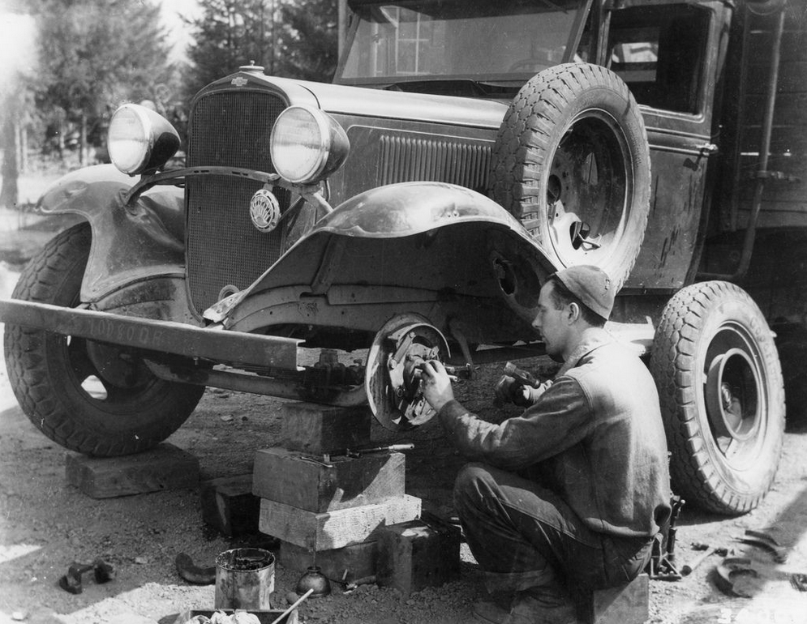

Vehicle’s mechanic.