USSR Battle Set: order “Red Star” #675160, medal “for Bravery” #286668, medal “for Combat Merit” #412946, medal “for Bravery” without number, medal “for Victory over Germany” with documents.

order “Red Star” #675160.

Medal “for Bravery” #286668 is an early variation on quadro suspension device, medal - thin, screw made from bronze, diameter of medal "ear" 5,5-6,25 mm. Medals of this type can be found in range of numbers from 155066 - 490828. (T1,V4). After decree from June 19, 1943 changed way of wearing medal, quadro suspension device changed into pentagonal suspension device, so some chevaliers them changed manually.

Medal “for Combat Merit” #412946 is an early variant for wearing for quadro suspension device and stamped number, medal thin ~2.2 mm. Can be found in range of numbers 225067 - 480345 (T1,V3). After decree from June 19, 1943 changed way of wearing medal, quadro suspension device changed into pentagonal suspension device, so some chevaliers them changed manually.

Awarded to:

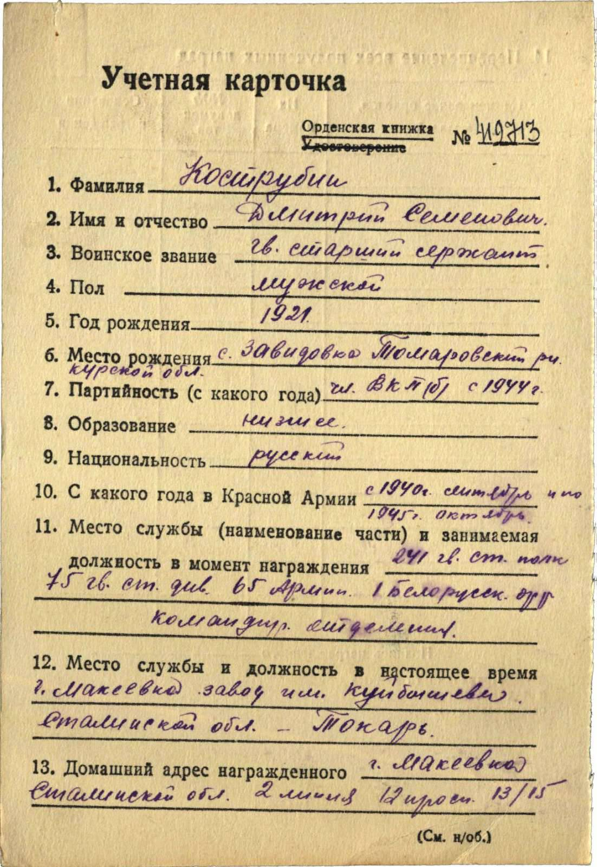

Kostrubin Dmitriy Semenovich (Кострубин Дмитрий Семенович) – guard’s senior sergeant, male, birth in 1921, member of CPSU since 1944, primary education, Russian, served in Red Army from September 1940 to October 1945.

Was awarded by:

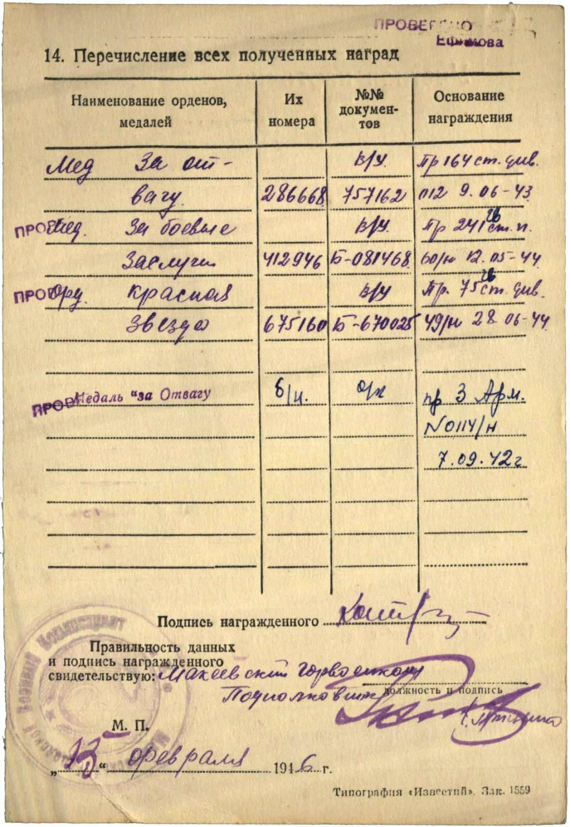

Medal “for Bravery” #286668

Medal “for Combat Merit” #412946

Order “Red Star” #675160

Medal “for Bravery” without number

Medal “for Bravery” without number awarded for:

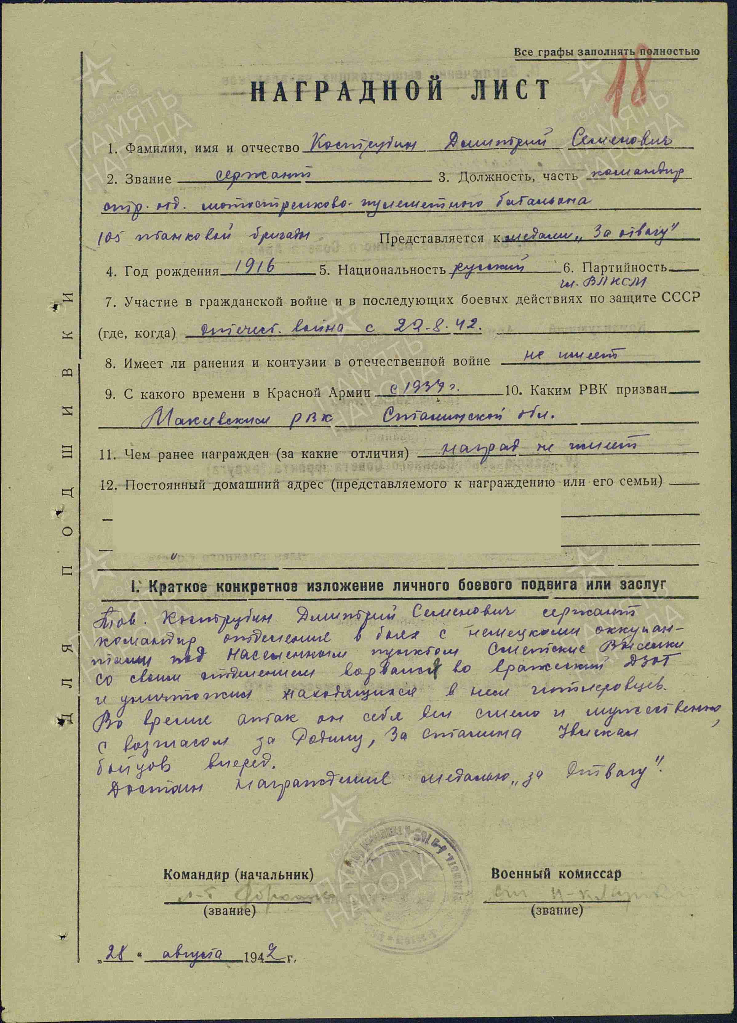

Kostrubin Dmitriy Semenovich – senior sergeant, commander of squad of separate training rifle company of 164 rifle division.

Kostrubin in combats with German’s invaders near settlement Smetskie Veselki with his squad burst into enemy’s pillbox and killed located there Germans.

During attacks he led bravely and courageously, with screaming “for Motherland, for Stalin” called soldiers into attack.

Deserves awarding by medal “for Bravery”.

“28” august 1942.

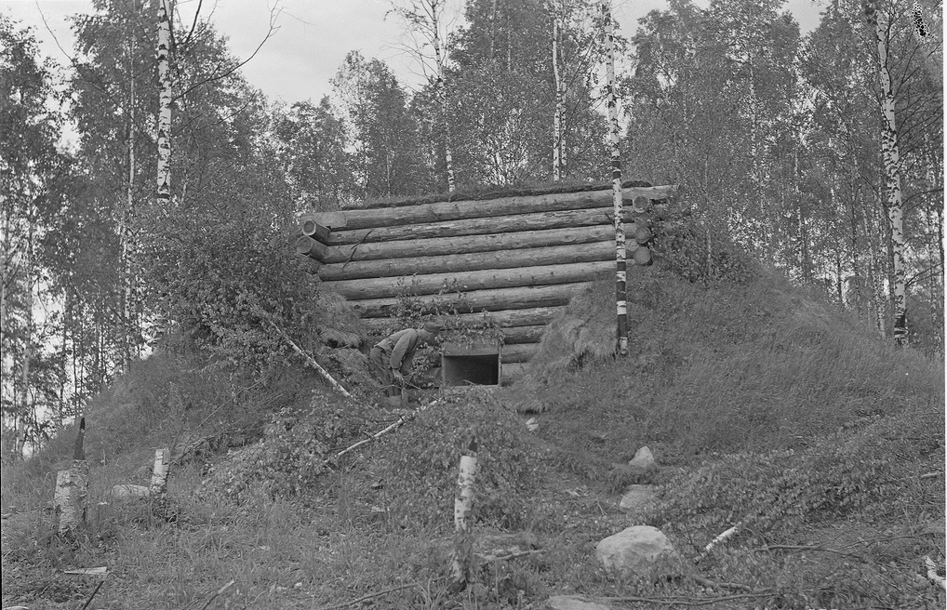

Pillbox

Medal “for Bravery” #286668 awarded for:

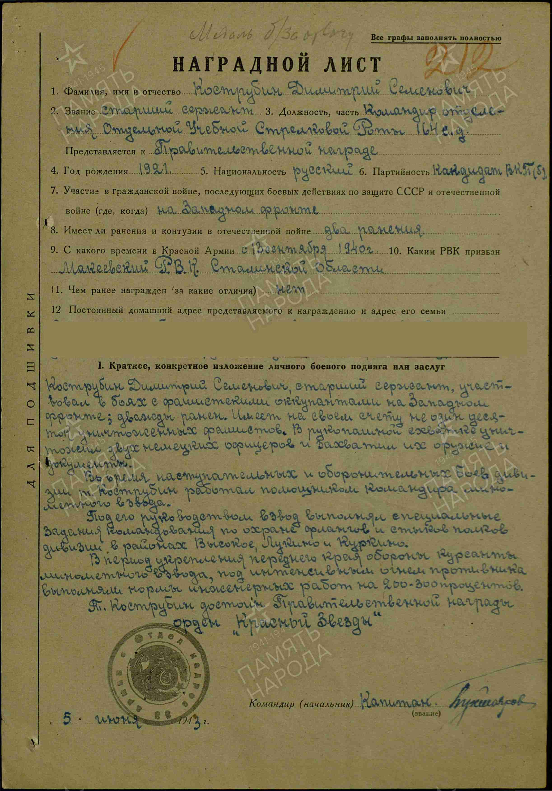

Kostrubin Dmitriy Semenovich – senior sergeant, commander of department of separate training rifle company of 164 rifle division.

Kostrubin Dmitriy Semenovich participated in combats with Germans invaders on Western Front and 2 times was wounded. On his count not single dozen of killed Germans. In close-range combat he killed 2 German officers and captured their weapons and documents.

During offensive and defensive combats of division Kostrubin worked as commander’s helper of mortar platoon.

Under his management platoon performed special task of command on protection of battlefield’s sides and joints between regiments of division in regions of Vysokoe, Lukino and Kurkino.

During strengthening of front line cadets of mortar platoon under heavy enemy’s fire performed norms on engineering works on 200-300%.

Kostrubin deserves Governmental award order “Red Star”.

Captain Puksharkov.

5 june 1943.

Medal “for Combat Merit” #412946 awarded for:

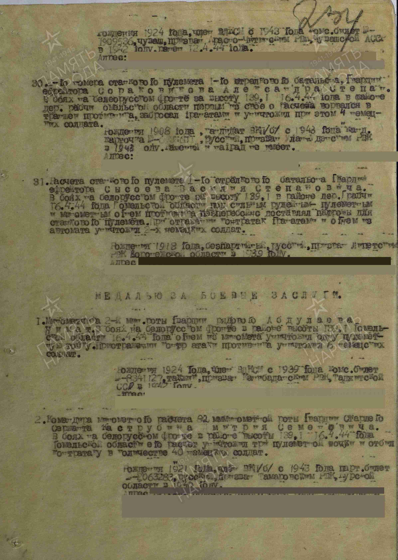

2. Commander of mortar crew of 82 mortar company Guard’s senior sergeant Kastrubin Dmitriy Sememovich. In combats on Belarusian front in region of altitude 139,1 in April 16, 1944 in Gomel region his calculation destroyed 3 machine-gun fire points and reflected counterattack of 40 German soldiers.

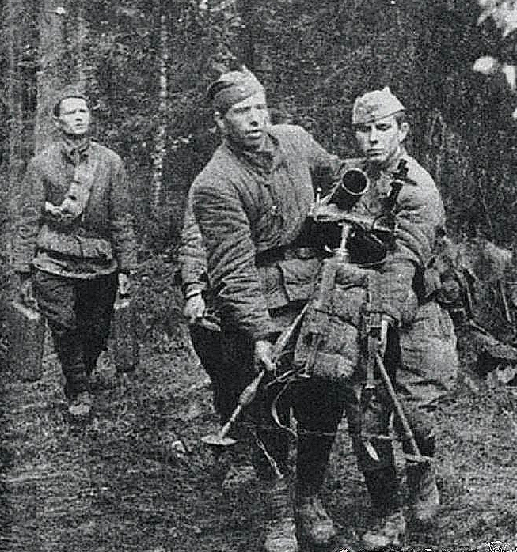

Mortar crew.

Order “Red Star” #675160 awarded for:

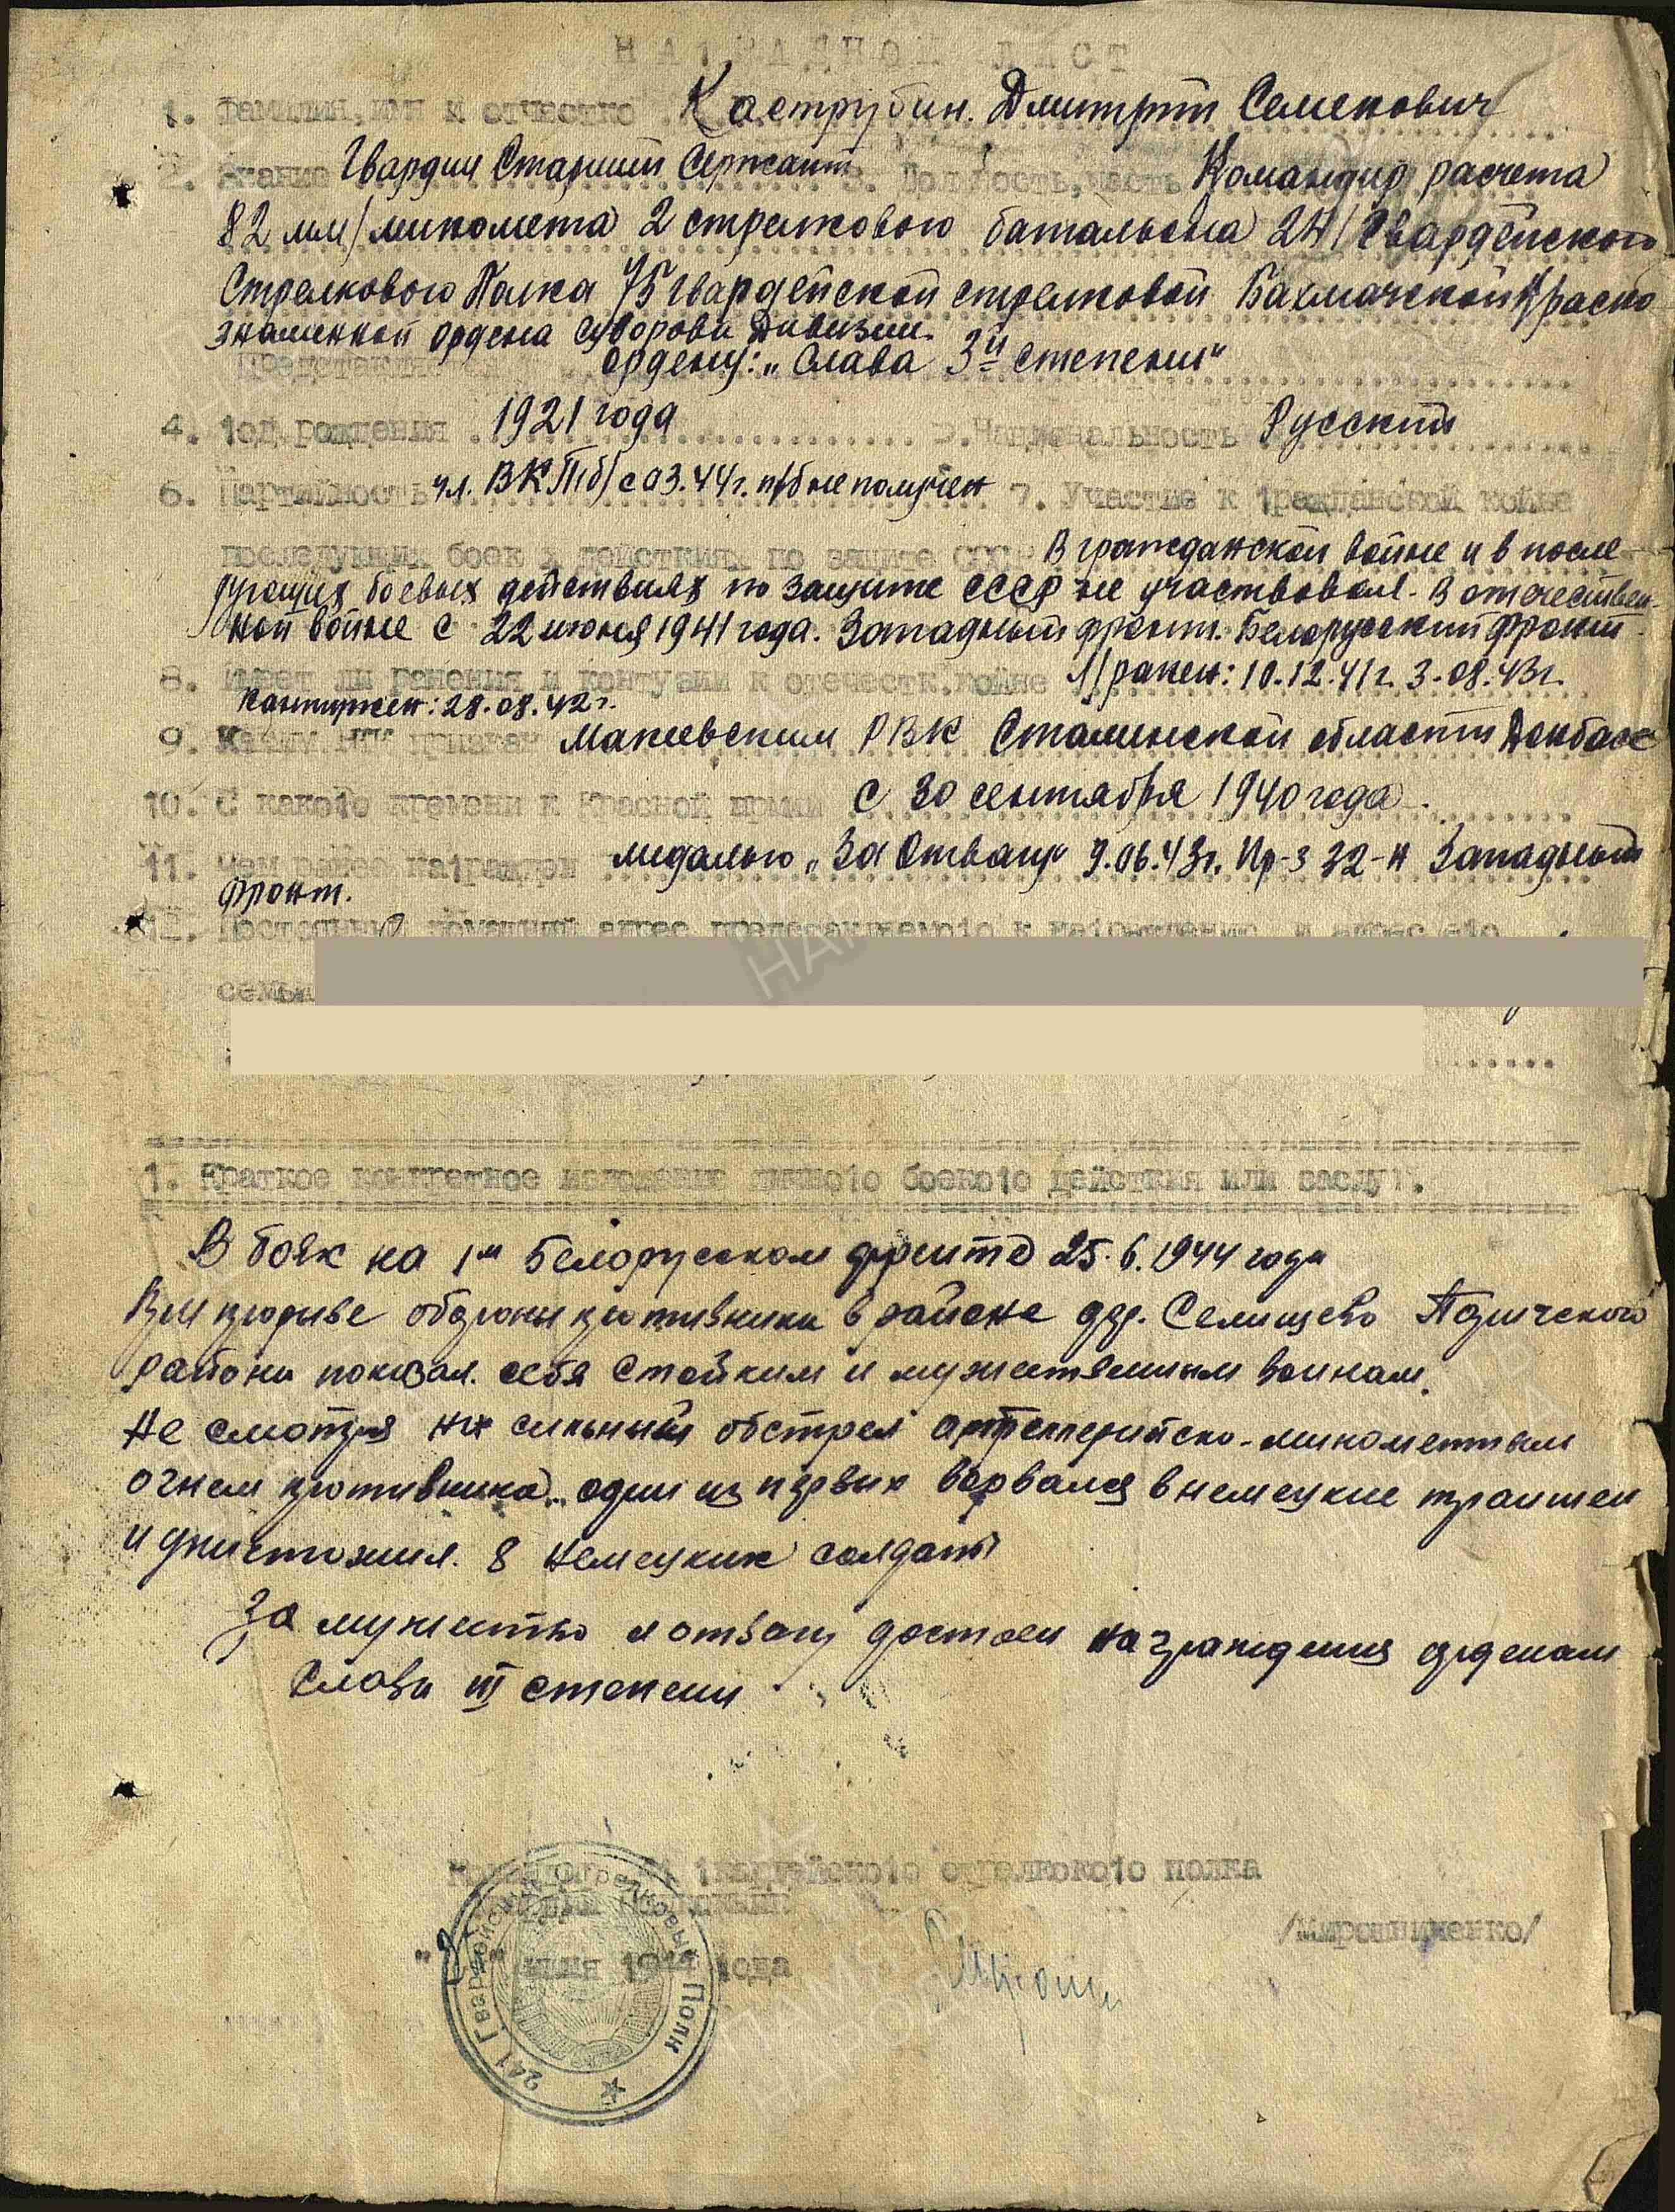

Kostrubin Dmitriy Semenovich – guard’s senior sergeant, commander of crew of 82mm mortar of 2nd rifle battalion of 241 guard’s rifle regiment of 75 guard’s rifle Bahmach Red Banner order of Suvorov division.

In combats on 1st Belarusian front in June 25, 1944 during breaking enemy’s defense in region of village Selischevo showed himself as steadfast and courageous soldier.

Despite on heavy artillery-mortar enemy’s fire he among first burst into enemy’s trenches and killed 8 German soldiers.

For bravery and courage deserves awarding by order “Glory” 3rd Class”.

Commander of 241 guard’s rifle regiment

Guard’s colonel /Miroshnichenko/

“9” June 1944.

But higher award commission after reading his feat decided award him by higher grade award – order “Red Star”.