USSR Order “Red Star” #2640310 with documents. Also presented red army book.

Awarded to:

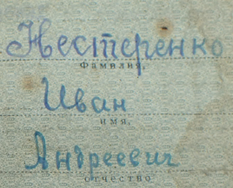

Nesterenko Ivan Andreevich

(Нестеренко Иван Андреевич)

Order “Red Star” #2640310 awarded for:

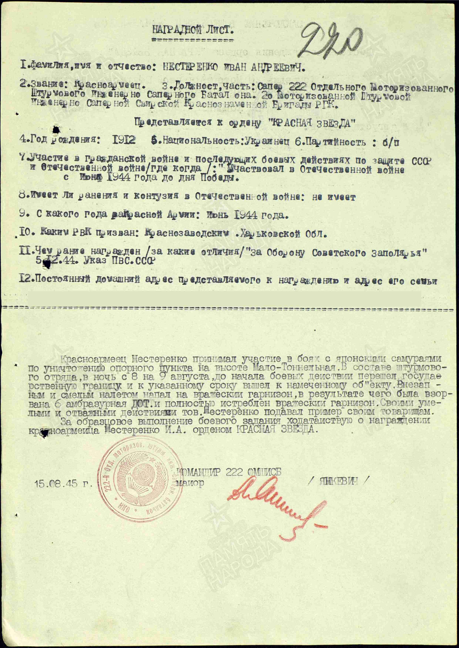

NESTERENKO IVAN ANDREEVICH – red army soldier, sapper of 222 separated motorized-rifle assault engineering sapper battalion of 26 motorized assault of engineering-sapper Siberian Red banner Brigade of Reserve of Main Command.

Nesterenko took an active role in combat against the Japanese invaders during the assault on the defensive position at High Malo-Tonnelnaya. As part of the attacking group, he crossed the state border during the night of August 8 to 9, reaching the target on time before the operation began. Launching a sudden and unexpected strike, he attacked the enemy garrison, resulting in the destruction of six pillbox embrasures and the elimination of all enemy soldiers. His bold and courageous actions served as an example to his comrades.

For excellent performing of combat task asking about awarding by red army soldier Nesterenko by order RED STAR.

COMMANDER OF 222 SEPARATED MOTORIZED-RIFLE ASSAULT ENGINEERING SAPPER BATTALION

Major / YANKEVICH /

15.08.1945.

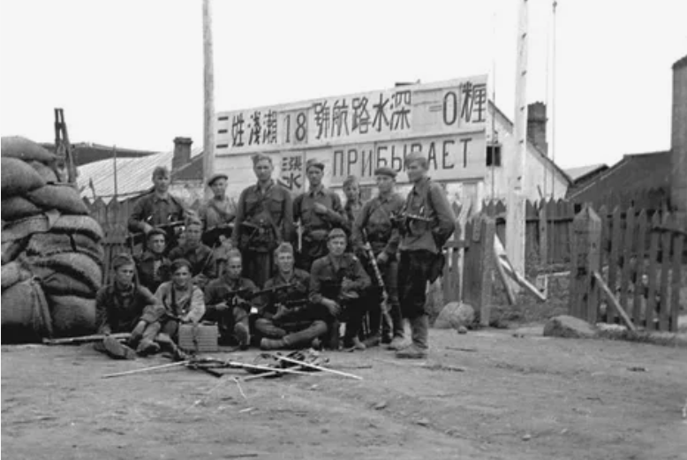

Soviet troops in Eastern Campaign 1945.