USSR Order “Red Star” #339396 with research.

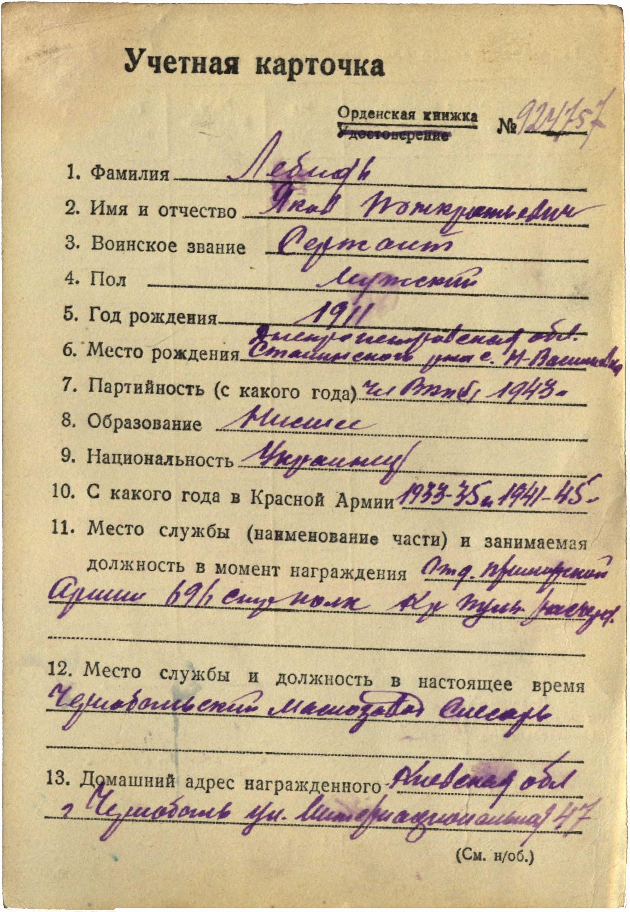 This order belong to suspended variant called "round shape". Produced on Krasnokamsk Mint, with stamp applied in one row, word "МОНЕТНЫЙ" slightly smaller than "ДВОР" and slightly curved upwards. Can be found in range of numbers 84000 - 125000 (T3,V2,R1).

Lebid Yakov Ponkratievich (Лебидь Яков Понкратьевич) – sergeant, male, birth in 1911, member of CPSU since 1948, lower education, Ukrainian, served in Red Army from 1933 to 1935 and 1941 to 1945.

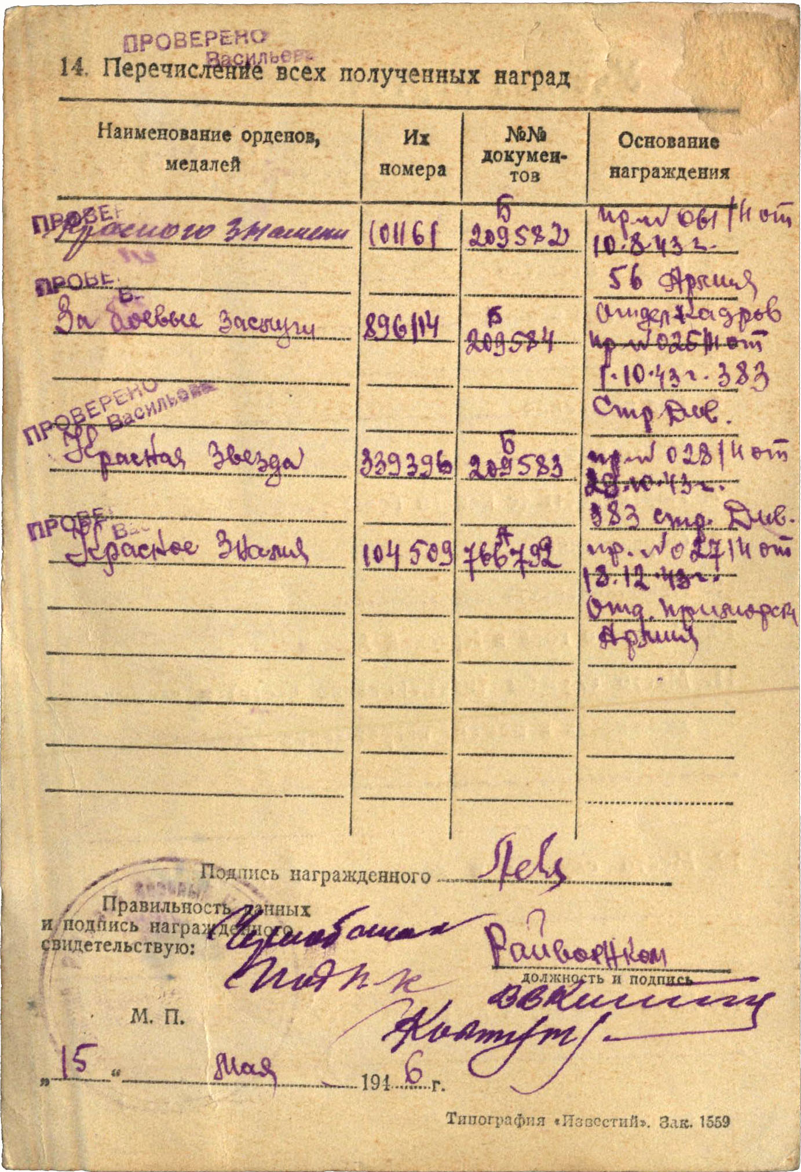Was awarded by:

Order “Red Banner” #101161

Medal “for Military Merit” #896114

Order “Red Star” #339396

Order “Red Banner” #104509

Order “Red Star” #339396 awarded for:

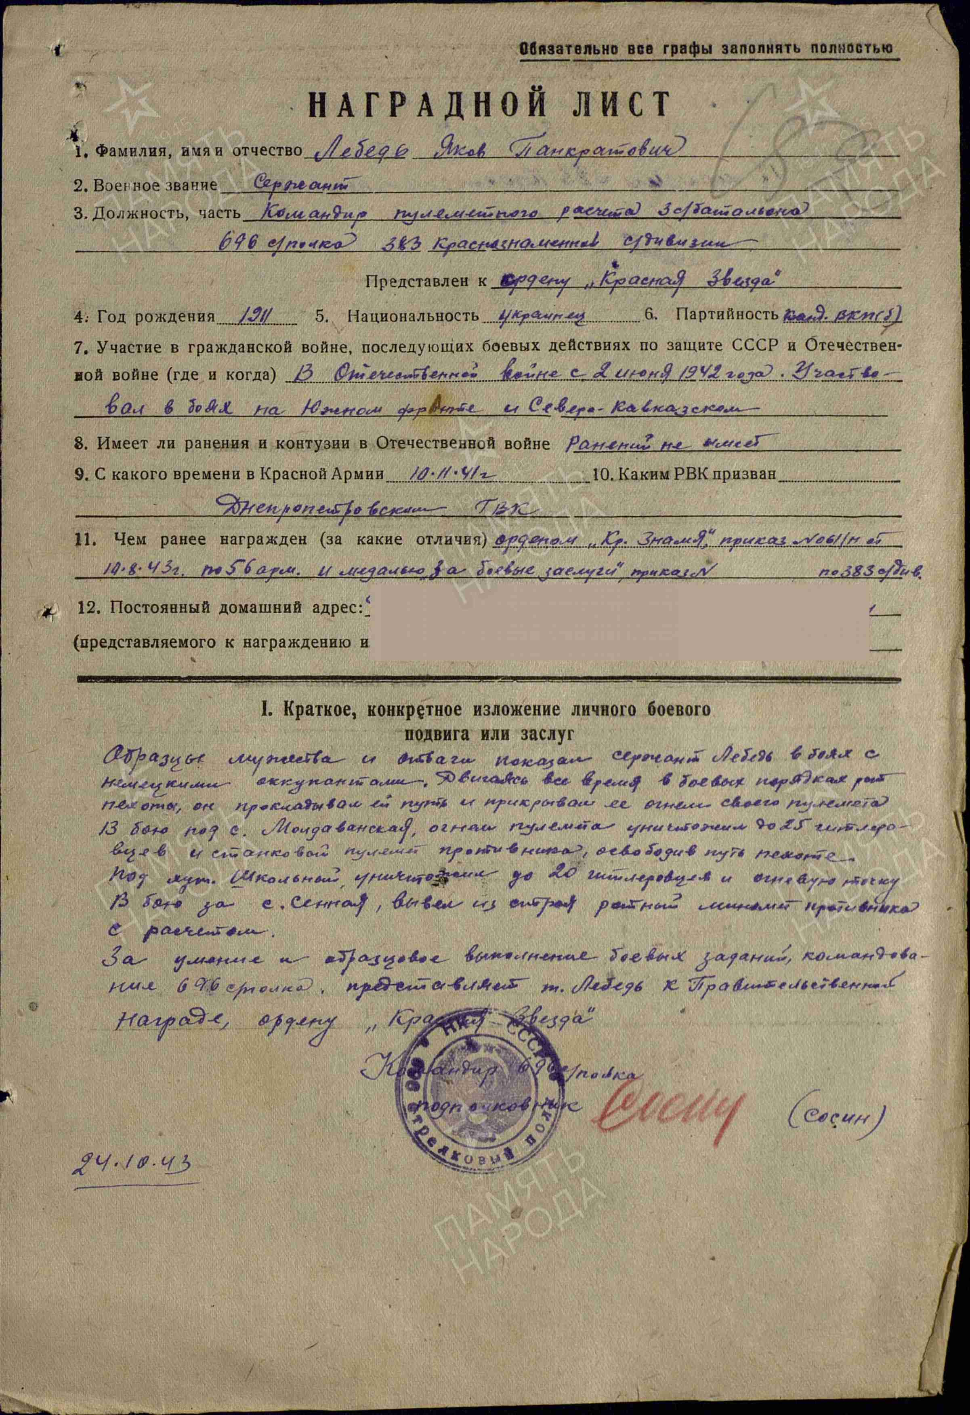

Lebid Yakov Ponkratievich – sergeant, commander of machine-gun crew of 301 battalion of 696 rifle regiment of 383 red banner division.

Examples of bravery and courage were shown by Lebid in battles against the German invaders. Constantly moving with the infantry company’s combat formations, he cleared the way and provided cover with machine-gun fire. In the battle at the village of Moldavanskaya, he killed 25 German soldiers and destroyed a heavy machine gun with his fire. In the battle for the village of Sennaya, he damaged an enemy mortar and wounded its crew. For his skill and excellent execution of combat tasks assigned by the command of the 696th Rifle Regiment, Lebid is recommended for the Government award, the Order of the Red Star.

Commander of 696 rifle regiment

Lieutenant-colonel (Sosin).

October 24, 1943.

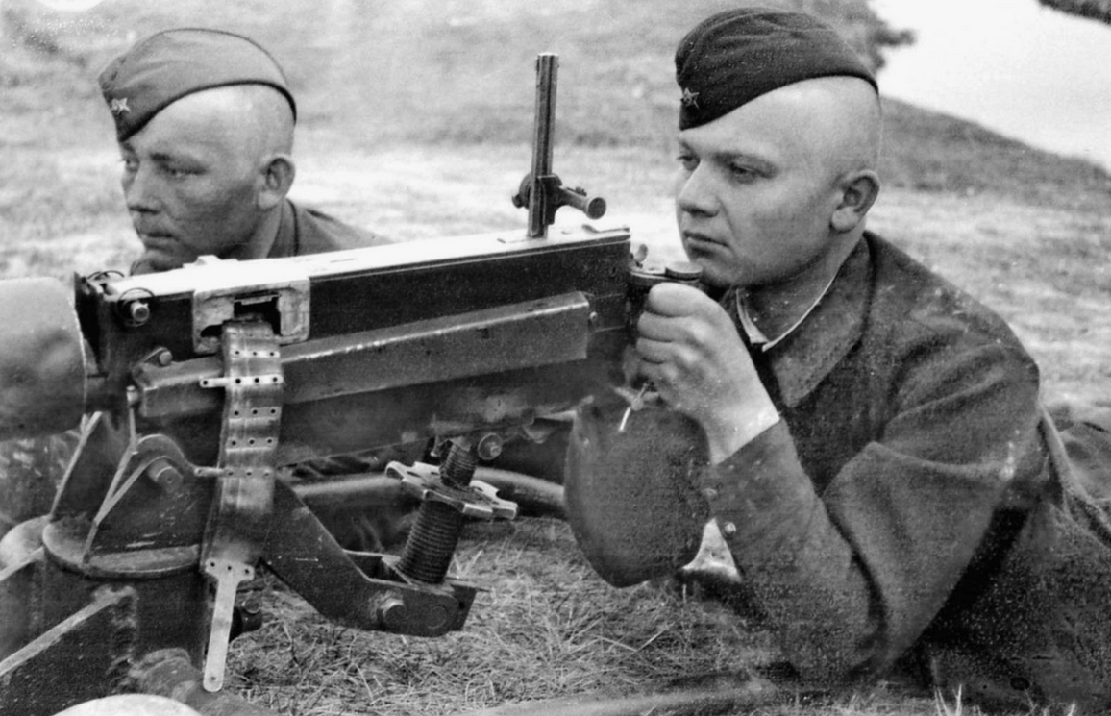

Machine-gunners.