USSR Battle Set: order “Red Star” #1476283, medal “for Courage” #156354, medal “for Distinguished Labor” without number, medal “for Defense Leningrad”, medal “for Victory over Germany”, badge “50 Breaking of Leningrad blockade” with documents.

Awarded to:

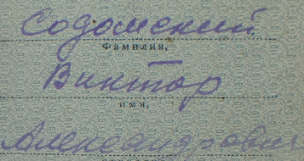

Sodomskiy Victor Aleksandrovich

Содомский Виктор Александрович

Medal “for Courage” #156354. Rare early variant on quadro suspension device and stamped number, medal thick ~2.9 - 3.0 mm. Can be found in range of numbers 50069 - 210563 (T1,V3). After decree from June 19, 1943 changed way of wearing medal, quadro suspension device changed into pentagonal suspension device, so some chevaliers them changed manually.

Medal “for Distinguished Labor” without number awarded in December 29, 1954.

Medal “for Victory over Germany” awarded in September 21, 1945. Document signed by Hero of Soviet Union, guard’s lieutenant-colonel Svitenko.

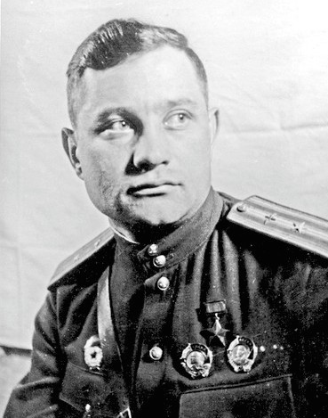

HSU – Svitenko Nikolay Ivanovich

Medal “for Defense Leningrad” awarded in October 3, 1943.

Medal “for Courage” #156354 awarded for:

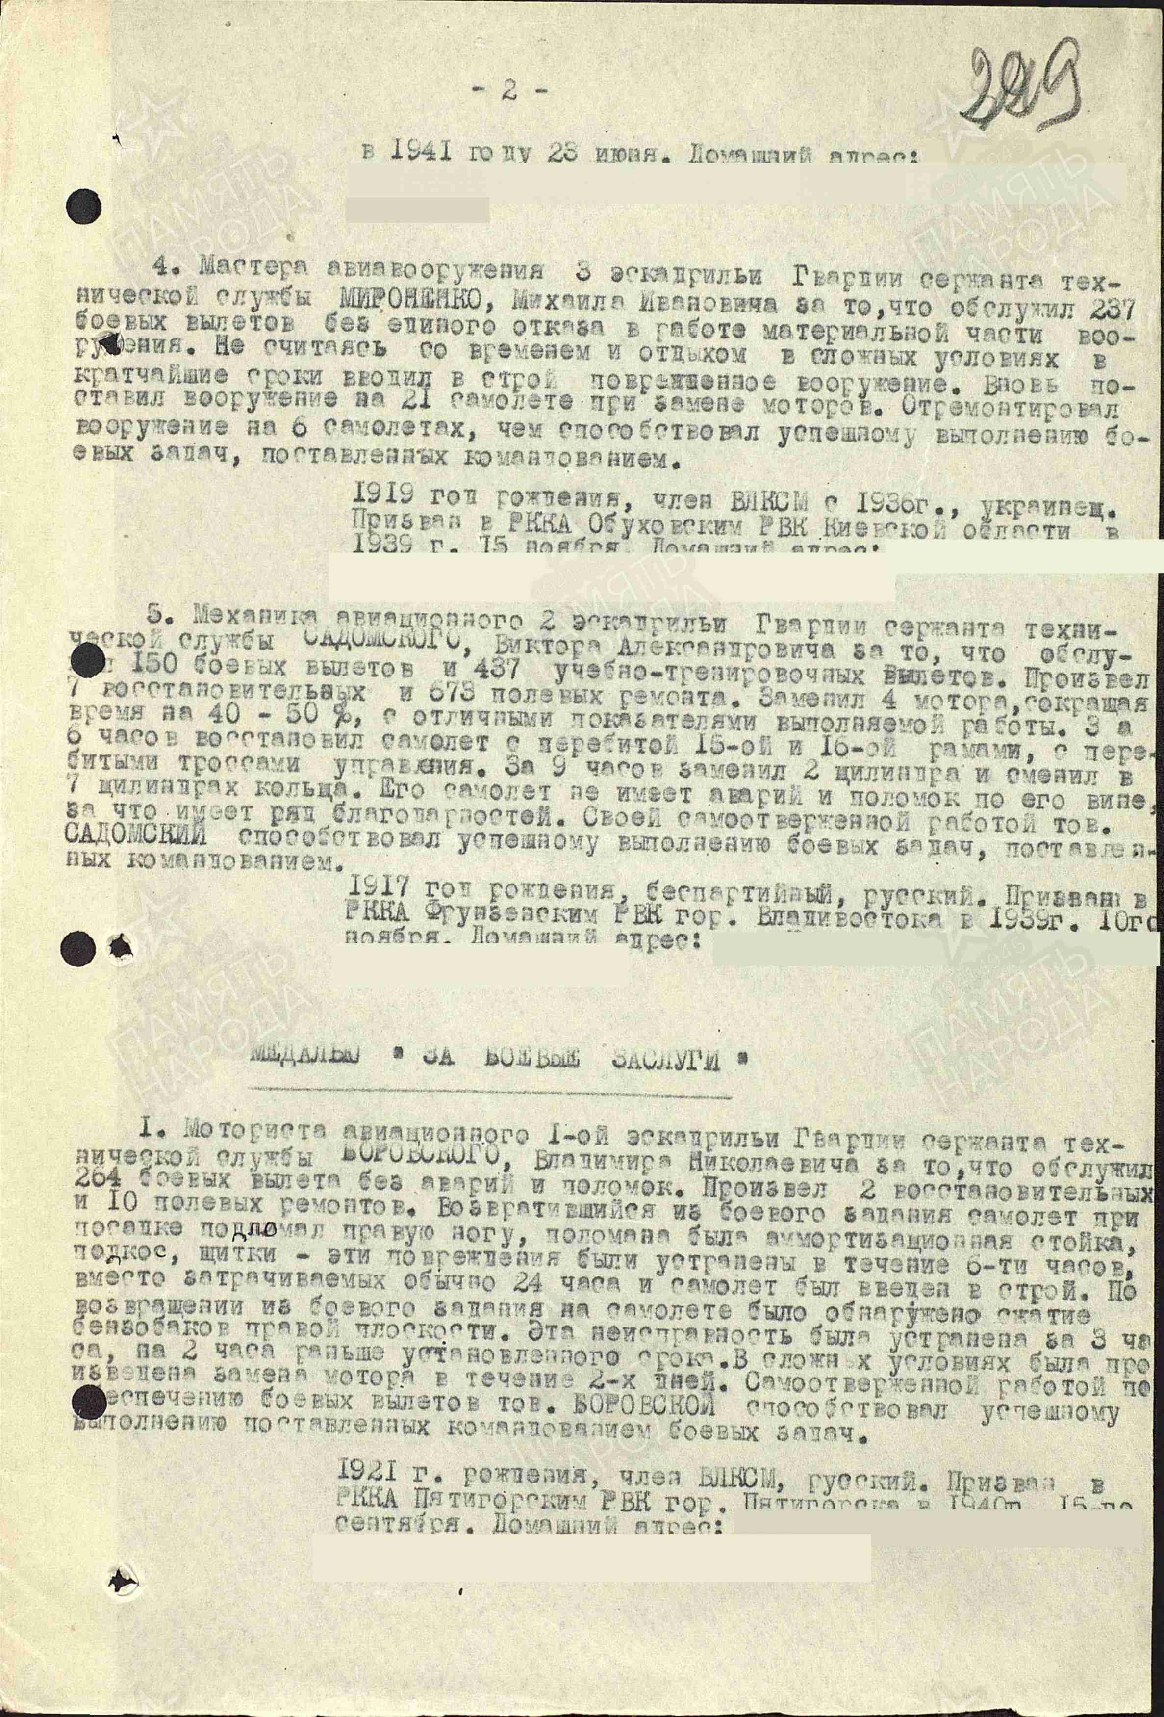

5. Aviation mechanic of 2nd squadron guard’s sergeant of technical service SODOMSKIY Victor Aleksandrovich for that, he serviced 150 combat flights and 437 training flights. Performed 7 restoring repairs and 673 field repairs. Changed 4 engines, performed repairs on 40-50% faster, with excellent indicators of performed work. For 6 hours restored plane with damaged 15 and 16 frames, with damaged control ropes. For 9 hours he changed 2 cylinders and changed 7 cylinder rings. His plane flies without accidents through his fault, for what he received several gratitudes. By his selflessness work SADOMIRSKIY contributed success performing of combat tasks, assigned by command.

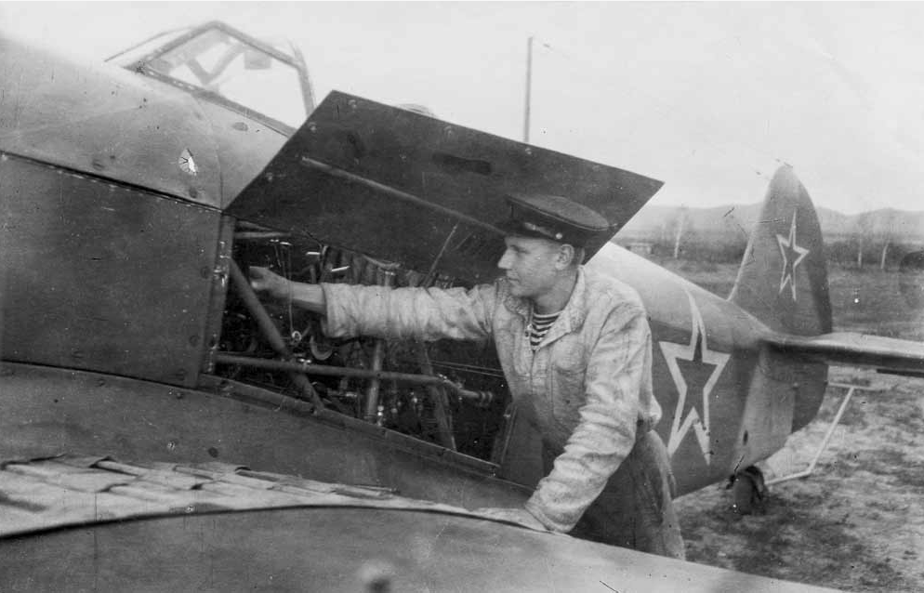

Aviation technic.

order “Red Star” #1476283 awarded for:

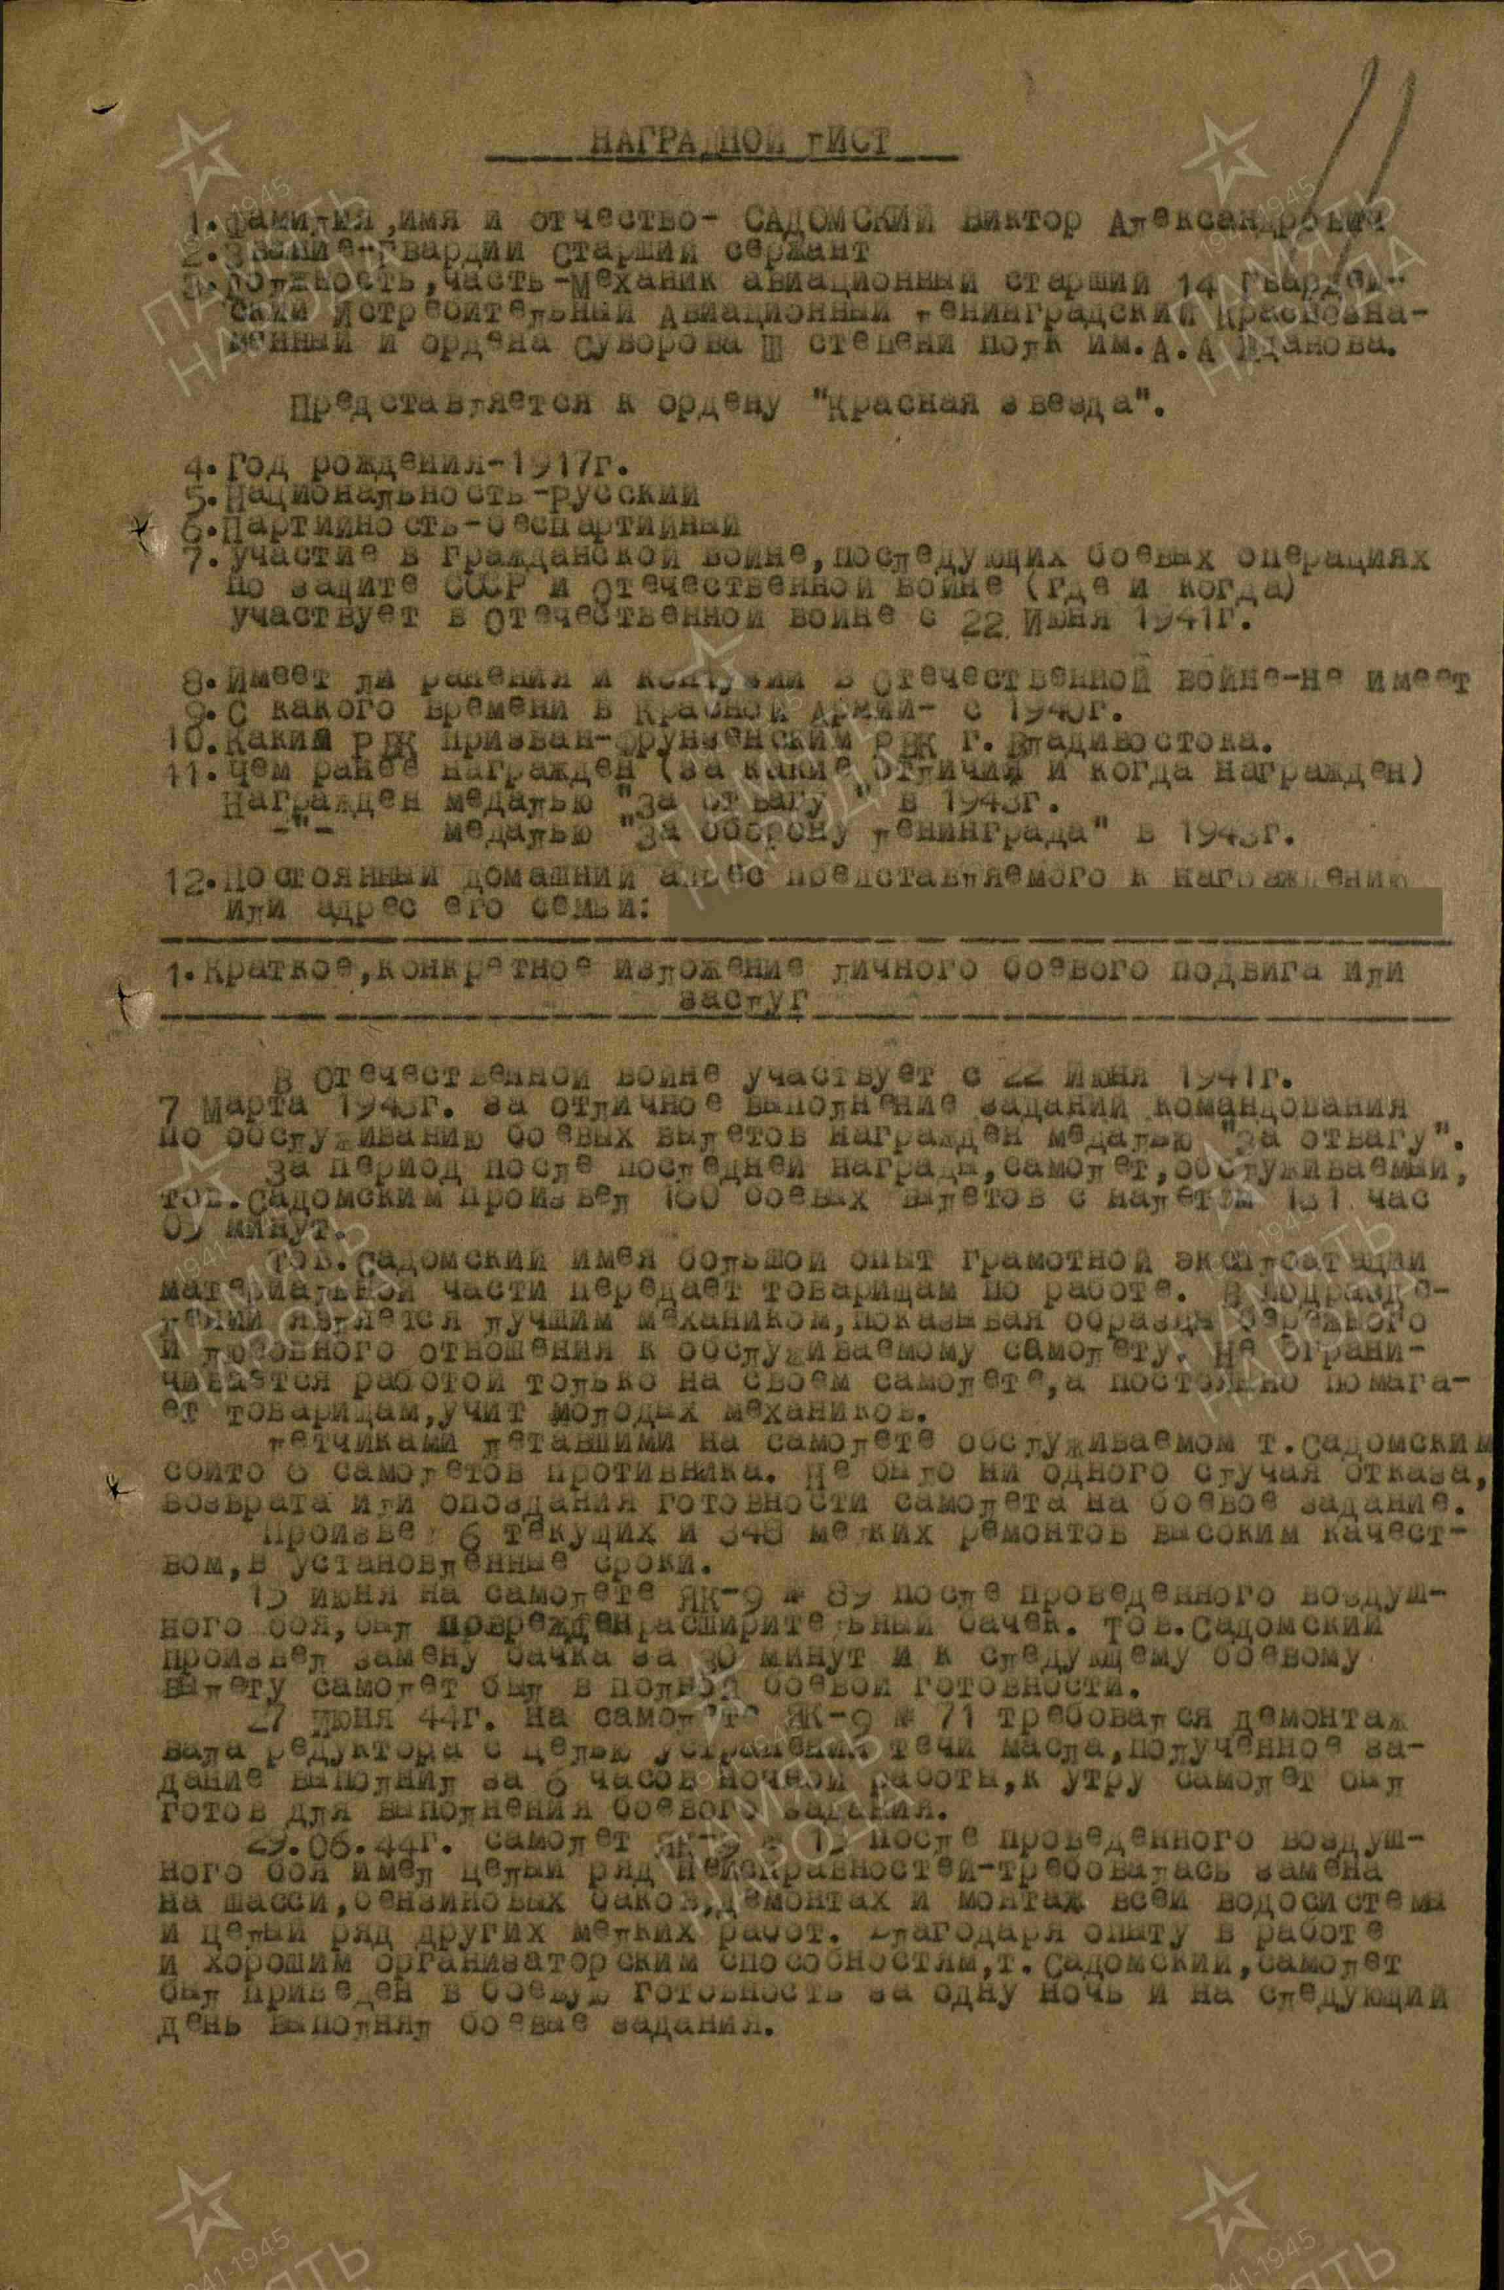

SODOMSKIY VICTOR ALEKSANDROVICH – guard’s senior sergeant, senior aviation mechanic of 14 Guard’s fighter aviation Leningrad Red Banner order of Suvorov 3rd Class regiment named after A. A. Zhdanov.

In WWII participated from June 22, 1941 to March 1943 for excellent performing of command’s tasks on servicing of combat flights awarded by medal “for Courage”.

After last awarding plane serviced by Sodomirskiy performed 160 combat flights with total 161 flight hours and 05 minutes.

Sodomirskiy has rich experience of using of equipment and shared with other mechanics. He was best mechanic into unit, showing examples of caring of servicing plane. He work not only with his plane, also help to other and teach young mechanics.

Pilots, that flying on servicing by Sodomirskiy plane shot down 6 enemy planes. There is no single case of breaking or late for combat mission.

Performed 6 current and 348 small repairs with excellent quality and timely.

In June 15 on plane YAK-9 #89 after air combat was damaged expansion tank. Sodomirskiy changed it for half hour and to next flight plane was in full combat readiness.

In June 27, 1944 plane YAK-9 #71 needed dismantling gearbox with chain, eliminating oil leak, received task he performed during night for 6 hours, at morning plane was ready perform combat tasks.

In June 29, 1944 plane YAK-9 #15 after air combat received row of damages: chassis needed to be replaced, petrol tanks needed to be replaced, water system needed to be dismantled and installed, and a whole range of other minor jobs needed to be done. Through rich experience in work and excellent management skills Sodomirskiy repaired plane during one night and on next morning it perform combat tasks.

During breaking Leningrad blockade and expulsion of Germans from Estonia without rest he spent all forces and knowledges on performing of combat tasks on servicing of combat flights and improved his knowledge.

For excellent performing of combat tasks of command on servicing of combat flights, for courage and bravery, showed in work, submit and ask about awarding Sodomirskiy by order “Red Star”.

COMMANDER OF 14 GUARD’S FIGHTER

AVIATION LENINGRAD RED BANNER ORDER OF

SUVOROV 3RD CLASS REGIMENT

NAMED AFTER A. A. ZHDANOV.

HERO OF SOVIET UNION GUARD’S LIEUTENANT-COLONEL

/ SVITENKO /

“25”may 1945.

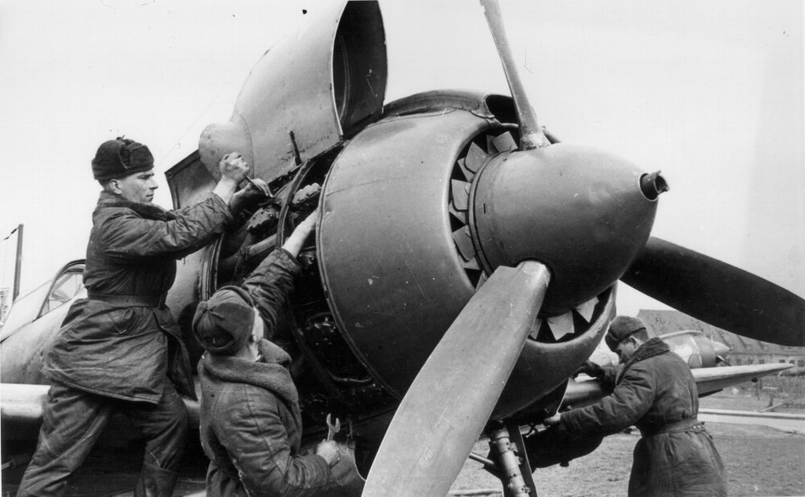

Repairing of plane.