USSR Battle Set: order “Red Star” #231898, order “Red Star” #3370423, order “Red Star” #3543281 with document.

Order “Red Star” #231898is rare early variation called "heel", because has rounded platform near screw's base. With native silver screw-nut.

Presented certification of veteran of Armed service:

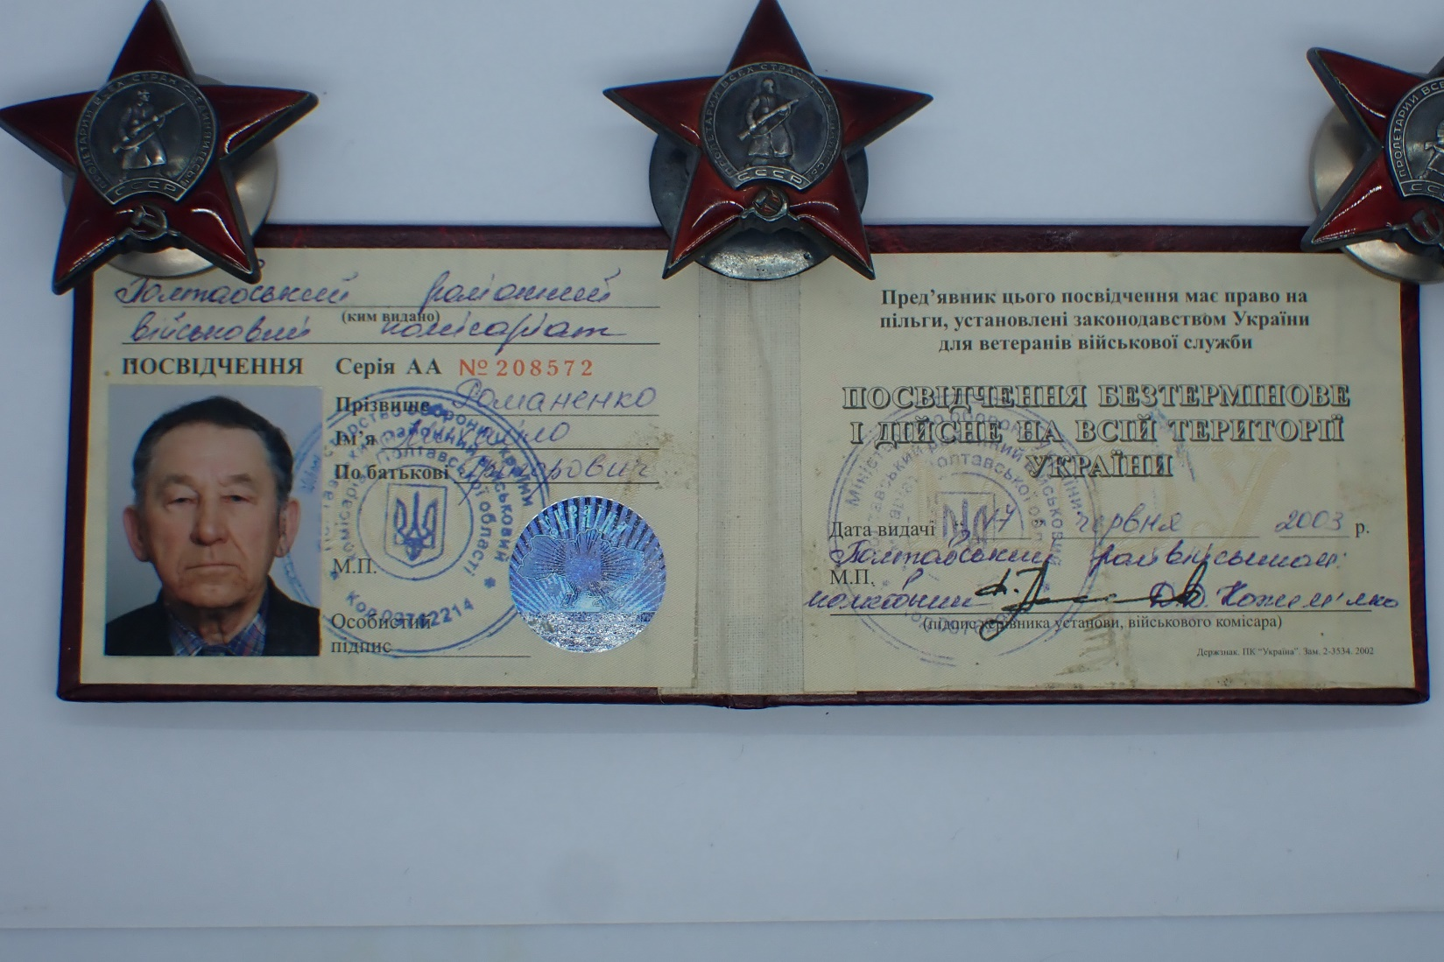

Awarded in June 17, 2003.

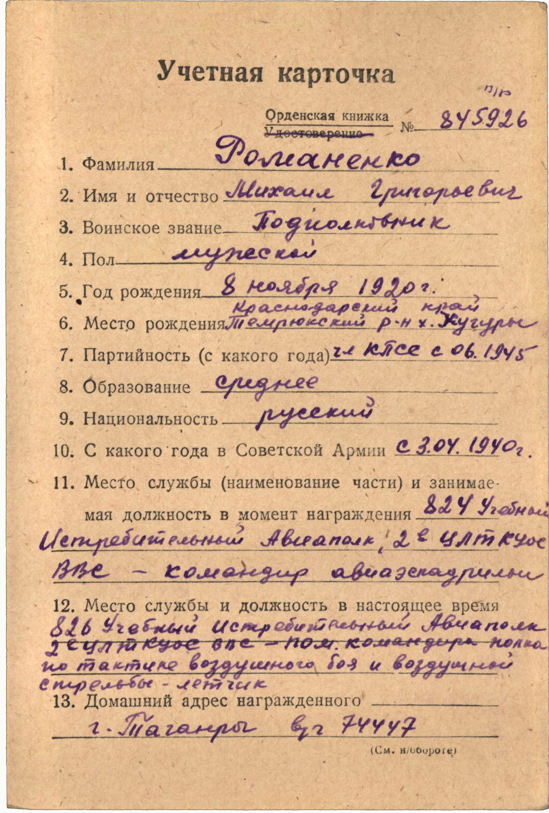

Romanenko Mikhail Grigorievich (Романенко Михаил Григорьевич) – lieutenant-colonel, male, birth in November 8, 1920, member of CPSU from June 1945, primary education, Russian, served in Red Army from April 3, 1940.

Was awarded by:

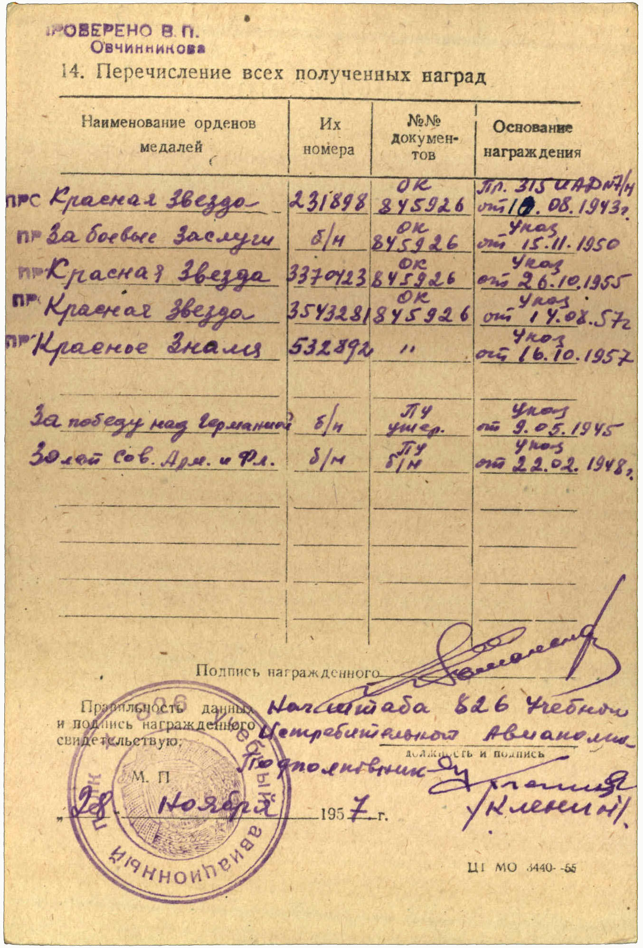

Order “Red Star” #231898

Medal “for Military Merit” wn

Order “Red Star” #3370423

Order “Red Star” #3543281

Order “Red Banner” #532892

Medal “for Victory over Germany”

Medal “30 Years of Soviet Army and Fleet”

Order “Red Star” #231898 awarded for:

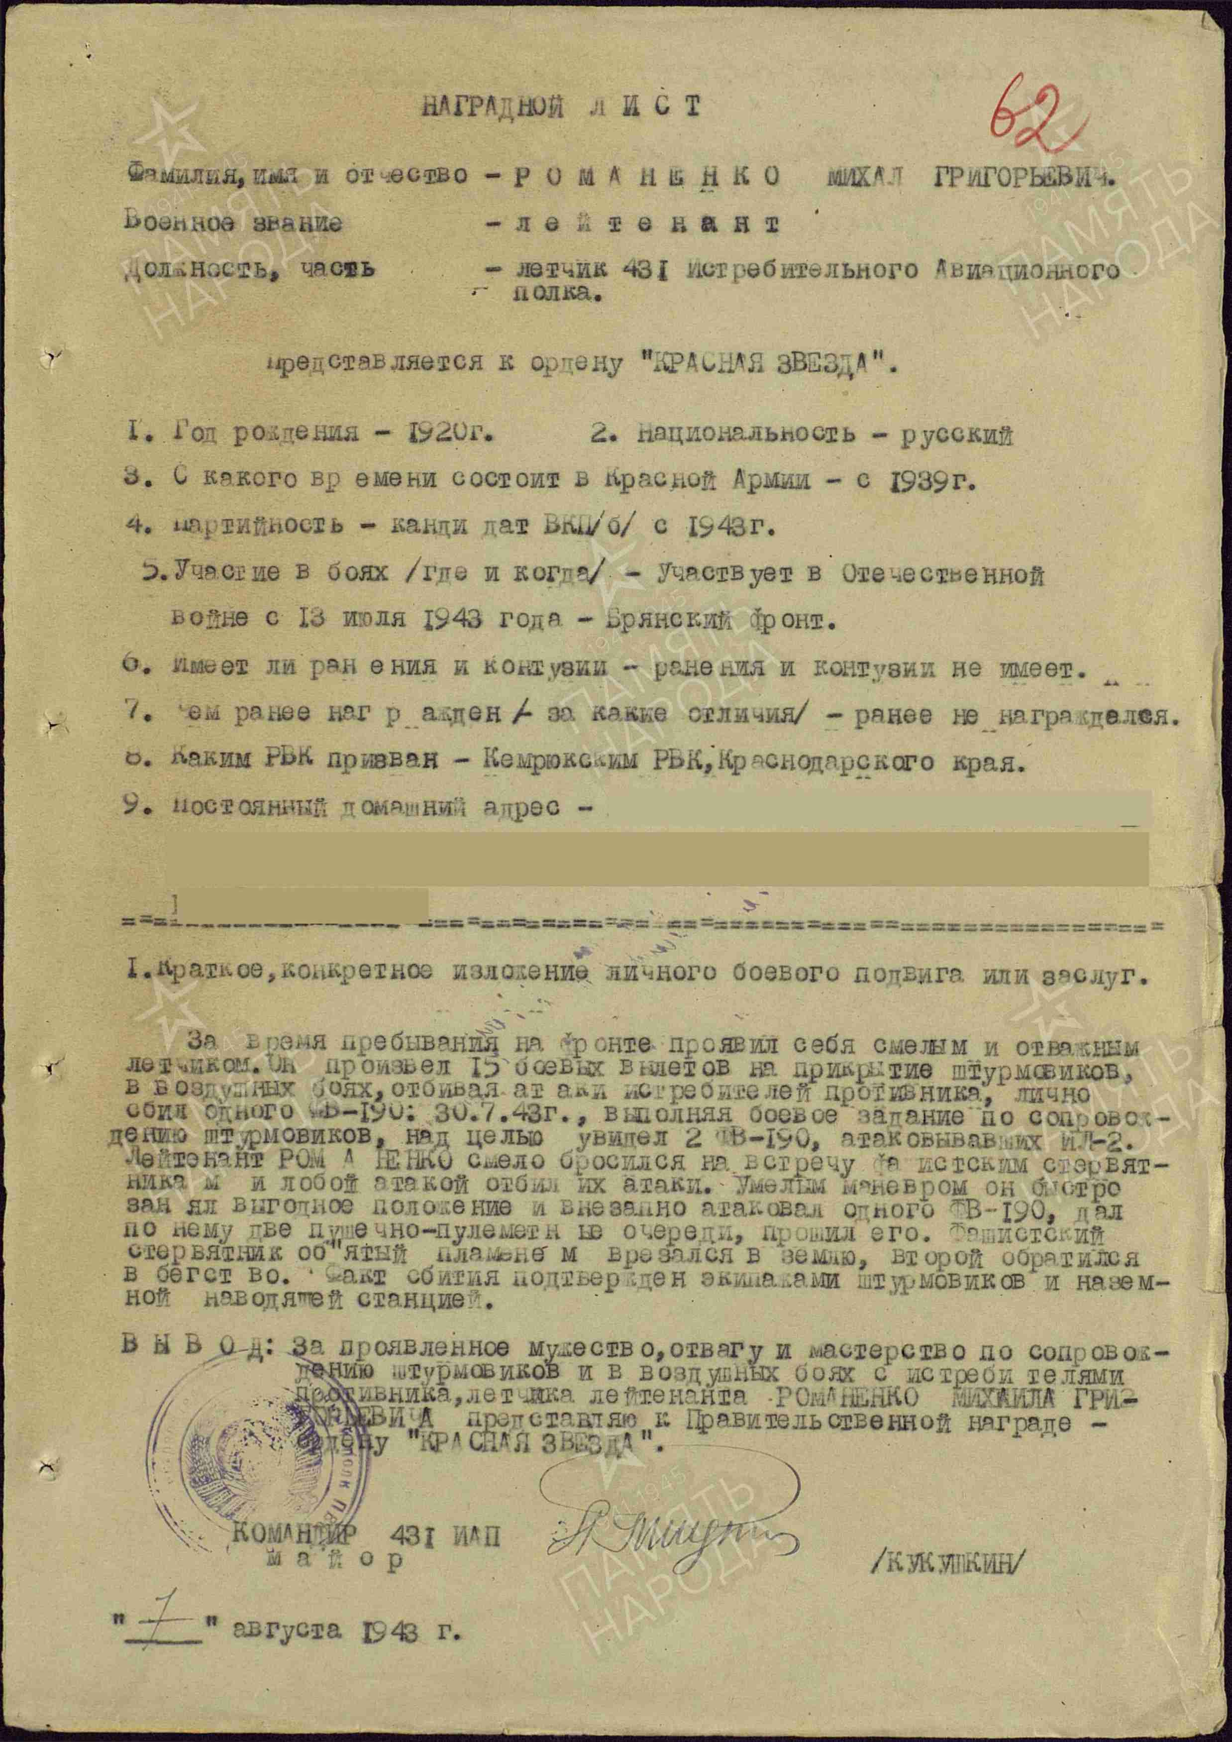

ROMANENKO MIKHAIL GRIGORIEVICH – lieutenant, pilot of 431 fighter aviation regiment.

During the war, he proved himself to be a brave and courageous pilot. He completed 15 combat missions escorting attack aircraft, repelling all enemy fighter attacks during air battles, and personally shot down one FW-190 on July 30, 1943. While carrying out a mission to escort attack planes, he spotted two FW-190s attacking one of our IL-2 aircraft.

ROMANENKO immediately launched an attack and repelled the enemy. With skillful maneuvering, he quickly gained an advantageous position and launched a sudden assault on one FW-190, firing two cannon-machine-gun bursts and damaging it. The burning German plane crashed to the ground, while the second aircraft fled. The downing of the enemy plane was confirmed by the attack aircraft crews and ground control personnel.

Conclusion: For demonstrating bravery, courage, and skill in escort missions and air combat with enemy fighters, ROMANENKO was recommended for the government award—the Order of the Red Star.

COMMANDER OF 431 FIGHTER AVIATION REGIMENT

M a j o r /KUKUSHKIN/

“7” august 1943.

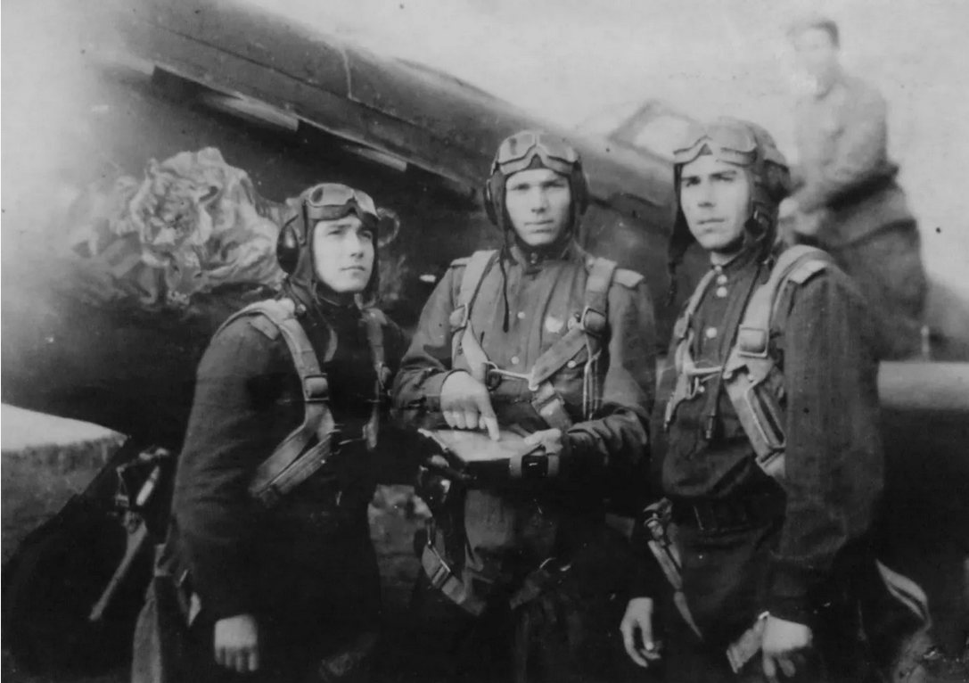

Soviet pilots.