USSR Battle Set: order “Glory” 3rd Class #207326, medal “for Courage” #3043053, medal “for Military Merit” #538168 with documents.

Awarded to:

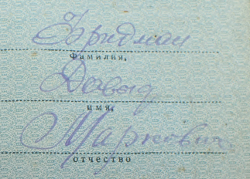

Fridman Davyd Markovich

(Фридман Давид Маркович)

Also presented Red Army book, certification of Veteran of WWII, pension certificate.

medal “for Military Merit” #538168 awarded for:

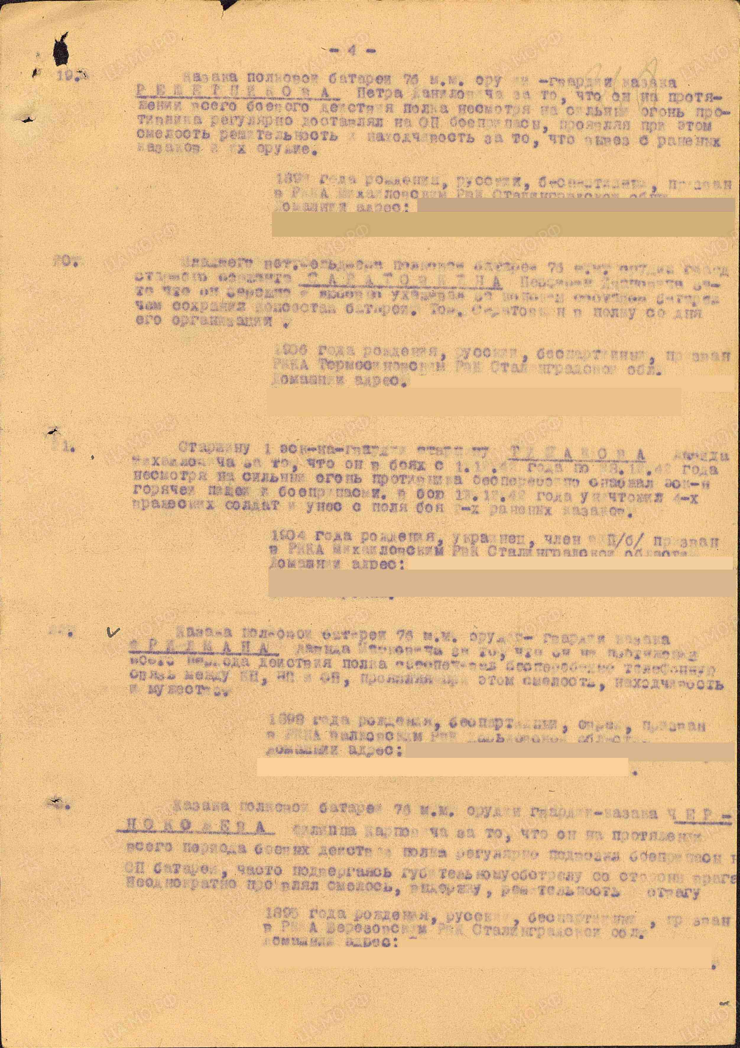

22. Cossack of the 76mm field battery – FRIDMAN Davyd Markovich, for consistently ensuring timely telephone communication between the Observation Post, Command Post, and Headquarters throughout the regiment's entire period of combat operations, displaying bravery, determination, and courage.

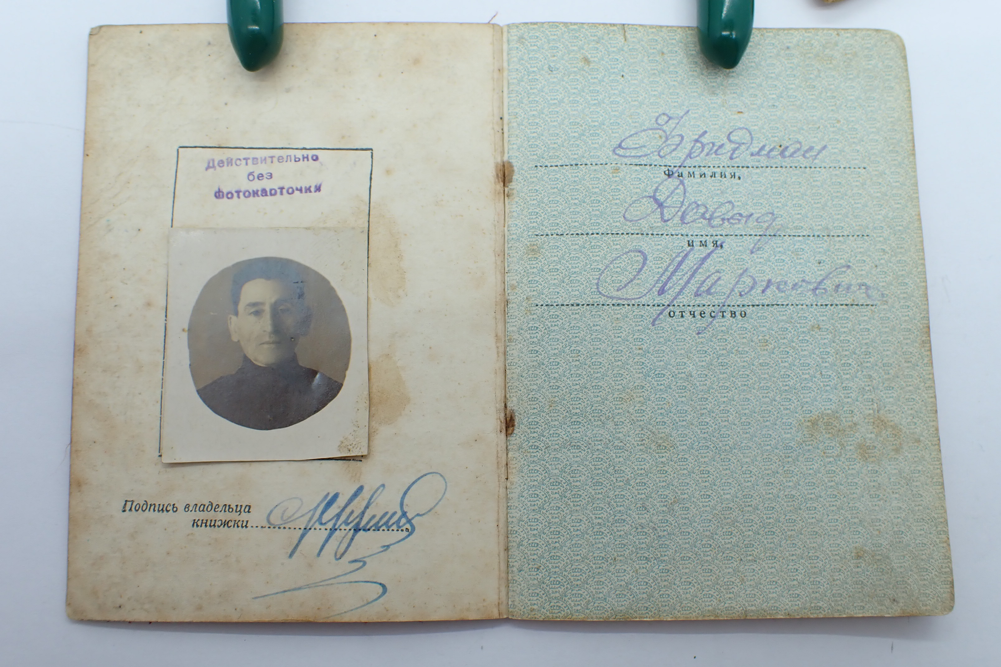

Fridman Davyd Markovich

order “Glory” 3rd Class #207326 awarded for:

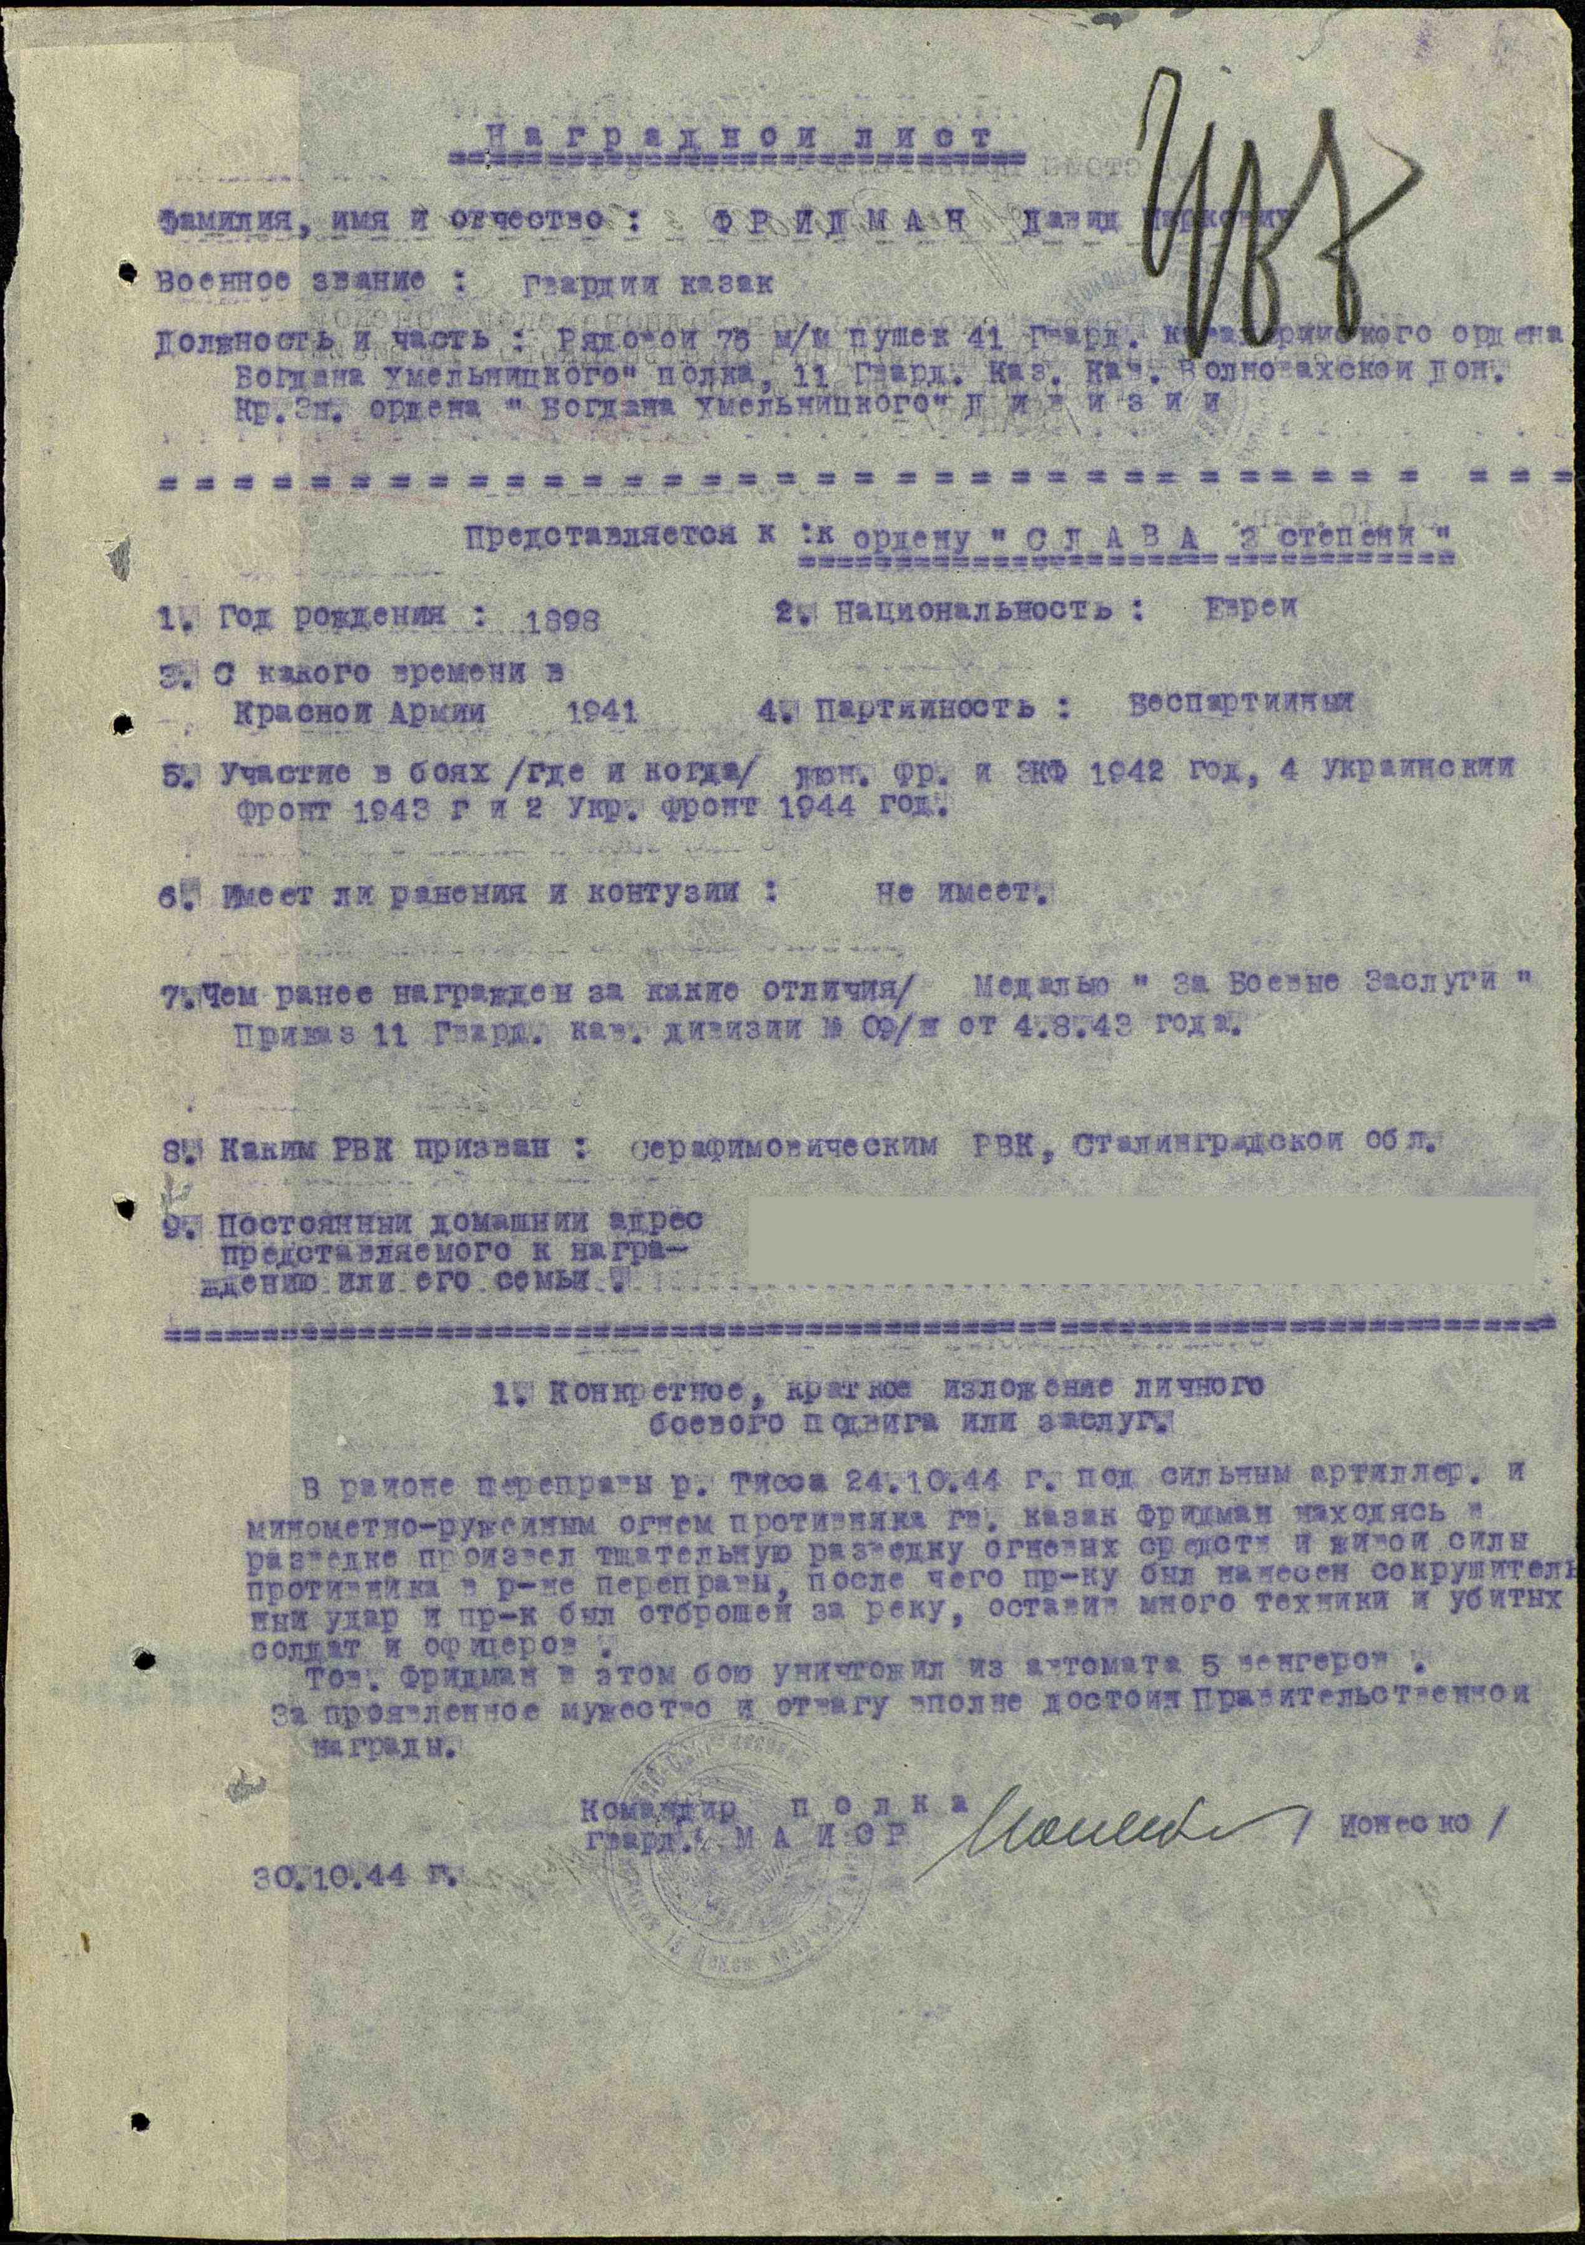

FRIDMAN Davyd Markovich – Guards Cossack, Jew, soldier of a 76mm gun in the 41st Guards Artillery Regiment, Order of Bohdan Khmelnytsky, part of the 11th Guards Cossack Cavalry Volhovatsky Don Red Banner and Order of Bohdan Khmelnytsky Division. On October 24, 1944, during the crossing of the Tisza River under intense enemy artillery, mortar, and rifle fire, Cossack Fridman carried out active reconnaissance of enemy fire positions and troop concentrations. His actions led to a heavy strike on the enemy, forcing them to retreat across the river, abandoning significant equipment and suffering heavy losses in killed soldiers and officers. In this battle, Fridman personally killed five Hungarian soldiers with a machine gun. For his bravery and courage, he deserves a government award.

Commander of regiment

Guard’s MAJOR /Ionesko/

30.10.1944

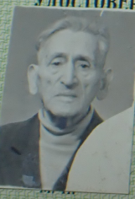

Fridman Davyd Markovich

medal “for Courage” #3043053 awarded for:

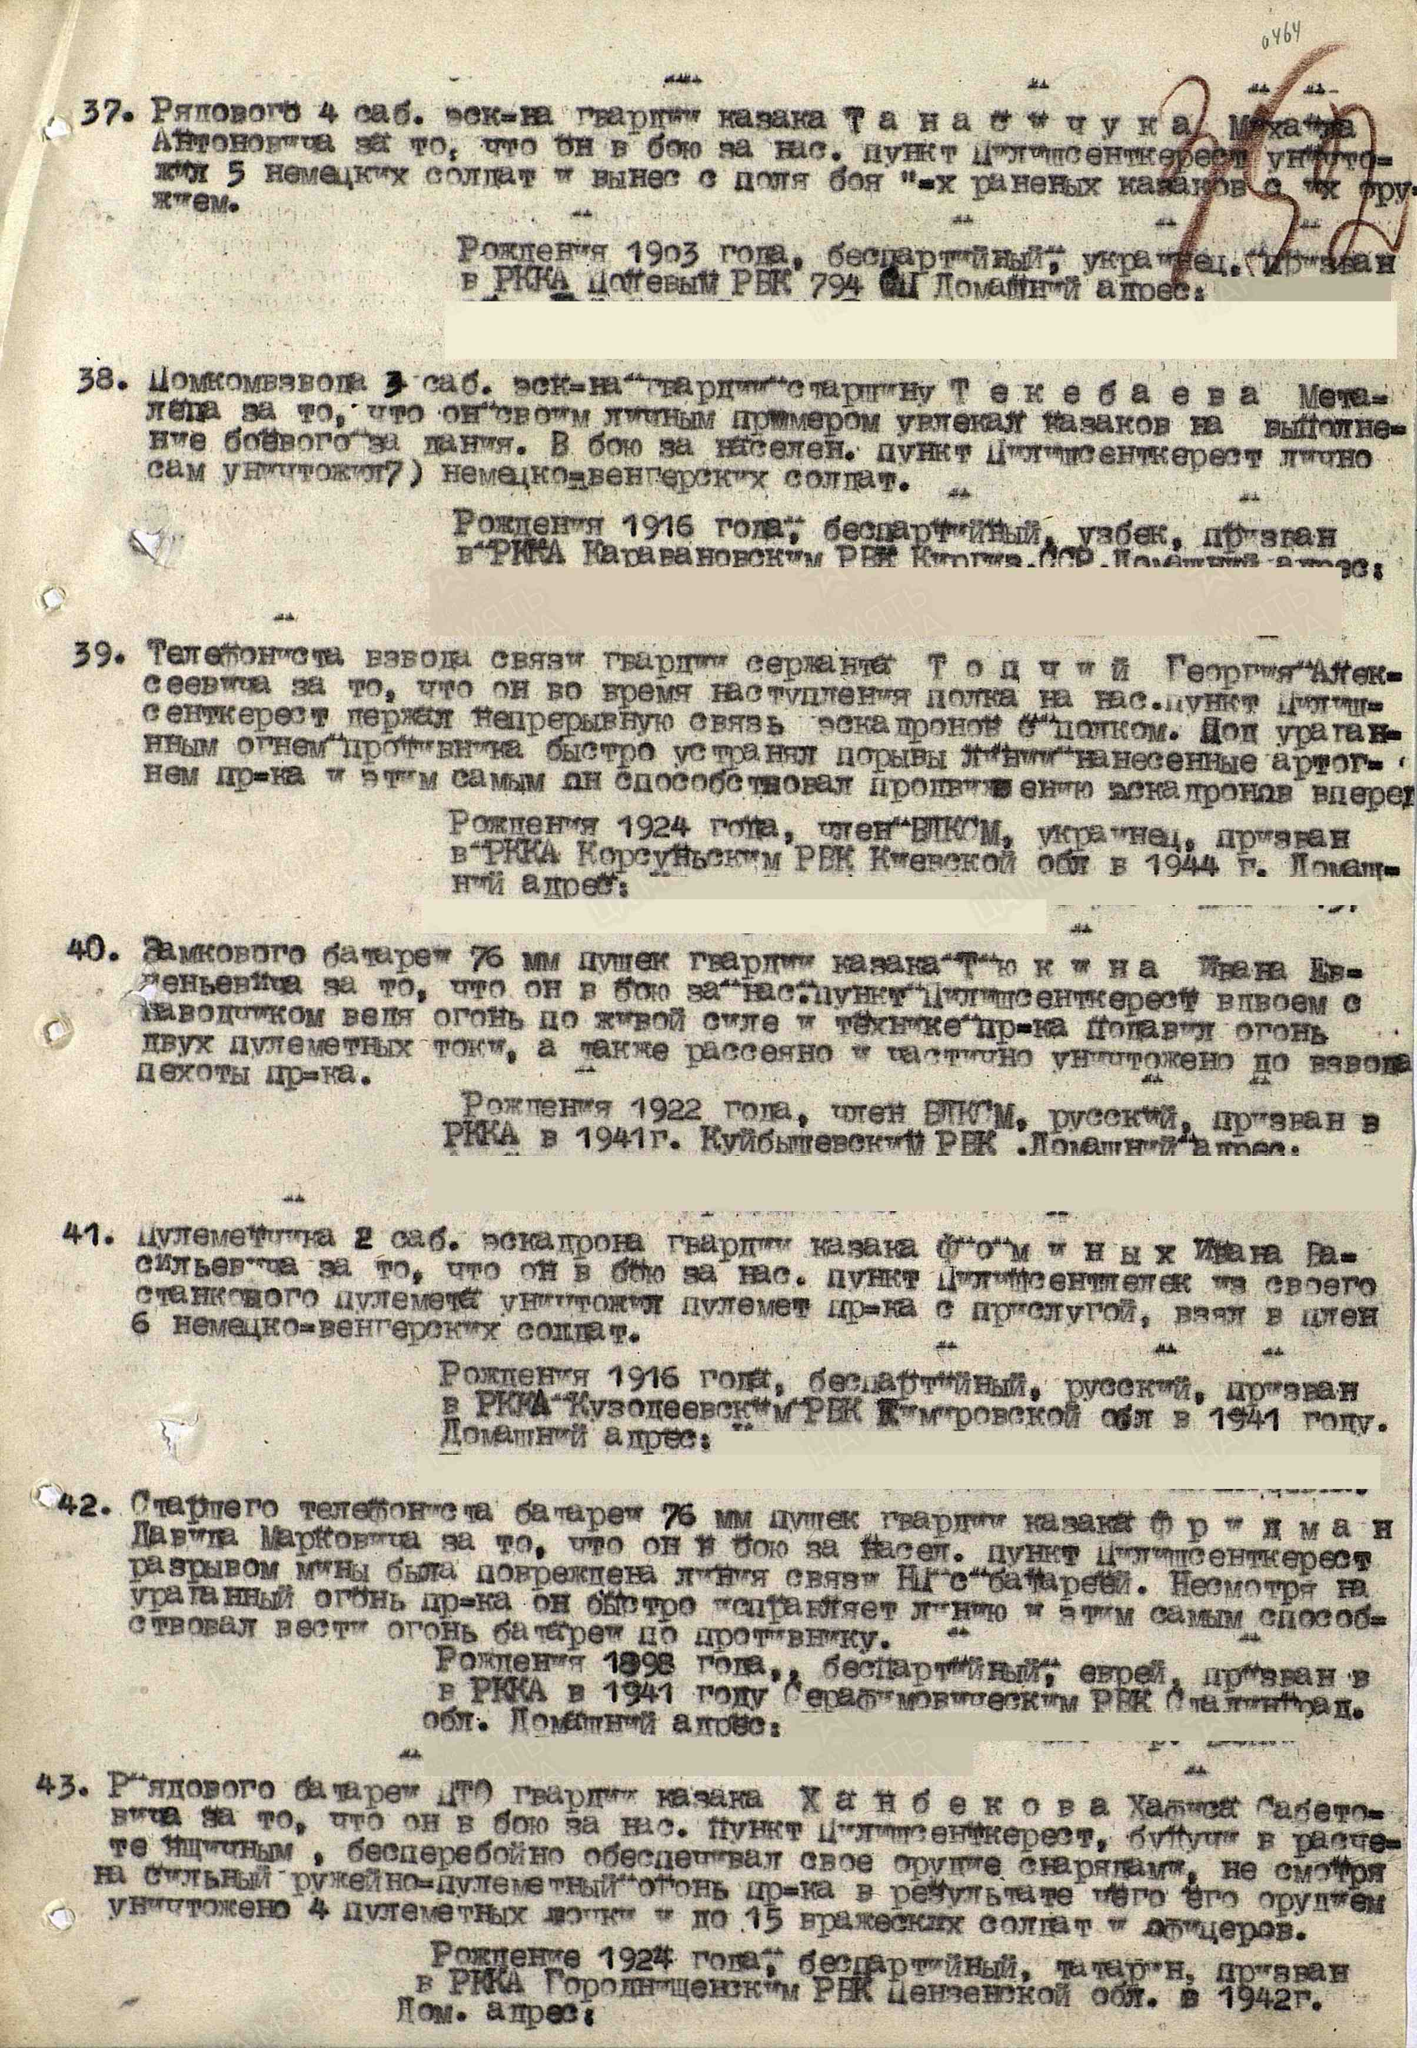

42. Senior telephone operator of the 76mm artillery battery, Guards Cossack Fridman Davyd Markovich, for promptly repairing the communication line to the battery's Observation Post after it was damaged by a mine explosion during the battle for a settlement. Despite heavy enemy fire, he restored the line quickly, enabling effective artillery fire control against the enemy.

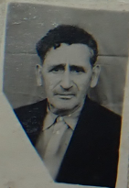

Fridman Davyd Markovich