USSR Battle Set: order “Red Star” #1811211, medal “for Courage” #996740, medal “for Courage” #2428981, medal “for Military Merit” without number, medal “for Liberation Prague”, medal “for Victory over Germany”, order of “Patriotic War” 2nd Class (85) #3157447, order of “Patriotic War” 2nd Class (85) #5030431, badge “Guard”, Czechoslovakia medal “For bravery before enemy”, Czechoslovakia medal “20 years of Slovak National Uprising 1944-1964” with documents.

Awarded to:

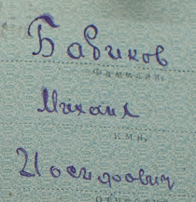

Babikov Mikhail Iosifovich

(Бабиков Михаил Иосифович)

Order “Red Star” #1811211 variation with serial number applied with specific font. Produced on Moscow Plant "Platinapribor" in March-June, 1945 and can be found in range of numbers 1792164 - 1949660. (T3,V2,R4).

Medal “for Courage” #2428981 has some traces of repair of medal’s ear.

Medal “for Victory over Germany” awarded in February 23, 1946. Document signed by commander of 571 Fighter aviation regiment, major Treus.

Medal “for Liberation Prague” awarded in April 23, 1946. Document signed by commander of 571 Fighter aviation regiment, major Treus too.

He was awarded by 2 same Jubilee orders of “Patriotic War” 2nd Class #3157447 & #5030431, usually people receive only 1 order, but for some mistake reasons he got 2, and this meets very rare!

Also presented list of all his awards from military archive:

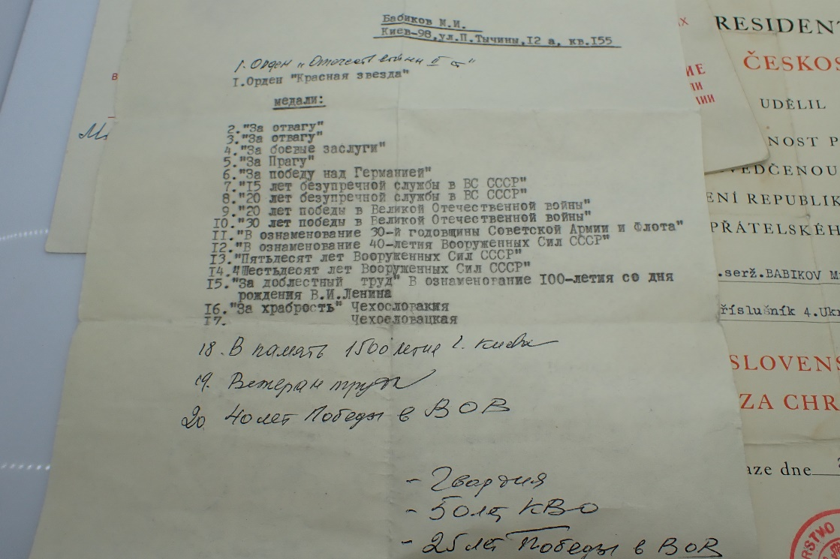

Also presented document to medal “30 Years of Soviet Army and Navy” awarded in March 11, 1949.

Czechoslovakia medal “20 years of Slovak National Uprising 1944-1964” awarded in August 29, 1964.

Czechoslovakia medal “For bravery before enemy” awarded in April 25, 1946.

medal “for Courage” #996740 awarded for:

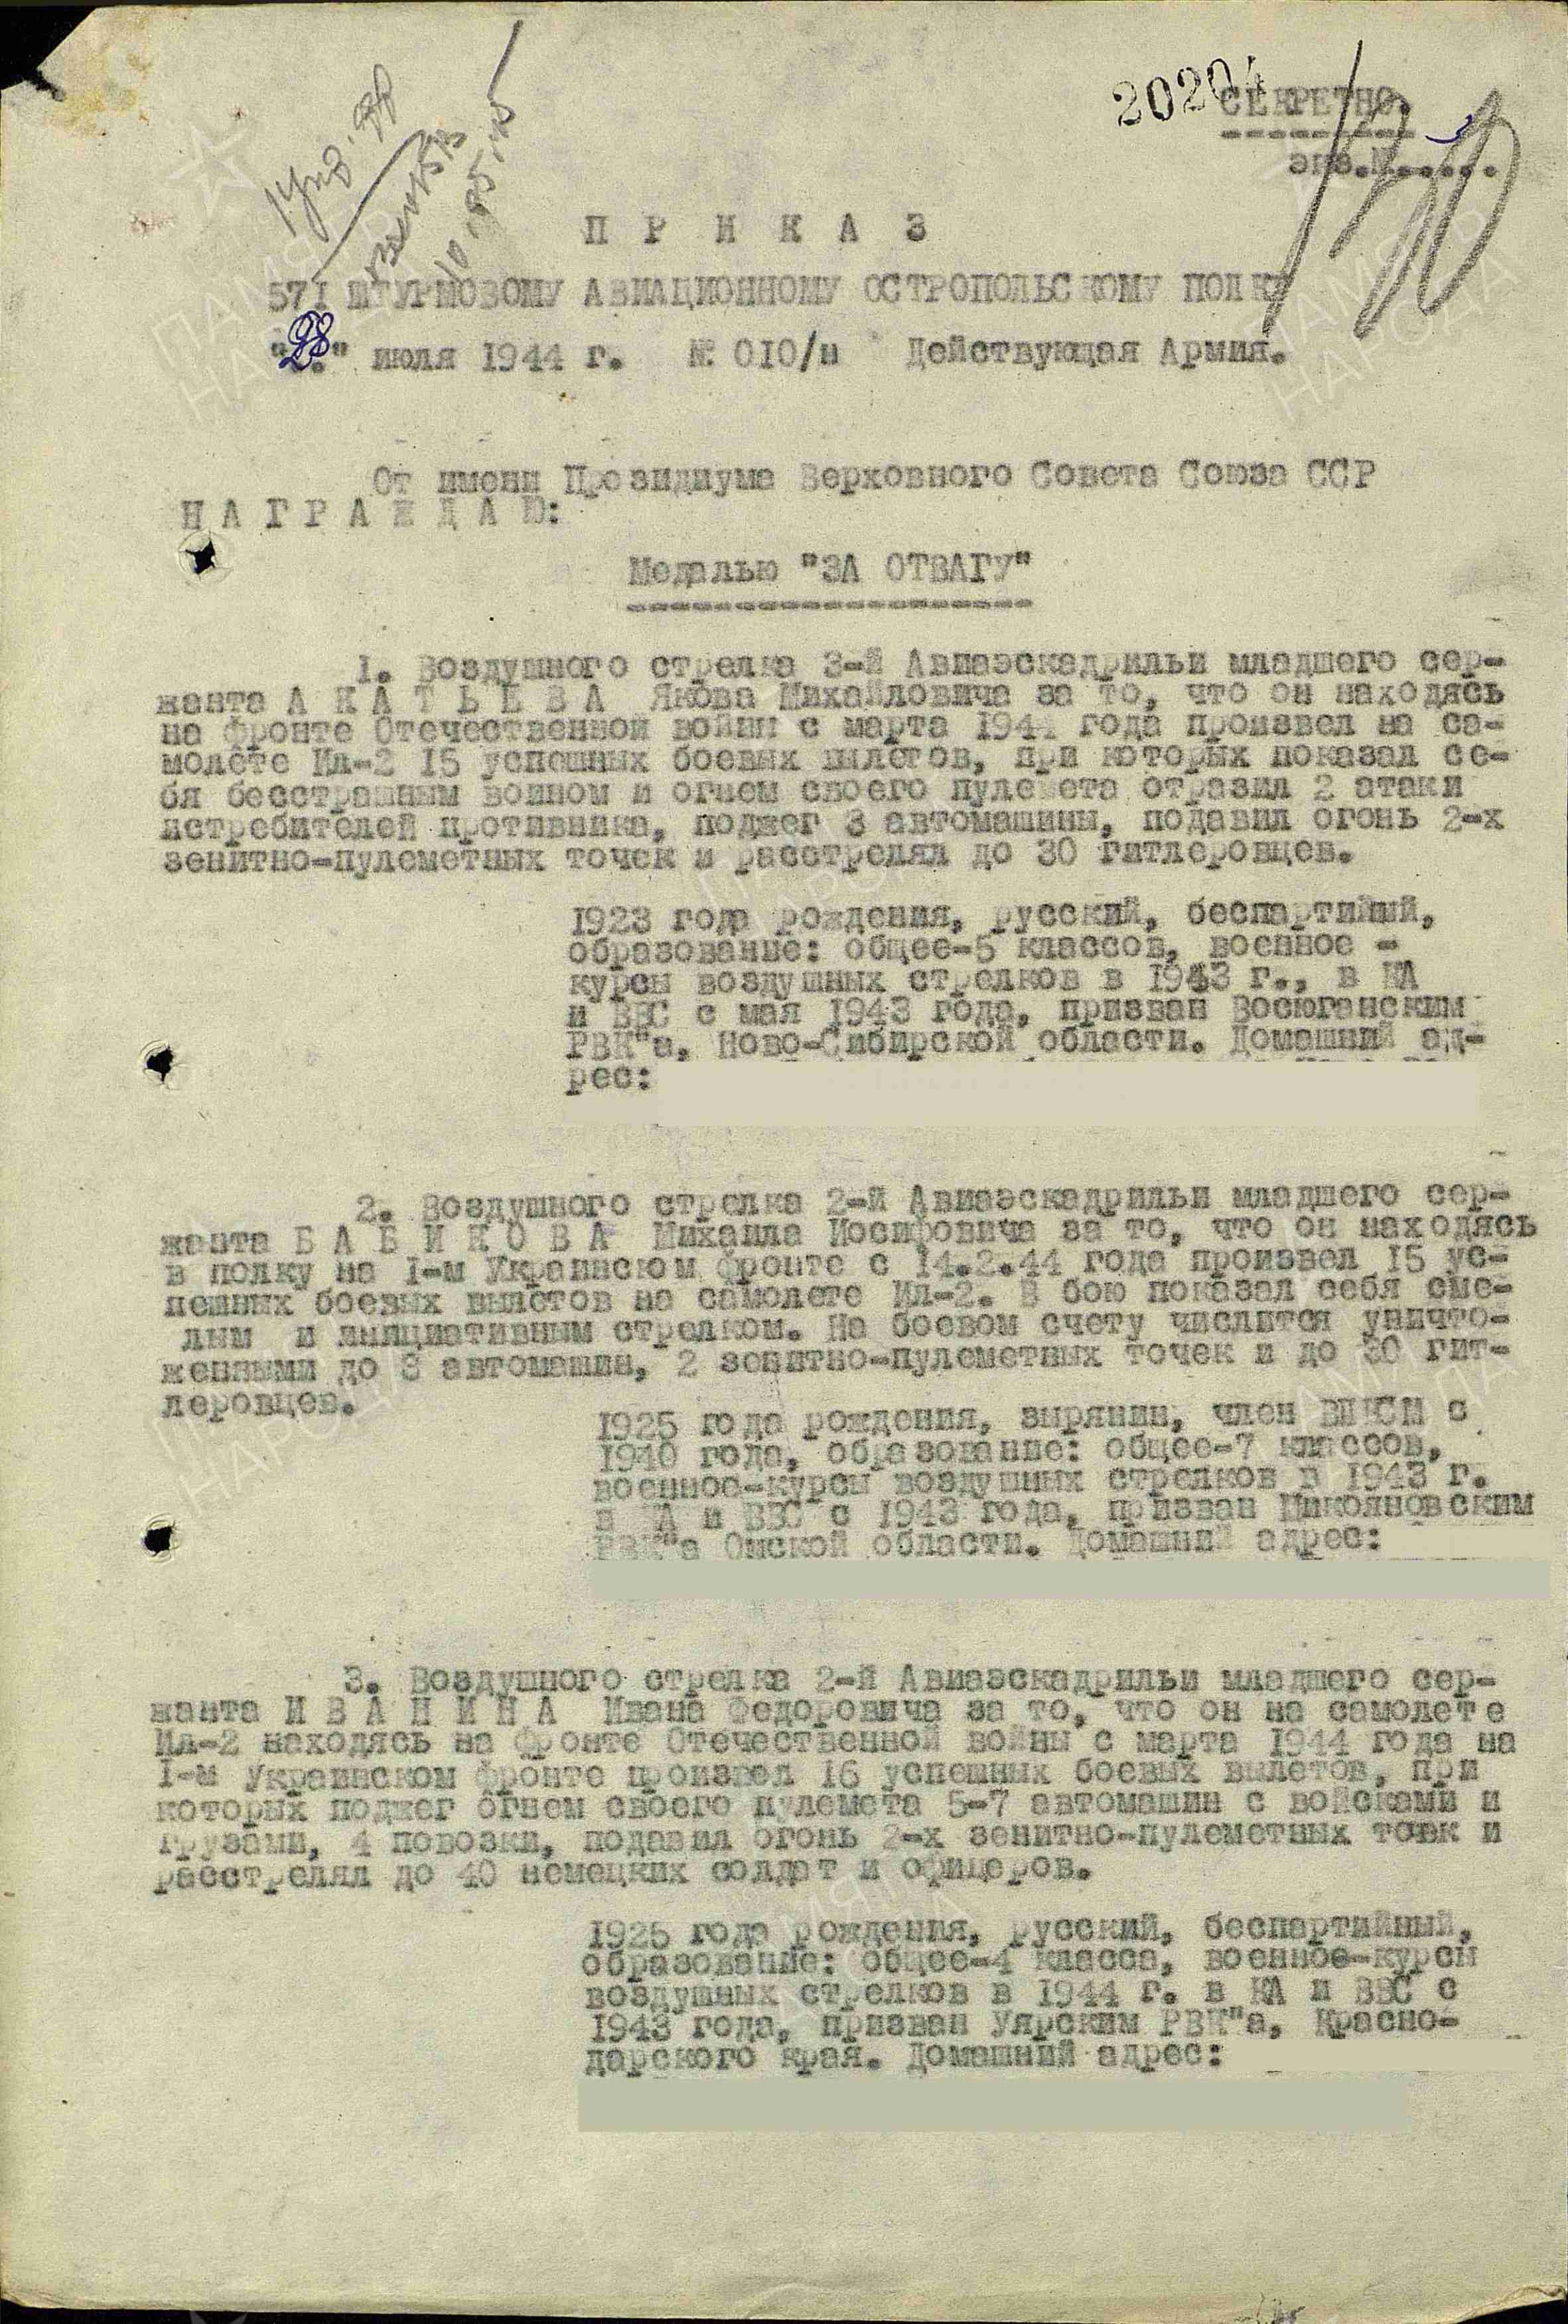

2. Air shooter of 2nd aviation squadron lance sergeant BABIKOV Mikhail Iosifovich for that, he being in regiment on 1st Ukrainian front from February 14, 1944 performed 15 success combat flights on plane IL-2. In combat showed himself as brave and initiative shooter. On his combat count destroyed 3 vehicles, 2 air defense points and killed 30 Germans.

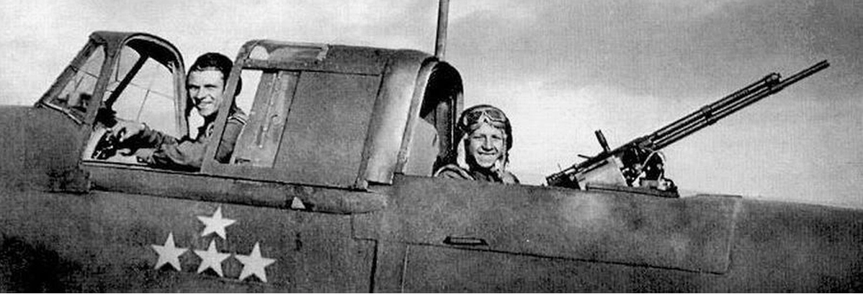

Air shooter on IL-2

Order “Red Star” #1811211 awarded for:

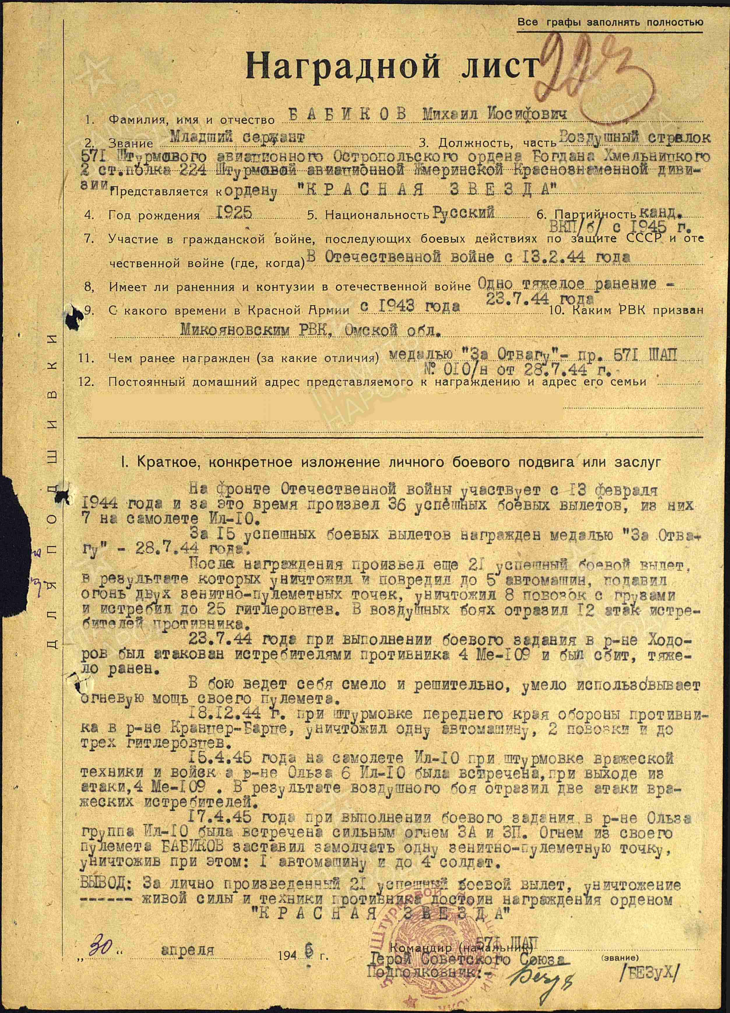

BABIKOV Mikhail Iosifovich - lance sergeant, air shooter of 571 assault aviation Ostropolskiy order of Bohdan Khmelnutsky 2nd Class regiment of 224 Assault aviation Zhmerinka Red Banner division.

Participated in World War II since February 13, 1944, and completed a total of 36 successful combat sorties, including 7 aboard the IL-10 aircraft.

For completing 15 successful missions, he was awarded the Medal "For Courage" on July 28, 1944.

Following that award, he carried out an additional 21 successful sorties. As a result of these missions, he destroyed or damaged approximately 5 vehicles, neutralized 2 enemy anti-aircraft positions, destroyed 8 cargo carriages, and eliminated 25 German soldiers. In air combat, he successfully repelled 12 attacks by enemy fighter planes.

On July 23, 1944, while executing a combat mission in the Hodorov area, he was attacked by four ME-109 fighters. His aircraft was shot down, and he sustained serious injuries.

He has demonstrated courage and decisiveness in combat, using his weapon with skill.

On December 12, 1944, during an attack on the front line in the Krancer-Barce area, he destroyed 1 vehicle, 2 carriages, and killed 3 enemy soldiers.

On April 15, 1945, while flying in a group of six IL-10 aircraft attacking enemy forces near Olza, the formation was intercepted by four ME-109 fighters. He successfully repelled two attacks.

On April 17, 1945, during another mission in the Olza region, the IL-10 group encountered heavy anti-aircraft fire. Babikov suppressed one enemy firing position with his machine gun, destroyed one vehicle, and killed 4 soldiers.

Conclusion: For personally completing 21 successful combat missions and for the destruction of enemy personnel and equipment, he is deserving of the Order of the Red Star.

“30” April 1946 Commander of of 571 assault aviation regiment

Hero of Soviet Union

Lieutenant-colonel /BEZUH/

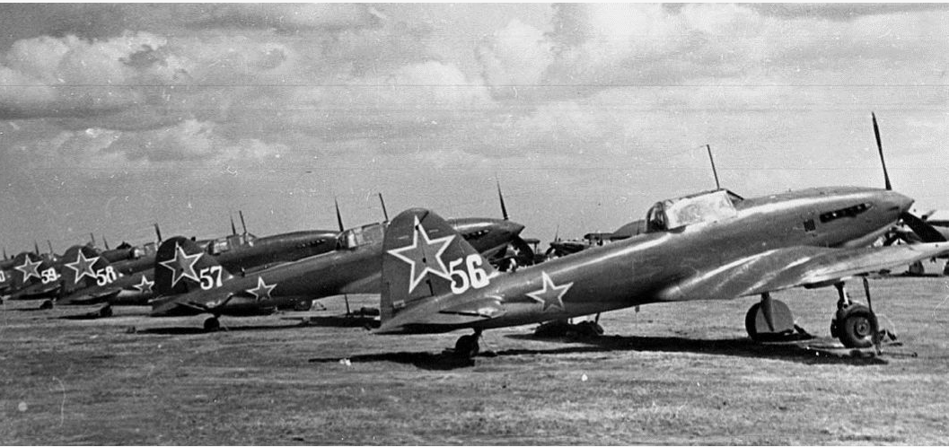

IL-10 planes.

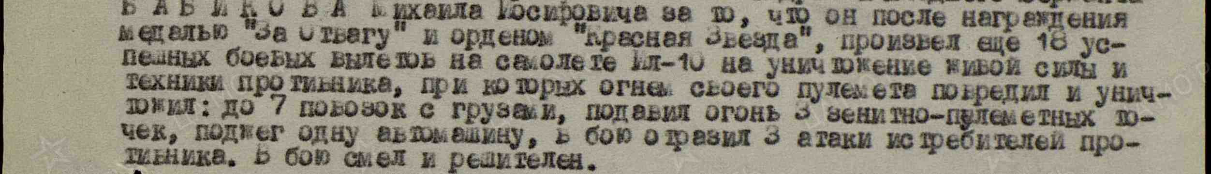

medal “for Courage” # 2428981 awarded for:

To the air gunner of the 2nd Aviation Squadron, Junior Sergeant Babikov, Mikhail Iosifovich, for the fact that, after being awarded the medal "For Courage" and the Order of the Red Star, he completed 16 successful combat sorties in an Il-10 aircraft to destroy enemy manpower and equipment. During one of the flights, his machine gun jammed. Under heavy fire, he repaired the gun in flight; then, when the aircraft was hit and caught fire, he extinguished the flames, resumed fire from his machine gun, and shot down two enemy fighters.

Born in 1923, Jewish, candidate of the VKP(b) [Communist Party], education: 7 grades, military – 6-month air gunner course; in the Red Army since 1943; drafted by the Ikonnikovsky District Military Commissariat, Ryazan Oblast. Permanent address: [omitted].