USSR Battle Set: order “Red Star” #1529347, order “Red Star” #1530530, order “Red Star” #3443074 with research.

Awarded to:

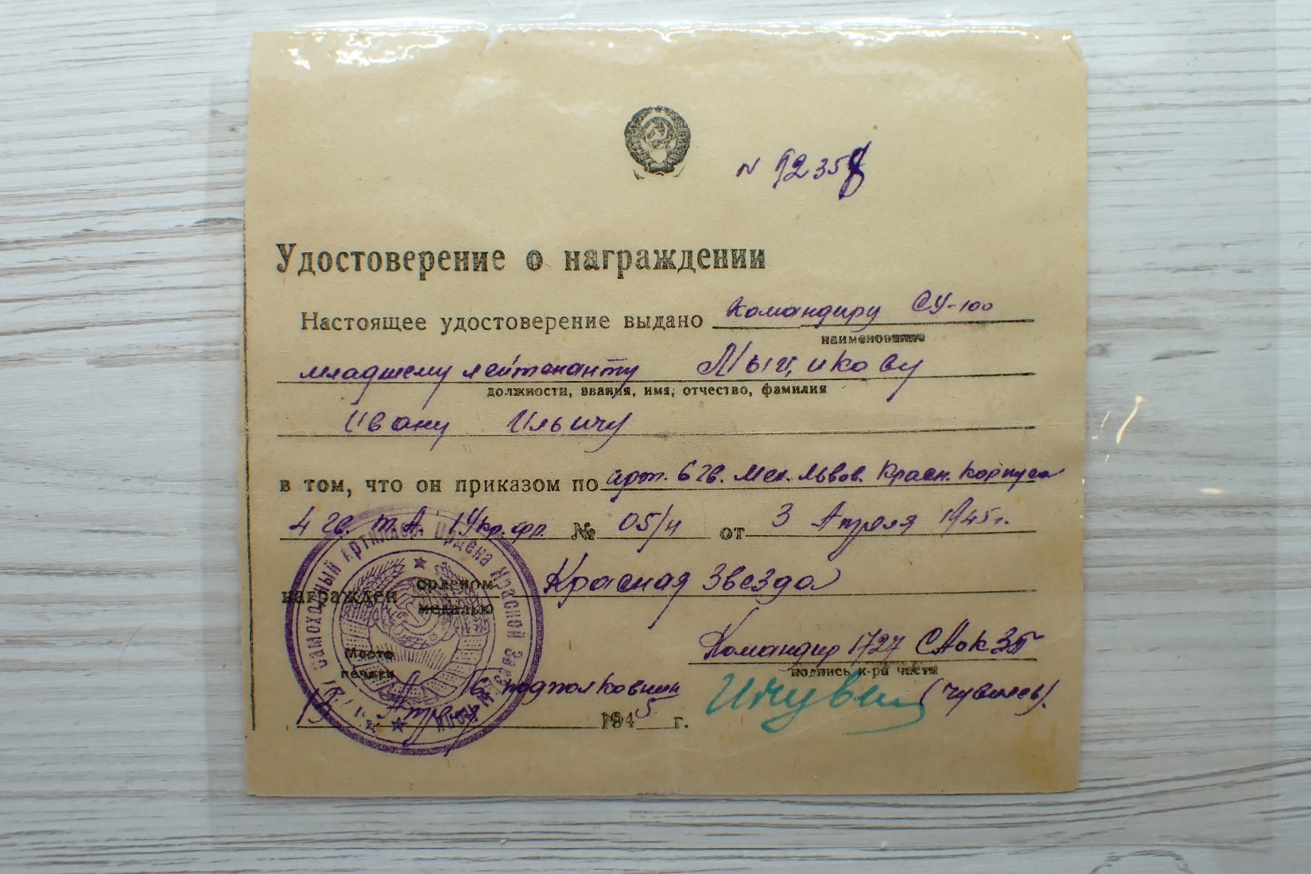

Commander of SU-100 self moving cannon, junior lieutenant Mytsikov Ivan Iliych (Мыциков Иван Ильич)

**He was awarded by 3 orders of “Red Star” which meets very rare!**

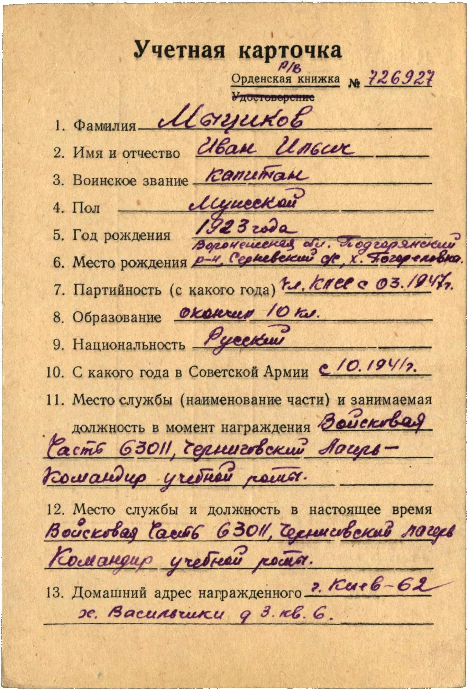

Mytsikov Ivan Iliych – captain, male, birth in 1923, member of CPSU since 03, 1947, education 10 classes, Russian, served in Red Army from 1941.

Was awarded by:

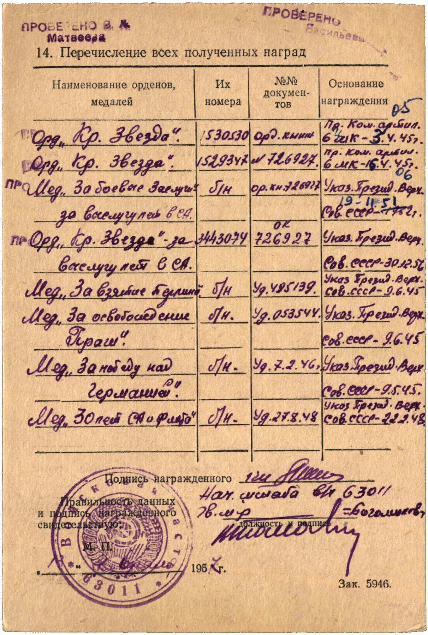

Order “Red Star” #1530530

Order “Red Star” #1529347

Medal “for Military Merit” wn

Medal “for Impeccable Service” Armed Forces

Order “Red Star” #3443074

Medal “for Impeccable Service” Armed Forces

Medal “for Capture Berlin”

Medal “for Liberation Prague”

Medal “for Victory over Germany”

Medal “30 Years of Soviet Army and Navy”

order “Red Star” #1529347 awarded for:

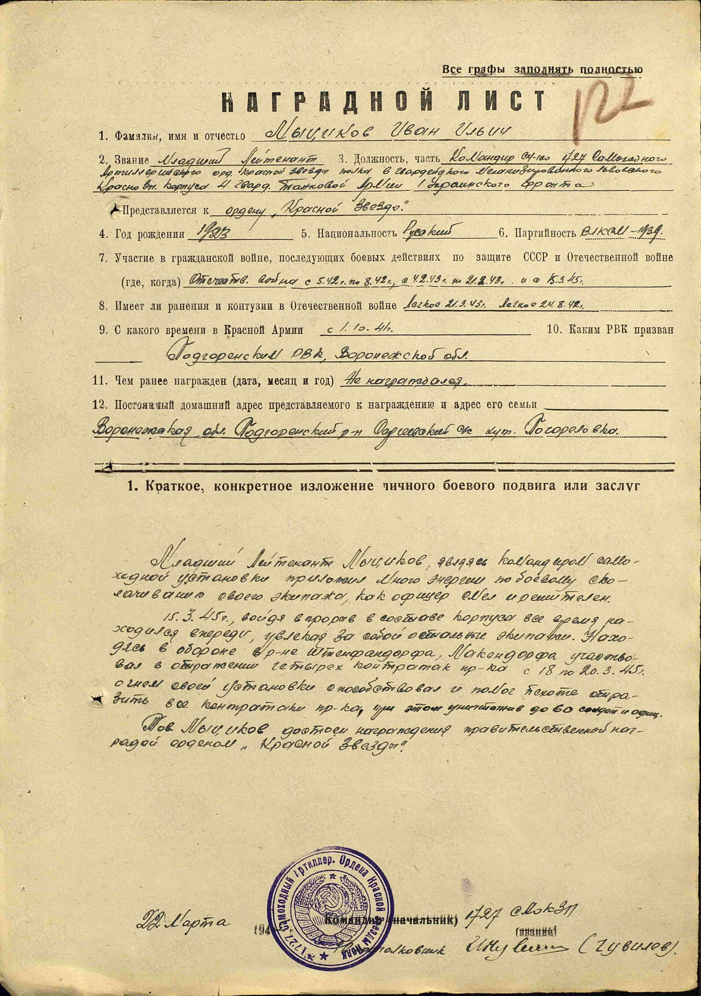

Mytsikov Ivan Iliych – junior lieutenant, commander of SU-100 of 1727 self moving artillery order of Red Star regiment of 6 guard’s Mechanized Lvov Red Banner corps of 4 guard’s Tank Army of 1st Ukrainian Front.

Mytsikov as commander of self moving cannon spent a lot of energy of educating of his crew, as officer decisive.

In March 15, 1945 breaking enemy’s defense he always was ahead and inspired other crews. Being into defense in region Stefandorf, Michendorf participated in reflecting 4 enemy counterattacks from March 18-20, 1945 by fire of his cannon helped reflect all counterattacks to our infantry, destroying during this around 60 soldiers and officers.

Mytsikov deserves awarding by governmental award order “Red Star”.

22 March 1945 Commander of 1727 self moving artillery order of Red Star regiment

Lieutenant-colonel (Guvilev)

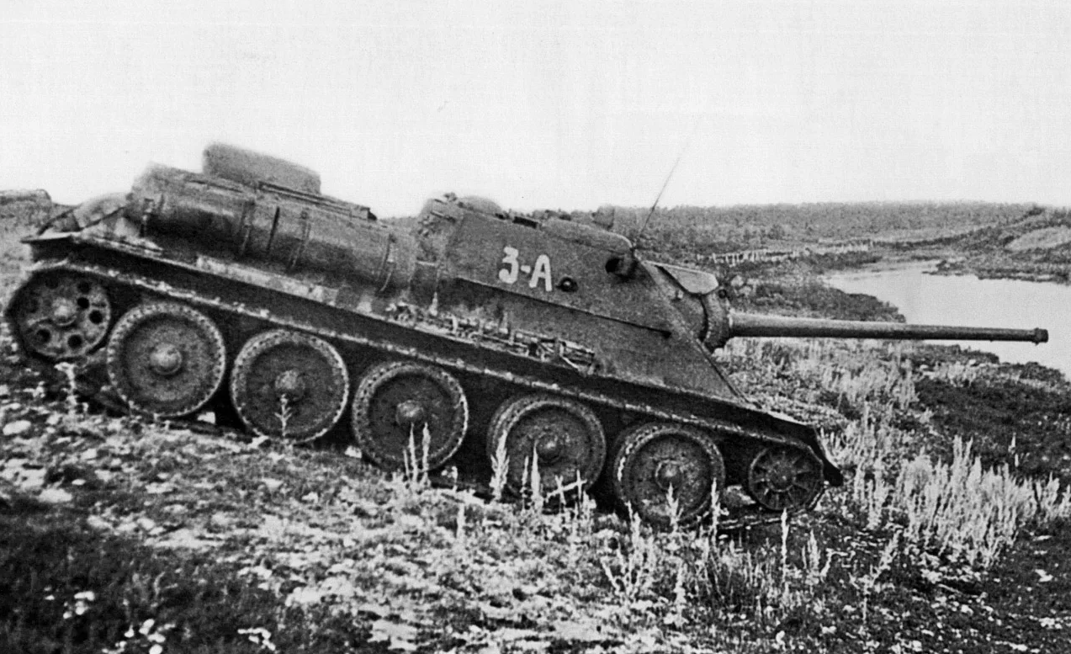

SU-100.

Order “Red Star” #1530530 awarded for:

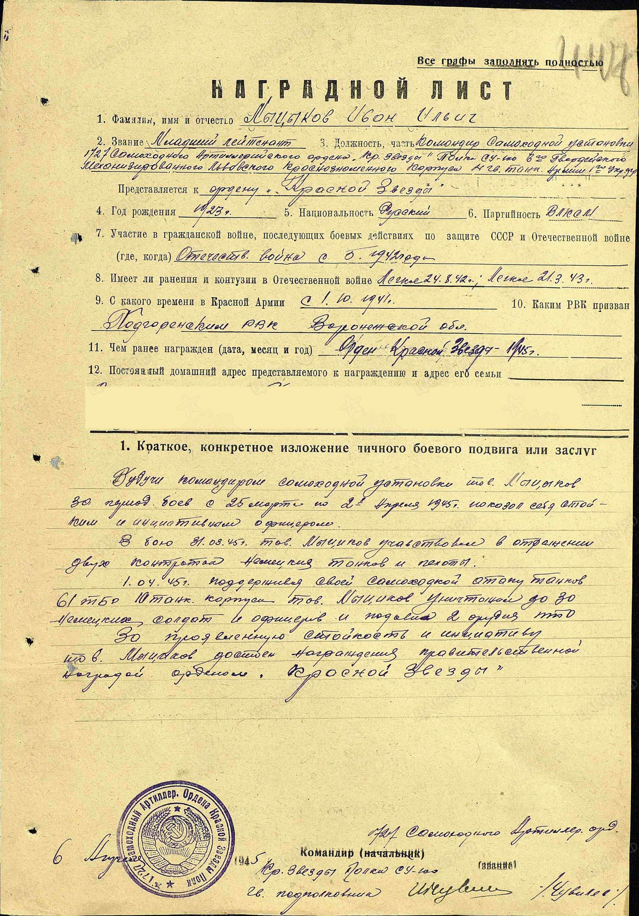

Mytsikov Ivan Iliych – junior lieutenant, commander of self-moving cannon of 1727 self moving artillery order of Red Star regiment of 6 guard’s Mechanized Lvov Red Banner corps of 4 guard’s Tank Army of 1st Ukrainian Front.

As commander of self-moving cannon Mytsikov during combats from March 25 to April 2, 1945 showed himself as uncompromising and initiative officer.

In combat from March 31, 1945 participated in reflecting 2 counterattacks of German’s infantry and tanks.

In April 1, 1945 supporting attack of tanks of 61 tank brigade of 10 tank corps by fire of his cannon Mytsikov killed around 30 German’s soldiers and officers and suppressed 2 anti-tank cannons.

For showed persistence and initiative deserves governmental award order “Red Star”.

6 April 1945 Commander of 1727 self moving artillery order of Red Star regiment

Lieutenant-colonel (Guvilev)