USSR Battle Set: order “Red Banner” #269394, order “Patriotic War” 2nd Class #271106, order “Red Star” #289537, order “Badge of Honor” #330334 with document.

Awarded to:

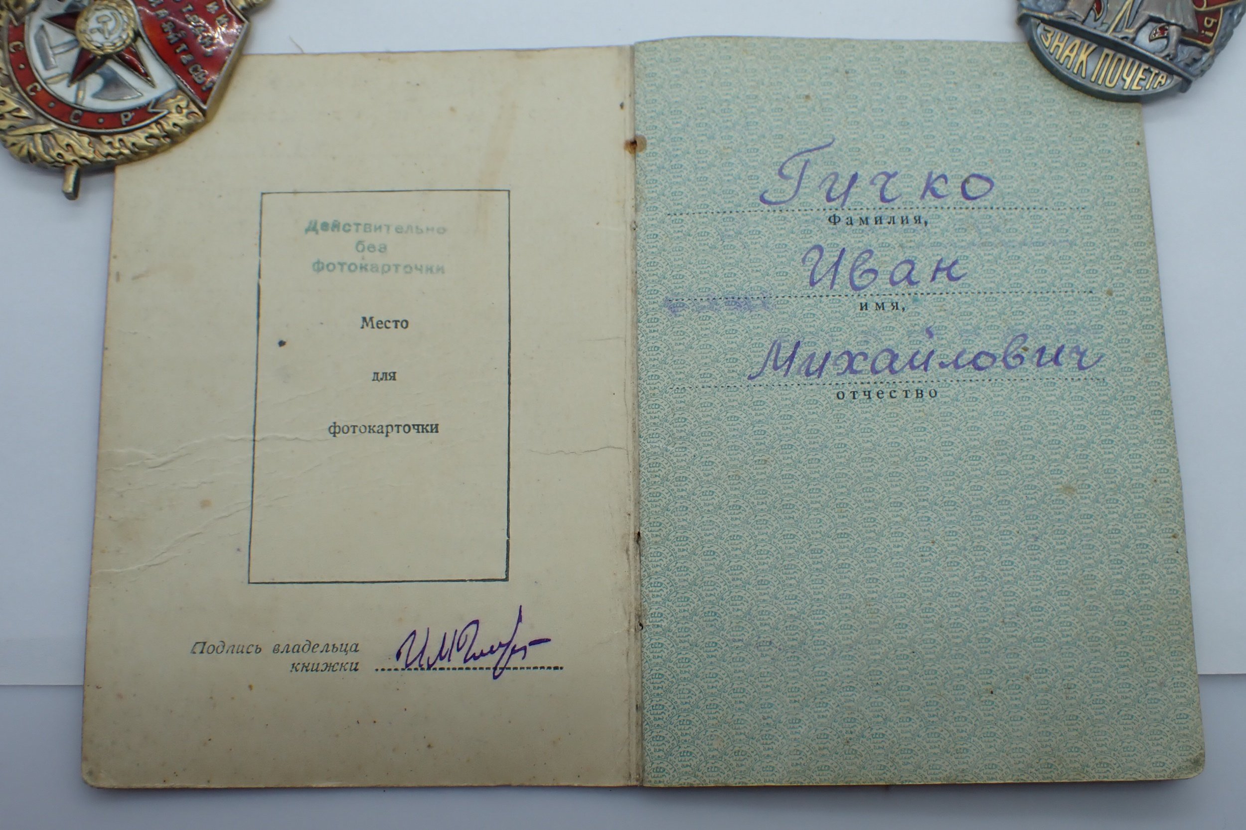

Gichko Ivan Mikhaylovich

(Гичко Иван Михайлович)

Order “Red Banner” #269394 is suspended variant, "round" shape. Produced on Moscow Mint in 1945. Reverse with rounded deepening, stamp of mint stamped in one row, slightly rounded upwards, applied by big font. Can be found in range of numbers 188493 – 273503 (RB,T3,V4,R2).

Order “Red Star” #289537 with native silver screw-nut.

Order “Red Star” #289537 awarded for:

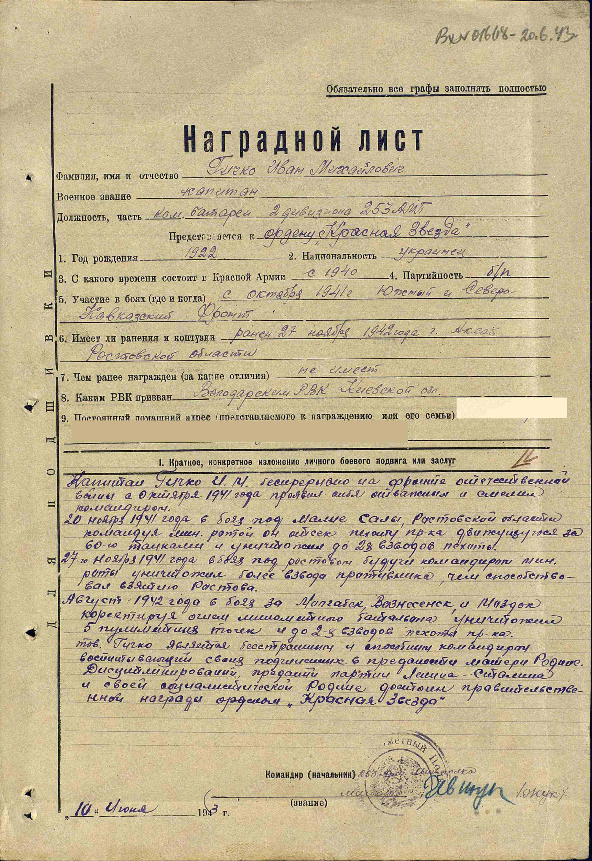

Gichko Ivan Mikhaylovich – captain, commander of artillery battery of 2nd division of 253 army’s mortar regiment.

Gichko constantly participated in WWII from October 1941 showed himself as brave and courageous commander.

In November 20, 1941 in combat under village Malye Saly of Rostov region commanding by mortar company of cut enemy infantry moving with 60 tanks and destroyed around 28 platoons of infantry.

In November 27, 1941 in combat near Rostov as commander of mortar company destroyed more than platoon of enemies, what contributed to success of capturing of Rostov.

In August 1942 in combat for Molgobek, Voznesensk and Mozdok aiming fire of mortar battalion destroyed 5 machine-gun fire points and around 28 platoons of enemy infantry.

Gichko fearless and capable commander, teaching his subordinates to devotion to Motherland.

Disciplined, devoted to Communist Party and Motherland deserves governmental award order “Red Star”.

Commander of 253 army’s mortar regiment

“10” June 1943 major %Zhuk%

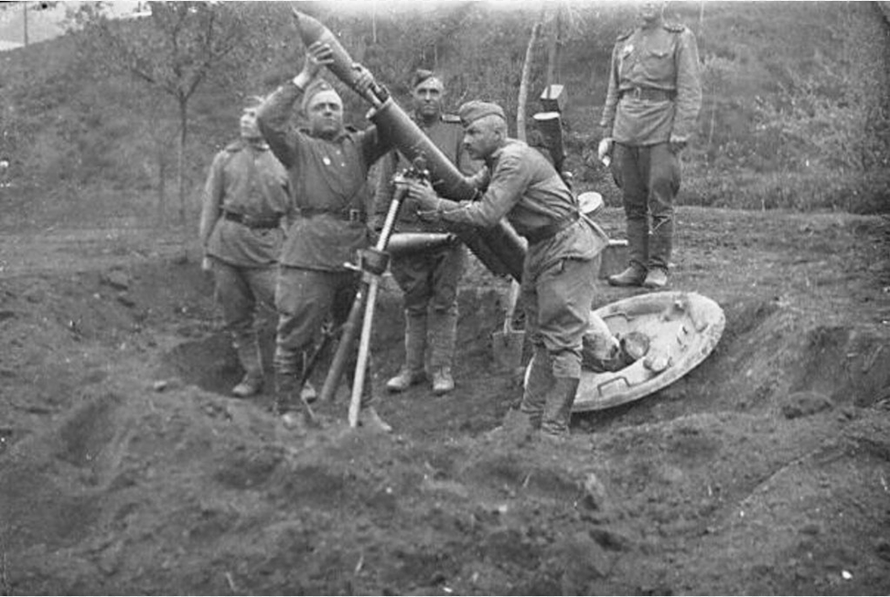

Mortar gunners

order “Patriotic War” 2nd Class #271106 awarded for:

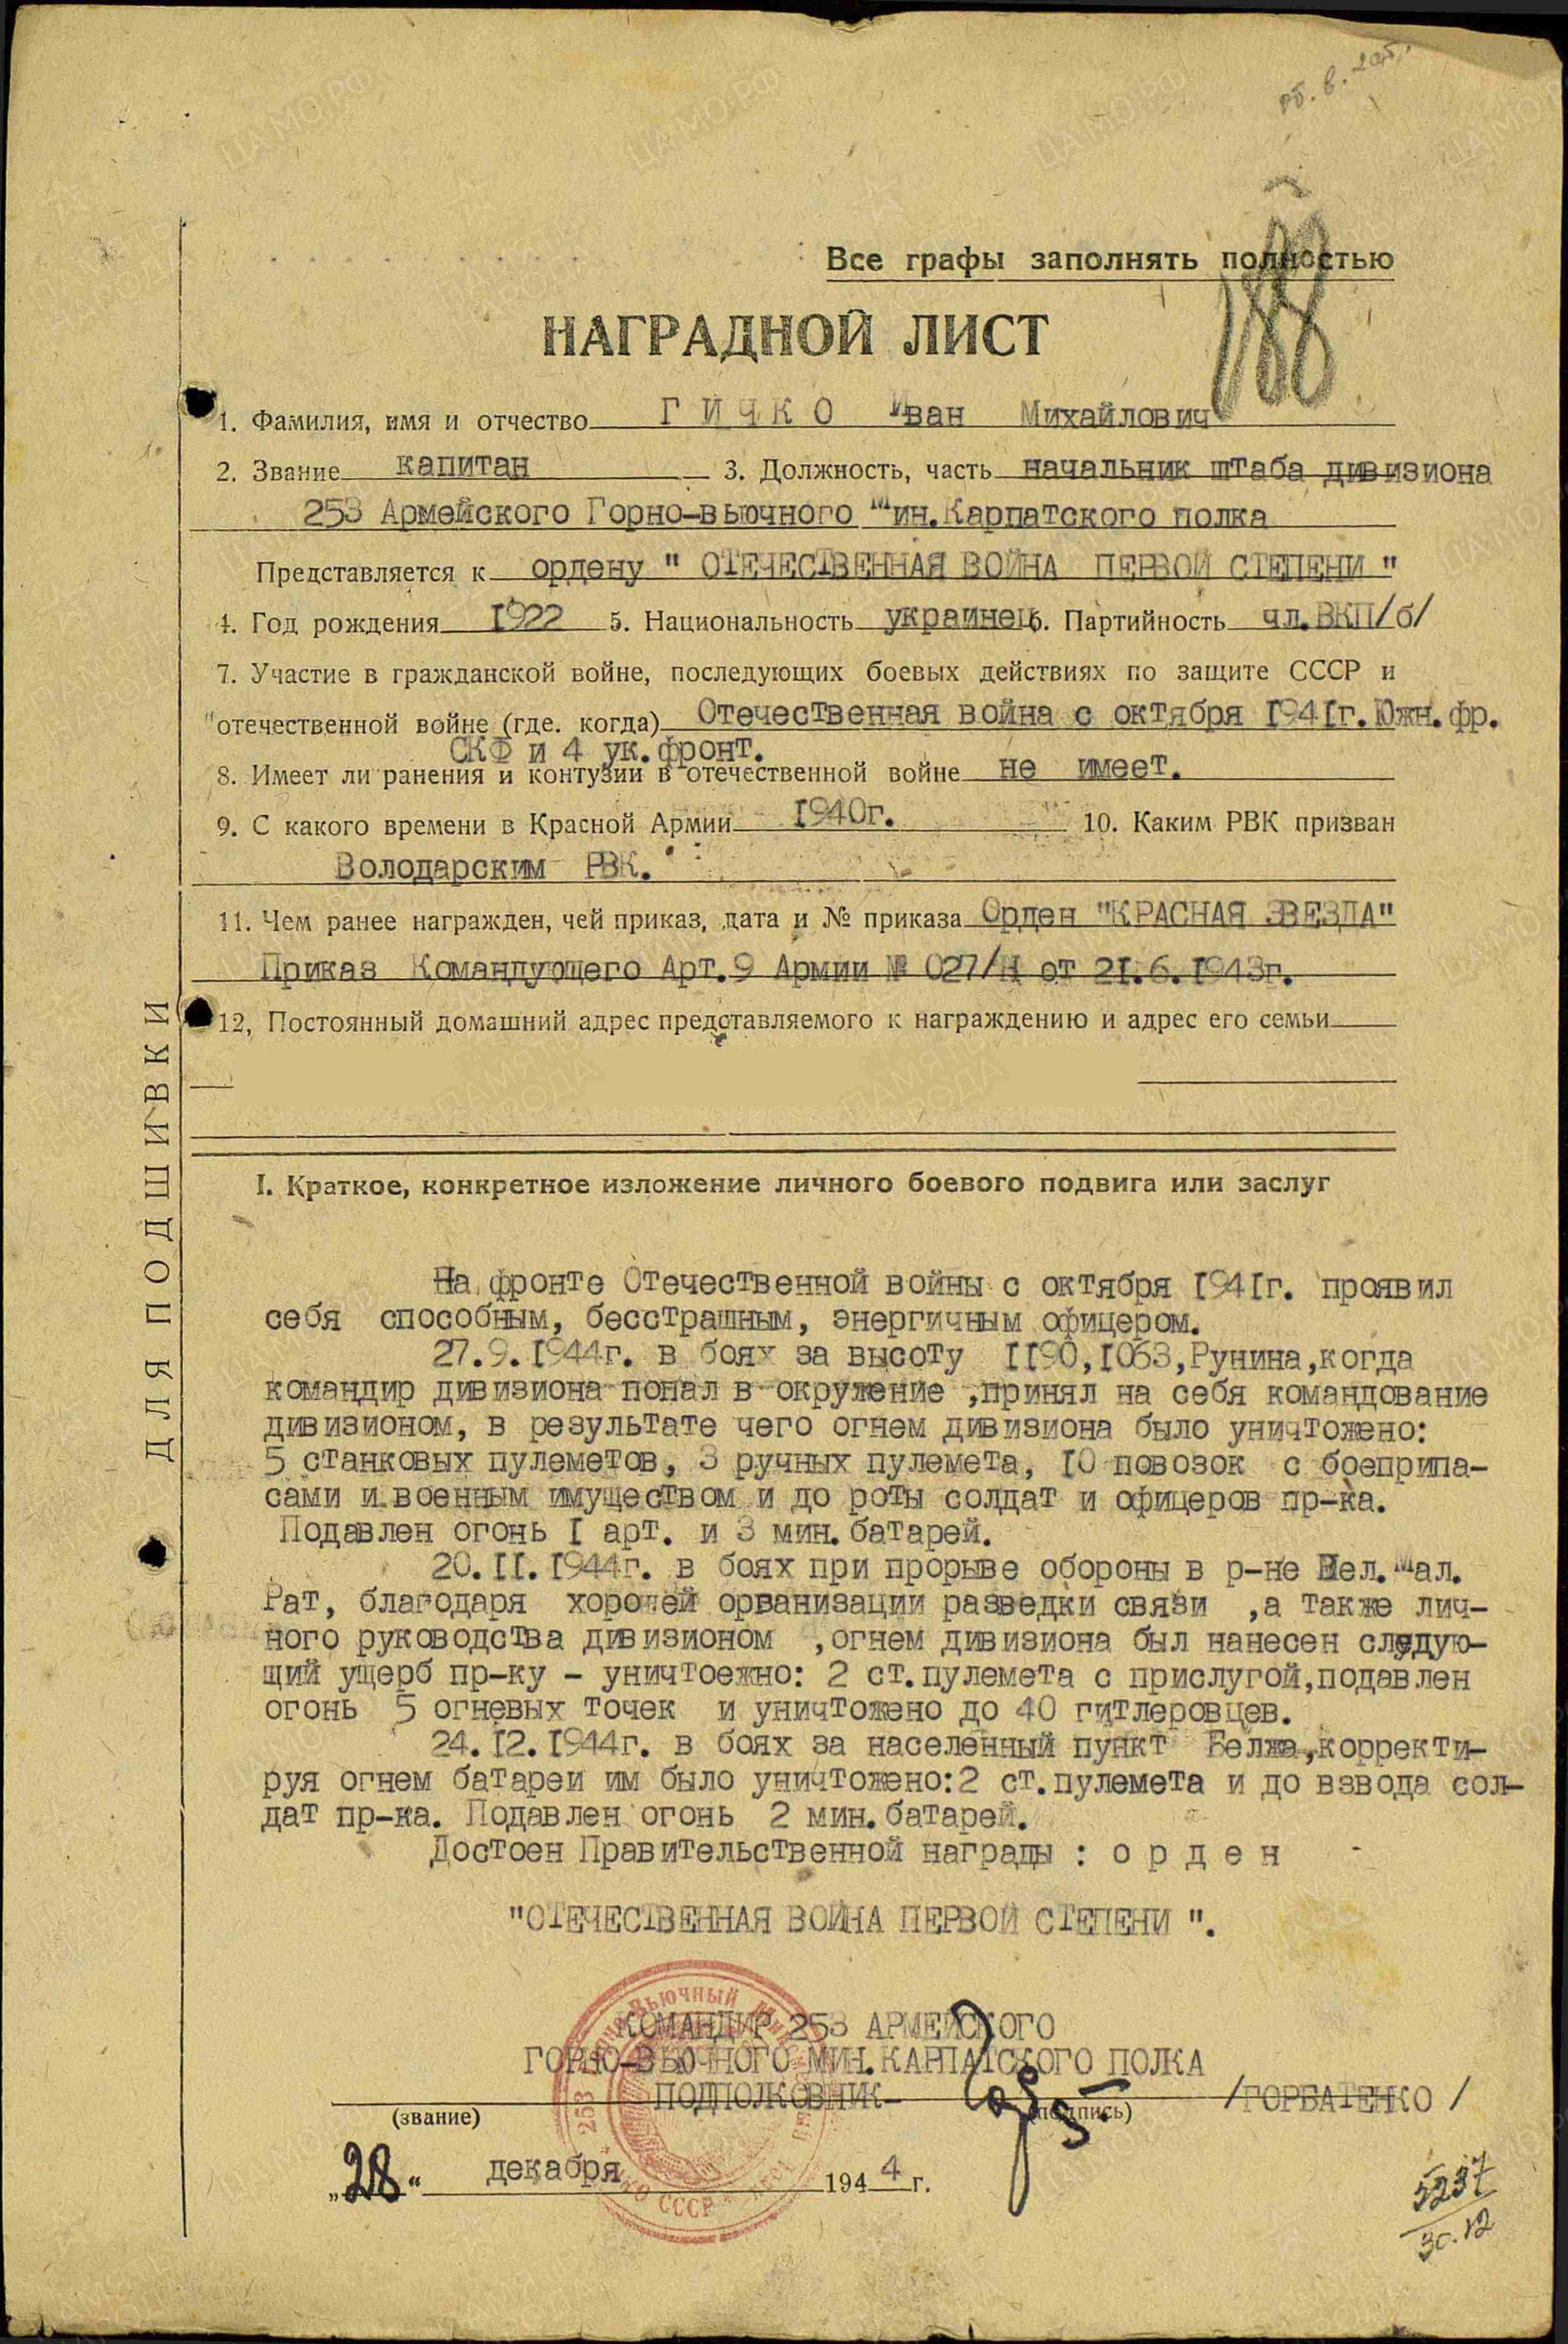

GICHKO Ivan Mikhaylovich – captain, chief of division’s head quarter of 253 army’s mortar Carpathian regiment.

Participated in WWII since October 1941, showed himself as brave, capable and active officer.

In September 27, 1944 in combat for altitude 1190, 1063, Runina, when commander of division was surrounded, he took management of division on himself, as result by fire of division destroyed: 5 heavy machine-guns, 3 light machine-guns, 10 wagons with ammunition and military equipment and around company of enemy soldiers and officers. Suppressed fire of 1 artillery and 3 mortar batteries.

In November 20, 1944 in combats during breaking enemy defense, through excellent organization of communication and personal management by division, by division’s fire caused following losses to enemy: 2 heavy machine-guns with crew, suppressed fire of 5 fire points and killed 40 Germans.

In December 24, 1944 in combat for settlement Belzha, aiming mortar battery fire he destroyed: 2 heavy machine-guns and around platoon of enemy soldiers. Suppressed fire of 2 mortar batteries.

Deserves Governmenta award : o r d e r “PATRIOTIC WAR FIRST CLASS”.

COMMANDER OF 253 ARMY’S

MORTAR CARPATHIAN REGIMENT.

LIEUTENANT-COLONEL /GORBATENKO/

“28” December 1944

But higher award commission after reading his feat decided award him by lower grade award – order “Patriotic War” 2nd Class.

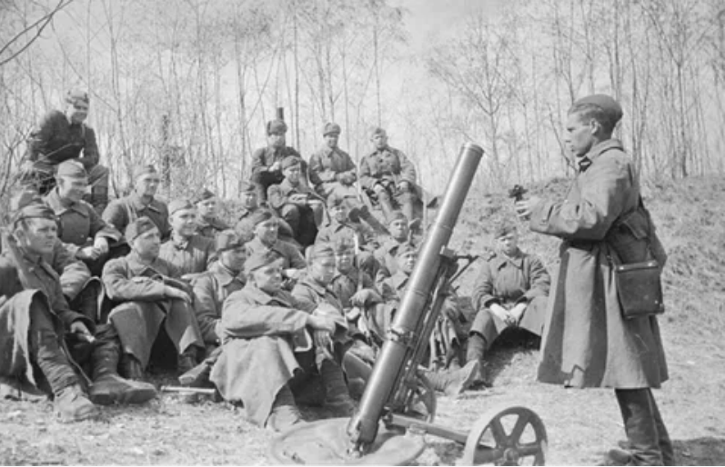

Mortar-gunners.

order “Red Banner” #269394 awarded for:

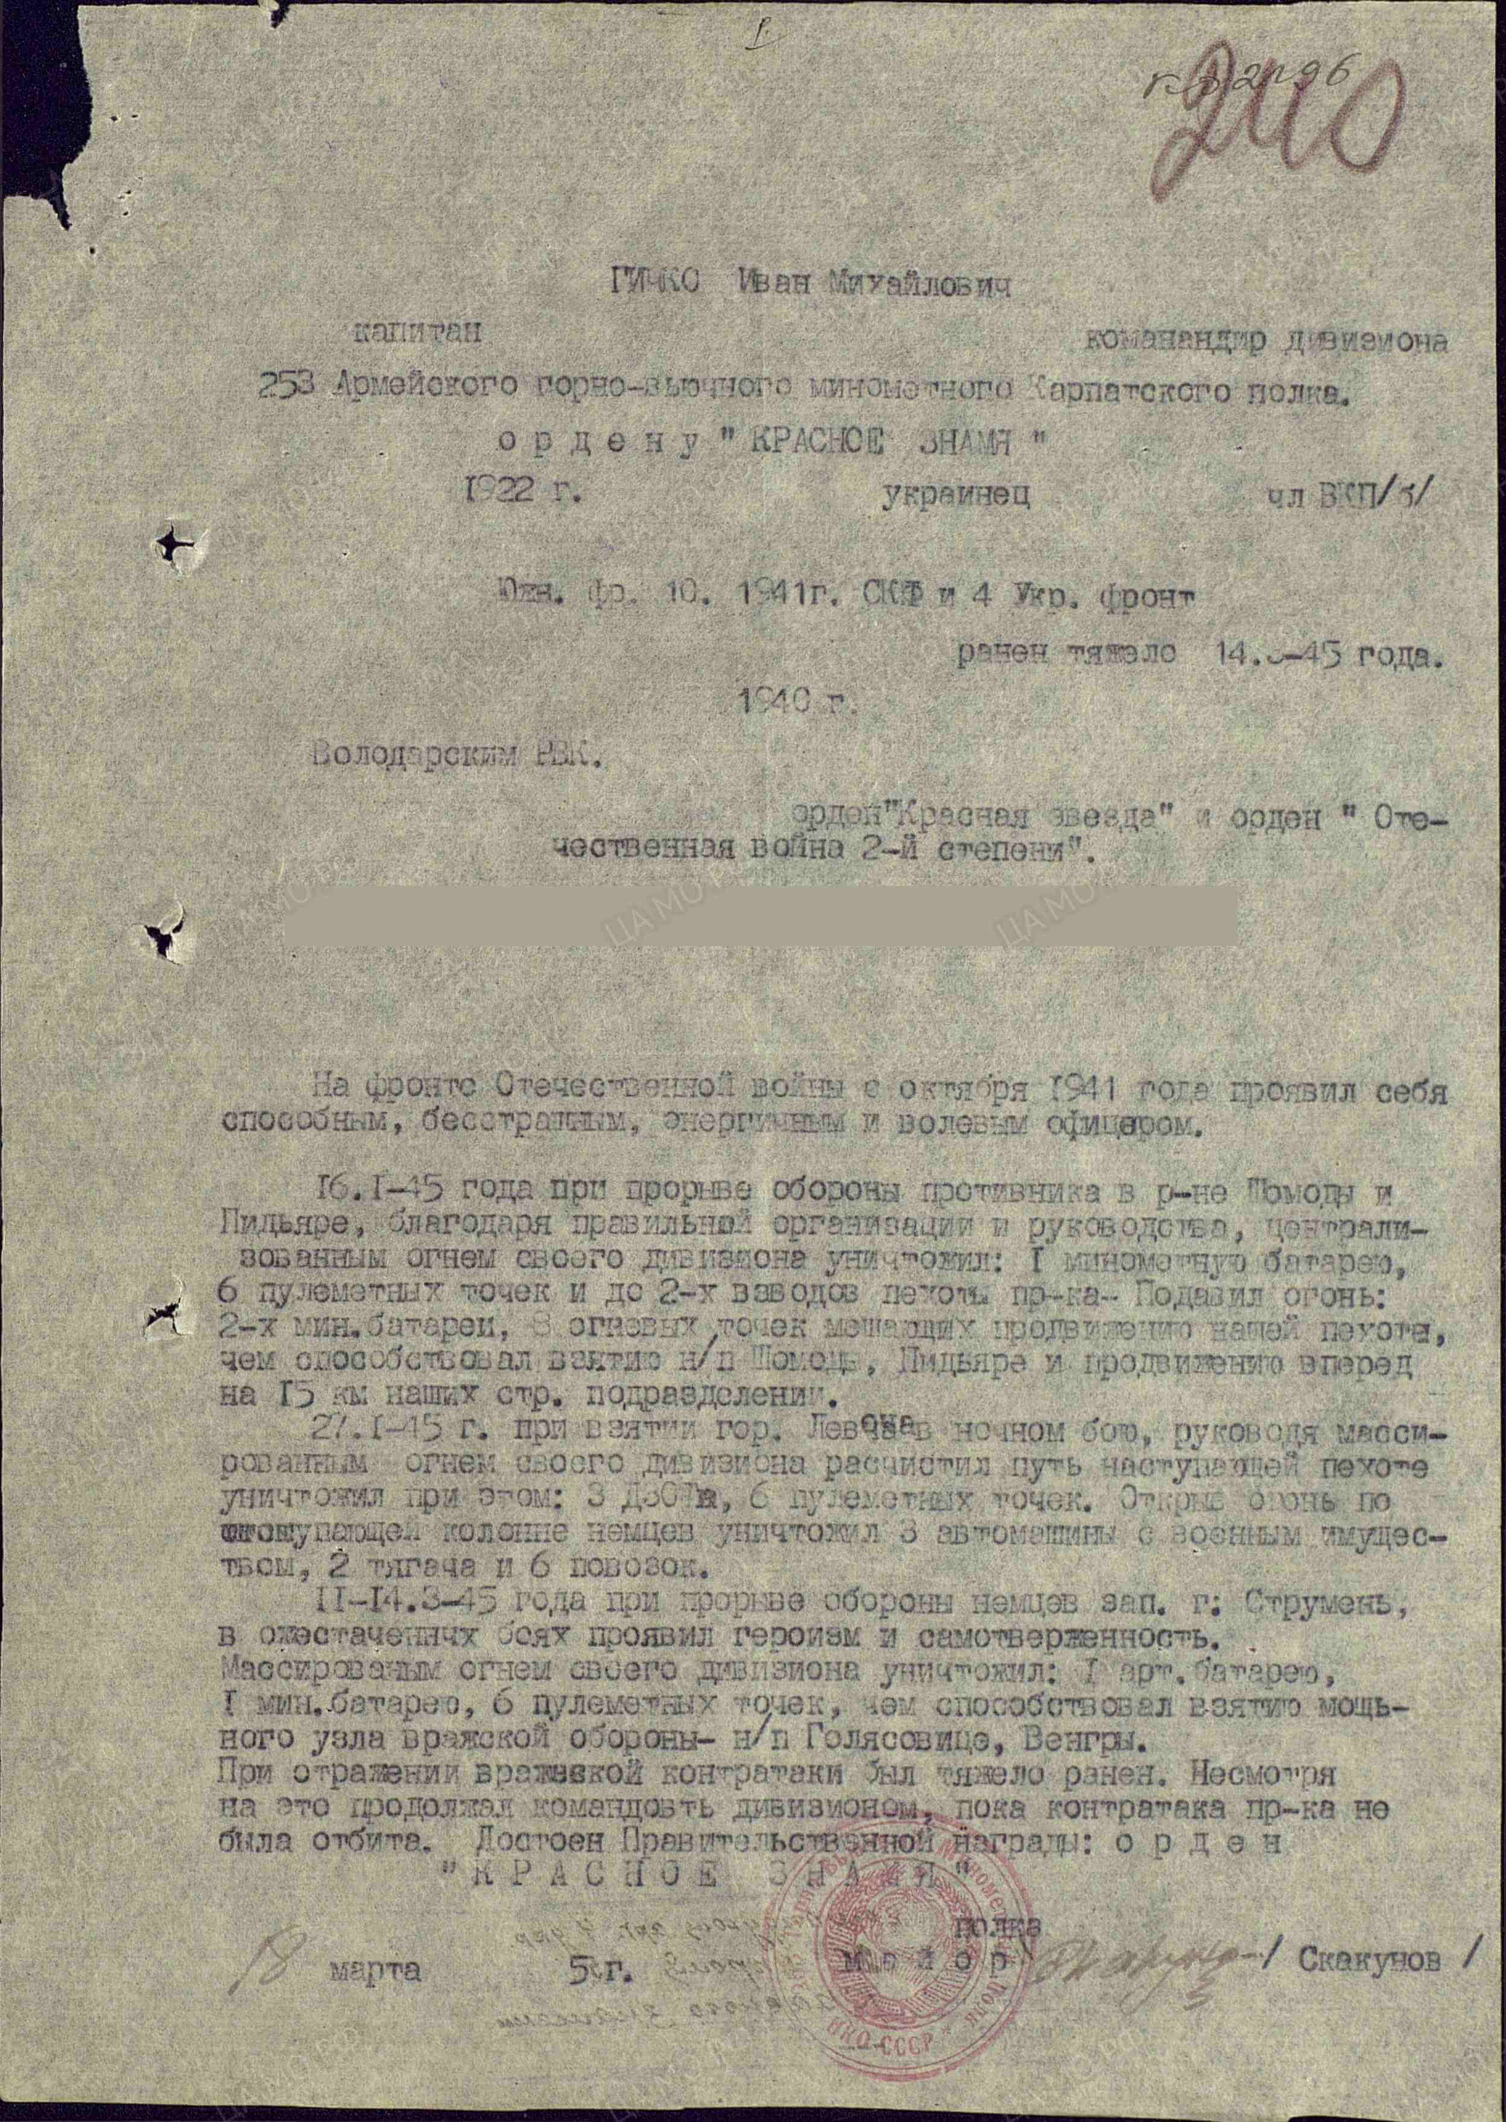

GICHKO Ivan Mikhaylovich – captain, commander of division of 253 army’s mortar Carpathian regiment.

In January 15, 1945 during breaking enemy’s defense in region of Somogy and Pidiare, by fire of his division destroyed: 1 mortar battery, 6 machine-gun fire points and 2 enemy platoons of infantry. Suppressed fire: 2 mortar batteries, 3 fire points, that prevented moving of our infantry, what contributed capturing of settlements Somogy, Pidiare and advancing of our infantry on 15 km.

In January 27, 1945 during capturing town Levoča (Slovakia) in night combat, managing by massive fire of his division cleaned path for advancing infantry and destroyed during this: 3 pillboxes, 6 machine-gun fire points. Opening fire on advancing German’s column destroyed 3 vehicles with military equipment, 2 tractors and 6 wagons.

In March 11-14, 1945 during breaking German’s defense Western town Strumień in fierce combats showed heroism and dedication. By massive fire of his division destroyed: 1 artillery battery, 1 mortar battery, 6 machine-gun fire points, what contributed to capturing settlements Golasowice, Węgry.

During reflecting enemy’s counterattack was heavy wounded. Despite on this, he continued manage by division, until reflect counterattack. Deserves Governmental award: order “RED BANNER”.

Commander of regiment

Major /Skakunov/

18 march 1945

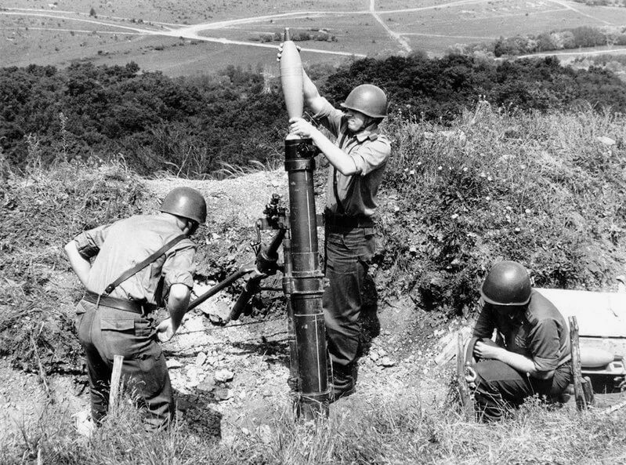

Mortar gunners.