USSR Battle Set: order “Red Star” #2616034, medal “for Courage” #3328924, medal “for Military Merit” #907478 with document.

Awarded to:

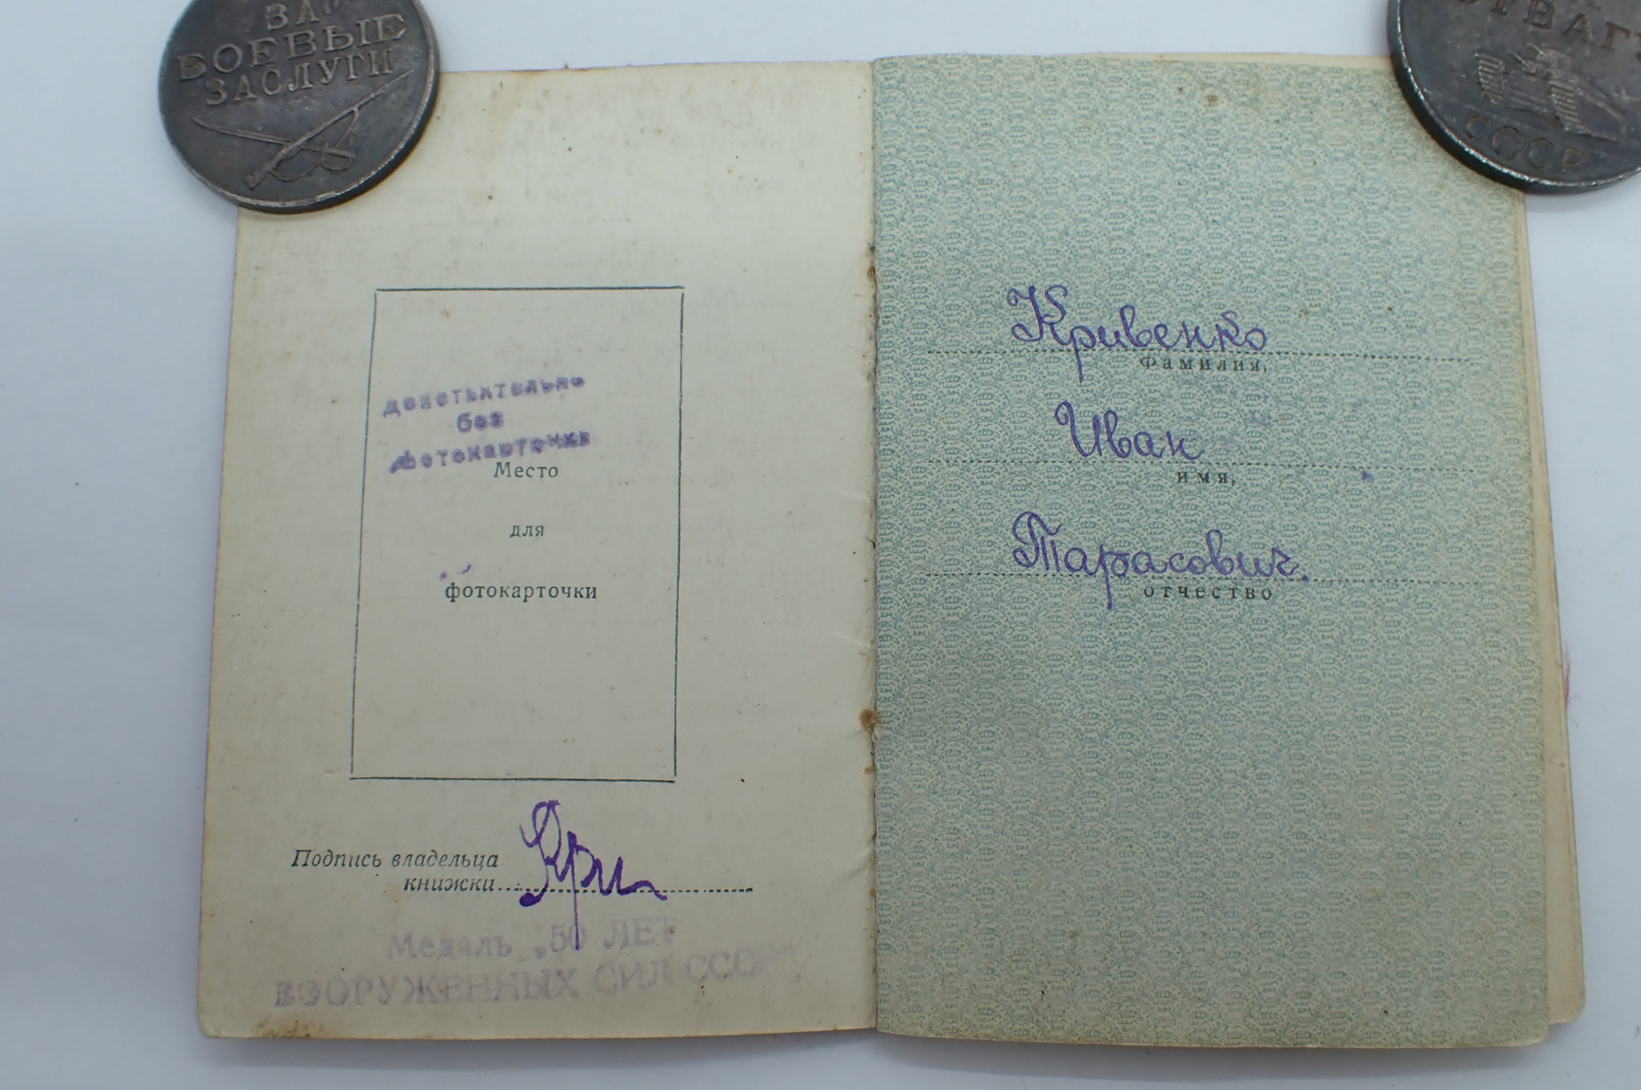

Krivenko Ivan Tarasovich

(Кривенко Иван Тарасович)

medal “for Military Merit” #907478 awarded for:

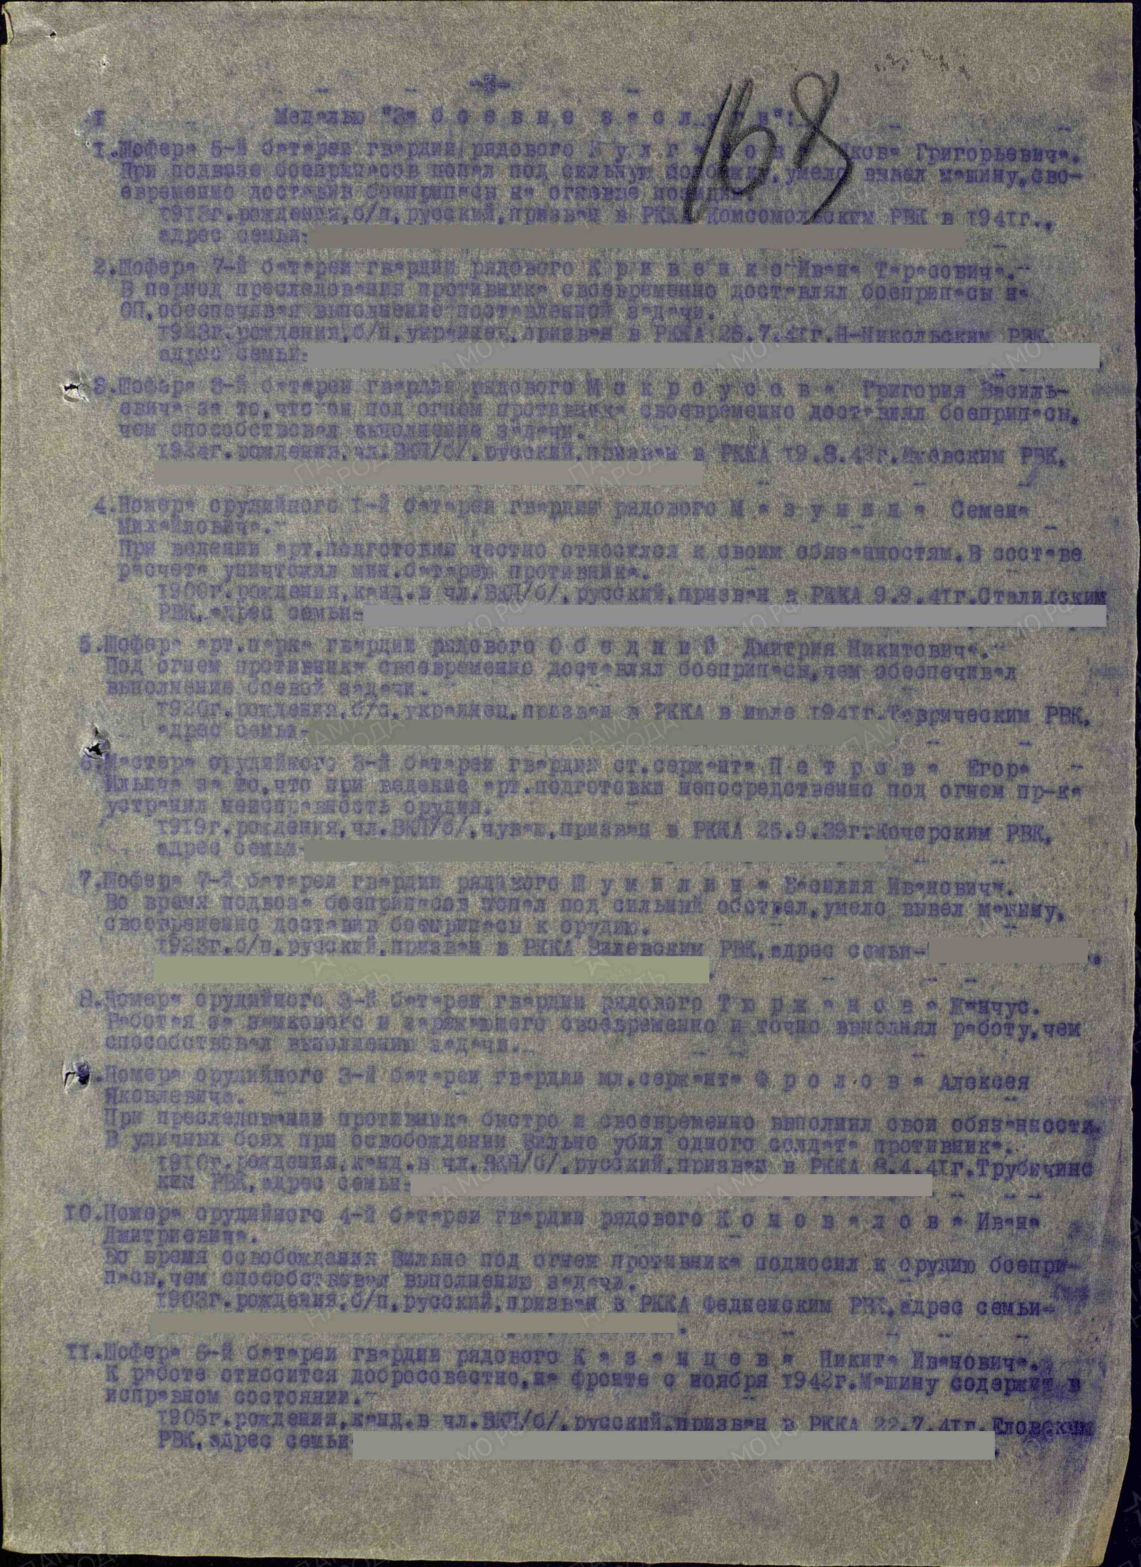

2. Driver of 7 artillery battery guard’s soldier Krivenko Ivan Tarasovich. During enemy’s chasing timely delivered ammunition on fire points, what secured performing of assigned combat task.

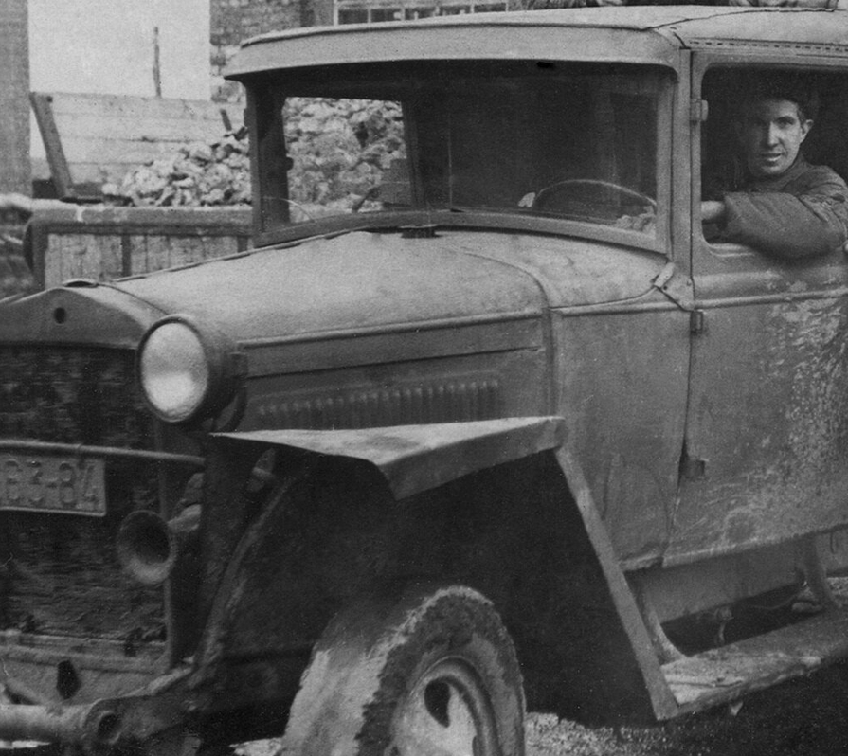

Driver.

medal “for Courage” #3328924 awarded for:

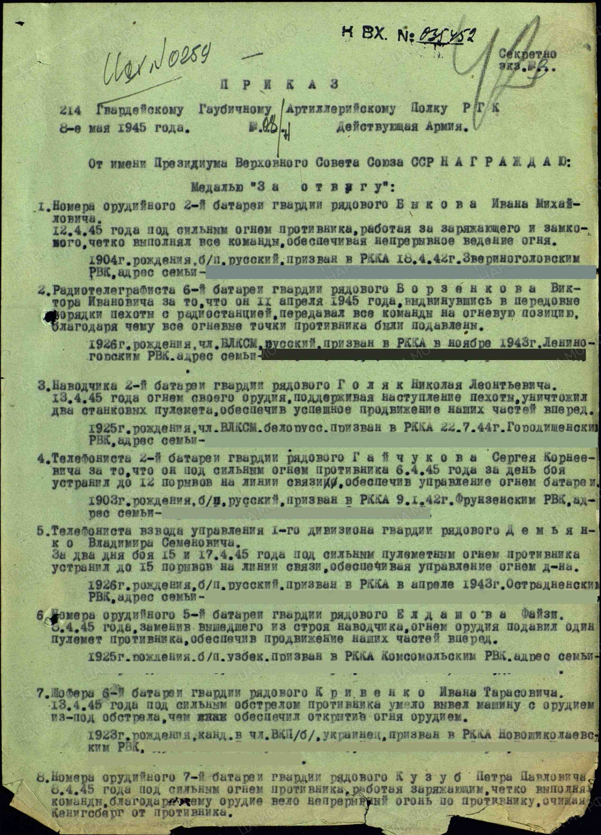

7. Driver of 6 artillery battery guard’s soldier Krivenko Ivan Tarasovich. In April 13, 1945 under heavy enemy fire he skillfully drive vehicle with cannon and secured opening of fire by this cannon on new place.

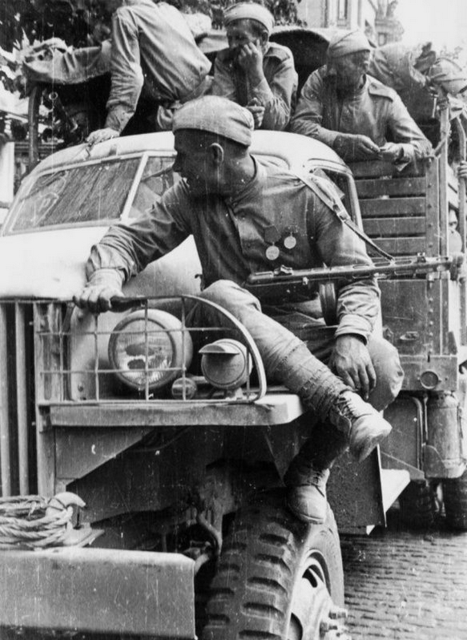

Vehicle.

order “Red Star” #2616034 awarded for:

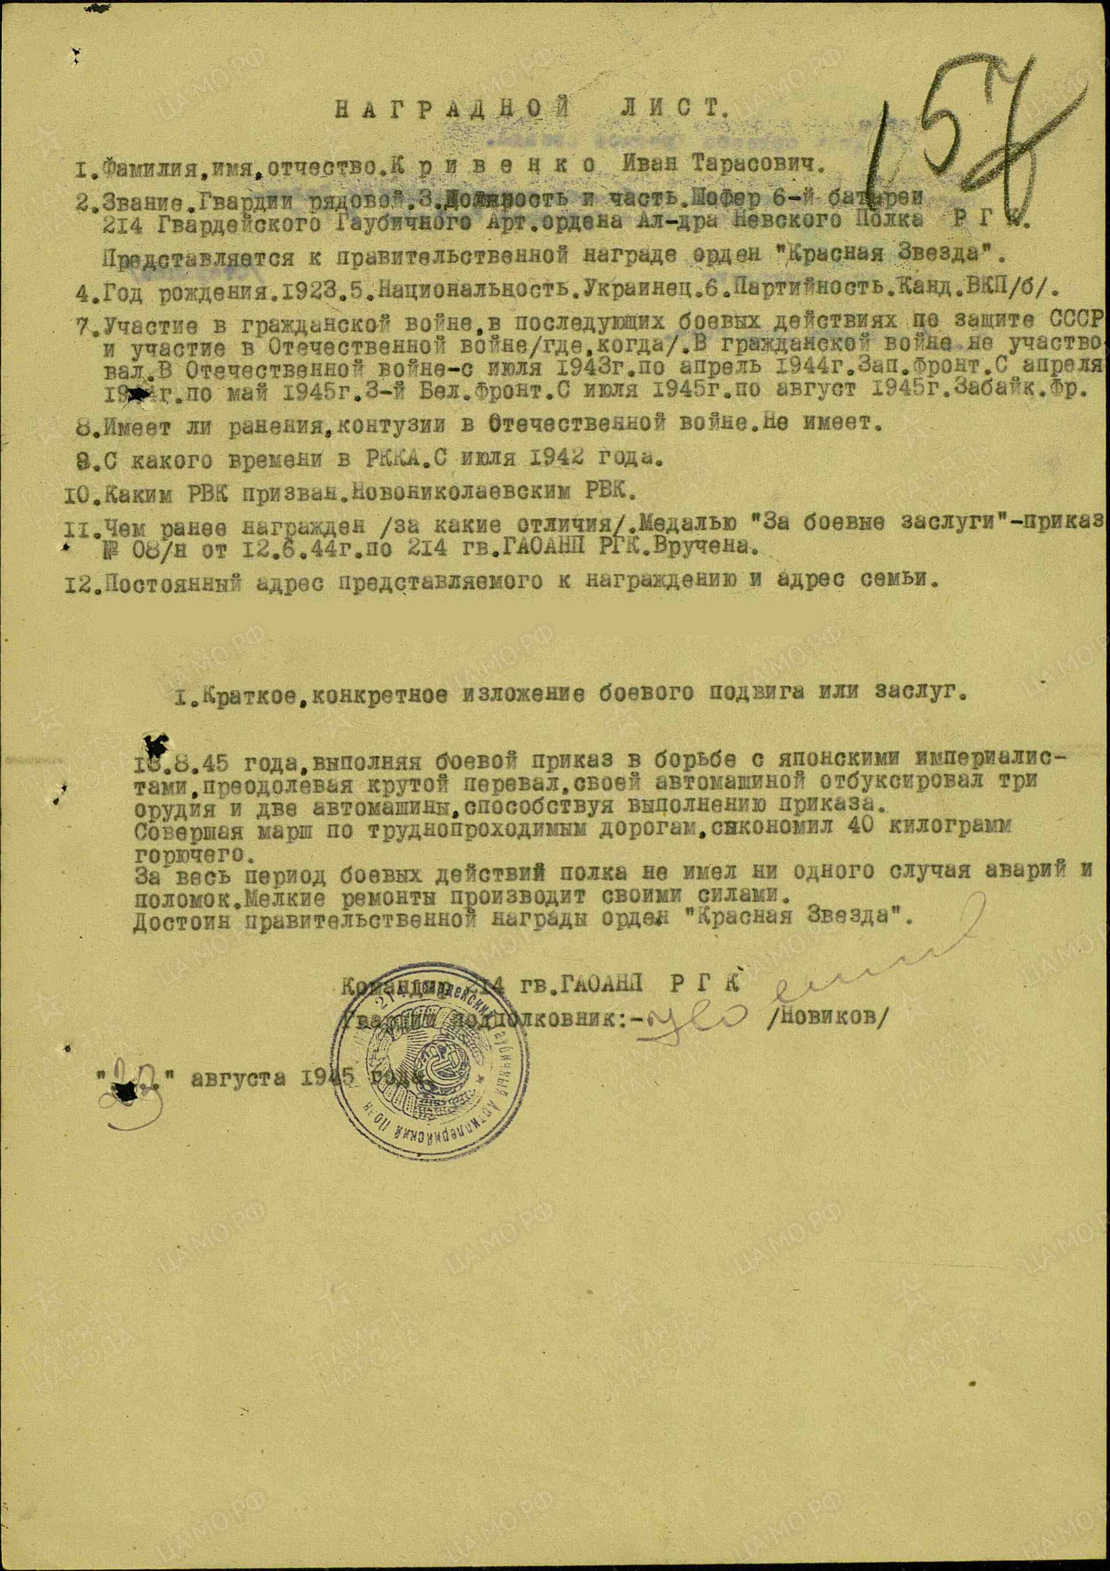

Krivenko Ivan Tarasovich – guard’s soldier, driver of 6 battery of 214 guard’s howitzer artillery order of Alexander Nevsky regiment of reserve of main command.

In August 13, 1945 performing by combat task in combats with Japanese imperialists, moving across mountains, by his vehicle he pulled 3 cannons and 2 vehicles, what contributed to performing of assigned combat task.

Performing march in off-road condition he saved 40kg of fuel.

During combat actions of regiment he didn’t have any single break or accident. Small repairs of vehicle performed personally.

Deserves governmental award order “Red Star”.

Commander of 214 guard’s howitzer artillery order of Alexander Nevsky regiment

Guard’s lieutenant-colonel /Novikov/

“23” august 1945.